Mars UP Church

Apostles’ Creed
I believe in God the Father Almighty, Maker of heaven and earth; and in Jesus Christ His only Son our Lord; who was conceived by the Holy Ghost, born of the Virgin Mary, suffered under Pontius Pilate, was crucified, dead and buried; He descended into hell; the third day He rose again from the dead; He ascended into heaven, and sitteth on the right hand of God the Father Almighty; from thence He shall come to judge the quick and the dead. I believe in the Holy Ghost, the holy catholic church; the communion of saints; the forgiveness of sins; the resurrection of the body; and the life everlasting. Amen.

Gloria Patri
Glory be to the Father, and to the Son, and to the Holy Ghost. As it was in the beginning, is now and ever shall be,
world without end.
Amen. Amen.

Come Holy Spirit, Come
Before the Service – Speak to God!
During the Service – Let God speak to you!
After the Service – Speak to each other!

(*Please stand, if able)
Welcome and Mars Messages

Prelude

*The Call to Worship
Leader: Jesus calls us to be the light of the world-
People: To loose the bonds of injustice, open the eyes
that are blind, and deliver from prison those
who sit in darkness.
Leader: God invites us to be a light to the nations-
People: To carry God’s salvation to the ends of the
earth.
Leader: The Holy Spirit dwells in us, Giving us strength to
do God’s work.
People: We live in God’s hope for us and for the world!

*Hymn 562
“Be Thou My Vision”

Call to Confession

Prayer of Confession
God of glory, you sent Jesus among us as the light of the world, to reveal your love for all people. We confess that our sin and pride hide the brightness of your light. We turn away from the poor; we ignore cries for justice; we do not strive for peace. Forgive us, God. In your mercy, cleanse us of our sin, and baptize us once again with your Spirit, so that, as forgiven and renewed people, we may reflect the love and life of Jesus Christ into our world.

The
Lord’s Prayer

Our Father,
who art in heaven,

hallowed be Thy
name,

Thy kingdom come,
Thy will be done,
on earth
as it is in heaven.

Give us this day
our daily bread;

and forgive us
our debts,
as we forgive
our debtors;

and lead us not
into temptation,
but deliver us
from evil.

For Thine
is the kingdom,
and the power,
and the glory,
forever. Amen.

The Doxology

Praise God
from whom
all blessings flow;
praise Him
all creatures
here below;
praise Him above,
ye heavenly host;
praise Father, Son,
and Holy Ghost.
Amen.

Assurance of Pardon

Gloria Patri
Children’s Chat

Scripture Matthew 5:13-16

Morning Message Rev. Brian Hauser
“Taste and See”

*Hymn 682
“Guide Me, O Thou Great Jehovah”

Prayers of the People and Lord’s Prayer

Offering
Offertory
*Doxology
*Offering Prayer

*Communion Hymn 462
“Come, Share the Lord”

Celebration of the Lord’s Supper

*Hymn 563
“Open My Eyes That I May See”

*Benediction

*Postlude
Church Staff
Rev. Brian Hauser
Pastor
pastor@mars-up.org
724-689-3412

Mrs. Shelly Bocheff
Administrative Assistant
marsup@mars-up.org

AV TEAM
Alma Staskiewicz, Lisa Barbour, Marie Matthews, Bill Guesman, John Ivory, Mike Bocheff, Herb Wellman

Mars United Presbyterian Church

232 Crowe Ave
PO Box 805
Mars, Pennsylvania 16046
724-625-1365
www.mars-up.org
marsup@mars-up.org

Church Office Hours:
Mon -Thurs from 9 a.m. -2:30 p.m.
Flowers today are presented to the Glory of God and in honor of Diana’s 12th Birthday by the Wells Family

MUP Session

Class of 2025 Class of 2024 Class of 2023
John Ivory Alma Staskiewicz Lisa Barbour
Susan Cox Louise Fox Mary Ann Croop
Jay Wilson Marie Matthews Don Lewis
Herb Wellman

Clerk of Session: Herb Wellman

MUP Deacons

Class of 2025 Class of 2024 Class of 2023
Jill Cooper Steve Martin Sharon Gibbs
Robyn Beckwith Marge Nicklas Carol Kopar
Missy Wells Pat Auld Alice Leonberg

Moderator: Steve Martin

Morning Worship:
10:00 am

5th Sunday after the Epiphany

Prayer of Preparation
Lord, we come to you today with so many things on our hearts.

You call us to be in relationship of trust and love with you and you offer healing to us for those portions of our lives that are broken and injured.

Help us to be open to your mercy and healing love. For we ask this in Jesus’ Name.
AMEN.

Mars United Presbyterian Church
Welcome!

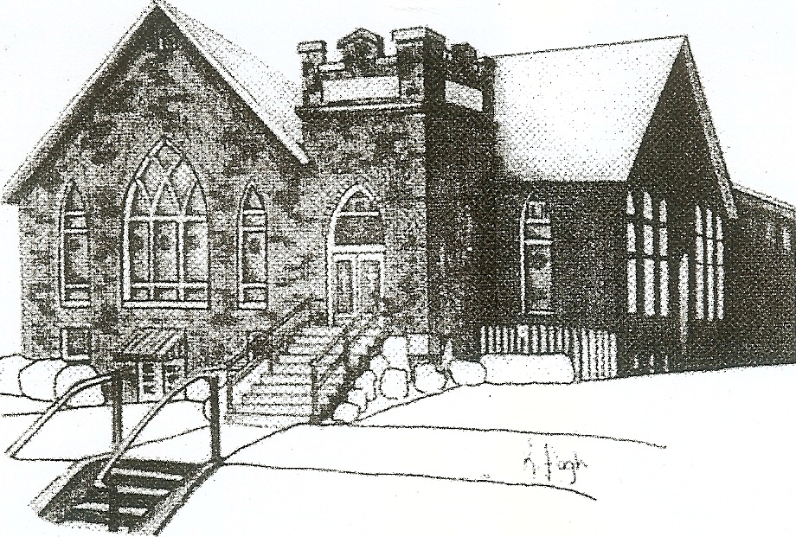
We are your hometown church: Faithful to Tradition, Loving in Fellowship, & Reaching for Tomorrow!

February 5, 2023

We welcome you and we are glad you’ve chosen to Worship with us today!

CALENDAR: February 5th – February 12th

Church Office Hours: Monday -Thursday from 9 a.m. – 2:30 p.m.

Today, February 5, 2023
VOLUNTEERS☺

LAST SUNDAY’S In-House ATTENDANCE: 51

LAST SUNDAY’S OFFERING:
Operating Funds: $4075.00
Mission: $100.00
Per Capita: $437.70
Special: $310.00
Hard tack: $20.00
Total: $4942.70

Tarry N Talk Hosts
Worship/Membership Committee

9:00 am Sunday School Hour
10:00 a.m. THE MORNING WORSHIP SERVICE
11:15 am Congregational Meeting- Annual Report
11:15 am Deacon Meeting
1:00 pm Youth Group
Monday, February 6, 2023
1:30 pm Women’s Bible Study
6:00pm Boy Scouts – 400
6:00pm Cub Scouts 4131
7:00pm Leader meeting
Tuesday, February 7, 2023
9:00 am A team
7:00 pm AA
Wednesday, February 8, 2023
9:00 am Material Girls
Thursday, February 9, 2023
Friday, February 10, 2023
Saturday, February 11, 2023
7:00 am Ski Trip/Peak N Peak
Sunday, February 12, 2023 Scout Sunday
9:00 am Sunday School Hour
10:00 am THE MORNING WORSHIP SERVICE
2:45 pm Girl Scouts
Welcome to all who are Worshiping with us today!

Guests
We sincerely hope our service is a blessing to you. We ask that our guests please take a few minutes to complete one of the Connect Cards found in the pew holder.

Should you have questions regarding any aspect of our church, including membership, please contact Pastor Brian or the church office during the week at 724-625-1365. Thank you for being with us today.

2021 ANNUAL REPORT Hard copies are available in Tarry N Talk for your convenience.

PRAYER – JOYS & CONCERNS
Lou Beckwith Paige Lauten
Paige Barbour (daughter of Andrew and Steph Barbour) Sandy Wahl
Reid Christopher Hall (June Stirling’s nephew)
Lindy McCartney (Lisa Barbour’s Sister)

ANNOUNCEMENTS

Bulletins are printed Thursday mornings; let us know if you have an announcement
PER CAPITA ASSESSMENT
It is that time of year, our individual Per Capita Assessment is due to the Butler Beaver Presbytery. We are requested to pay $43.77 to them per member of congregation of confirmation age and older. You can place your assessments in the offertory and ear mark it for your Per Capita Assessments. The BBP help provide support in negotiating salaries, insurances and pensions with our pastors and employees. Most importantly they provide a resource for us to tap into when we are in need of guidance. Please consider paying your Per Capita Assessment as soon as possible as we partner with our Presbytery to become stronger, smarter and more cohesive. As always, we give thanks for your generosity and support.

CONGREGATIONAL MEETING There will be a Congregational meeting TODAY after worship to discuss the annual report from 2022.

MSPS It’s that time again for those early preschool Sign-ups! Early registration is available for MUP church members and those MOPS members. Registration will be held on Monday, February 6th from 1:30 to 2:00pm. Questions? Please contact Heidi Beahm at 724-272-9911

2022 ANNUAL REPORT Hard copies are available in Tarry N Talk for your convenience.
REMINDER
– NEXT SUNDAY IS DEACON KINDNESS– If you are able, please contribute via the offering next Sunday. Special envelopes are available in the pews.

MUP SKI TRIP It’s that time again! Time for Mars UP Church to take to the slopes for an exciting day of fun and fellowship together at Peak N Peak Ski Resort! The date of the ski trip will be Saturday, February 11th. This event is open to all!!! We will leave the church at 7:00am and ski/snowboard for the day. Watch for more details to follow or talk to Pastor Brian.

