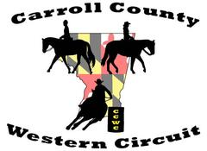
Carroll County Western Circuit
2021 Sponsor Form

Carroll County Western Circuit
Held at Carroll County Agriculture Center & Shipley Arena
706 Agriculture Center Drive, Westminster, MD 21157

Sponsor Name: ________________________ Phone Number: ___________________
Address: ______________________________________________________________
Email: ________________________________________________________________
Website Link: __________________________________________________________

TOTAL enclosed $________________
(checks payable to Carroll County Western Circuit)

Please mail payment or donation along with this form by March 31, 2021 to:
Debbie Worrell, 5206 Sidney Road, Mt. Airy, MD 21771

Product Donations are also greatly appreciated (suggested items are gift certificates, coupons, tack, horse feed, shavings, halters, show headstalls, grooming items, art work, handmade horse items, Breyer Horses, spurs, horse clothing, jewelry, etc.).

______________________________ _______________________________
______________________________ ________________________________

Please contact Debbie Worrell, Treasurer at 240-372-3478 if you have any questions.

Thank you for your support!

