YMCA SUMMER CAMP
- REMINDERS…
- Please pack a morning snack!
- LUNCH AND AFTERNOON SNACK ARE PROVIDED DAILY
- Wear sunscreen every day!
- Please pack a morning snack each day. No nuts or nut products!
- Bring an extra set of clothes.
- Please wear camp T-shirt for any field trip we may take!
- **ALL EVENTS ARE SUBJECT TO CHANGE**
JUNE 2022
PLEASE DROP OFF YOUR CHILD BY 8:30 ON FIELD TRIP DAYS!!!!
Sunday | Monday | Tuesday | Wednesday | Thursday | Friday | Saturday
 | MAY 30 | MAY 31 | 1 | 2 | 3 | 4
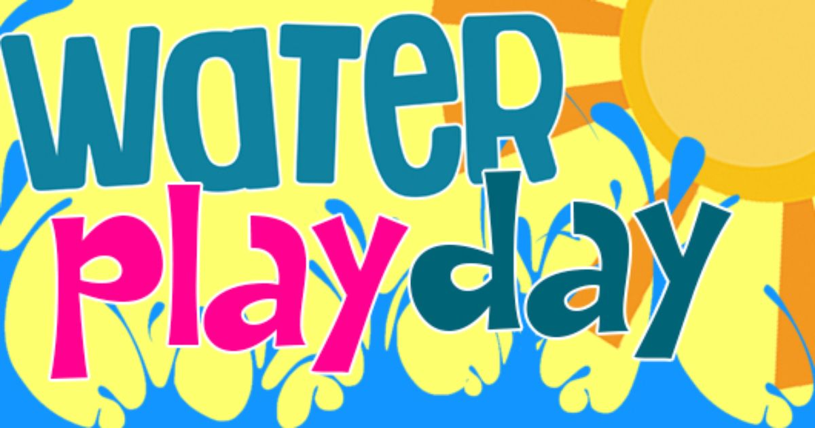 | MEMORIAL DAY  NO CAMP | 1ST DAY OF SUMMER CAMP  SNOWBALLS |  | WATER DAY  AT YMCA  ICE CREAM TRUCK | DRESS UP DAY-  DISNEY | 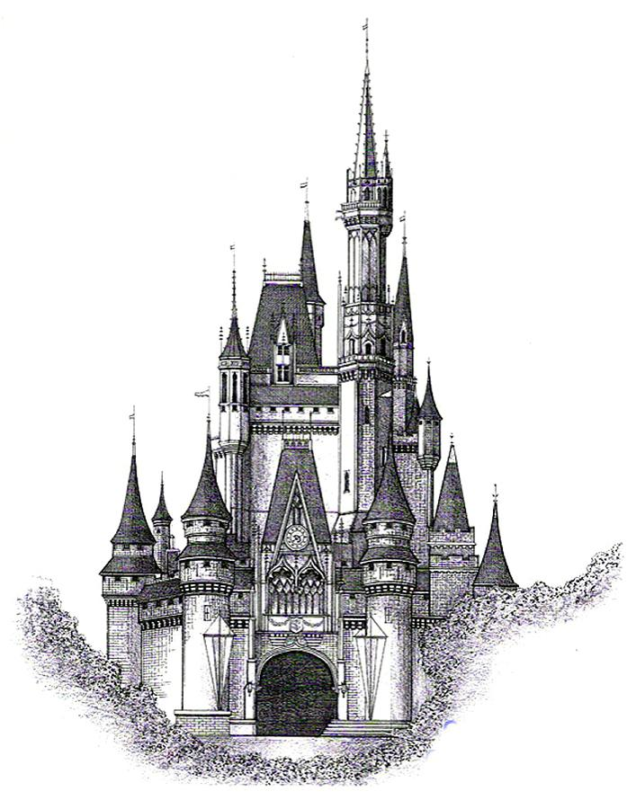
5 | 6 | 7 | 8 | 9 | 10 | 11
 |  | SNOWBALLS | WATER DAY  AT YMCA | ICE CREAM TRUCK | DRESS UP DAY-  HAWAIIAN | 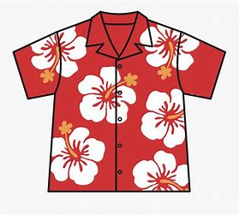
12 | 13 | 14 | 15 | 16 | 17 | 18
 |  | SNOWBALLS | FIELD TRIP  MOVIES: GRAND 14 | WATER DAY  AT YMCA  ICE CREAM TRUCK | DRESS UP DAY-  INSIDE OUT
 |  | 21 | 22 | 23 | 24 | 25
 | VACATION BIBLE SCHOOL | SNOWBALLS  VACATION BIBLE SCHOOL | WATER DAY  AT YMCA  VACATION BIBLE SCHOOL | ICE CREAM TRUCK  VACATION BIBLE SCHOOL | DRESS UP DAY-  CAREER DAY  VACATION BIBLE SCHOOL
26 | 27 | 28 | 29 | 30 | JULY 1 | JULY 2
 |  | SNOWBALLS | LAFAYETTE SCIENCE MUSEUM  AGES 7-12 | CHILDREN’S MUSEUM  AGES 4-6  ICE CREAM TRUCK | DRESS UP DAY –  PAJAMA DAY

