Senior Health Solutions
11791 108th Ct Seminole FL 33778
Tel 727-397-1850
Fax 866-231-9293
Tkendall@shsins.com

September 23, 2015

Hello All,
I hope this letter finds you well. It is that time of the year again! Time to review your Medicare plans for the coming year. It is time to make sure that you are in the right plan for your current situation.
As most of you know, the drug plans all change their formularies on October 1 for a January effective date. The annual enrollment period is from October 15th to December 7th. All decisions must be made by that final date.
I will be calling some time during the first week of October to help decide if we need to meet. Please feel free to call me at any time before that if you have any specific questions or concerns.
I have enclosed several extra cards for you to give to anyone that may need my help. Even if their current plan is the right one for next year it cannot hurt to review it to make sure. Being in the wrong plan could cost hundreds or even thousands of out of pocket expenses.
I look forward to speaking with you soon.

Warm regards,
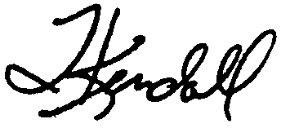
Thom Kendall

