**2018 Williston Coyotes Baseball  
Varsity Roster**

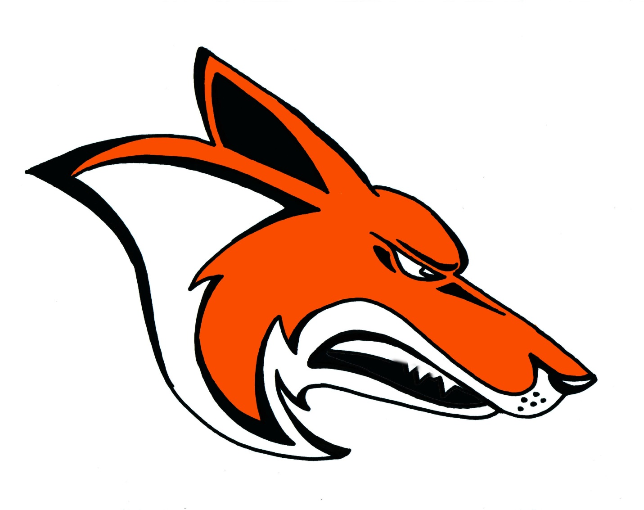

|  |  |  |  |
| --- | --- | --- | --- |
| **NUMBER** | **VARSITY** | **GRADE** | **POSITION** |
| 1 | JAXEN MEYER | 10 | IF/P |
| 2 | BRAEDEN ZASTE | 12 | OF/P |
| 4 | ZACH CARSON | 11 | OF/P |
| 7 | BRADY ABERLE | 11 | C/UTL/P |
| 8 | GARRET HILL | 10 | IF/P |
| 9 | BRADY DOEDEN | 11 | UTL/P |
| 9 | CAMDIN MILLER | 10 | IF/P |
| 14 | REED HANSON | 11 | IF/P |
| 15 | JACK HEEN | 11 | C/IF/P |
| 24 | KOBY KLASSEN | 12 | UTL/P |
| 35 | JADIN NORBY | 12 | IF/P |
| 44 | CHANCE JOHNSON | 12 | 1B |

**Head Coach:** Aaron Finders  
**Assistant Coaches:** Josh Finders, Dustin Bratlien, Andy Mock, Jon Westphal, Brent Lysne, and Trever Sorenson  **Superintendent:** Michael Campbell  
**Principal:** Jason Germundson  
**Assistant Principal:** Audrey Larson & Jonathan Abuhl  
**Athletic Director:** David Mieure   
**Sports Medicine:** Carrie Eder  
**School Song:** Williston Fight Song   
**School Colors:** Black, Orange, and White

[www.wdasports.org](http://www.wdasports.org)  
www.westerndakotaassociation.org

**Sports Medicine Provided By:** **