1/14/2017 The 9th Year, 10th Month, 10th Day

The joybysurprise.com website is back on the internet now. GoDaddy tech support had their advanced team working on it but they were unable to get it fixed.

While it was off the internet, I thought about things. All that people have to do is open their bibles and read and they'd be ok. I also know that at some point all the good teachings will be removed from the internet. The bibles will also probably be removed from society at some point.

Few people visit the joybysurprise.com website, about 6 to 30 a day. My mailing list is small, and when I send out a new article that has a link to the website in it, usually no one responds to visit the site. I have website statistics available that tell me when someone visits the site and what page they go to. It seems that almost no one pays any attention to the articles I send out.

So, I accepted the situation with the website being gone. I prayed that if Abba, our heavenly Father, wanted the website on the internet, that it would be there and if not, that it wouldn't be on the internet. It's His website. Then I went to the computer and tried publishing the site again after about 6 hours downtime and it published perfectly and is now back on the internet.

Roman, Jewish Hillel, and Karaite Calendars all Agree in December, 2016

From time to time the Roman calendar, Hebrew calendar, and the sighting of the new moon in Israel used by Hebrew Karaites, results in a month in which the days determined by all 3 methods agree. Usually the Hebrew calendar doesn't agree with the Roman calendar because the new moon used to determine the Hebrew calendar first day of the month gradually floats through the pre-set days and months of the Roman calendar.

In December, 2016, all three calendars agreed. Roman calendar December 1 was the Hebrew Hillel calendar day 1, and the new moon sighted in Israel by the Karaites also resulted in Karaite day 1 being December 1. There was an additional Karaite offset month-wise this year. Some few Karaites went with an early observation of the Aviv barley in Israel in the Spring of 2016 which started the biblical year a month earlier for them than most other Karaites and the regular Jewish Hillel calendar observers. This means observing the Feasts of YaHuWaH Elohim a month earlier than almost everyone else does. This is not a light matter.

For most Karaite observers, December, 2016, was the 9th biblical month. For a few Karaite observers December, 2016, was the 10th biblical month.
Ezekiel, Write Down this Day

Ezekiel 24:1 Again in the ninth year, in the tenth month, in the tenth day of the month, the word of YaHuWaH came unto me, saying,
2 Son of man, write thee the name of the day, even of this same day: the king of Babylon set himself against Jerusalem this same day.

The prophet Ezekiel was instructed by YaHuWaH Elohim to write down, make a record of, a certain day. The only reason to make a record of a certain date is so that someone in the future can refer to that date. The day was the 9th year, 10th month, 10th day of the month. Years in Ezekiel's time were reckoned from the time that a King began to reign.

Some Kings in Israel co-reigned with others for a time so the new King could get acquainted with ruling the Kingdom. King David co-reigned with King Solomon for a while, about 6 months, before giving control of the Kingdom entirely to King Solomon. Today in the United States we have about a 2 1/2 month period for the newly elected President to get situated and for the outgoing President to instruct the incoming President on what to expect when he is given complete control.

"Ezekiel, Record the 9th Year, the 10th Month, the 10th Day"

The graphic below shows a modern timeline relationship dated from the election of the present day King of Babylon, the same way that years were counted in King David's time.

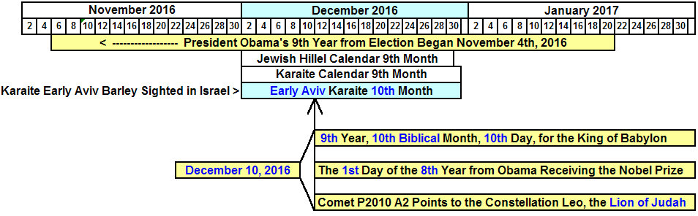

President Obama's 9th year began at the end of 8 years from November 4, 2008. November 3, 2016, completely filled the 8 year allotment.

In President Obama's 9th year, in the 10th biblical early aviv Karaite month, on the 10th day of the month, December 10, 2016, President Obama began the 1st day of his 8th year as a Nobel Peace Prize recipient. He received the Nobel Peace Prize on December 10, 2009. Eight is the number of new beginnings in the bible, and President Obama entered a new phase of his role as a Nobel Peace Prize recipient on December 10, 2016.

We also note that our Creator, YaHuWaH Elohim, also marked December 10, 2016, with a sharp reversal in the path of a strange comet, P2010 A2. Not only did our Creator tell Ezekiel to note the 9th year, 10th month, 10th day, but our Creator Himself also noted the day for us via the path of a comet in a way that no man can alter or erase. YaHuWaH Elohim wanted us to get the message!

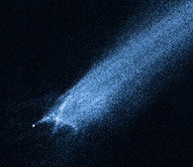
Comet P2010 A2
The Strange Comet

Info here: http://www.joybysurprise.com/the-odd-comet.html

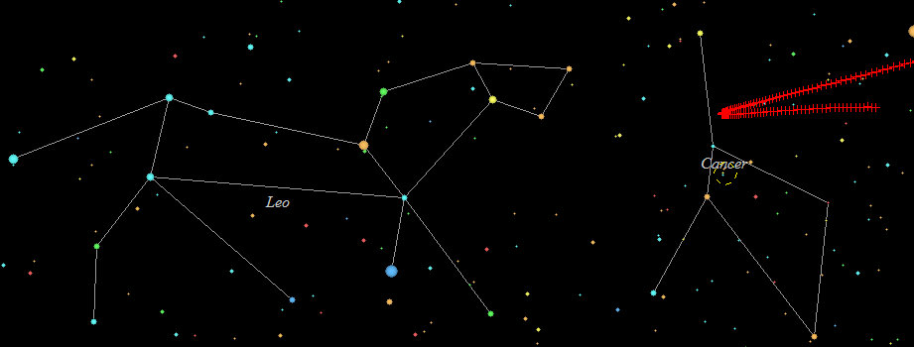
Comet P2010 A2 points to the Lion of Judah on December 10, 2016, 9th Year, early aviv barley 10th Month, 10th Day

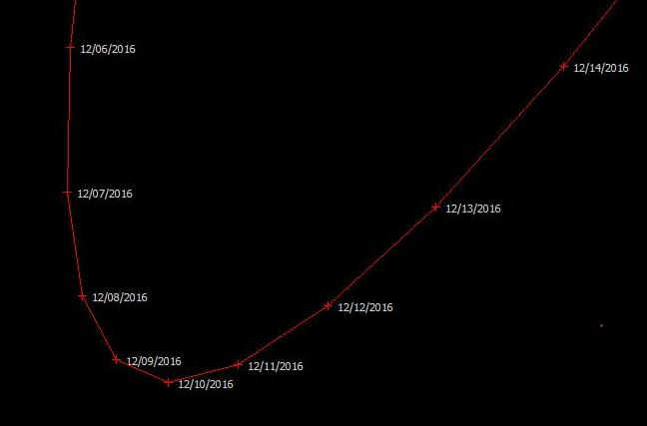
The record of YaHuWaH Elohim in the sky concerning the 9th year, early aviv 10th month, 10th day

Above: The extreme close-up of the path of comet P2010 A2 showing the precise tip of the pointer on 12/10/2016

We know that on December 23, 2016, which was the 14th inclusive day from December 10, 2016, the King of Babylon, President Barack Obama, allowed the condemnation of the State of Israel by the United Nations Security Council. This is not a light matter.

Be aware that on 1/14/2017 the Palestinian Authority officially opened an Embassy to the Vatican in Rome. Link: http://www.timesofisrael.com/abbas-at-vatican-peace-could-suffer-if-us-embassy-moves/?utm_source=The+Times+of+Israel+Daily+Edition&utm_campaign=a80fd72221-EMAIL_CAMPAIGN_2017_01_14&utm_medium=email&utm_term=0_adb46cec92-a80fd72221-55467209

Also know that on 1/15/2017 there will be a meeting of 70 nations in Paris who will take further actions in regard to Israel. Information here: http://www.joybysurprise.com/world-news.html

