**TIRZEPATIDE INJECTION SITES**

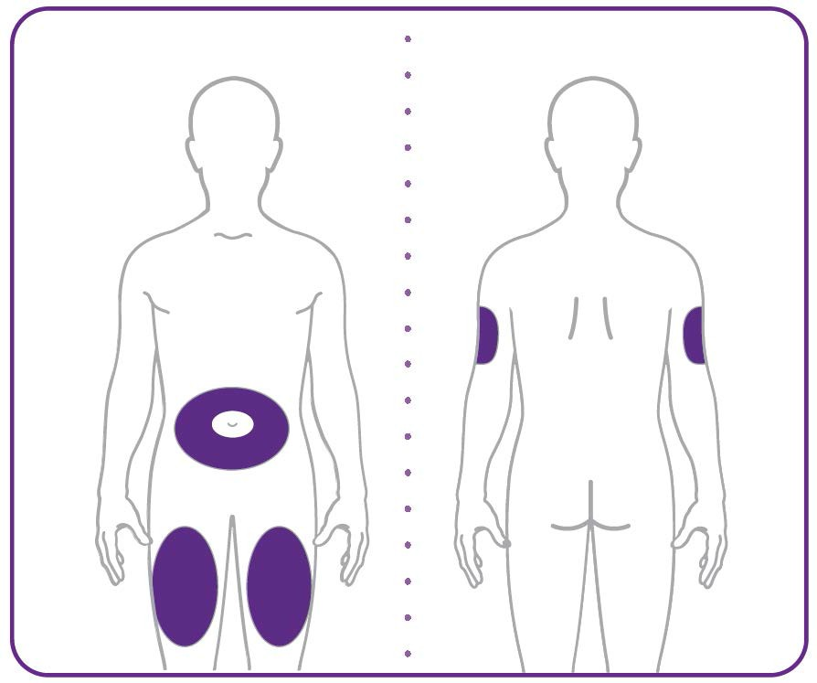

* Your healthcare provider can help you choose the injection site that is best for you.
* You or another person can inject the medicine into your stomach or thigh.
* Another person should give you the injection in the back of the upper arm.

**TIRZEPATIDE DOSING GUIDE 10mg/ml | (100 Units = 1ml = 1cc)**

|  |  |  |  |  |  |
| --- | --- | --- | --- | --- | --- |
| **MG** | **CC** | **UNITS** | **MG** | **CC** | **UNITS** |
| **15** | 1.5 | 150 | 7.8 | 0.78 | 78 |
| 14.8 | 1.48 | 148 | 7.6 | 0.76 | 76 |
| 14.6  14.6 | 1.46 | 146 | **7.5** | 0.75 | 75 |
| 14.4 | 1.44 | 144 | 7.4 | 0.74 | 74 |
| 14.2 | 1.42 | 142 | 7.2 | 0.72 | 72 |
| 14.0 | 1.40 | 140 | 7.0 | 0.70 | 70 |
| 13.8 | 1.38 | 138 | 6.8 | 0.68 | 68 |
| 13.6 | 1.36 | 136 | 6.6 | 0.66 | 66 |
| 13.4 | 1.34 | 134 | 6.4 | 0.64 | 64 |
| 13.2 | 1.32 | 132 | 6.2 | 0.62 | 62 |
| 13.0 | 1.30 | 130 | 6.0 | 0.60 | 60 |
| 12.8 | 1.28 | 128 | 5.8 | 0.58 | 58 |
| 12.6 | 1.26 | 126 | 5.6 | 0.56 | 56 |
| **12.5** | 1.25 | 125 | 5.4 | 0.54 | 54 |
| 12.4 | 1.24 | 124 | 5.2 | 0.52 | 52 |
| 12.2 | 1.22 | 122 | **5.0** | 0.50 | 50 |
| 12.0 | 1.20 | 120 | 4.8 | 0.48 | 48 |
| 11.8 | 1.18 | 118 | 4.6 | 0.46 | 46 |
| 11.6 | 1.16 | 116 | 4.4 | 0.44 | 44 |
| 11.4 | 1.14 | 114 | 4.2 | 0.42 | 42 |
| 11.2 | 1.12 | 112 | 4.0 | 0.40 | 40 |
| 11.0 | 1.10 | 110 | 3.8 | 0.38 | 38 |
| 10.8 | 1.08 | 108 | 3.6 | 0.36 | 36 |
| 10.6 | 1.06 | 106 | 3.4 | 0.34 | 34 |
| 10.4 | 1.04 | 104 | 3.2 | 0.32 | 32 |
| 10.2 | 1.02 | 102 | 3.0 | 0.30 | 30 |
| **10** | 1.00 | 100 | 2.8 | 0.28 | 28 |
| 9.8 | 0.98 | 98 | 2.6 | 0.26 | 26 |
| 9.6 | 0.96 | 96 | **2.5** | 0.25 | 25 |
| 9.4 | 0.94 | 94 | 2.4 | 0.24 | 24 |
| 9.2 | 0.92 | 92 | 2.2 | 0.22 | 22 |
| 9.0 | 0.90 | 90 | 2.0 | 0.20 | 20 |
| 8.8 | 0.88 | 88 | 1.8 | 0.18 | 18 |
| 8.6 | 0.86 | 86 | 1.6 | 0.16 | 16 |
| 8.4 | 0.84 | 84 | 1.4 | 0.14 | 14 |
| 8.2 | 0.82 | 82 | 1.2 | 0.12 | 12 |
| 8.0 | 0.80 | 80 | 1.0 | 0.10 | 10 |
| **MG** | **CC** | **UNITS** |  |  |  |
| 0.8 | 0.08 | 8 |  |  |  |

0.6 0.06 6

0.4 0.04 4

0.2 0.02 2