WHAT is the CORE PROGRAM?

The 3rd Edition Core Standards Verification Program highlights the 65 established standards that can be described as “high risk” for Wisconsin law enforcement agencies; those standards that address mandates, statutory requirements and inherent risk.

CORE PROGRAM FOCUS

The Wisconsin Law Enforcement Accreditation Group (WILEAG) has identified 65 CORE standards from within the 262 6th Edition standards in its ACCREDITATION PROGRAM.

These 65 select standards and the associated agency policies are at the heart of the program. They are focused on:
- Key Federal & State statutory mandates related to law enforcement.
- Requirements arising from case law.
- Inherent issues related to high-risk law enforcement operations & Use of Force.
- Sensitive areas involving community relations.

CORE PROGRAM PURPOSE

The program serves 2 purposes for agencies that successfully participate:

- It provides independent verification that the agency is meeting minimum expectations in essential areas of operations and management.
- It serves as a stepping stone to full accreditation for those agencies that aspire to that level of professional excellence.

CORE PROGRAM BENEFITS

Successful agencies benefit with independent verification that their policies and practices in the essential (core) areas of operations and management meet minimum standards.

CORE PROGRAM ELIGIBILITY

The program is designed to serve smaller Wisconsin law enforcement agencies. It will be available to agencies serving Fourth Class Cities (cities, villages and towns under 10,000 population) and sheriff’s offices serving counties with a county population of 30,000 or less. Also available for first time agencies regardless of size.

CORE PROCESS OVERVIEW

- A candidate agency signs up for the program.
- The agency develops and formally implements the policies needed to be in compliance with the requirements of the WILEAG CORE STANDARDS VERIFICATION PROGRAM.
- The agency applies for a review and submits the required materials committing to on-going upkeep of policies and proofs of compliance and a 3-year cycle of re-verification.

- One WILEAG reviewer will verify that the agency’s entire submission is in
compliance by
scrutinizing policy
language and proofs.

Challenging Wisconsin’s Law Enforcement Agencies to Achieve Excellence

WILEAG’s primary mission is to offer a voluntary and affordable method of achieving professionalism through the accreditation of law enforcement agencies and to assist those agencies to better serve their communities.

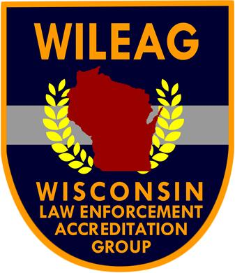

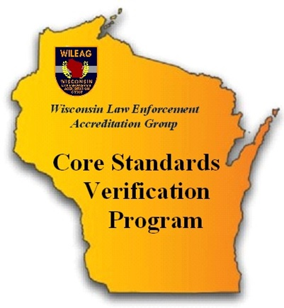

To receive additional information regarding WILEAG:
contact the Executive Director at
262-563-3108 or Email
executive.director@wileag.info

WHAT IS ACCREDITATION?
Accreditation is a process whereby an agency is evaluated on the existence of and its compliance with prescribed standards. Colleges, nursing homes and hospitals have all had accreditation programs for years.

WHAT IS THE WISCONSIN LAW ENFORCEMENT ACCREDITATION PROGRAM?
It is an agency accreditation program administered by the Wisconsin Law Enforcement Accreditation Group (WILEAG) specifically tailored to the needs and capacities of Wisconsin agencies since 1996 and has shown continuous growth in membership to the present time.

HISTORY OF WILEAG PROGRAM
The WILEAG program has evolved as a result of an initiative by the Wisconsin Chiefs of Police Association. The intent is to offer a high quality and affordable alternative to the national law enforcement accreditation program (CALEA) that was established in 1979.

WILEAG OPERATIONS & ADMINISTRATION
The WILEAG program standards are set by the WILEAG Governing Board. Standards cover virtually all key areas of agency operations and administration.

THE GOVERNING BOARD
The Board is comprised of 16 members who come from leadership roles in Wisconsin law enforcement agencies as well as professionals from related disciplines. The WILEAG Governing Board confers accredited status after a review of the findings and upon the positive recommendations of the on-site assessment team. Assessors are respected, experienced law enforcement professionals (or recent retirees). They volunteer and are trained for the assessor role.

BENEFITS OF AGENCY ACCREDITATION
The findings of the independent review and achievement of accredited status provide:
- a well-deserved sense of professionalism and pride by the agency, the agency’s personnel and the community that the agency serves.
- communities gain security in the knowledge that their agencies are well managed and utilizing the best police practices in the State of Wisconsin.
- prosecutors have the assurance that enforcement operations and personnel are consistently well-directed.
- local officials know that there is an independent review and evaluation of agency operations.
PROCESS OVERVIEW
Achieving accredited status is a multi-phase, self-paced process:
- each agency adopts and implements the standards.
- each agency does an in-depth self-assessment to determine readiness for the on-site assessment.
- the WILEAG assessment team conducts an on-site review and presents findings, as well as recommendations, to the WILEAG Governing Board.
- the WILEAG Governing Board grants accreditation to the agency or counsels the agency on the steps necessary to achieve accreditation.

COST
The cost is just $650 per year, the gains are immeasurable. You and your agency deserve to be recognized for achieving law enforcement excellence! Join us.
SPONSORSHIP SUPPORT PROVIDED BY:
Wisconsin Police Leadership Foundation
Cities & Villages Mutual Insurance Company (CVMIC)
Deer Creek Technologies
PowerDMS
Lexipol

