3/11/2017 Bill Clinton, Hassan Rouhani, Prince Charles, and Israel’s 70th Year

Below is a graphic the illustrates the curious relationships between Israel's 70th year as a sovereign state and the conception or birth dates of Bill Clinton, Hassan Rouhani, and Prince Charles.

It happens that the midpoints and endpoints of Israel's 70th year are complementary with the special birthing events in the lives of the people mentioned above. All four events complement and call attention to each other.

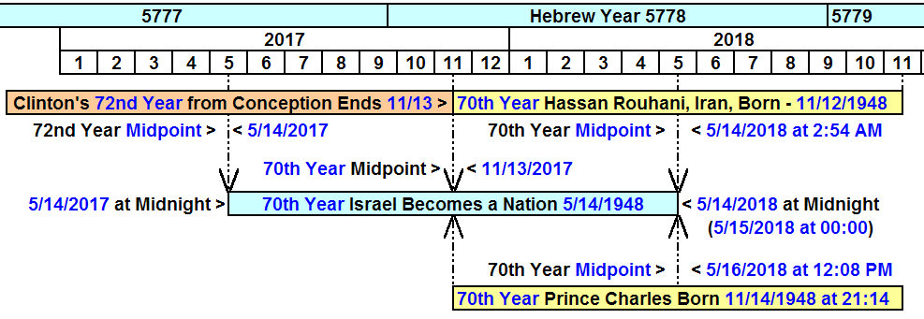

1. The central focus of Iranian President Hassan Rouhani's 70th year since birth is Israel's 70th anniversary as a sovereign state on 5/14/2018. The exact birth time of President Rouhani couldn't be found so an arbitrary 12:00 noon, half way through the day on 11/12/1948, was chosen for the calculation of the 70th year midpoint in his life.

2. The central focus of Prince Charles's 70th year from his birth is 5/16/2018 at 12:08 PM, exactly 36 hours and 8 minutes after Israel's 70th anniversary on 5/14/2018 at midnight.

3. The end of Bill Clinton's 72 year from conception is 11/13/2017, which is the exact midpoint of Israel's 70th year. The 72nd year from Bill Clinton's conception date ties in with two 36 year periods that relate to ancient Babylon and the number 666 through the Babylonian Magic Square.

All of these events that are interrelated time wise have chiastic structures that call attention to Israel's 70th year as a modern nation, with Israel's 70th year itself calling attention to these particular people.

The relationships between the birth of the modern State of Israel and the births of these prominent people reveal the secret workings of our magnificent heavenly Father, YaHuWaH Elohim. They attest to His existence, and to His mighty powers and abilities to work unseen in the intimate lives of peoples and the affairs of nations.

