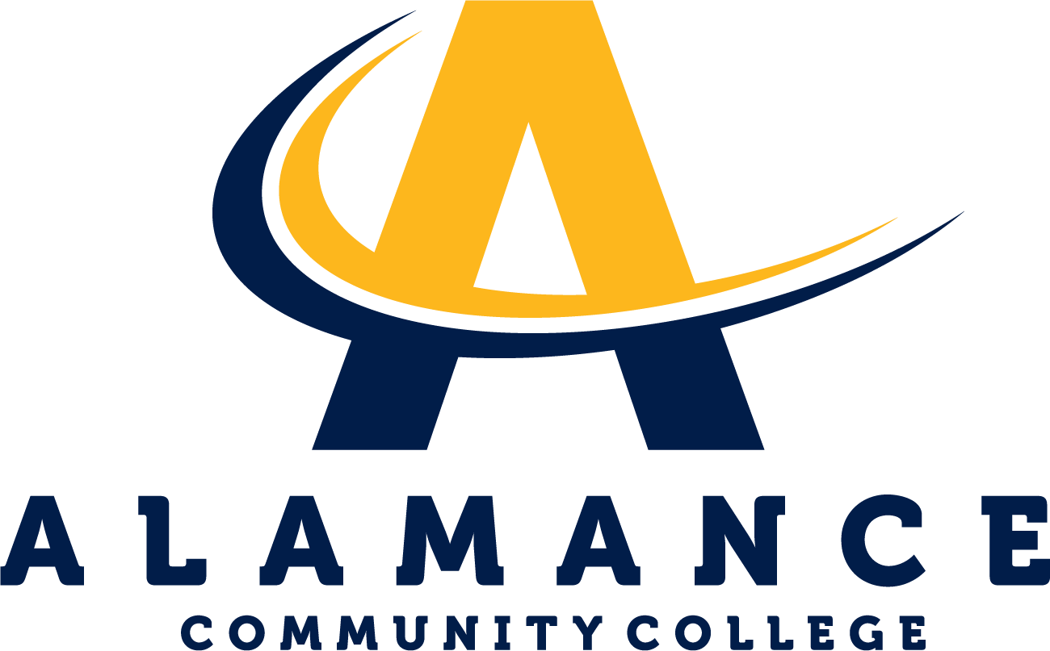

**Natural Sciences Department**

# **Basic Anatomy & Physiology: Bio 163 T/Th 9:30 AM - 12:20 PM Online Asynchronous TBD 5/21/2025 - 7/18/2025** **Contact Information**

**Instructor:** Dr. Kate Brilakis

Phone: 703.498.9997

Email: [kkbrilakis150@alamancecc.edu](mailto:kkbrilakis150@alamancecc.edu)  
Course Website: <http://www.katebrilakis.com/home.html>

**Department Head:** Mary Beth Morgan  
Office: H122 - Powell Building  
Phone: 336-506-4275   
Email: mkmorgan784@alamancecc.edu

**Course Description**This course provides a basic study of the structure and function of the human body. Topics include a survey of human body systems as well as an introduction to homeostasis, cells, tissues, nutrition, acid-base balance, and electrolytes. Upon completion, students should be able to demonstrate a basic understanding of the fundamental principles of anatomy and physiology and their interrelationships.  
  
**Accessibility Services**Alamance Community College is committed to providing equal educational opportunities for students with documented disabilities. Students who require accessibility services or reasonable accommodations are required to identify themselves as having a disability and provide current diagnostic documentation to the Student Support Center in the Main Building,   
Room 233. All information is confidential. For more information, please contact Kirsten Garrison, Accessibility Services Coordinator, at 336-506-4130 or email at kmgarrison728@alamancecc.edu.

# **Course Competencies**

By the end of this course student will be able to:  
 Competency: Demonstrate knowledge of body organization.  
 Competency: Be able to recognize and identify regions of the body.  
 Competency: Be able to define homeostasis and relate it to functioning at the cellular   
 level and whole-body level.  
 Competency: Know the major parts of a eukaryotic cell.  
 Competency: Be able to list the four main classes of organic molecules and explain their   
 functions in living systems.  
 Competency: Identify the names and locations of major bones and muscles.  
 Competency: Describe blood flow through the body and heart.  
 Competency: Be able to identify the form and function of the organs in major body   
 systems (integumentary, skeletal, muscular, nervous, digestive, lymphatic,   
 cardiovascular, endocrine, reproductive, and respiratory).  
**Course Credit**Class: 4.00   
Lab: 0.00   
Clinical: 0.00   
Work: 0.00   
Credit: 5.00  
  
**Skills Development**Soft Skills: Critical Thinking   
Hard Skills: Understanding the role of each organ system role in maintaining homeostasis

# **Required Text**

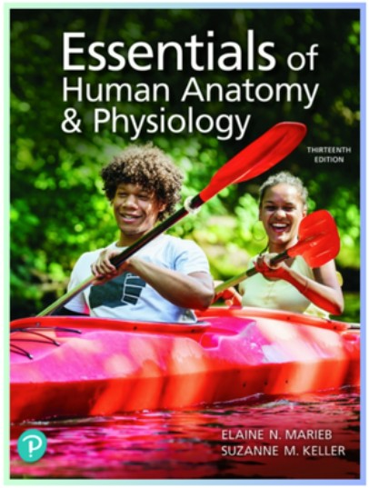

Title:

Essentials of Human Anatomy and Physiology

ISBN:

9780135625606

Authors:

Elaine Marieb

Publisher:

Pearson

Edition:

13

th

Mastering A&P with Pearson eText for Essentials of Human Anatomy &

Physiology

**Course Grading and Requirements  
  
4 Lecture Tests/130 points each** (520 points/1000points = 52% of total grade)  
**3 Lab Practical Tests/110 points each** (330 points/1000 points = 33% of total grade)  
**Pearson Mastering Homework Assignments** (150 points/ 1000 points = 15% of total grade)   
  
During the semester, you’ll accumulate points by completing lecture/lab assessments and homework. The letter grade you earn at the end of the semester will reflect the total points you earn. Periodically, there will be opportunities to earn supplemental points by answering questions posed in our class recordings. Your answers to these questions are due at the start of the following class. Submitted answers must be typed to earn credit.   
  
There’s no time in our compressed semester to offer make-up tests. However, if you do miss a test, you can opt to take a cumulative test that assesses your knowledge of the first 3 sections. The grade you earn on that test will replace the 0 from the missed test. If you’ve never missed a test but you want to replace a test grade, you can opt to take the cumulative test. The grade you earn on the cumulative test will replace the grade from your lowest test grade. If you decide to take the cumulative test, that test grade *will count*. This cumulative test will be offered at the end of the term after you complete your 4th lecture test.   
 If you are absent on the last day, a zero must be submitted for test 4.   
  
The lab tests will be practical meaning you will be asked questions using slides, models and diagrams. Because of the extensive time it takes to set up a practical test, there are no make-up tests *under any circumstances* for these practical tests.   
  
Our text this term is accompanied by an online learning resource called Mastering. You’ll be able to earn points by completing assignments designed to complement and reinforce the information we learn in class. Each assignment will have a posted due date. Please attend to these assignments being mindful of their due dates. Extensions will not be available.   
  
I try to engage all students regardless of their primary learning strategy. I’ve developed a website that offers pictures, tutorials and narratives for every topic we will explore.   
 The URL is: <http://www.katebrilakis.com/home.html>  
This resource will be used as a reference during our classes. You are also encouraged to access this site as you review each topic. I post study questions for each topic that can serve as a scaffold for developing your study guide in preparation for our section tests.   
  
 **Please keep in mind that you’ve signed up for an 8 week semester.**  
To be successful, you’ll need to stay on top of the work. This will require daily attention to your coursework. Tests will be taken in person at the start of the class period after which we will have either lab or lecture. I’ve scheduled our testing dates so that we will not have a lecture test on the same day as a lab test.   
Grading Scale:   
89.6 – 100% = A 896 points/1000 points  
79.6 – 89.5% = B 796 points/1000 points  
69.6 – 79.5% = C 696 points/1000 points  
59.6 – 69.5% = D 596 points/ 1000 points  
Below 59.6% = F less than 596 points/ 1000 points  
 **Student Success**We want you to succeed in this course, and ACC offers a variety of free resources to help you, including the Academic Support Center, the Writing Lab, and the STEM Lab. The Academic Support Center (Main 348) provides free tutoring and an open computer lab where you can complete your coursework. The Writing Lab (Main 349) offers individual sessions with a writing consultant who can assist with the development, organization, grammar, and mechanics of your assignments. The STEM Lab (Main 391) provides a walk-in environment with experienced tutors to help with math and many STEM-related courses. No appointments are required to use the STEM Lab.   
 **Attendance**You’re expected to attend and be on time for all scheduled classes/labs. When you arrive to class, please sign the attendance roster. At 9:30, I will put the roster away. If you are late, please take your seat quietly so as not to disturb the other students. At the end of class, you may ask to register an “L” on the attendance roster for that day. To encourage students to arrive and be prepared to start class by 9:30, and to participate during class, students who do so will earn 2 points added to their total 163 grade. If you are late and/or absent 3 or more times or choose to be disruptive during class, you will not earn these points.   
 Again, our class starts at 9:30. Arriving late = arriving after 9:30.   
  
This class follows a hybrid format. In addition to the meetings on campus, we’ll have the opportunity to meet for a virtual class online for one hour each week. Y*ou are not required to attend this virtual class* although I’d be tickled to have students present with whom to engage. The virtual class will meet via our Moodle platform. I will record every virtual class and post the recording on Moodle. You are required to watch each virtual class recording before our next meeting on campus.   
  
If you have not attended at least one face-to-face class meeting or completed one assignment/activity for an online class by ACC’s 10% date, you’ll be recorded as “never attended” and will be no longer enrolled in the class. This is done by the registrar.   
If you’ve never attended by the 10% date, you may petition the registrar for reinstatement in the class. You’ll be asked to provide information as to the extenuating circumstances and provide documentation to support your request. Reinstatement will only be considered when the absences were due to unforeseeable and uncontrollable circumstances. A decision regarding reinstatement may be appealed to the appropriate Dean within two (2) business days. The Dean’s decision is final.  
  
Any student who has been absent for 20% or more of the total contact hours prior to the withdrawal date of the course may be administratively withdrawn from the course by the registrar. A grade of “WP” will be assigned for any course from which the student is administratively withdrawn. Administrative withdrawals will be allowed up to the published Administrative Withdrawal deadline each semester (the 80% point of the semester). Thereafter, the earned grade will be posted. Under extenuating circumstances, a student may petition, in writing, the instructor, for reinstatement in the course upon demonstrating the capacity and likelihood of satisfactorily completing requirements as indicated on the course syllabus. Tuition refunds or credits will not result from an administrative withdrawal.  
For more information, consult Policy 5.2.1 - Attendance at Alamance CC College Catalog.   
  
**Classroom Conduct/Participation**  
If you engage in any behavior during class that is disruptive, you may be instructed to leave the classroom and/or be restricted from participating in class. Continuous disruptive behavior will result in dismissal from the course.  
The Biology courses offered at ACC are conducted from the standpoint of science as a specific method of investigating the natural and physical world. The content of science courses emphasizes current scientific understanding of the living & non-living world derived from the rigorous collection and analysis of data. As an active process, science is continually updating, refining, and re-testing its body of knowledge. ACC Science classes do not include the presentation or discussion of alternative explanations rooted in theology.

# **Veteran Services**

Alamance Community College is dedicated to serving the men and women, who have served and currently serve, in the armed forces. I am a veteran and respect your service. All students eligible for Military Education benefits, including Spouses and Dependents, are treated with the utmost respect for their sacrifices. Veterans, Guardsmen, and active-duty military personnel with special circumstances (e.g., upcoming deployments, drill requirements, disabilities) are welcome and encouraged to communicate these to the instructor. Please contact Brian Barringer, Veterans Coordinator, for more information at 336506-4398 or email bmbarringer477@alamancecc.edu.

# **Title IX**

Alamance Community College is committed to fostering a safe, productive learning environment. Title IX provides that no person in the United States shall, on the basis of gender, be excluded from participation in, be denied the benefits of, or be subjected to discrimination under any education program or activity receiving Federal financial assistance. As part of Title IX protections, sexual misconduct — including harassment, domestic and dating violence, sexual assault, and stalking — is also prohibited on our campus.

ACC encourages anyone experiencing sexual misconduct to talk to someone about what happened, so they can get the support they need and we can respond appropriately. If you wish to speak **confidentially** about an incident of sexual misconduct, please contact one of the following campus resources:   
College counselors/advisors - Student Support Center, Main 233   
Jenny Brownell, Student Support Center, 336-506-4146 jennifer.b rownell@alamancecc.edu   
Brian Barringer, Student Support Center, 336-506-4398 brian.barringer@alamancecc.edu   
Dr. Patricia Alghali, Student Support Center, 336-290-0502 [patricia.alghali@alamancecc.edu](mailto:patricia.alghali@alamancecc.edu)  
  
**Crossroad Sexual Assault Response and Resource Center, 336-228-0813**Alamance Community College is legally obligated to investigate reports of sexual misconduct, and therefore it cannot guarantee the confidentiality of a report, but it will consider a request for confidentiality and respect it to the extent possible. If you wish to report sexual misconduct or have questions about campus policies and procedures regarding sexual misconduct, please contact our school’s Title IX coordinator, Valerie Fearrington, Gee Bldg. 105, 336-506-4133, vfearrington969@alamancecc.edu.   
As a faculty member, I am required to report incidents of sexual misconduct and thus cannot guarantee confidentiality. I must provide our Title IX coordinator with relevant details such as the names of those involved in the incident.  
  
To help support a welcoming environment, Alamance Community College uses Inclusive Practices. Inclusive Practices is a self-assessment where staff and faculty intentionally focus on the student experience to help foster a sense of belonging.   
**The four tenets of Inclusive Practices are:**\* Do you see me?  
* Do you hear me?  
* Will you treat me fairly?  
* Will you protect me?  
We are committed to your success because YOU BELONG HERE.  
For more information on ACC's Office of Belonging or for questions, please contact Josefvon Jones at 336-506-4289 or by emailing, jjones827@alamancecc.edu.

# **Student Support Services**

**TimelyCare** is ACC's free, virtual mental health platform. Curriculum students can access TimelyCare by downloading the app on their phone or going to timelycare.com/alamancecc and logging in with their ACC email address. Access begins the first day of the semester. Services include scheduled counseling sessions, on-demand (talk-now) counseling sessions and self-care resources on things like sleep habits, healthy eating, anxiety, depression, yoga and more! Contact the Student Support Center at studentsupport@alamancecc.edu or 336-506-4362 for more information or for any access issues.  
  
 **TRiO Student Support Services** (SSS) is a federally funded program granted by the U.S. Department of Education. TRiO services provide opportunities for academic development, assist students with basic college requirements, and motivate students toward the successful completion of their postsecondary education. The goal of the TRiO SSS program is to increase student retention and graduation rates. Learn more about the TRiO program  
  
The **PACE Success Coaches** support and inspire students to engage in self-discovery, mitigate barriers, persist from application to completion, and become lifelong learners and global citizens. PACE coaches provide academic support and college and community resources to meet the needs of students. Learn more about PACE Success Coaching  
  
**ACC’s Food Pantry** distributes food to currently enrolled students. Food is free; no income information is required. Students are welcome to pick up a bag of groceries once a week from the Student Success Center, Main 233 or at the Dillingham Campus, Room 108.  
Learn more about the ACC Food Pantry  
  
**ACC Public Safety**: Sign up for ACC alerts to stay connected and informed of emergency and inclement weather notifications and campus closures. Learn more about ACC Alerts  
  
Alamance Community College has partnered with **Single Stop,** a non-profit organization, to provide students with easier access to a wide range of resources and benefits. Students can be quickly and conveniently screened for resources related to food, housing, earned income and child care tax credits, childcare-related resources, health care resources, and more. Kristen  
Sutherland, Single Stop coordinator, at 336-506-4039 or at kmsutherland239@alamancecc.edu .

The **Student Support Center** is your resource for a variety of important student services. Located in the Main Building (Room 233) of the Graham Campus, the center is committed to your success by making available programs and resources focused on student’s academic, vocational, and personal growth and achievement. For more information, please visit the Student Support Center online, or call 336-506-4362

# **Virtual Conferencing**

Our course will use Collaborate to conduct virtual meetings and/or office hours.  
Instructions on how to access this platform will be provided.

# **Classroom Technology Policy**

A laptop or desktop is required for this course to access online and electronic class materials.

# **Communication Policy**

Communication between students and the college will be conducted using ACC’s ACCess Email addresses. You are expected to set up your ACCess email account and check it regularly for instructor, advisor and college emails. Course announcements sent through Moodle will go to your access account.

Communication between students and the college will be conducted using ACC’s ACCess Email addresses. You are expected to set up your ACCess email account and check it regularly for instructor, advisor and college emails. Course announcements sent through Moodle will go to your access account.  
  
I will do my best to respond to emails within 24 hours. If you don’t hear from me within that time frame, chances are I didn’t get your email. Please try again! If it is an emergency, feel free to text me.

# **Academic Dishonesty and Plagiarism**

Alamance Community College expects every student to be committed to honesty and academic integrity. To ensure that all students understand ACC's expectations, specific examples of cheating and plagiarism, two common forms of dishonesty, are outlined below. The lists are representative, but not all-inclusive of various types of academic dishonesty.

Cheating includes copying tests, assignments, projects, presentations, and similar work; submitting work that was previously submitted in another course or at another institution without instructor approval; changing grades without the instructor's knowledge; using unapproved sources (print, electronic, or web materials, etc.) during tests; receiving and giving assistance with tests or other assignments without instructor approval; and any action which misrepresents or defrauds.

Plagiarism includes representing others' work (papers, tests, assignments, projects, etc.) in any form, print, electronic, web, etc., as your own; not giving credit to work created or composed by another author (refer to The Publication Manual of the American Psychological Association, the MLA Handbook for Writers of Research Papers, or other approved style guide); or submitting a purchased paper, project, or presentation as your own original work.

Other academic honesty violations include allowing others to copy your work, providing your work to others for submission as their own, lying to improve your grade or others' grades, changing a graded work and submitting it for regrading, stealing or destroying others' work, collaborating on work without instructor approval, and impersonating another by taking their examination.

If a student commits an act of academic dishonesty, the consequences may include one or more of the following at the discretion of ACC administrators: receive a zero grade on that assignment, receive an "F" in that course, and/or be suspended or expelled from the college. View the entire policy in ACC's Course Catalog

# **Honors Statement**

Students interested in becoming participants in the honors program should contact John Neathery, Program Coordinator at 336.506.4242 or john.neathery@alamancecc.edu. To learn more, visit the Honors Program on the ACC website,

Students interested in becoming participants in the honors program should contact John Neathery, Program Coordinator at 336.506.4242 or john.neathery@alamancecc.edu.

Please visit www.alamancecc.edu/honors for more information.

**BIO 163 Lecture Schedule Summer, 2025 T/Th May 22st to July 18**  
**Date Chapter(s) Topic  
Section 1:**May 22 1 Homeostasis and the Human Body  
May 27, (28) 2 Basic Chemistry  
May 29, June 3, (4) 3 & 4 Cells, Tissues, Membranes and Skin   
**Thursday, June 5 Section 1 Test**  
**Section 2:**June 10 5 Skeletal Physiology

June (11) 6 Muscular Physiology  
June 12, (17) 7 Nerve Function

June (18) 8 Special Senses

**June 19 ACC Closed/National Independence Day  
June 24 Section 2 Test   
  
Section 3:**June (25) 9 Endocrine System  
June 26 10 Blood  
July 1 11 Cardiovascular System  
July (2) 12 Lymphatic System and Immunity

**July 8 Section 3 Test**  
**Section 4:**July (9) 13 Respiration  
July 10 14 Digestion and Metabolism   
July 15 15 Urinary System   
July 16 16 Reproductive Systems

**July 17 Section 4 Test**

**Bio 163 Lab Schedule Summer, 2025 T/Th May 22 to July 18  
  
Lab # Date Topic**Lab 1 May 22 Intro to our Lab  
Lab 2 May 27 Histology  
Lab 3 May 29 Axial Skeleton   
Lab 4 June 3 Appendicular Skeleton   
Lab 5 June 5 Muscles I (on practical 2)  
 **June 10 Practical 1 on labs 1,2,3 & 4**  
Lab 6June 12 Muscles II  
Lab 7 June 17 Brain/Spinal Cord  
 **June 19 ACC closed: National Independence Day**Lab 8 June 24 Special Senses  
 **June 26 Practical 2 on labs 5,6,7,& 8**Lab 9 July 1 Circulation: the Heart  
Lab 10 July 3 Circulation: Blood VesselsLab 11 July 8 Respiratory System & Digestive System  
Lab 12 July 10 Urogenital Systems  
 **July 15 Practical 3 on labs 9,10,11 & 12**