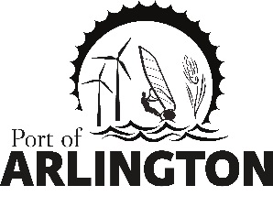

Irrigation Feasibility Study Work Session
Thursday, February 21, 2019
2:00 pm
Meeting Location:
Gronquist Building / Gilliam Room
11650 Railroad Ave.
Arlington, OR 97812

- Cascade Earth Sciences Engineers Feasibility Report Synopsis
- Questions and Answer Session

Upcoming Meetings:
Regular Commission Meeting on Tuesday, March 13, 2019 Port of Arlington Office
This meeting location is accessible to persons with disabilities. A request for an interpreter for the hearing impaired or for other accommodations for persons with disabilities should be made at least 48 hours before the meeting by contacting Kelly.margheim@portofarlington.com / 541-454-2868
Posted: Tuesday, February 4, 2019: Bank of Eastern Oregon - Condon & Arlington; U.S. Post Office - Condon & Arlington; Condon Times-Journal; Arlington City Hall; Port Office and Website.
PO Box 279
Arlington, Oregon 97812

