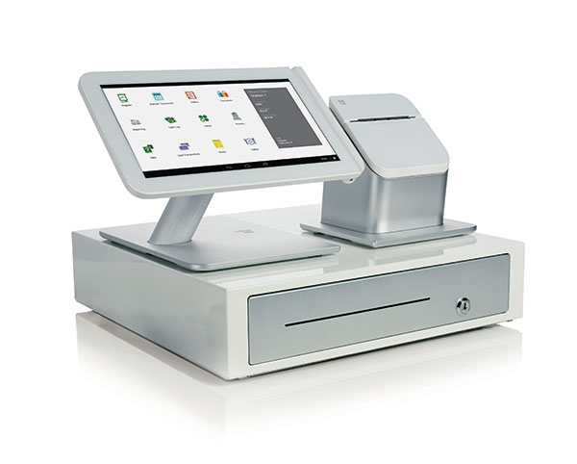
VeriFone
Quick Reference Guide
Customer Service: (316) 269-4592

CREDIT CARD SALE
- Select Sale
- If enabled for server or clerk id, enter id and press ENTER
- Type the amount and press ENTER
- INSERT/SWIPE/TAP the card or TYPE the card number and press ENTER. Will be prompted for exp date on manual entries.
- If prompted, select CREDIT or DEBIT.
- (If enabled -Manual Only) Indicate if the card is present by selecting YES or NO.
- (If enabled -Manual Only) Type in the 3 or 4-digit code on the back of the card after the account number or press ENTER if unknown.
- (If ENTER above) Select NO if no code present or XREAD if the code is not legible.
- (If enabled – Manual, Card Not Present Only) Type the address of the cardholder and press ENTER
- (If enabled – Manual Only) Type the zip code of the cardholder and press ENTER.
- The terminal will go out for approval.
- (If enabled – Purchasing Card Only) Type the Customer Number and press ENTER.
- (If enabled – Purchasing Card Only) Type the tax amount and press ENTER.
- (If no tax amount) Select the reason for no tax.
- (If enabled – Amount of Sale exceeds balance on Pre-Paid card) The terminal will display the approved amount and the amount that is still owed by the customer. ACCEPT ANOTHER FORM OF PAYMENT FOR THE REMAINING BALANCE. To cancel the transaction and return the authorized amount to the card, initiate a VOID transaction.
- Select YES or NO to print a second receipt.

DEBIT/EBT CARD SALE
- Select SALE.
- (If enabled) Type the server or clerk id and press ENTER.
- Type the amount and press ENTER.
- (If enabled) Type the tip amount and press ENTER.
- INSERT/SWIPE/TAP the card.
- Select DEBIT or EBT.
- (EBT Only) Select Cash Benefits or Food Stamps.
- (If enabled – Cash Benefits Only) Type the cash amount and press ENTER.
- Have the customer type their PIN # and press ENTER.
- (Manual EBT Only) Type the 3-digit generation # of the card and press ENTER.
- The terminal will go out for approval.
- If enabled – Amount of Sale exceeds balance on Pre-Paid card) The terminal will display the approved amount and the amount that is still owed by the customer. ACCEPT ANOTHER FORM OF PAYMENT FOR THE REMAINING BALANCE. To cancel the transaction and return the authorized amount to the card, initiate a VOID transaction.
- Select YES or NO to print a second receipt.
REFUND
- Scroll Menu. Select REFUND.
- (If enabled) Type the server or clerk id and press ENTER.
- Type the amount and press ENTER.
- INSERT/SWIPE/TAP the card or TYPE the card number and press ENTER. Will be prompted for exp. Date on manual entries.
- Select CREDIT, DEBIT OR EBT
- (Debit/EBT only) Have the customer type their pin # and press ENTER.
Refund cont’d
- (Manual EBT only) Type the 3-digit generation # of the card and press ENTER.
- The terminal will go out for approval.
- Select YES or NO to print a second receipt.
VOID
- Select VOID.
- To void the last transaction, select YES. For another transaction, select NO.
- (If no above) Select either Invoice # or Acct # to retrieve the transaction.
- (INV Selected) Type in the last invoice # from the original receipt and press ENTER.
- (ACCT Selected) Type the last 4 digits of the card number and press ENTER.
- Select YES if this is the transaction to be voided.
- (Debit/EBT Only) Have the customer type their PIN # and press ENTER.
- The terminal will go out for approval.
- Select YES or NO to print a second receipt.

FORCE
- Scroll Menu, Select FORCE.
- (If enabled) Type the server or clerk id and press ENTER.
- Type the amount and press ENTER.
- INSERT/SWIPE/TAP the card or TYPE the card number and press ENTER. Will be prompted for exp. date on manual entries.
- Select CREDIT or EBT.
- (Manual EBT Only) Type the 3-digit generation # of the card and press ENTER.
- (EBT Only) Type in the Voucher number and press ENTER.
- The terminal will dial out to confirm approval.
- Select YES or NO to print a second receipt.

REPRINT
- Press the REPRINT key.
- Select either Last Receipt or Any Receipt.
- (Any Receipt Selected) Type in the invoice # from the original receipt and press ENTER.
- Duplicate receipt will print.

PRINTED REPORTS
- Press the REPORTS key.
- Select DETAIL Report for individual transactions, TOTALS report for grand totals or GIFT DETAIL to view individual Gift
Card transactions. Scroll the menu to view additional reports including Server and Batch History Report.

ADD SERVER/CLERK
- Press ENTER.
- Select SERVERS.
- Select ADD SERVER.
- Type the management password and press ENTER.
- Type the numeric password (5-10 digits) for the server and press ENTER.
- Renter the password and press ENTER.
- Type a Server/Clerk number and press ENTER or press [X] to cancel.

TIP ADJUSTMENT (RESTAURANT ONLY)
- Press the ADJUST key.
- Select how to retrieve the transaction.
- (If INV # Selected) Type in the invoice # from the original receipt and press ENTER.
- Select ADJ to adjust the displayed transaction.
- Type the Tip Amount and press ENTER.
- Scroll the batch by pressing previous or next to adjust another transaction or press [X] to cancel. Press [X] again to return to main menu.

SETTLEMENT
- Scroll Menu. Select SETTELMENT
- If totals are correct, press ENTER to continue. A second confirmation screen may appear for Debit/EBT transactions on certain configurations.
- The terminal will go out for approval and print a Settlement Report.

EMV NOTES
- When prompted for Card Entry, Insert card with chip facing in and upward.
- EMV card must remain inserted during the entire transaction.
- Follow the on screen prompts.
- Receipt will print after card is removed.

