Prof. Ritsuo Nishida was awarded ISCE Silver Medal 2015
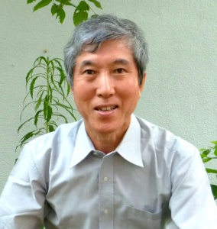
Abstract for medal lecture:
Ecological significance of plant secondary metabolites in insect-plant-interactions
Ritsuo Nishida, Kyoto University, Japan
Plants produce a diverse array of secondary metabolites as chemical
barriers against herbivores. Phytophagous insects are highly adapted to these allelochemicals and may use such unique substances as specific host-finding cues (kairomones), defensive substances of their own (allomones), and as sex pheromones by selectively sensing, incorporating and/or processing specific plant metabolites. Insects also serve as pollinators often effectively guided by specific floral fragrances (synomones) in the mutualistic interactions. My research aims to understand the ecological significance of such phytochemicals in the highly diverse interactions between insects and plants.

