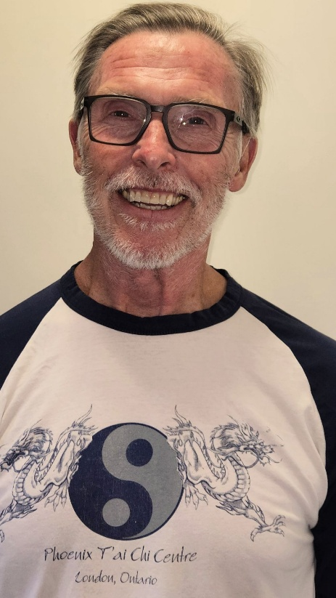
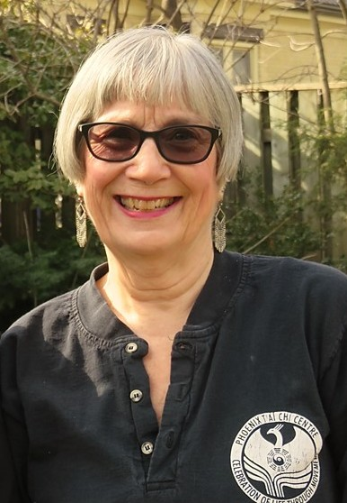
Tai Chi for Arthritis

Thursdays 5:30-6:30pm

September 25th – November 27th 2025
Fee: $95 for 10 classes
Location: Phoenix Tai Chi Centre
19A Holborn Ave at Briscoe St. W., LONDON

Tai Chi for Arthritis" is a program designed by Paul Lam MD with a team of Tai Chi and medical experts, based on Sun-Style Tai Chi. It is easy to learn, no matter age, physical ability or prior knowledge of Tai Chi, safe and effective. Recent randomized studies have shown the program to relieve pain, improve quality of life and it is safe. The CDC also promotes Tai Chi as an exercise form to prevent falls among older adults. The program is supported by the Arthritis foundations of the USA, Australia and the UK.
The program includes warm-up, wind-down, Qigong exercises, special precautions and a set of 18 movements Tai Chi. (For those who wish to continue, the set does go to 42 moves). Sun-style is especially beneficial for arthritis because it contains powerful Qigong Exercises to enhance healing and increase energy, agile steps to improve mobility, and much depth to hold the learner’s interest. The TCA set and warm-ups loosen up the musculoskeletal system, lubricating joints and tendons throughout the entire body. The slow, continuous, relaxed and repetitive movements result in dynamic stretching, which enhances flexibility, increases range of motion and strengthens muscles. The emphasis on the importance of weight transfer helps to prevent falls. Together these factors lead to improved stamina, relaxation, balance, posture and immunity.
We have two certified instructors so we will be able to offer instruction to both beginners and those who have learned most, or all of the set and want to continue to review and refine.
Instructors: Terry Lynn Clarkin – Terry Lynn has personal experience with Fibromyalgia and
Osteoarthritis. She has been teaching Tai Chi for 12 years and Tai Chi for Arthritis since 2015. She was recertified by the Tai Chi for Health Institute in April 2024. George Wilkinson- George has been teaching Tai Chi for 10 years and TCA since 2021. He was recertified by the Tai Chi for Health Institute in April 2024.
For further Information email: terrylynnclarkin@hotmail.com
or call: 519-697-4260

