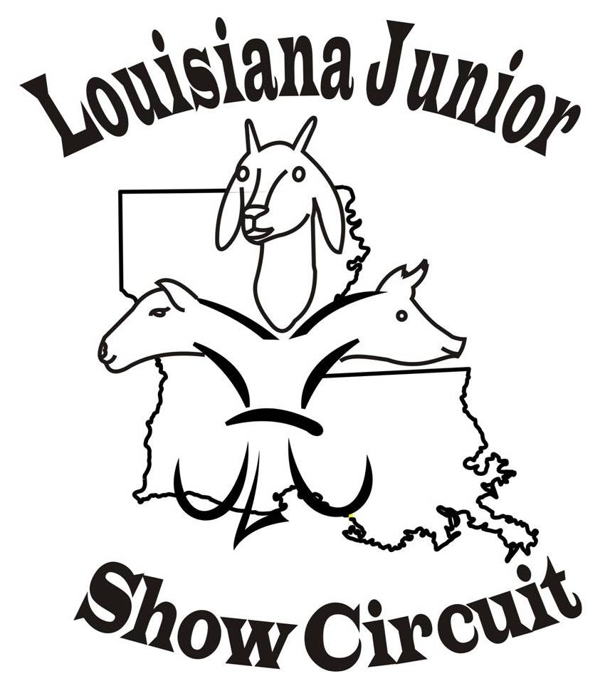
2022 LJSC SHOW Schedule

June 17th & 18th Cane River Classic, Natchitoches, LA cancelled
June 24th & 25th Watermelon Festival, Deridder, LA
July 1st & 2nd Holiday NO SHOW
July 8th & 9th Red River Showdown, Coushatta, LA July 15th & 16th Claiborne Classic, Haynesville, LA
July 22nd & 23rd Bayou Blitz. Grand Cane, LA
July 29th & 30th Black & Gold Showdown, Winnfield, LA
August 5th & 6th, August 12th & 13th
August 19th & 20st Gulf Coast Classic, Crowley, LA
Website (www.louisianajuniorshowcircuit.org.) and Facebook Louisiana Junior Show
Circuit (page and group) for updates. If interested in hosted a sanctioned show
please contact Nancy Nettles.
LJSC Contact Information
For Comments or questions concerning Louisiana Junior Show Circuit (LJSC) ~~~ Contacts:
Nancy Nettles - President Stephanie Chamberlin Secretary
(318) 455-2905
Email Membynancy1@aol.com
Lauribeth Padgett - Vice-President Judy Latiolais – Treasurer
Board Members: Dana Broussard, Guy Sanders, Josh Johnson,
Jennifer Winslett, and Melinda Miles

