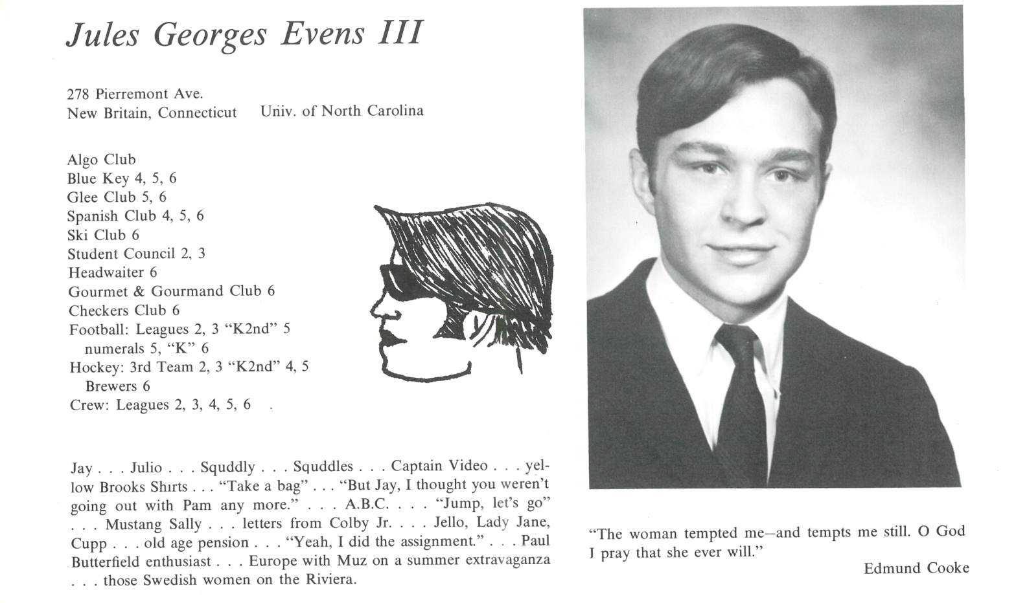

Jules G. Evens III

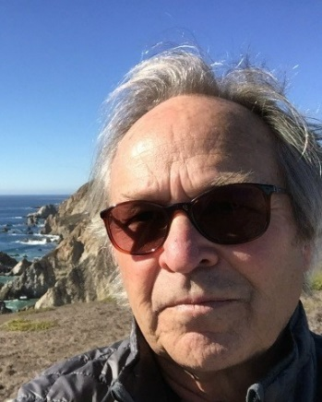After Kent and Chapel Hill . . . Went to Woodstock with James Clarkson (now MIA?) where I met my future wife on a Magical Mystery Tour. Co-Founded, with John F. Holzinger (Kent ’67), Loosely Inc., a Vermont-based enterprise specializing in house renovation, bank custodial work, softball, skiing, and semi-communal living. Moved to California in 1973 or ’74 living in Marin County while working as a field biologist at the Point Reyes Bird Observatory (thanks to Pit Armstrong?) with fieldwork on the west coast from Alaska to Central America. Grad school in biology at Sonoma State University and U. San Francisco (“a checkered career”). Concurrently, my wife Meryl and I were house parents at the Point Reyes Youth Hostel until out daughter, Veery, was born (1979), at which time we bought land and built a house in Point Reyes Station where we lived for 38 years.

In 1984, our son Noah appeared on the earth, and I started a small environmental consulting firm, Avocet Research Associates, which is still active in the Bay Area—primarily involved in wetland restoration and population monitoring of threatened and endangered bird species (marbled murrelet, spotted owl, etc.). Once grandchildren stated showing-up, we gradually relocated to Portland, splitting time between California and Oregon. Two years ago (2015) we sold the Point Reyes abode and became full-time Oregonians, although I still work in the Bay area at about half-speed. Now four grandchildren, all girls—“The League of Women Voters”—who are the source of endless amusement and amazement. Almost forgot to mention (!), in the early 2000s I was appointed “Senior Amigo” in a Belizean escapade known as “Dos Amigos.” The “Junior Amigo” was Peter T. Moehrke (Kent ’67) and “therein lies a tale.” Together we focused our attention on tropical ecology, backgammon, and effortless frivolity. All-in-all it’s been a great ride. Now health and happiness are all that matters.

See you all at the 60th!

P.S. Polar Bear always wanted to be “Mr. Connecticut,” but I heard through the grapevine that he claims I took that title. Not sure that’s true, Bear.



______________________________________________________________

______________________________________________________________ ______________________________________________________________ ______________________________________________________________ ______________________________________________________________ ______________________________________________________________ ______________________________________________________________ ______________________________________________________________ ______________________________________________________________

Attach Picture in .jpg Format

______________________________________________________________

______________________________________________________________

___________________________________________________________________________________ _________________________________________________________________________________________________________________________________________________________________________________________________________________________________________________________________________________________________________________________________________________________________________________________________________________________________________________________________________________________________________________________________________________________________________________________________________________________________________________________________________________________________________________________________________________________________________________________________________________________________________________________________________________________________________________________________________________________________________________________________________________________________________________________________________________________________________________________________________________________________________________________________________________________________________________________________________________________________________________________________________________________________________________________________________________________________________________________________________________________________________________________________________________________________________________________________________________________________________

___________________________________________________________________________________