Mars UP Church

Apostles’ Creed
I believe in God the Father Almighty, Maker of heaven and earth; and in Jesus Christ His only Son our Lord; who was conceived by the Holy Ghost, born of the Virgin Mary, suffered under Pontius Pilate, was crucified, dead and buried; He descended into hell; the third day He rose again from the dead; He ascended into heaven, and sitteth on the right hand of God the Father Almighty; from thence He shall come to judge the quick and the dead. I believe in the Holy Ghost, the holy catholic church; the communion of saints; the forgiveness of sins; the resurrection of the body; and the life everlasting. Amen.

Gloria Patri
Glory be to the Father, and to the Son, and to the Holy Ghost. As it was in the beginning, is now and ever shall be,
world without end.
Amen. Amen.

Come Holy Spirit, Come
Before the Service – Speak to God!
During the Service – Let God speak to you!
After the Service – Speak to each other!

(*Please stand, if able)
Welcome and Mars Messages

Prelude

Call to Worship

Leader: Come, let us worship and bow down in awe of
God’s steadfast love for us.

People: For God gives ear to our words; God listens to
the sound of our cries.

Leader: Come, let us take refuge in the God of our
salvation.

People: For God is our shield, our protection in times of
trouble.

Leader: Come, let us rejoice and sing for joy!

People: For God is surely in this place! Let us worship
God!

Opening Prayer

*Hymn 562 “Be Thou My Vision”

Scripture Matthew 28:16-20
The
Lord’s Prayer

Our Father,
who art in heaven,

hallowed be Thy
name,

Thy kingdom come,
Thy will be done,
on earth
as it is in heaven.

Give us this day
our daily bread;

and forgive us
our debts,
as we forgive
our debtors;

and lead us not
into temptation,
but deliver us
from evil.

For Thine
is the kingdom,
and the power,
and the glory,
forever. Amen.

The Doxology

Praise God
from whom
all blessings flow;
praise Him
all creatures
here below;
praise Him above,
ye heavenly host;
praise Father, Son,
and Holy Ghost.
Amen.

Children’s Chat

Morning Message Rev. Brian Hauser
“Response”

*Song
“The God Who Stays”

Celebration of Graduates

Prayers of the People and Lord’s Prayer

*Communion Hymn 478 vs. 1,3
“Have You Any Room for Jesus”

Celebration of the Lord’s Supper

Communion Solo Elizabeth Hixon
“Remembrance”

*Hymn 526
“The Solid Rock”

*Benediction

*Postlude

Flowers are presented today to the Glory of God and with thanks and praise of Peter’s 15th birthday by the Wells family.

Church Staff
Rev. Brian Hauser
Pastor
pastor@mars-up.org
724-689-3412

Mrs. Shelly Bocheff
Administrative Assistant
marsup@mars-up.org

AV TEAM
Alma Staskiewicz, Lisa Barbour, Marie Matthews, Bill Guesman, John Ivory, Mike Bocheff, Herb Wellman

Mars United Presbyterian Church

232 Crowe Ave
PO Box 805
Mars, Pennsylvania 16046
724-625-1365
www.mars-up.org
marsup@mars-up.org

Church Office Hours:
Mon -Thurs from 9 a.m. -2:30 p.m.
MUP Session

Class of 2025 Class of 2024 Class of 2023
John Ivory Alma Staskiewicz Lisa Barbour
Susan Cox Louise Fox Mary Ann Croop
Jay Wilson Marie Matthews Don Lewis
Herb Wellman

Clerk of Session: Herb Wellman
Morning Worship:
10:00 am

Trinity Sunday

Prayer of Preparation
Lord, we come to you today with so many things on our hearts.

You call us to be in relationship of trust and love with you and you offer healing to us for those portions of our lives that are broken and injured.

Help us to be open to your mercy and healing love. For we ask this in Jesus’ Name.
AMEN.

MUP Deacons

Class of 2025 Class of 2024 Class of 2023
Jill Cooper Steve Martin Sharon Gibb
Robyn Beckwith Marge Nicklas Carol Kopar
Missy Wells Pat Auld Alice Leonberg

Moderator: Steve Martin

MUP Music Committee
Keith Nichols – Chair
Sally Olsen – Clerk
Alma Staskiewicz
John Ivory
Linda Lees
Karl Kennedy

Mars United Presbyterian Church
Welcome!

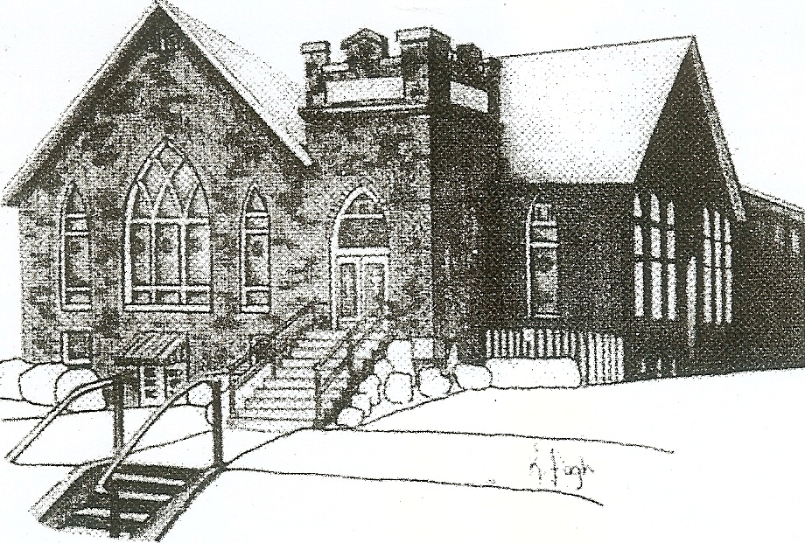
We are your hometown church: Faithful to Tradition, Loving in Fellowship, & Reaching for Tomorrow!

June 4, 2023

We welcome you and we are glad you’ve chosen to Worship with us today!

CALENDAR: June 4th – June 11th

Church Office Hours: Monday -Thursday from 9 a.m. – 2:30 p.m.

Today, June 4, 2023
VOLUNTEERS☺

LAST SUNDAY’S In-House ATTENDANCE: 62

LAST SUNDAY’S OFFERING:
Operating Funds: $1525.00
Kindness: $210.00
Mission: $10.00
Bldg Improv. $10.00
Total: $1755.00

Tarry N Talk Hosts
Worship/Membership committee

10:00 a.m. THE MORNING WORSHIP SERVICE
Monday, June 5, 2023
1:30 pm Women’s Bible Study
Tuesday, June 6, 2023
9:00 am A team
7:00 pm AA
Wednesday, June 7, 2023
9:00 am Material Girls
Thursday, June 8, 2023
Friday, June 9, 2023
Saturday, June 10, 2023
Sunday, June 11, 2023
10:00 am THE MORNING WORSHIP SERVICE

Welcome to all who are Worshiping with us today!

Guests
We sincerely hope our service is a blessing to you. We ask that our guests please take a few minutes to complete one of the Connect Cards found in the pew holder.

Should you have questions regarding any aspect of our church, including membership, please contact Pastor Brian or the church office during the week at 724-625-1365. Thank you for being with us today.

PRAYER – JOYS & CONCERNS
Lou Beckwith Paige Lauten
Paige Barbour (daughter of Andrew and Steph Barbour) Sandy Wahl
Reid Christopher Hall (June Stirling’s nephew) Sue Morris
Lindy McCartney (Lisa Barbour’s Sister) Patty Jackson

ANNOUNCEMENTS
Bulletins are printed Thursday mornings; let us know if you have an announcement…

VACATION BIBLE SCHOOL “STELLAR” Registration for VBS is available now online at www.mars-up.org. July 9th thru July 13th 6:00 to 8:30 pm. SPECIAL OPENING SUNDAY AFTERNOON- Families join us for a HOT DOG BEAN kickoff at 5:00 pm in MUP Fellowship Hall

THE QUIET HOUR DEVOTIONAL is available in Tarry N Talk. Please feel free to take one for your summer devotional.

GRIEFSHARE SUMMER MEETINGS Griefshare will continue to hold one monthly meeting during the summer. Meetings will be held on June 19th, July 17th, and August 21st. The fall session will resume on September 18th at 6:30 For more information, please contact Denise @ ddemarco5@yahoo.com
MOTHERS OF PRESCHOOLERS (MOP) group will meet again in the Fall of 2023. To register or questions contact church office or Ashley Hauser at 814-270-9101. More detailed info to follow!!
MUP JUNE NEWSLETTER Hard copies of the June newsletter are available in Tarry N Talk. If you would like added to the mailing or emailing list, please contact the office.
SAVE THE DATE Mars UP church annual picnic will be held Sunday, September 10th at Adams Township Park. More Details to Follow

NEW TO YOU SALE Thank you to all those who donated, sorted, organized, cleaned and helped with the sale. We had a great turnout and will have our profits determined soon. Watch for Details!

