NEOGL Championships: May 1, 2 and 3 2026

Sokol Greater Cleveland
4939 Broadway Avenue Cleveland, 44127
“Star Studded”
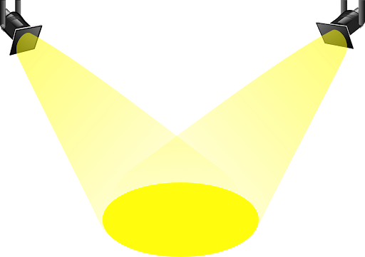

Friday May 1st 2026
Session I
Silver Ages 8 and 11 (56)
5:00 Doors open/Check in
5:10 General Stretch
5:30 Warm up first Event
5:45 Announcements/Introductions/Compete

Saturday May 2, 2026
Session 2
Silver 7 and under, 9 and 12 and older (84)
8:00 am Doors open/Check in
8:10 General Stretch
8:30 Warm up first Event
8:45 Announcements/Introductions/Compete

Session 3
Silver 10, Gold 9 and under, 10, 11, (81)
12:30 Doors open/Check in
12:40 General Stretch
1:00 Warm up first Event
1:15 Announcements/Introductions/Compete

Session 4
Gold 12 and over, Platinum All (70)
5:00 Doors open/Check in
5:10 General Stretch
5:30 Warm up first Event
5:45 Announcements/Introductions/Compete

Sunday May 3rd 2026
Session 5
Bronze 9 and over (74)
8:00 am Doors open/Check in
8:10 General Stretch
8:30 Warm up first Event
8:40 Announcements/Introductions/Compete

Session 6
Bronze 7 and under (53)
12:30 Doors open/Check in
12:40 General Stretch
1:00 Warm up first Event
1:10 Announcements/Introductions/Compete

Session 7
Bronze 8 (53)
5:00 Doors open/Check in
5:10 General Stretch
5:30 Warm up first Event
5:40 Announcements/Introductions/Compete



