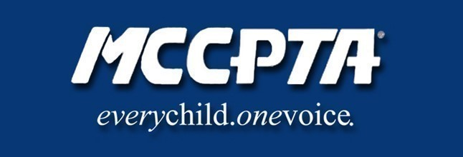
MCCPTA Board of Directors
March 9, 2022
Meeting MINUTES prepared by BOD Secretary, Sally McCarthy

7:05pm
President Cynthia Simonson called the meeting to order, read the PTA mission, and moved for the adoption of the February meeting minutes
7:05pm Officer Reports
- Cynthia Simonson, President updated the BOD about MCCPTA office space, discussed the list of school PTSAs currently without insurance
- Rodney Peele, Vice President- Educational Issues updated the BOD about the following: 1) Curriculum committee work; 2) Graduation requirements; 3) MSA testing in life sciences and government; 4) BOED meeting; and 5) the Workgroup on Assessments. Some BOD members asked questions about the requirements for passing v. requirements for graduation.
- Charisse Scott, Vice President- Programs updated the BOD about: 1) Celebration awards; 2) funded scholarships; 3) Budget amendment for the DA; 4) Family Forums and communication tools; and 5) Transcription services with the MoCo Office of Community Partnerships. Charisse will forward the plan and proposal to the DA for consideration.
- Laura Mitchell, Vice President- Advocacy updated the BOD about: 1) Revised plan to accept additional funding from National PTA; 2) Bell times advisory letter by H/W committee; and 3) substance abuse prevention program. Cynthia Simonson remarked that the letter should be circulated to the ExCom committee for review.
- Rochelle Fink, Vice President – Administration remarked that MCCPTA Nominating Committee has convened and there are many important openings this year. Rochelle encouraged all to consider positions and reach out to her.
- Francesco Paganini, Treasurer updated the BOD about the budget, the grant line updated to reflect the additional funding, and the reconciliation report.
7:57 pm Committee Reports
- MCCPTA Awards, Daria Daniel briefed the BOD about the updates to the submissions via google forms, reminded everyone that the deadline is April 1 and that awards will be presented at the May 19 MCCPTA Celebration.
- Bylaws Subcommittee, Kellie Schoolar Reynolds briefed the BOD about the upcoming actions needed to be considered and adopted by the locals, the BOD and DA: 1) must download the FREE STATE bylaws template; 2) all locals must submit bylaws in the new template by June 1; 3) MCCPTA will be doing this at the April 6 BOD, and holding a special, final DA on May 11 in order to meet the 30-day notice guideline.
- Health & Wellness, Hannah Donart, provided updates about the 1) Hydration station inventory for MCPS; and 2) the Poolesville Cluster CO2 pilot project.
8:10 pm New Business
- Motion to Approve National PTA Vax Grant Budget Amendment proceeds directly to the DA for approval in March
- Motion to Approve Budget Amendment, Charisse Scott
- Motion to Approve MCCPTA administrative affiliation with the Delaware PTA offered by Treasurer, Francesco Paganini, seconded by Sally McCarthy, approved unanimously.
- Motion to Approve MCCPTA BOD Statement on Sexual Harassment, Sally McCarthy approved unanimously.
- Motion to Approve the Academic Calendar Ad Hoc Committee Report, Francesco Paganini was not considered; instead, the BOD agreed to send to the DA for consideration and discussion.
9:13 pm Meeting adjourned
Upcoming MCCPTA Meetings
March 22 DA Meeting
April 6 BOD Meeting
April 26 DA Meeting
*UPDATE: May 11 LAST MCCPTA Meeting (Bylaws VOTE)*
May 19 MCCPTA Celebrations

