**WELCOME TO**

**HOLY SPIRIT LUTHERAN CHURCH**

A Member of the Evangelical Lutheran Church in America, New Jersey Synod

1220 Bayshore Rd., Villas, NJ 08251, 609-886-2414,

holyspiritlutheran@comcast.net, holyspiritvillas.com, facebook.com/holyspiritvillas

Vicar Vince Piekarski can be contacted at any time for conversation or prayer through call or text at 412-225-0287, or through email at vpie8282@gmail.com.

**SUNDAY, AUGUST 31ST, 2025**

**12TH SUNDAY AFTER PENTECOST**

**10:30AM WORSHIP SERVICE WITH HOLY COMMUNIO****N** 





We, the Evangelical Lutheran Church of the Holy Spirit, are People of God, who

are called by the Holy Spirit to pray, worship, joyfully proclaim Jesus Christ,

and compassionately witness and serve others in Christian Love.



We are glad that you joined us for Worship today! Thank you for enriching our time together! We would like to get to know you better, and for you to get to know us better too. Brochures, welcome gifts, prayer shawls, Bibles, and other items are available throughout the church. We would be happy to show you around and share about our ministries. Please do not hesitate to speak up and ask questions.

Also, please make sure you sign-in on our clipboard on the podium in the lobby.



Our Worship Services are conducted in coordination with our Conference Call.

Join us at 657-390-7423 or 701-802-5170, with access code 8221190#.

You may need to dial 1 first depending on your phone plan. After logging in please announce your name and feel free to talk with others until we get started.

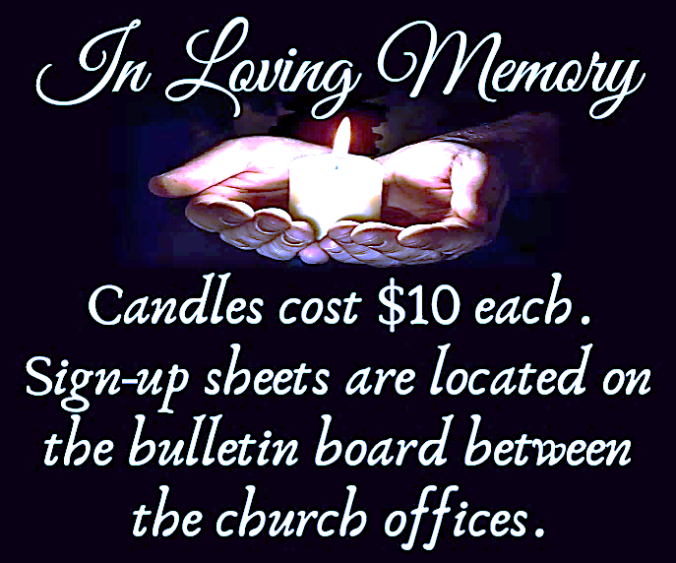

**SANCTUARY CANDLE FOR AUGUST**

Given to the Glory of God & In Memory of JEAN FARINA & SUE CUSANELLI

by Jean, Phil, & Bob Zimmerman.

**ALTAR CANDLES FOR AUGUST**

Given to the Glory of God & In Memory of HELENE & DOROFFEY KIROW

by Rose Lang, Vince & Heather Piekarski.

**CONFERENCE CALL CHECK-IN**

(Roll Call and Attendance.)

**WELCOME & ANNOUNCEMENTS**

(Vicar (V), Assistant (A), Reader (R), and Congregation (C).)

**INTRODUCTION**

A. Invited and inviting—that is the nature of the church. By God’s grace in holy

baptism we have a place at Christ’s banquet table. When, by the power of that

same Spirit, humility and mutual love continue among us, the church can be more

inviting still.

**PRELUDE**

(Music offered by our Organist at the start of our Worship Service.)

**Battle Hymn of The Republic**

**CHIMES**

(Music offered by our Organist at the start of our Worship Service.)

**God of Our Fathers**

V. We invite you to stand as you are able.

**CONFESSION & FORGIVENESS**

(All may make the sign of the cross, the sign that is marked at baptism.)

V. In the name of the Father,

and of the **☩** Son,

and of the Holy Spirit.

**C. Amen.**

V. Baptized into Christ, let us confess our sin.

(Silence is kept for reflection.)

V. Merciful God,

**C. you free us to love others,**

**but we neglect our neighbors and follow our own way.**

**You lead us by the Spirit of joy and peace,**

**but we turn away from the abundant life you offer.**

**You surround us with patience, kindness, and generosity,**

**but we grow weary in doing what is right.**

**In your mercy, forgive us.**

**Do not give up on us.**

**Heal us, break our bonds,**

**and show us the path of life.**

**Amen.**

V. You belong to Christ Jesus

and you are God’s children through faith.

In the cross of **☩** Christ,

and through the power of the Holy Spirit,

your sins are forgiven.

Clothed with Christ, you are a new creation.

**C. Amen.**



**GATHERING HYMN**

(We invite you to sing along with the music offered by our Organist.)

With One Voice—Blue Book

**719—God Is Here!**



**APOSTOLIC GREETING**

V. May the grace of our Lord Jesus Christ, the love of God,

and the communion of the Holy Spirit be with you all.

**C. And also with you.**

**KYRIE**

V. In peace, let us pray to the Lord.

**C. Lord, have mercy.**

V. For the peace from above, and for our salvation, let us pray to the Lord.

**C. Lord, have mercy.**

V. For the peace of the whole world, for the well-being of the church of God,

and for the unity of all, let us pray to the Lord.

**C. Lord, have mercy.**

V. For this holy house, and for all who offer here their worship and praise,

let us pray to the Lord.

**C. Lord, have mercy.**

V. Help, save, comfort, and defend us, gracious Lord.

**C. Amen.**

**HYMN OF PRAISE**

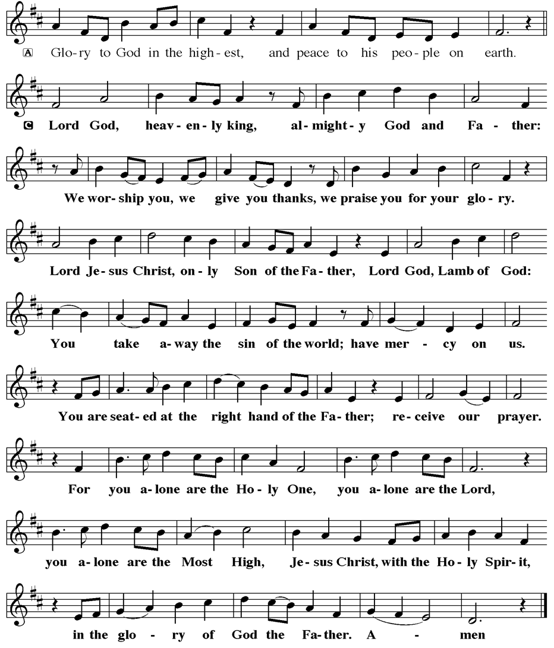

**PRAYER OF THE DAY**

V. The Lord be with you.

**C. And also with you.**

V. Let us pray,

O God, you resist those who are proud and give grace to those who are humble.

Give us the humility of your Son, that we may embody the generosity of Jesus

Christ, our Savior and Lord.

**C. Amen.**

(We invite you to be seated for our Readings and Psalm.)

**FIRST READING**

The book of Proverbs is part of a collection of writings known as wisdom

literature. Wisdom literature gave directions to Israel’s leaders and people for the

conduct of daily life. Today’s reading is about humility.

R. Our First Reading is from the 25th Chapter of Proverbs (Verses 6-7a).

R. 6 Do not put yourself forward in the king’s presence

   or stand in the place of the great,

  7a for it is better to be told, “Come up here,”

   than to be put lower in the presence of a noble.

R. This is the Word of the Lord.

**C. Thanks be to God.**

**PSALM**

R. Our Responsorial Psalm is from the 112th Psalm.

**C.** **The righteous are merciful and full of compassion.** (Ps. 112:4)

R. 1 Hallelujah! Happy are they who fear the Lord

   and have great delight in God’s commandments!

  2 Their descendants will be mighty in the land;

   the generation of the upright will be blessed.

**C. The righteous are merciful and full of compassion.** (Ps. 112:4)

R. 3 Wealth and riches will be in their house,

   and their righteousness will last forever.

  4 Light shines in the darkness for the upright;

   the righteous are merciful and full of compassion.

  5 It is good for them to be generous in lending

   and to manage their affairs with justice.

  6 For they will never be shaken;

   the righteous will be kept in everlasting remembrance.

**C. The righteous are merciful and full of compassion.** (Ps. 112:4)

R. 7 They will not be afraid of any evil rumors;

   their heart is steadfast, trusting in the Lord.

  8 Their heart is established and will not shrink,

   until they see their desire upon their enemies.

  9 They have given freely to the poor, and their righteousness stands fast forever;

    they will hold up their head with honor.

  10 The wicked will see it and be angry; they will gnash their teeth and pine away;

   the desires of the wicked will perish.

**C. The righteous are merciful and full of compassion.** (Ps. 112:4)

**SECOND READING**

The conclusion of the letter to the Hebrews contains suggestions for the conduct

of a holy life, all of which are shaped by God’s love toward us in Jesus Christ.

R. Our Second Reading is from the 13th Chapter of Hebrews (Verses 1-8, 15-16).

R. 1 Let mutual affection continue. 2 Do not neglect to show hospitality to strangers,

for by doing that some have entertained angels without knowing it. 3 Remember

those who are in prison, as though you were in prison with them, those who are

being tortured, as though you yourselves were being tortured. 4 Let marriage be

held in honor by all, and let the marriage bed be kept undefiled, for God will judge

the sexually immoral and adulterers. 5 Keep your lives free from the love of

money, and be content with what you have, for he himself has said, “I will never

leave you or forsake you.” 6 So we can say with confidence,

  “The Lord is my helper;

   I will not be afraid.

  What can anyone do to me?”

7 Remember your leaders, those who spoke the word of God to you; consider the

outcome of their way of life, and imitate their faith. 8 Jesus Christ is the same

yesterday and today and forever. 15 Through him, then, let us continually offer a

sacrifice of praise to God, that is, the fruit of lips that confess his name. 16 Do not

neglect to do good and to share what you have, for such sacrifices are pleasing

to God.

R. This is the Word of the Lord.

**C. Thanks be to God.**

V. I invite you to stand as you are able, and I invite you to announce the Gospel

Acclamation with me.

**GOSPEL ACCLAMATION**

**C.** **Alleluia. Take my yoke upon you, and learn from me; for I am gentle and**

**humble in heart. Alleluia.** (Matt. 11:29)

**GOSPEL READING**

Jesus observes guests jockeying for position at the table. He uses the

opportunity to teach his hearers to choose humility rather than self-exaltation.

Jesus also makes an appeal for hosts to imitate God’s gracious hospitality to

those in need.

V. The Holy Gospel According to Luke, the 14th Chapter (Verses 1, 7-14).

**C. Glory to you, O Lord.**

V. 1 On one occasion when Jesus was going to the house of a leader of the

Pharisees to eat a meal on the Sabbath, they were watching him closely.

7 When he noticed how the guests chose the places of honor, he told them a

parable. 8 “When you are invited by someone to a wedding banquet, do not sit

down at the place of honor, in case someone more distinguished than you has

been invited by your host, 9 and the host who invited both of you may come and

say to you, ‘Give this person your place,’ and then in disgrace you would start to

take the lowest place. 10 But when you are invited, go and sit down at the lowest

place, so that when your host comes, he may say to you, ‘Friend, move up

higher’; then you will be honored in the presence of all who sit at the table with

you. 11 For all who exalt themselves will be humbled, and those who humble

themselves will be exalted.”

12 He said also to the one who had invited him, “When you give a luncheon or a

dinner, do not invite your friends or your brothers and sisters or your relatives or

rich neighbors, in case they may invite you in return, and you would be repaid.

13 But when you give a banquet, invite the poor, the crippled, the lame, and the

blind. 14 And you will be blessed because they cannot repay you, for you will be

repaid at the resurrection of the righteous.”

V. This is the Gospel of the Lord,

**C. Praise to you, O Christ.**

(We invite you to be seated.)

**SERMON**

(Delivered by Vicar Vince Piekarski.)

V. We invite you to stand as you are able.



**HYMN OF THE DAY**

(We invite you to sing along with the music offered by our Organist.)

Lutheran Book of Worship—Green Book

**453—If You But Trust in God to Guide You**

**APOSTLES’ CREED**

V. God has made us his people through our Baptism into Christ. Living together in

trust and hope let us confess our faith together using the Apostles’ Creed.

**C. I believe in God, the Father almighty,**

**creator of heaven and earth.**

**I believe in Jesus Christ, God’s only Son, our Lord,**

**who was conceived by the Holy Spirit,**

**born of the Virgin Mary,**

**suffered under Pontius Pilate,**

**was crucified, died, and was buried;**

**he descended to the dead.**

**On the third day he rose again;**

**he ascended into heaven,**

**he is seated at the right hand of the Father,**

**and he will come to judge the living and the dead.**

**I believe in the Holy Spirit,**

**the holy catholic church,**

**the communion of saints,**

**the forgiveness of sins,**

**the resurrection of the body**

**and the life everlasting.**

**Amen.**

**PRAYERS OF INTERCESSION**

(The prayers are prepared locally for each occasion.)

V. Let us pray for the church, the creation, and the whole people of God, for God is

near.

(A brief silence.)

A. For the leaders of the church, we pray. Inspire deacons, pastors, Sunday school

teachers, and Christian education directors with a passion for speaking the word

of God. Equip all the baptized to share your word of grace. Hear us, O God.

**C. Your mercy is great.**

A. For the well-being of creation, we pray. Sustain farm workers and all who labor in

fields and vineyards to grow the food we eat. Revive plains and pastures, and

provide for the cattle and creatures who rely on the land for their sustenance.

Hear us, O God.

**C. Your mercy is great.**

A. For the leaders of towns, cities, provinces, states, and nations, we pray. Guide

them to enact equitable laws and policies for all. On this Labor/Labour Day

weekend, make us mindful of workers whose labor often goes unnoticed. Hear

us, O God.

**C. Your mercy is great.**

A. For the lowly and those who are ignored, we pray. Provide for the needs of

vulnerable communities, those who are unemployed, burdened by debt, or

struggle to make ends meet. Accompany all who need reassurance of your loving

presence; especially:

BettyAnn Rich-White (Church Member)

Chip & Marie Hand (Church Members)

Lynn Bargstadt (Church Member)

Frank Ford (Church Member)

Carol Amundsen (Church Member)

Kim McGinley (Church Member)

Anthony DeLuca (Church Member)

Frank Brunner (Church Member)

Joan Sommerman (Church Family)

Arleen Kinka (Church Family)

Rick Lang (Church Family)

Suzie Clark (Rose Lang's Friend)

Francis Clock (Dianna DeNote’s Family)

Andrew Hudak (Rose Lang’s Friend)

Viena Murtha (Bob Fritsch’s Friend)

Sharon Waicus (Skip & Bonnie Millard's Friend)

Karen O'Brien (Paul Bowker's Friend)

Dustin Irizzary (Mary Melnicoff's Family)

The Bryan Family (Wanda Bryan's Family)

Craig Brearey (Judy Brannan & Mary Melnicoff's Friend)

Sarah Dutton (Frank Ford's Family)

Christina McNasby (Fran Green’s Family)

The Kinkson Family (Judy Brannan's Friends)

Mark Stephen Dennis (Diana DeNote's Family)

Bill Lodge (Skip & Bonnie Millard's Friend)

Ron Anderson (Bill Kelly's Friend)

Pat Labrae (Kathy Poehler's Friend)

Bud Brearey (Judy Brannan & Mary Melnicoff's Friend)

Mary Skain (Kathy Poehler's Friend)

Robert Chaplin (Mary Melnicoff's Friend)

Jack Wieckouski (Theresa & Kim McGinley's Family)

Carolyn Santarpio (Bob Fritsch's Friend)

Ken Mortensen (Del McKenna's Family)

Harry (Judy Brannan's Friend)

Janet K (Philomena Noak's Friend)

Michael Hart (Diana DeNote's Friend)

Rocco Leonard DeNote (Diana DeNote's Family)

Al Singer & Family (Frank Ford's Friends)

Sherri Lynn (Bob Fritsch's Friend)

John Bannco (Bob Fritsch's Friend)

Nancy Pazarinie (Bob Fritsch's Family)

Jane & Paul Eiben (Rose Lang's Friend)

Joe DiMassimo (Judy Brannan & Mary Melnicoff's Friend)

Tommy Stanford (Sue Waltz's Family)

Audrey McAlister (Sue Waltz's Family)

Joe Waltz (Sue Waltz's Family)

Ronald Velli (Kathy Poehler's Friend)

Denny Papst (Rose Lang’s Friend)

Mike & Alice Rhoades (Rose Lang’s Friends)

Chris (Judy Brannan's Friend)

Helen Ehlers (Judy Brannan's Friend)

Hailey (Fran Green's Friend)

Leanne Bueth (Joan Kilcoyne's Family)

Janett MacFarlane (Carol Amundsen's Friend)

Patrick Davenport (Sue Waltz's Friend)

Sonja Anderson (Theresa & Kim McGinley's Family)

Thish Kelly (Theresa & Kim McGinley's Family)

Joanne Shipper (Del McKenna's Family)

Edward Chapleski (Allison Call's Family)

Scott Levin (Rose Lang's Friend)

Lynne Curlett (Del McKenna's Family)

Alice Ann Dennis (Diana DeNote's Family)

Nancy Taylor (Ted & Diane Bell's Family)

Santa Isabel Lutheran Church (Elizabeth, NJ)

Messiah Lutheran Church (Oakland, NJ)

Mary Matta (Rose Lang's Friend)

Carol Brand (Skip & Bonnie Millard’s Friend)

Joyce Thompson (TDPWC Member)

Barbara Paynter (Leon Stitt’s Family)

Kristy (Pastor David Jones’ Family)

Robert Fox (Carol Amundsen's Friend)

Carol Jordan (Vicki Rinier's Family)

Larry (Carol Amundsen’s Cat)

Ruth (Anthony & Vincent Bruno's Family)

(Additional Names Added Prior to the Worship Service.)

A. Hear us, O God.

**C. Your mercy is great.**

A. For the hospitality ministries of this congregation, we pray. Give ushers and

greeters a spirit of welcome for visitors, and bless the work of those who feed and

nourish us. Hear us, O God.

**C. Your mercy is great.**

A. For all the saints who from their labors rest, we give thanks. With them, we offer

our sacrifice of praise to you, O God, the same yesterday and today and forever.

Hear us, O God.

**C. Your mercy is great.**

(Here other intercessions may be offered.)

V. Watch over all of us who are worried and suffering, and especially those whose

names we now say aloud or hold within our hearts (pause). Hear us, O God.

**C. Your mercy is great.**

V. Confident in God’s presence and promise, we entrust our prayers to the one who

always receives them; through Jesus Christ, our wisdom and companion.

**C. Amen.**

**SHARING OF THE PEACE**

V. May the peace of the Lord be with you always.

**C. And also with you.**

V. Now, let us share God’s Peace with one another.

(Please respect your neighbor if they desire to still only offer a peace sign or wave.)

(Following the Sharing of the Peace, we invite you to be seated.)

**OFFERING**

V. We now worship God with our tithes and offerings, wine and bread for use in holy

communion, and monetary gifts to support our ministry for service in God’s name.

Our Ushers will be around to your pews to pass the Offering Plates.

(Ushers come forward to get the Offering Plates from the Assistant.)

(Vicar and Assistant prepare the Altar for Communion.)

**OFFERING SONG**

(We invite you to sing along with the music offered by our Organist.)

Worship & Praise

**156—What Have We to Offer?**

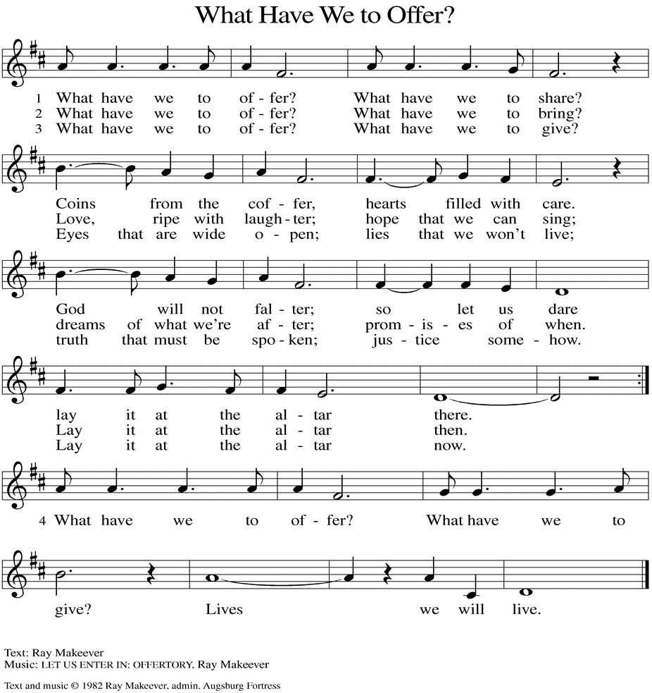

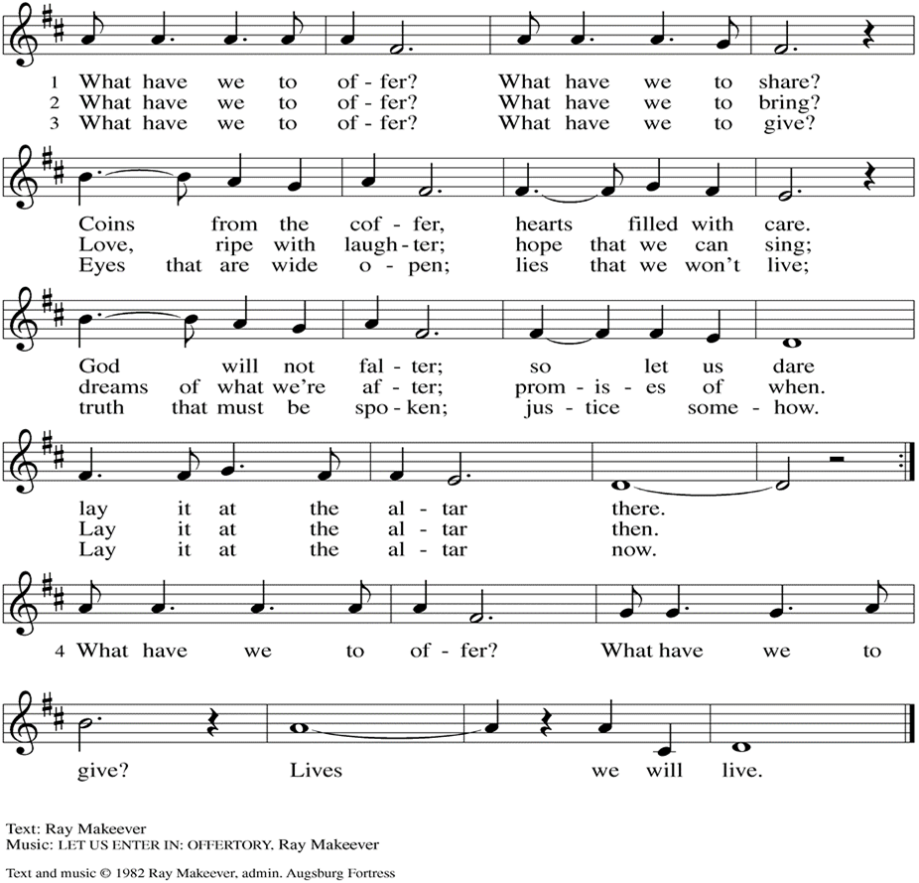

(Usher(s) brings the Tithes and Offerings up front to the Assistant.)

V. We invite you to stand as you are able.

**OFFERING PRAYER**

V. Let us pray,

Creator God,

in your wisdom you bring forth all that is good

and the harvest is plentiful.

Strengthen us at your table with these gifts of the earth

and our labor,

that we may work for the good of all;

through Jesus Christ, our Savior.

**C. Amen.**

**GREAT THANKSGIVING**

V. The Lord be with you.

**C. And also with you.**

V. Lift up your hearts.

**C. We lift them to the Lord.**

V. Let us give thanks to the Lord our God.

**C. It is right to give him thanks and praise.**

V. It is indeed right and salutary that we should at all times and in all places offer

thanks and praise to you, O Lord, holy Father, through Christ our Lord; who rose

beyond the bounds of death and, as he promised, poured out your Spirit of life

and power upon the chosen disciples. At this the whole earth exults in boundless

joy. And so, with the Church on earth and the hosts of heaven, we praise your

name and join their unending hymn:

**SANCTUS**

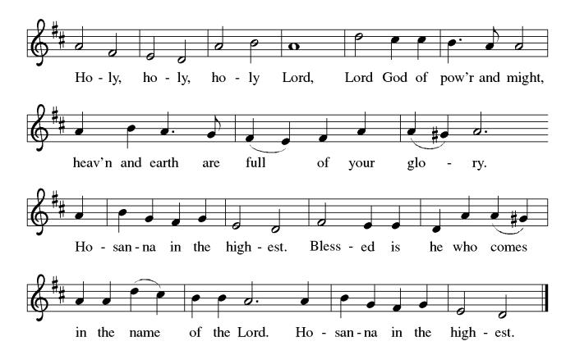

**THE EUCHARISTIC PRAYER**

V. Blessed are you, Lord of heaven and earth, in mercy for our fallen world you gave

your only Son, that all those who believe in Him should not perish, but have

eternal life. We give thanks to you for the salvation you have prepared for us

through Jesus Christ. Send now your Holy Spirit into our hearts that we may

receive our Lord with a living faith as He comes to us in His holy supper.

**C. Amen. Come, Lord Jesus.**

V. In the night in which he was betrayed our Lord Jesus took bread,

he gave thanks; broke it, and gave it to his disciples, saying:

*Take and eat; this is my body, given for you.*

*Do this for the remembrance of me.*

V. Again, after supper, He took the cup, he gave thanks,

and gave it for all to drink, saying:

*This cup is the new covenant in my blood,*

*shed for you and for all people for the forgiveness of sin.*

*Do this for the remembrance of me.*

**THE LORD’S PRAYER**

(We ring the bell throughout the Lord’s Prayer at all services to

invite those in the community to join in praying the Lord’s Prayer.)

V. May we now join with one another and pray together as Jesus has taught us.

**C. Our Father, who art in heaven, hallowed be thy name, thy kingdom come,**

**thy will be done, on earth as it is in heaven. Give us this day our daily**

**bread; and forgive us our trespasses, as we forgive those who trespass**

**against us; and lead us not into temptation, but deliver us from evil. For**

**thine is the kingdom, and the power, and the glory, forever and ever.**

**Amen.**

**LAMB OF GOD**

**C:\Users\Vince and Heather\Downloads\Lamb of God, ELW Setting Four (Melody).tif**

(We invite you to be seated.)

**HOLY COMMUNION**

V. All who are baptized and believe in Jesus Christ are welcome at this very table.

Now, this is where I remind you that we are doing things a little different today as

we are communing by Intinction. That simply means that you will be given a

gluten-free cracker and then invited to dip it in the chalice of red wine or white

grape juice before consuming it. If you happen to make an error and place your

cracker in your mouth please do not be worried. Go ahead and consume that,

and we will give you another cracker to be able to dip.

Now, I know this is a little different, but I have full confidence that you all can do

it! I also know that several of you have done this in the past at special services or

funerals. We will even start with an example, as I will commune first today and

you can watch how I do so.

As always, please wait for your usher to dismiss you from your pew. If you desire

a special blessing instead of communion please give me a sign. If you need us to

come to you please do not hesitate to inform the usher.

**INVITATION TO COMMUNION**

V. Now, the kingdom of God is set before you.

Eat and rejoice.

**C. Amen.**

(Distribution of Holy Communion)

**COMMUNION HYMN**

(Please enjoy various music offered by our Organist during your

quiet time, prayer, and reflection following Holy Communion.)

(Vicar and Assistant remove Communion Vessels from the Altar.)

V. We invite you to stand as you are able.

**POST COMMUNION BLESSING**

V. May the body and blood of our Lord Jesus Christ strengthen us and keep us

always in His grace.

**C. Amen.**

**POST COMMUNION CANTICLE**

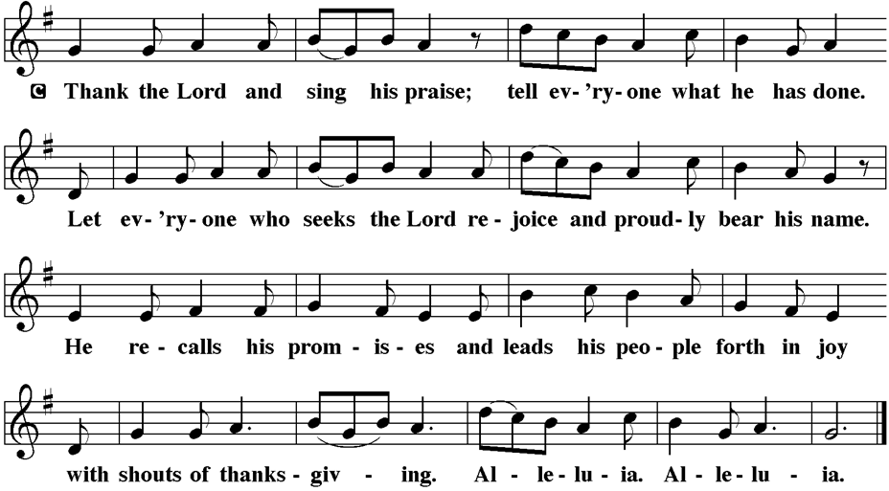

**PRAYER AFTER COMMUNION**

A. Let us pray,

God,

you gathered us to your table

and we drank deeply of your grace.

Send us out by your Spirit

to love our neighbors as ourselves

and proclaim your love in Jesus’ name.

**C. Amen.**

**BLESSING**

V. The love of God abound in you;

the grace of our Savior Jesus Christ fill your hearts;

and the life of the Spirit

**☩** bless you and give you peace.

**C. Amen.**



**SENDING HYMN**

(We invite you to sing along with the music offered by our Organist.)

With One Voice—Blue Book

**778—O Christ the Same**

(Assistant extinguishes the Altar Candles half way through the Sending Hymn.)

(Vicar processes out once the Altar Candles have been extinguished.)

(We invite you to be seated.)

**BIRTHDAYS, ANNIVERSARIES, & ANNOUNCEMENTS**

(Offered by Assistant and Congregation.)

**No Birthdays or Anniversaries this Week**

**DISMISSAL**

A. Go in peace. Live by the Spirit.

**C. Thanks be to God.**

**POSTLUDE**

(Music offered by our Organist as we depart following our Worship Service.)

**America The Beautiful**



**LICENSES & EXPIRATION DATES**

Worship Service Content is used via permission through Augsburg Fortress Liturgies Annual License #SB144368. The next Subscription Renewal Date is 2/28/2026.

Our Hymns and Worship Music are used via permission through CCLI One

License #11327166. The next Subscription Renewal Date is 1/31/2026.



**INTINCTION DURING COMMUNION**

Following discussion and the vote of our Church Council we will be introducing and educating on Intinction while communing together in months that have a fifth Sunday. If you have any questions please see Vicar Vince. Our first time doing this will be **TODAY, Sunday, August 31st**, during our 10:30AM Worship Service.

**WORSHIP MINISTRY**

The most important thing we do each week is gather together as God's people to Worship. God is the center and focus of everything we do. Participating in Worship is active, as Liturgy means the work and actions of the people gathered. Everything we do during the week to prepare for Worship, and everything we do as we Assist in leading Worship is important. We are thankful for all the wonderful work being done. If you have questions, or are interested in any position, reach out to Vicar Vince.

Sign-up sheets are located on the bulletin board between the church offices.



**PREACHING AT BROOKDALE**

Vicar Vince will be Preaching at Brookdale Senior Living in Cape May Court House

**TODAY, Sunday, August 31st, at 1PM**. Holy Communion will follow the service.

**CLINICAL PASTORAL EDUCATION**

Vicar Vince has been blessed with the opportunity of joining Chaplain Stephen Faller on-line for CPE classes on **Sunday afternoons from 4PM-8:30PM** on Zoom. Please be respectful of this if you happen to see his car at the church.

**DONATION STATION**

Get on the train and place all purchased items in the specified project donation bins located on the counter by the front doors. See Heather for more information.



**FOOD PANTRY**

**Open every Thursday**, and the **last Saturday of every month**, from **10AM to 1PM**. 59 people were served in July. 485 people have been served in 2025. Donations can be dropped in the basket in the Narthex, placed in the outdoor drop-box by the Church Office door, placed in the money jug in the back of the Church, mailed into the Church Office, or placed in the Offering Plate. Volunteers are needed each week. Sign-up sheets are located on the bulletin board between the church offices.

If you have questions or need training see Heather, Vicar Vince, or Bonnie.

A special thank you goes out to all who donate, pray, and help in any way!

|  |  |  |
| --- | --- | --- |
| **Thursday, 9/4** | **Thursday, 9/11** | **Thursday, 9/18** |
| Garnet & Volunteer | Garnet & Volunteer | 2 Volunteers Needed |

**COMMUNITY FOOD DONATIONS, DELIVERIES, & MORE**

Our local North Cape May Acme provides us with Expiring Soon, Recently Expired, and Slightly Damaged Food & Items weekly. Kathy helps those in need by delivering items each Wednesday & Saturday in the community, brings leftover items to the Church for church members in need, and those who visit the food pantry during the week. Additional items are taken to the Branches in Rio Grande on Mondays.

**BULLETIN ENTRY DEADLINE**

The Bulletin is Printed on **Thursdays** during Church Office Hours. Changes need to be submitted to Vicar Vince or Heather no later than **Thursday by 4PM**. Thank you!

**CHURCH OFFICE HOURS**

Open **Thursdays from 6PM to 8PM** to serve the Congregation, the Community,

and to continue handling the business of the Church. Feel free to stop in to talk,

pick-up or drop off something, pray in the Sanctuary, or for whatever reason.

**AN INVITATION HAS BEEN EXTENDED FOR ONE AND ALL**

Please consider joining our neighbors for an afternoon of special music.

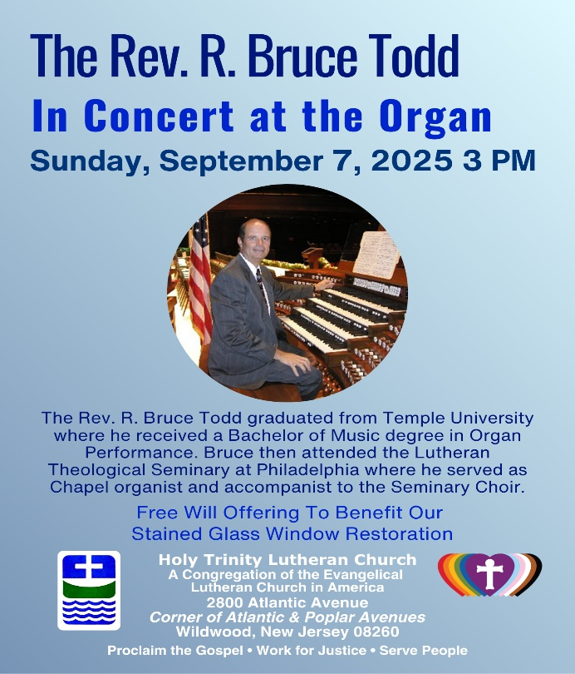

**WOMEN OF THE CHURCH**

The next monthly meeting will be held on **Monday, September 8th, at 6PM**.

New members are always welcome to attend! Contact Judy for more information.

**BIBLE STUDY & FAITH DISCUSSIONS**

​​​​​Bible Study & Faith Discussions was started in order to focus on various readings,

books, Bible verses, people of faith, and other general topics. Group Members offer

various points of view while reviewing the Bible and various aspects of faith while

being respectful and supportive of each other. **Join us on Tuesdays at 6PM when we return from our Summer Break on September 9th**.

**SOMETHING FUN TO DO TO SUPPORT OUR NEIGHBORS**

Please consider joining our neighbors while you are out and about.

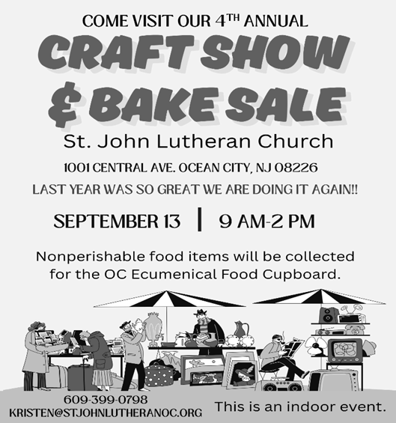

**NEWSLETTER**

Collect information, stories, pictures, and reports for our next seasonal publication. Submit everything to Vicar Vince in-person or via email at vpie8282@gmail.com no later than **Sunday, September 14th**, for the Fall Publication.

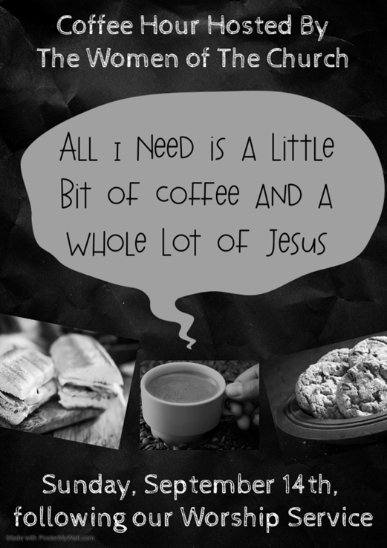

**CHURCH COUNCIL**

Share your comments, concerns, questions, or joys with one of our Church Council Members who can bring them back to our meetings. Visitors are always welcome to attend and listen to what is going on in and around the church. Join us In- Person or on our Conference Call at our next Meeting on **Tuesday, September 16th, at 6PM**.

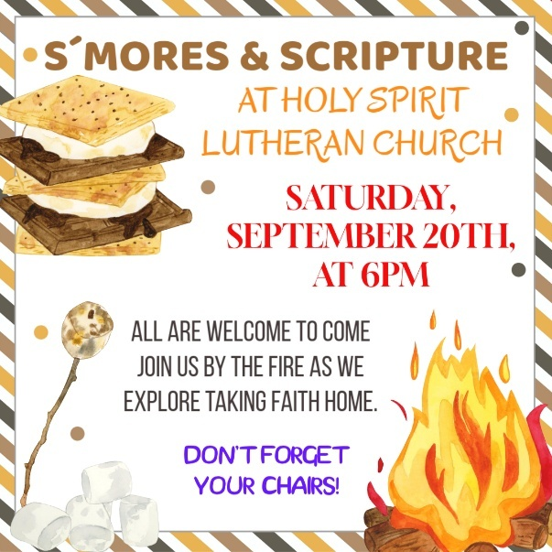

**75TH ANNIVERSARY MEETING**

We are in the final planning stages of celebrating this legacy. Join us at our next Committee Meeting on **Sunday, September 21st, following our Worship Service**.

**PREACHING AT BROOKDALE**

Vicar Vince will be Preaching at Brookdale Senior Living in Cape May Court House on **Sunday, September 28th, at 1PM**. Holy Communion will follow the service.

**SPECIAL PREACHER**

Chip Hand has been confirmed and is happy to be here and Preaching on

**Sunday, October 5th**, while Vicar Vince and Heather are on their annual trip to Knoebels. Please note there will not be Holy Communion that Sunday as a result.

**THEOLOGICAL EDUCATION FOR EMERGING MINISTRIES**

Vicar Vince will be back in Gettysburg, PA at United Lutheran Seminary for

Congregational Studies in Context classes from **October 15th to October 18th.**



We are on the Bishop’s Calendar for **Sunday, October 19th with one Worship Service to be held at 3PM**, that was voted on by Church Council. Planning will occur for special preaching, music, and a catered meal. This congregation is a legacy that we have all lived in and through over the years, or maybe just for a short time. However, it is a legacy that we hope and desire to continue to carry on and move forward for those people that will be able to gather and worship with us now and in the future. We are the church carries a strong mentality with it, and it does not just mean within these very walls. We need to celebrate our faith and all that led up to the 75 years of our Congregation and being part of this community. We also look to celebrate our vision and moving forward as well. A special account has been created for specific giving for this event. We have also applied for a Feast of Abundance $1,000 grant from United Lutheran Seminary for our Community Meal.

**CONFIRMATION & SUNDAY SCHOOL**

“Here We Stand” allows our young folks to go through a 2-year process while focusing on the Bible and Luther’s Small Catechism. **We are on Summer Break and will begin year 2 of our studies on Sunday, October 26th, from 9-10AM**.

We are also exploring resuming regular Sunday School classes for children of all ages to attend. We are looking at various dates and times in this planning process.

See Heather, Bonnie, & Vicar Vince for more information.

**FALL HARVEST**

True Deliverance Praise & Worship Center will be holding a Fall Harvest with Treat Bags and Activities in the afternoon. All are invited on **Sunday, October 26th**.

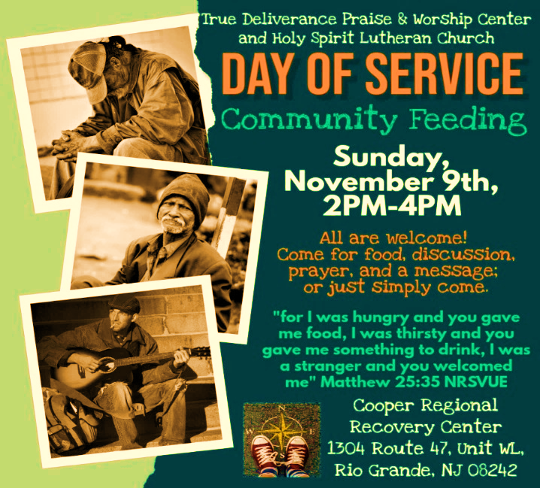

**PRAYER LIST**

Our Prayer List continues to lengthen and we realize the important need for prayers and healing. Sometimes the unfortunate result is that someone has passed away, and the words “The Family & Friends of” appear before someone’s name. However, sometimes we forget names are still on the list and their health has improved or the they are no longer struggling, and they can be removed. Please share the good and bad stories as we continue to pray for strength and healing. Names can be added or removed from the list on the clipboard in the Narthex prior to the Worship Service, by calling the church office, or addressing it on the Conference Call. Please let us know the relation to the person(s) you listed so we can be more mindful with our prayers. Names will stay on the list until removed by the person(s) who requested prayer.

**PRAYER SHAWL MINISTRY**

Prayer Shawls, Lap Quilts, Scarves, and other items have been made with love. Blessed items are located in the Narthex, and are free for anyone. Members of the group continue working at home on new stitches and patterns. We are blessed to be able to continue collecting new items. We have a donation station of yarn and other items located in the Narthex. You can find some new supplies for your next creation!

**HOME COMMUNION MINISTRY**

A Minister is available if you have a loved one, or if you desire services. We look forward in sharing the Word and Holy Communion! Please inform Vicar Vince, Kathy, or the Church Office so plans can be made for visits.

**TITHES, OFFERINGS, & ENVELOPES**

Please see Heather if you have not received or would like 2025 Offering Envelopes. For we do indeed worship God with our tithes and offerings. “Each of you must give as you have made up your mind, not reluctantly or under compulsion, for God loves a cheerful giver.” (2 Corinthians 9:7) Drop your envelopes in the offering plate, mail them to the church, or drop them in the locked mailbox. Thanks for your continued support in the mission of our church, its ministries, the NJ Synod, and other needs!

**ED GREEN CAPITAL IMPROVEMENT FUND**

We continue raising money for unforeseen costs or repairs.Kathy sells Wawa Tickets for $6, the donation bin is in the back of the church, and we have our Annual Church Rummage Sale. Thanks for your continued donations, prayers, and support!

**SPACE AVAILABLE**

​​​​​Do you know anyone interested in utilizing our Fellowship Hall for a Party or Event?

It is a suggested $50 refundable security deposit, and $250 for facility use. There is no alcohol or games of chance permitted due to ELCA policy. Please contact Vicar Vince or the Church Office with questions, for info, or to reserve a date and time.

**INTERESTED IN BECOMING A NEW MEMBER**

Have you been attending our church for a while? Have you just recently returned to church after being away for a bit? Maybe you transitioned from another church,

or just started to recently attend our church. We are glad to have you, and would love to have you as a member of our Congregation. See Vicar Vince for more info.

**BAPTISM**

We are a church whose unity is in Jesus Christ, who gathers us around word and water, wine and bread. Baptism is a significant part of our faith journey as we come from the baptismal waters to live a new life as children of God. Our baptism sets us out on a lifelong journey that is characterized by our relationship to God, our relationship to our faith community, our relationships in our community and the wider world. Living our baptismal covenant means living a life of growth in the faith practices of discipleship. Please see Vicar Vince for more information.

**FIRST COMMUNION**

Although no particular age for first communion is prescribed by The Use of the Means of Grace, one guideline is offered. Because admission to the Sacrament is by invitation of the Lord to the baptized, "baptized children begin to commune on a regular basis at a time determined through mutual conversation that includes the pastor/vicar, the child, and the parents or sponsors involved, within the accepted practices of the congregation.” Each congregation is encouraged to ask the question of readiness for first communion, establish their own policies regarding age and practice, and accompany that practice with catechesis appropriate to the age of the communicant. If anyone has questions, please see Vicar Vince.

**2025 CHURCH DIRECTORY**

Additional copies are by the Church Office on the bookshelves. We continue keeping it updated and undoubtedly miss a few changes or have made a few errors. There are spaces for changes in info, new people’s info, notes, and your favorite Bible verses. Please continue to inform the Church Office of any changes or updates.

**LIBRARY**

New books are added to our library from time to time. Several are borrowed and read and exchanged. Who knows, you might find one particularly interesting and share that with someone as well. Reading is a great way to pass spare time, learn, and explore. You may find some fresh ideas for prayer, ways to grow more spiritually, ways to grow closer to God, or some opportunities to understand our faith more. Visit the library between the church offices and see what books are there!

We also have an extended library located in Vicar Vince’s office. There are Bibles of various translations, books from his personal collection, books inherited from Pastor Leah, movies, past Bible Study Curriculums, and more. Just ask to check things out!

**TAKING FAITH HOME**

Vicar Vince was introduced to Milestones Ministries weekly guides for faith-filled studies and conversations through a Seminary class. A decision was made to pass these along to you. If you missed a week, or lost your insert, check our website for past issues. Feel free to ask questions and provide feedback to Vicar Vince.

**FAVORITE HYMNS**

Carol is willing to play some of your favorite hymns for the Prelude & Postlude each Sunday during our Worship Service. Feel free to let her know of your suggestions.

**JERSEY JOTTINGS & THE NJ SYNOD APP**

A weekly e-newsletter that connects our synod together with weekly prayer, upcoming events, synod and churchwide activities, mission stories, congregational activities, and more. Sign up by going to https://www.njsynod.org/stay-connected and filling out the form or download the app on your smartphone.



**VICAR APPOINTMENT ON MARCH 19TH, 2023**

A Memorandum of Understanding on the Matter of Pastoral Appointment

In Theological Education for Emerging Ministries (TEEM) Candidacy

TO: Congregation Council, Holy Spirit Lutheran Church, Villas

FROM: The Rev. Tracie L. Bartholomew, Bishop, New Jersey Synod

Dear Brother and Sisters in Christ,

This memorandum is in support of your discussions with Vincent Piekarski as pastor of Holy Spirit, Villas. Because this is not the usual pattern for completing the educational and candidacy requirements for ordination, it is my hope that this memorandum will both provide guidelines and engage in conversation with those who are invested in this process.

I would say at the outset that because Vincent is an outstanding candidate for the Ministry of Word and Sacrament, we will all want to do whatever is necessary to assure that his placement serves the mission of the church in the best possible fashion.

The following notes reflect my own understanding of this matter:

(1) The appointment for Vincent will begin on April 1, 2023. At this time, Vincent

will assume all responsibilities of a regularly called pastor, including presiding at

the Sacrament of Holy Communion and Baptism at Holy Spirit, Villas.

(2) A pastoral appointment in the TEEM process is an option for completing

seminary educational requirements and the steps of the candidacy process.

Upon completion of the candidacy process and seminary education, the

candidate may receive and accept a call to ordained ministry from the

congregation where the appointment is being served.

(3) This appointment is jointly supervised by the Office of the Bishop and the TEEM

pastor’s seminary. A mentoring relationship with a local pastor is required for the

length of this appointment.

(4) The synod of candidacy origin will be responsible for the approval process.

(5) Upon approval for ordination, the congregation would be expected to extend a

call to the pastoral appointee.

(6) Compensation for the TEEM pastor will be according to the guidelines of the New

Jersey Synod. All normal forms of compensation should be in place for the term

of the appointment, including stipulation that base salary and housing shall be in

accord with synod guidelines for first call at time of ordination.

(7) The ELCA Portico benefit plan for lay persons in full-time church service should

be used for the pastoral appointee up to the time of ordination, whereupon the

benefit package is to be converted to the plan for ELCA clergy.

(8) A decision for Pastoral Appointment is made with the agreement of a synod and

its candidacy committee, and the ELCA, normally represented by the regional

staff person of each in consultation with the seminary and its Director for

Contextual Education.

(9) Pastoral Appointment in a TEEM Candidacy is an option that is to serve the

mission of the Church in a particular and vital way and is not to be viewed or

used as a means to circumvent the normal candidacy process and/or first call

placement process.

In the specific case of Vincent, the New Jersey Synod remains responsible for the candidacy and approval process, and has agreed to this proposal for Appointment at Holy Spirit, Villas.

Continued blessings to both Holy Spirit and Vincent Piekarski as you embark on this journey of mutual ministry. As partners in ministry, we walk with you and rejoice in this new relationship.

**VICAR VINCE’S DAY OF REST**

A day of rest can have physical, mental, and spiritual beneficial. “Mittwoch,” German for mid-week, or Wednesday, is the day that Vicar Vince will use to recharge and do some other things. Please do not hesitate to reach out if there is an emergency!

**VICE PASTOR UPDATE**

Pastor William Hodgetts continues to attend our monthly Church Council Meetings. Pastor William continues to provide Supervision and Direction for Vicar Vince.

**TWO OFFERINGS FOR YOU FROM OUR NEIGHBORS**

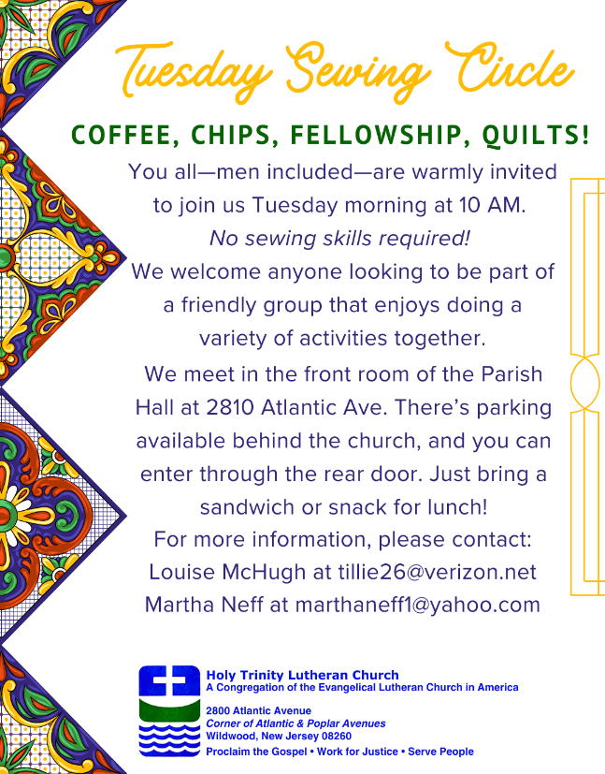 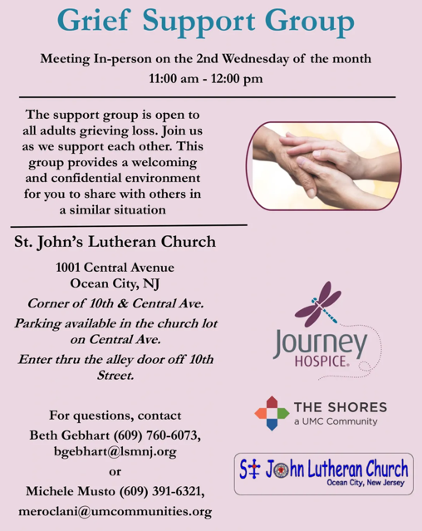

**TRUE DELIVERANCE PRAISE & WORSHIP CENTER**

Reverend Maria Brooks and True Deliverance Praise & Worship Center utilize our facilities from 1-4PM on Sundays. TDPWC helps with the Food Pantry and hosts or assists with other events throughout the year. TDPWC hosts a **Prayer Line** on **Mondays, Thursdays, & Fridays at 5PM** on the **Conference Call 1-657-390-7957.**

**WHAT IS THE EVANGELICAL LUTHERAN CHURCH IN AMERICA?**

The ELCA was formed in 1987 by the merger of three Lutheran Church bodies –

the ALC (American Lutheran Church), the LCA (Lutheran Church in America),

and the AELC (Association of Evangelical Lutheran Churches).

To learn more, go to the ELCA's website at www.elca.org.

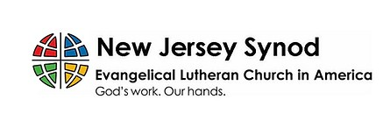

**WHAT IS THE NEW JERSEY SYNOD?**

The New Jersey Synod is a geographical grouping of Evangelical Lutheran Church in America (ELCA) congregations that share the mission and ministry of the Church on the New Jersey territory. It is one of 65 synods in the ELCA. The NJ Synod is comprised of 143 congregations, which include over 45,000 baptized members.

|  |  |
| --- | --- |
| **2025 FINANCIAL STANDING** | |
| **JULY INCOME** | $4,808.38 |
| **JULY SPENDING** | $6,264.46 |
| **JULY GAIN OR (LOSS)** | ($1,456.08) |
| **2025 INCOME** | $43,858.38 |
| **2025 SPENDING** | $52,247.87 |
| **2025 GAIN OR (LOSS)** | ($8,389.49) |
| **ED GREEN CAPITAL IMPROVEMENT FUND** | $12,552.55 |
| **FOOD PANTRY FUND (SOCIAL MINISTRY)** | $11,611.24 |
| **CD** | $25,993.77 |
| **75TH ANNIVERSARY** | $7,660.41 |

**CHURCH STAFF & VOLUNTEERS**

**VICAR, BIBLE STUDY & FAITH DISCUSSIONS,**

**EVENTS, NEWSLETTER, & WEBSITE**

Vicar Vince Piekarski

**VICE PASTOR**

Pastor William Hodgetts

**ORGANIST & PIANIST**

Carol Amundsen

**CHURCH OFFICE, SUNDAY SCHOOL, & FOOD PANTRY**

Heather Piekarski

**CHURCH COUNCIL PRESIDENT**

Mary Melnicoff

**CHURCH COUNCIL VICE PRESIDENT**

Judy Brannan

**CHURCH COUNCIL TREASURER**

Bonnie Millard

**CHURCH COUNCIL SECRETARY**

Vicki Rinier

**CHURCH PROPERTY**

Frank Ford & Wayne Rand

