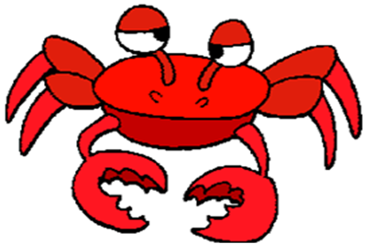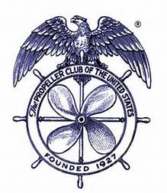

TACOMA PROPELLER CLUB

ANNUAL CRAB FEED

SATURDAY, FEBRUARY 8, 2025

HOLY CROSS PARISH HALL

5510 NORTH 44TH STREET

6:00 – 10:00 PM

SPONSORSHIP LEVELS AND VALUES

DUNGENESS - $800

Reserved Table

8 Event tickets & 8 Drink tickets

2 Bottles of wine (1 each red & white) on table

Signage

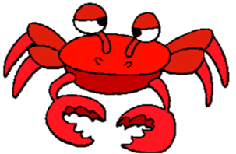Recognition at event

KING - $500

4 Event tickets & 8 Drink tickets

Signage

Recognition at event

SNOW - $300

2 Event tickets & 4 Drink tickets

Signage

Recognition at event