Richard Mueller was able to get a small number of us access to the Carmelita tourmaline mine on 4/22/17. The Carmelita Mine in north of Warner Springs in the Chihuahua Valley. The mine owners said the road up there was only for 4 wheel drive vehicles with high clearance and they were not kidding. Once we were up there we had beautiful views of the valley.
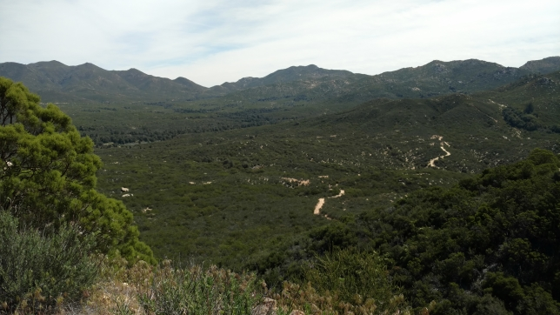
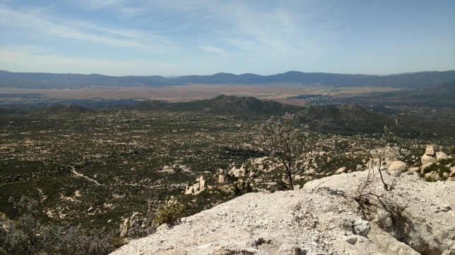

Once we got to the top of the hill and the dump it was time for some digging. Some folks preferred surface collecting and some went in search of pockets with the potential for tourmaline, kunzite, morganite and quartz points, all of which have been found at this mine.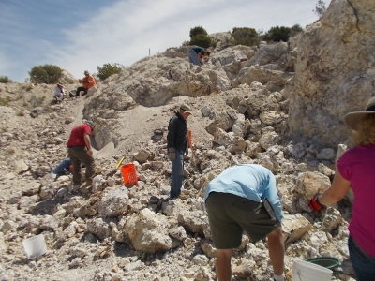
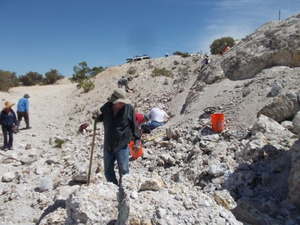
Top of the hill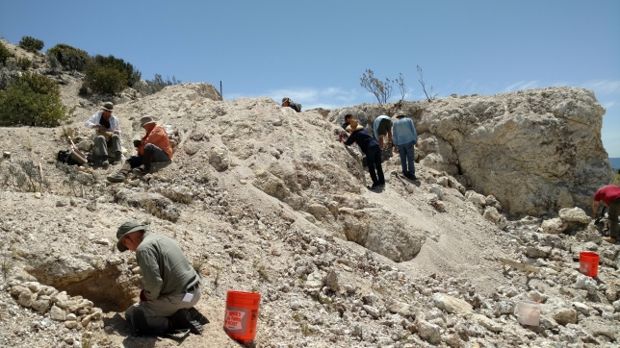
Cheryl lives on the edge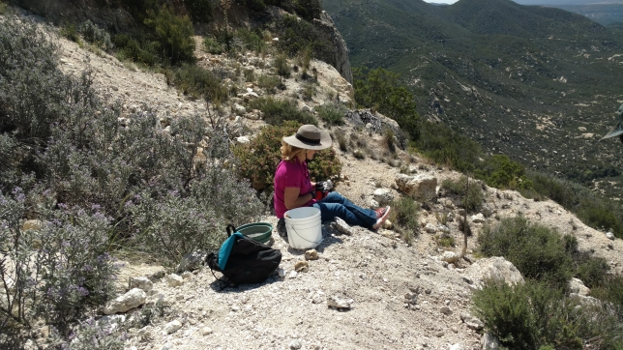
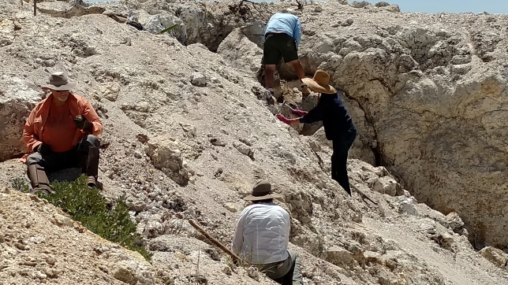
Brian digs in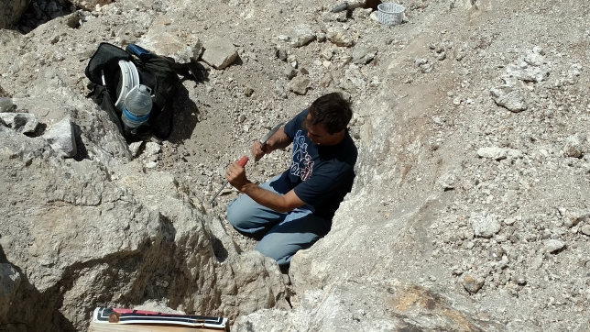
To hammer or not to hammer, Wes evaluates his options.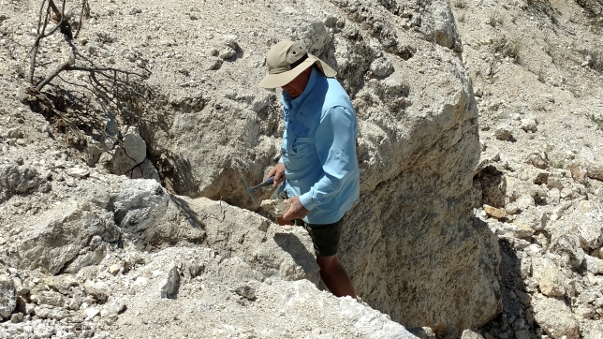
Paul takes a break from working the tailings pile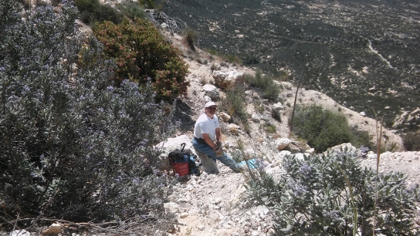
Donna ready to attack the tailings pile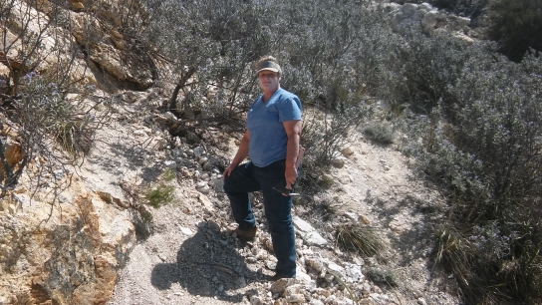It got pretty windy around lunch time so we hid behind the vehicles for a quick bite.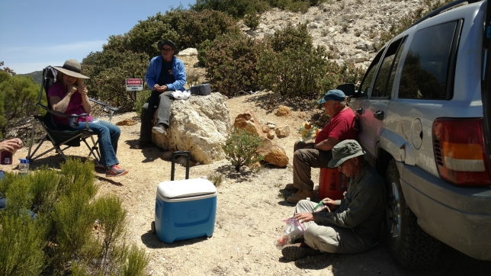
After lunch it was time for the much anticipated tour of the mine.
Mine entrance (In we go) Schorl in the mine wall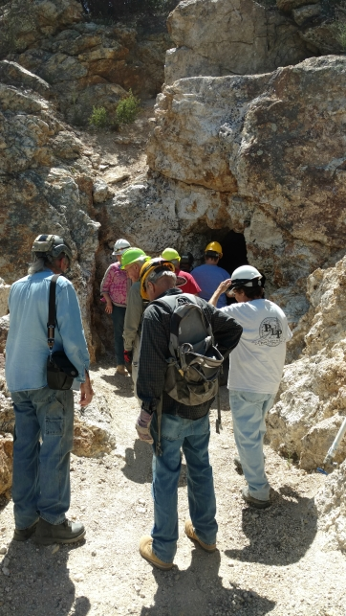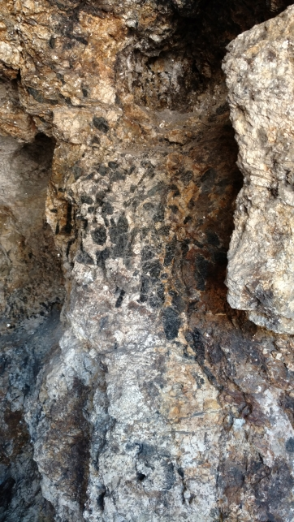
End of the mine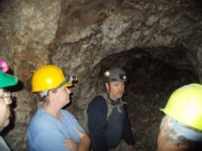
Richard feels right at home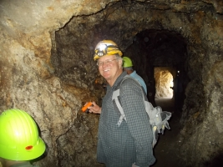
Inside the cave of wonders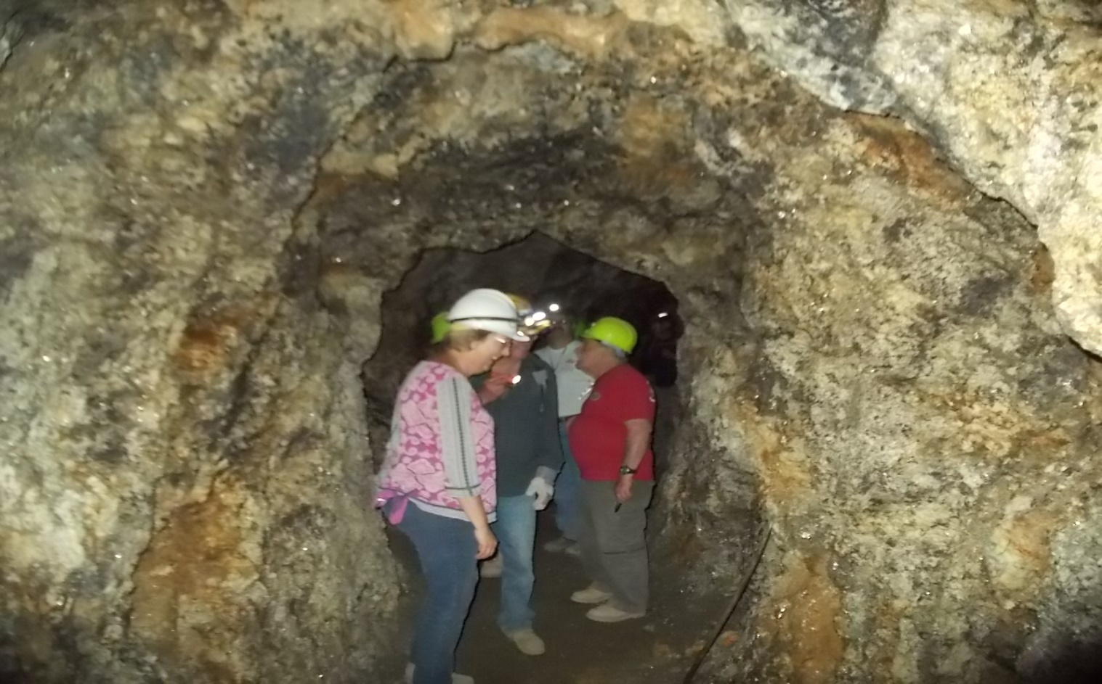
Band of schorl across the ceiling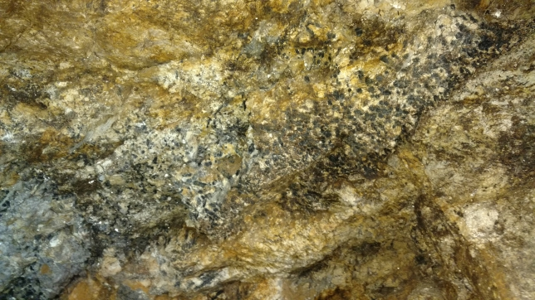
Schorl, lepidolite (purple), feldspar (white)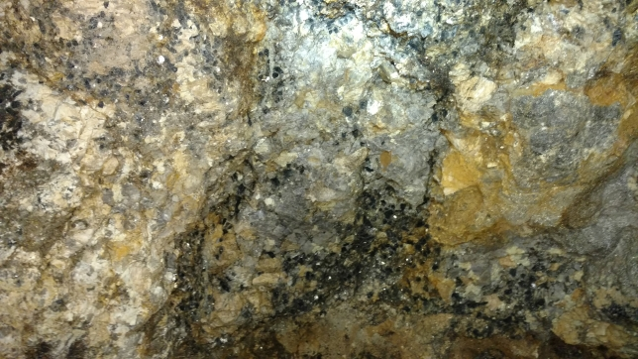
Big schorl cluster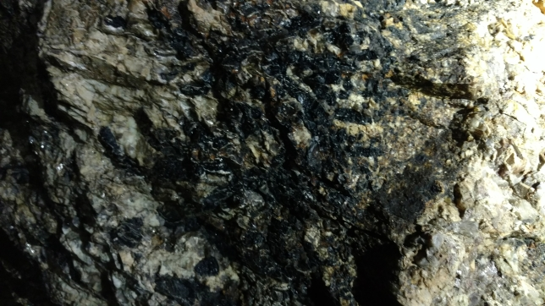
On our way out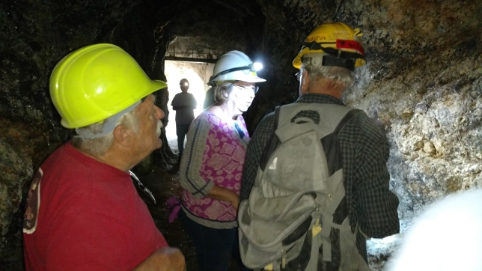
Happy Rock Hounds.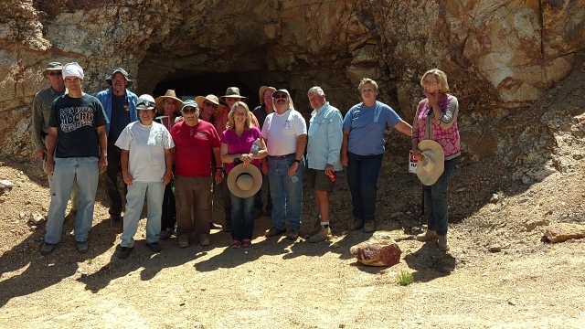
We went on this trip with the anticipation of finding some specimen grade material, with the hope of maybe finding a gem tourmaline pencil or two. Here is what we found. Lepidolite (gray), clevelandite (white), muscovite (storybook mica on right side)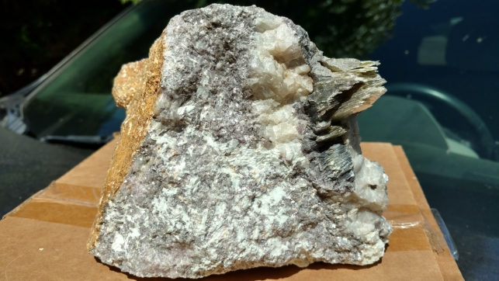
Lepidolite with better lavender color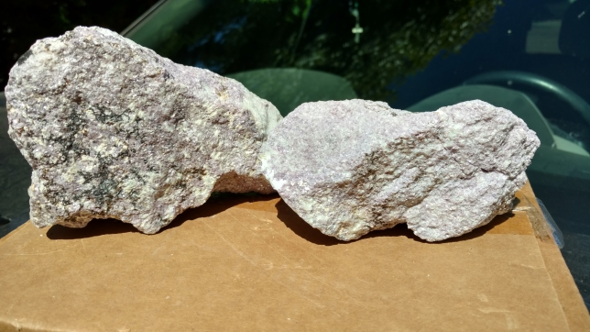
Schorl with a small morganite crystal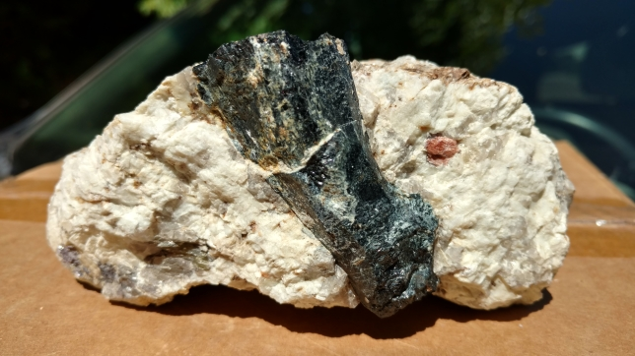
Quartz points (donated by the mine owners) and storybook mica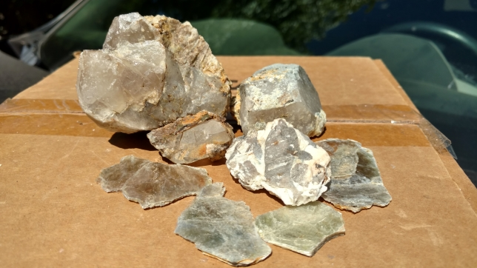
All in all we had a great time playing in the dirt and exploring an operating mine. Thanks go out to Richard and the owners of the Carmelita Mine for a fun afternoon.

The End

