**Dr Cheng Soo May, PhD, JP**

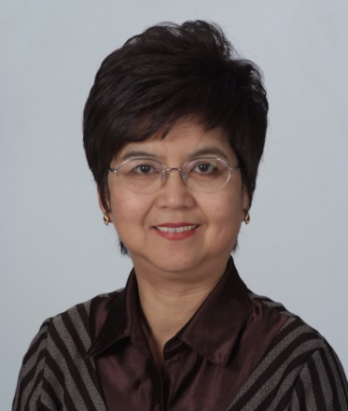Currently based in Hong Kong, Dr Cheng heads up the Learning Exchange Group, an educational enterprise with branches in Australia, Hong Kong and China. It offers services to educational institutions and learners at various levels, from vocational to doctoral studies. These services include:

* forging partnerships between institutions
* skill and cross-cultural training
* student placements, study tours
* employment counseling
* thesis-research and writing
* and more

She has had a long academic career, and today continues to offer her professorial services in teaching management, human resources management, international business, marketing and consumer behavior in several universities in the Asia-Pacific. These include:

* National University of Singapore
* Nanyang Technological University (Singapore)
* University of South Australia
* Central Queensland University (Australia)
* Asia-Pacific International College (Australia)
* University of Macau
* Saint Joseph University (Macau)
* Institute for Tourism Studies (Macau)
* City University of Hong Kong
* Open University of Hong Kong

She has supervised research projects at Honours, Masters and Doctoral levels across a wide range of management and marketing subjects. Her own research has been published in many journals, including *Journal of Retail and Service Management, Asia Pacific Journal of Management, the Journal of Enterprising Culture, the Asia-Pacific Business Review*, *Journal of East European Management Studies*, *Casino & Gambling International*, among others. She continues to review manuscripts for various academic journals.

She has also held senior administrative positions in many of these universities, including Vice-Dean, Program Coordinator, and Career & Internship Director. Now, she volunteers in some community organizations when time allows, and aspires to help create more opportunities for capacity building, self-sufficiency, and sustainable development of organizations and individuals.

**Enquiries are welcome:**

Email: [learnexhk@gmail.com](mailto:learnexhk@gmail.com)

Website: [www.learnexhk.org](http://www.learnexhk.org)

Tel: (852) 6557 6628