Sea Turtles JULY 2025  SUMMER!
SUNDAY |  |  | MONDAY | TUESDAY | WEDNESDAY | THURSDAY | FRIDAY | SATURDAY
 |  | 29 | 30 | 1 | 2 | 3 | 4 | 5
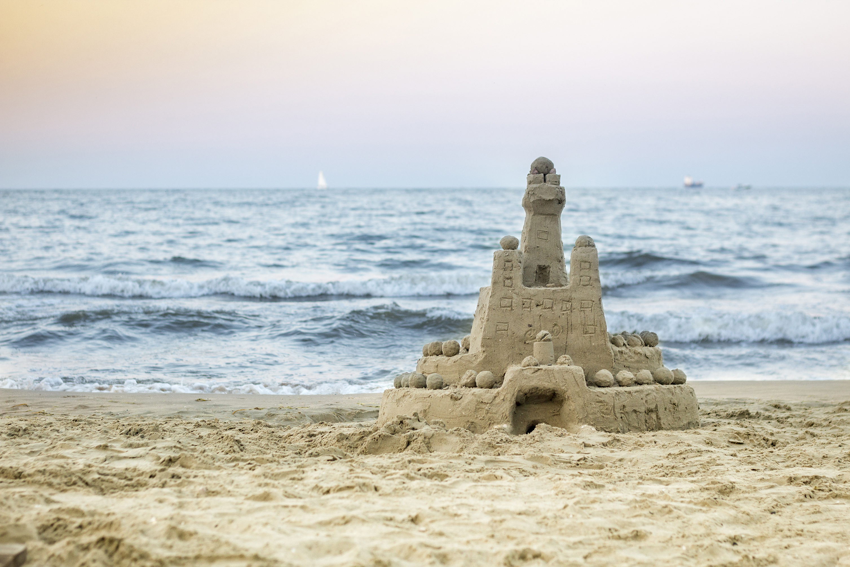 |  |  | Island View Beach | Closed  Canada Day | Esquimalt Water Park | Sooke Pothole’s | Langford Lake Beach
 | 6 |  | 7 | 8 | 9 | 10 | 11 | 12
 |  |  | Central Saanich Water Park | Aylard  Farm | Look Out Lake | Fort Rod Hill  Lighthouse $3 | Esquimalt Water Park
 | 13 |  | 14 | 15 | 16 | 17 | 18 | 19
 |  |  | Jaun De Fuca Sports Day $4 | Sooke Pothole’s | Witty’s Lagoon Hike | Beckwith Water Park | Matheson Lake | 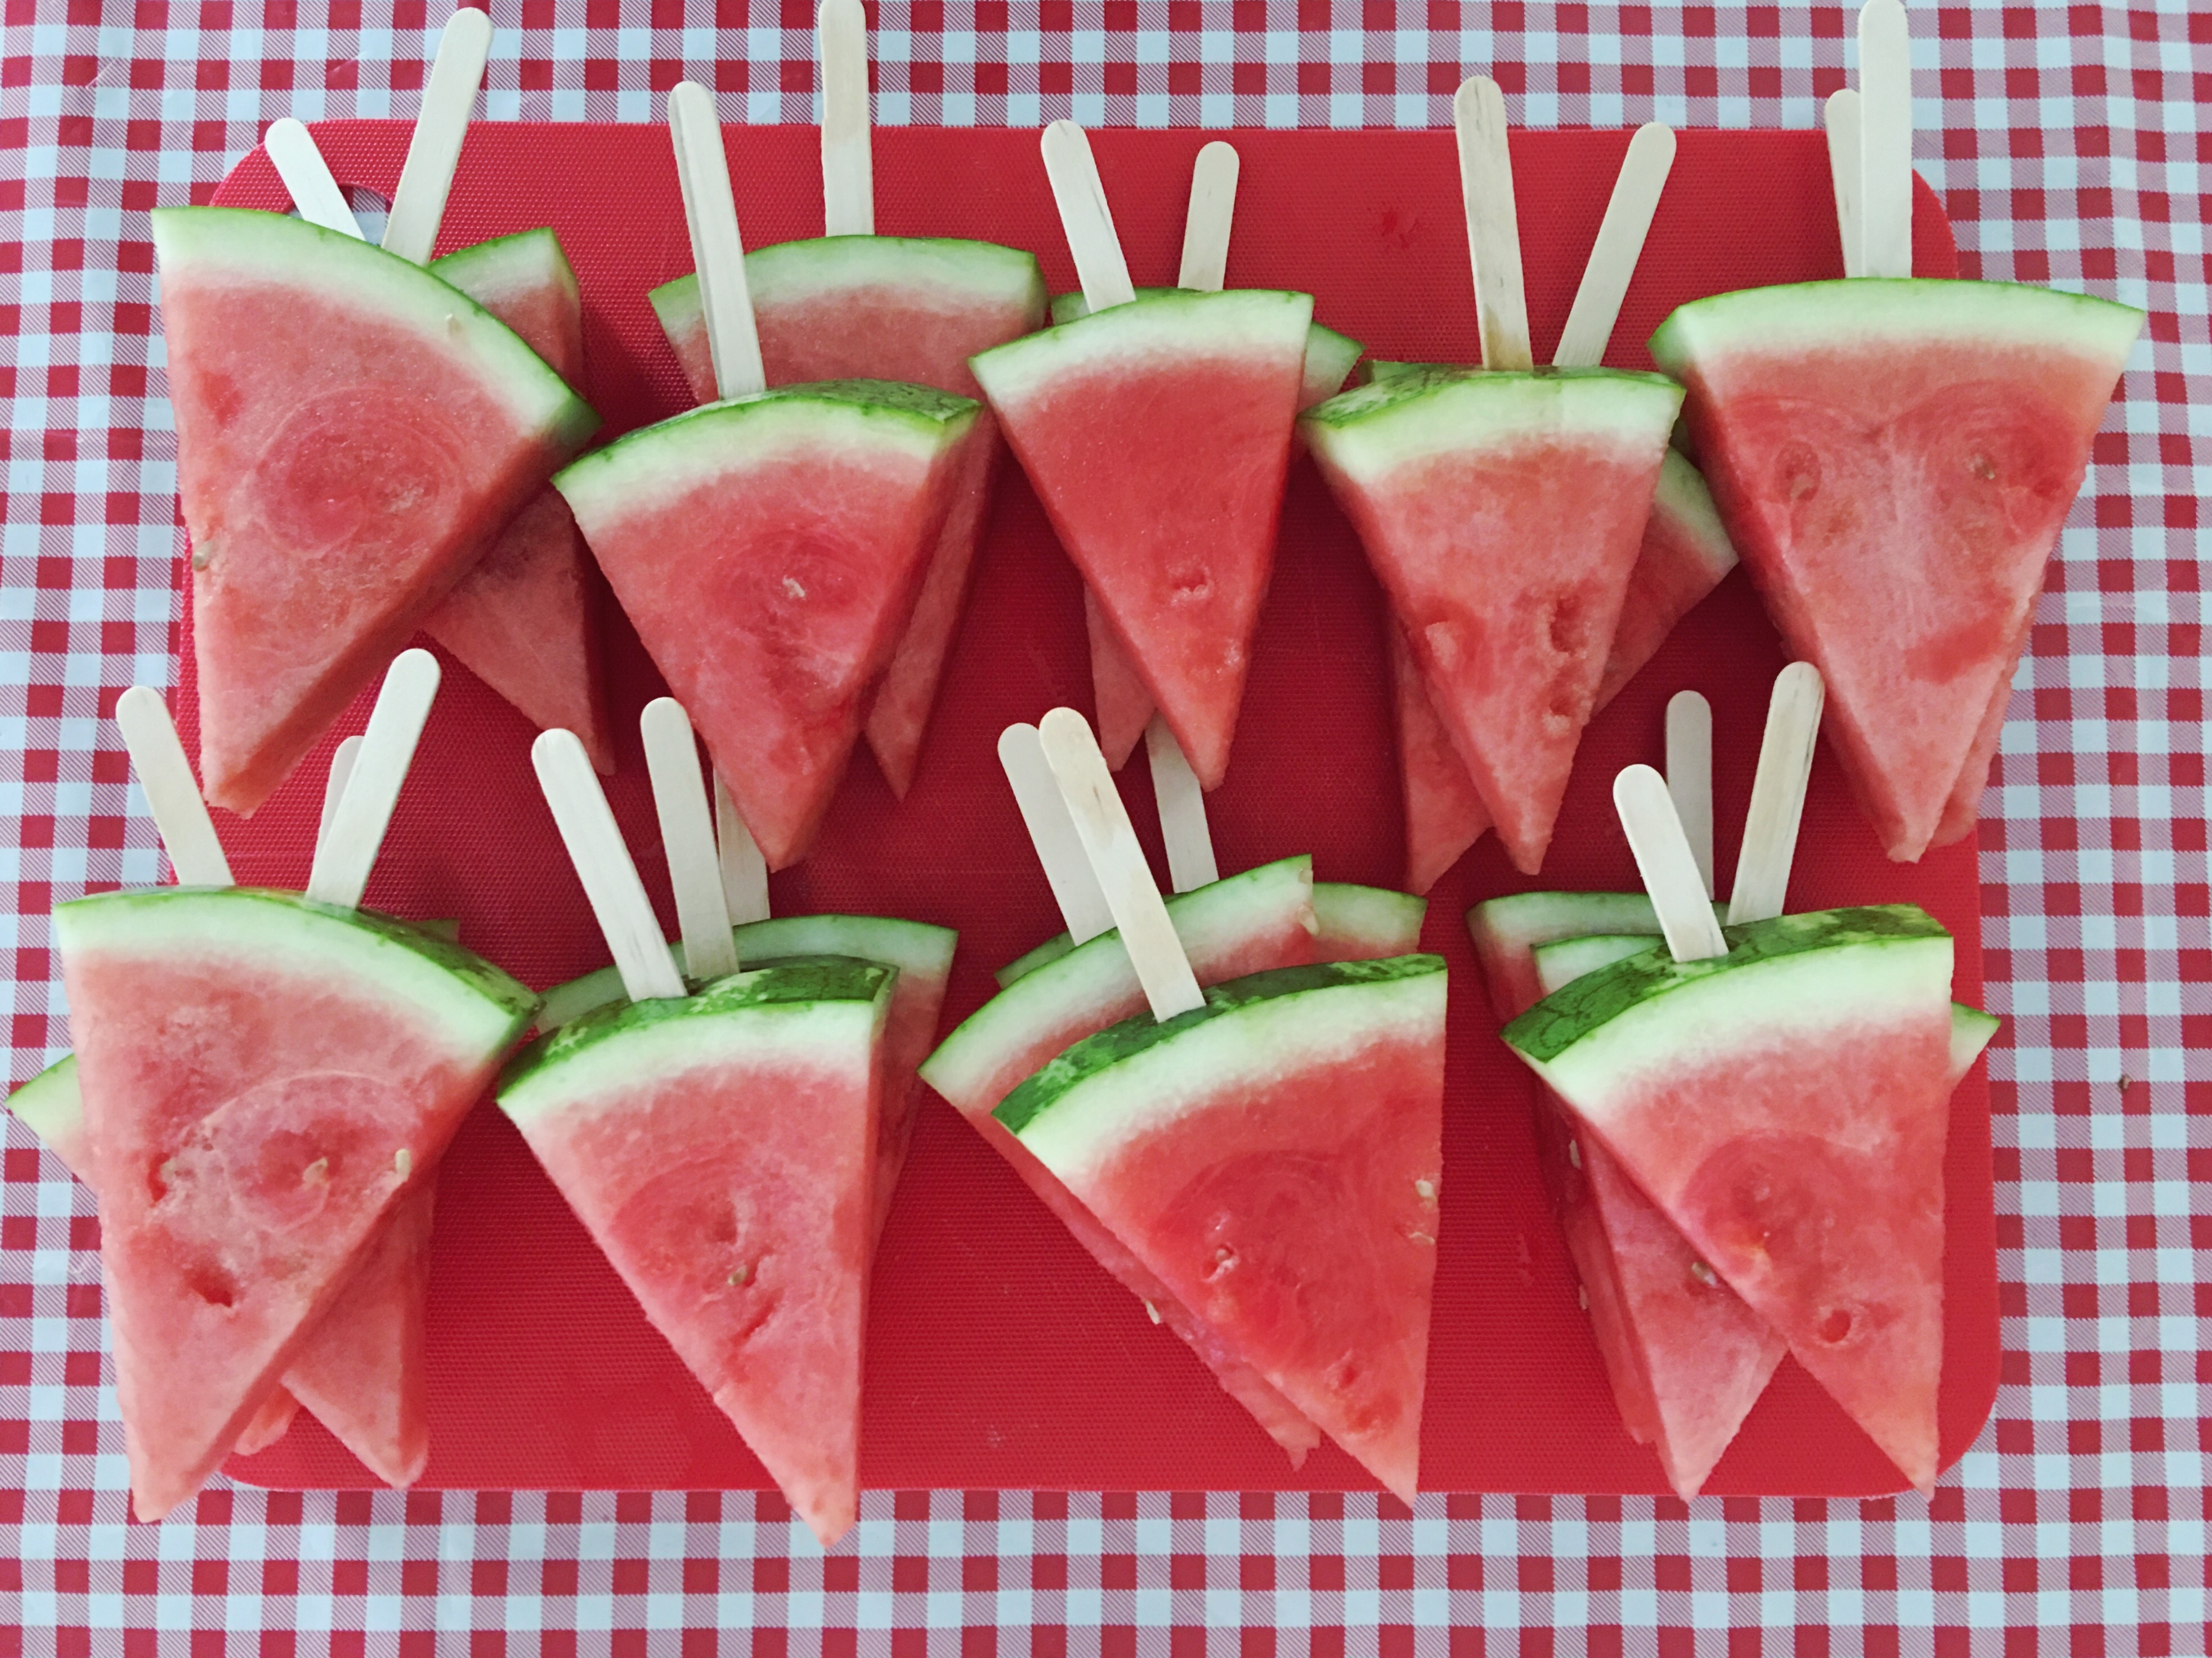
 | 20 |  | 21 | 22 | 23 | 24 | 25 | 26
 |  |  | Bamberton Beach | Bowling $8 | Gyro  Park | Langford Water Park | Look Out Lake
 | 27 |  | 28 | 29 | 30 | 31 | 1 | 2
 |  |  | Sooke Pothole’s | Glenlake Water Park | Aviation Museum $5 | Shawnigan Lake | Beckwith Water Park

