Instrument Cluster

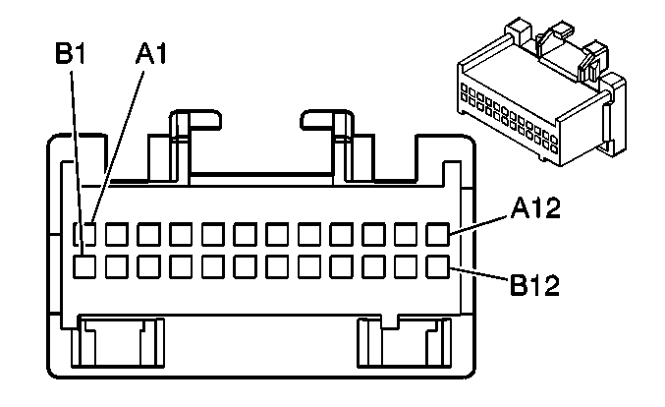

Connector Part Information |  | • 12110088  • 24-Way F Metri-Pack 100 Series (GRY)
Pin | Wire Color | Circuit No. | Function
A1 | BLK | 1750 | Ground
A2 | ORN | 640 | Fused Battery Feed
A3 | PPL | 806 | Crank Battery Feed
A4 | BLK/WHT | 99 | Low Washer Solvent Level Sensor Signal
A5 | YEL | 32 | Fused Interior Lamp Dim Signal
A6 | LT BLU | 811 | Driver Information Display Switch Signal - Metric Conversion (2-Door)
A6 | — | — | Not Used (4-Door)
A7 | GRY | 8 | Interior Lamp Dim Signal
A8 | PPL | 1500 | Fused Ignition 0 Feed
A9 | PNK | 893 | Driver Information Display Switch Signal - Select Menu (2-Door)
A9 | — | — | Not Used (4-Door)
A10 | LT BLU/WHT | 1414 | Turn Signal Switch Output - Left
A11 | DK BLU/WHT | 1415 | Turn Signal Switch Output - Right
A12 | BLK | 1550 | Ground
B1 | PPL | 209 | Brake Fluid Level Indicator Lamp Output
B2 | GRY | 1036 | Class 2 Serial Data Communication Line
B3–B4 | — | — | Not Used
B5 | BRN/WHT | 419 | Malfunction Indicator Lamp (MIL/SERVICE ENGINE SOON) Control
B6 | YEL/BLK | 68 | Low Engine Coolant Level Indicator Lamp Feed
B7 | PNK | 1200 | Headlamp Output - High Beam
B8–B10 | — | — | Not Used (2-Door)
B11 | ORN | 1816 | Driver Information Display Switch Signal - SET/RESET (2-Door)
B8–B11 | — | — | Not Used (4-Door)
B12 | PNK | 39 | Fused Ignition Feed

