Palm to Passion Sunday
March 28 & 29, 2026

Christ Lutheran Church
“A Place Where You are Always Welcome”
Services: Saturday 5:30 pm and Sunday 10:00 am
Wednesday 7 pm (lent and advent)
Sunday School: 9:00 am
600 North Main Street, Stockton, IL 61085 Office: 815-947-2033
Email:christlutheranchurch70@gmail.com http://www.christlutheranstockton.com
Ministers: ALL members of the congregation
Pastor: Rev. Chrissy Salser chrissytherev@att.net 815-988-9450
From Sundays and Seasons.com. Copyright 2017 Augsburg Fortress. All rights reserved. Reprinted by permission under Augsburg Fortress Liturgies Annual License #40643.New Revised Standard Version Bible, copyright 1989, Division of Christian Education of the National Council of the Churches of Christ in the United States of America. Used by permission. All rights reserved. Passion reading was adapted from Rev. Michael Thomas and Zion, Rockford.
WELCOME: Thank you for joining us for worship today. We are glad you are with us. Communion will be served in the aisle or in your pew. All are welcome to share this meal. Jesus is our host and invites everyone. Those who would like to come forward, bread and wine will also be available in the front. When directed by the usher, come forward down the center aisle, Pr Chrissy will give you bread (she will be masked and wearing gloves) and then you will take a cup of wine (grape juice) from the tray. After taking communion, you will return to your seat by the side aisle. For those who are unable to come forward, communion elements can be found as you entered worship. At that part of the service, you are invited to take the bread and wine (or grape juice) when Pr. Chrissy leads. On Saturday’s offering is collected as you enter or leave worship. On Sunday we will pass the plate as a response to God’s grace. Online giving is available. Please see QR code on back of bulletin or visit our website.
Introduction
Today, we encounter the paradox that defines our faith: Jesus Christ is glorified king and humiliated servant. We too are full of paradox: like Peter, we fervently desire to follow Christ, but find ourselves afraid, denying God. We wave palms in celebration today as Christ comes into our midst, and we follow with trepidation as his path leads to death on the cross. Amid it all we are invited into this paradoxical promise of life through Christ’s broken body and outpoured love in a meal of bread and wine. We begin this week that stands at the center of the church year, anticipating the completion of God’s astounding work.
Prelude
Welcome and Announcements
“The Way” by Ann Weems
The way to Jerusalem looks suspiciously like Highway 20, and the pilgrims look suspiciously like you and me. I expected the road to Jerusalem to be crowded with holy people... clerics and saints...
people who have kindness wrinkled in their faces and comfort lingering in their voices, but this is more like rush hour...
horns blowing, people pushing, voices cursing...
this is not what I envisioned!
O God, I’ve only begun and already I feel I’ve lost my way. Surely this is not the road and sure these are not the ones to travel with me.
This Lenten journey calls for holy retreat, for reflection, and repentance.
Instead of holiness this highway is crammed with the cacophony of chaos.
Is there no back road to Jerusalem? No quiet path where angels tend to weary travelers? No sanctuary from the noise of the world? Just this?
Can this hectic highway be the highway to heaven?
P: Blessed is the one who comes in the name of the Lord.
C: Hosanna in the highest! (Repeat several times.) Please stand.

Scripture Matthew 21:1-11
P: ¹ When they had come near Jerusalem and had reached Bethphage, at the Mount of Olives, Jesus sent two disciples, ² saying to them, “Go into the village ahead of you, and immediately you will find a donkey tied and a colt with her; untie them and bring them to me. ³ If anyone says anything to you, just say this, ‘The Lord needs them.’ And he will send them immediately.” ⁴ This took place to fulfill what had been spoken through the prophet: ⁵ “Tell the daughter of Zion, Look, your king is coming to you, humble and mounted on a donkey, and on a colt, the foal of a donkey.”
⁶ The disciples went and did as Jesus had directed them; ⁷ they brought the donkey and the colt and put their cloaks on them, and he sat on them. ⁸ A very large crowd spread their cloaks on the road, and others cut branches from the trees and spread them on the road. ⁹ The crowds that went ahead of him and that followed were shouting,
C: “Hosanna to the Son of David! Blessed is the one who comes in the name of the Lord! Hosanna in the highest heaven!”
P: ¹⁰ When he entered Jerusalem, the whole city was in turmoil, asking, “Who is this?” ¹¹ The crowds were saying,
C: “This is the prophet Jesus from Nazareth in Galilee.”
P: Glory to you, O Lord. C: Praise to you, O Christ.
Blessing of the Palms
P: The Lord be with You. C: And also with you
P: Let us pray. We praise you, O God, C: for redeeming the world through our Savior Jesus Christ. Today he entered the holy city in triumph and was proclaimed messiah and king by those who spread garments and branches along his way. Bless these branches and those who carry them. Grant us grace to follow our Lord in the way of the cross, so that, joined to his death and resurrection, we enter into life with you; through the same Jesus Christ, who lives and reigns with you and the Holy Spirit, one God, now and forever. Amen.
Procession of Palms The Palms
O’er all the way green palms and blossoms gay Are strewn this day in festival preparation, Where Jesus comes to wipe our tears away; E’en now the throng to welcome him prepare.
Refrain: Join all and Hosanna! Let Ev’ry voice resound with united Acclamation, Hosanna! Praised be the Lord, Bless Him who cometh to bring us salvation.
His word goes forth, and people by its might Once more their freedom gain from degradation; humanity doth give to each his right, While those in darkness find restored the light. Refrain
Sing and rejoice, O blest Jerusalem, Of all thy songs sing the emancipation; Thro boundless love, the Christ of Bethlehem Brings forth the hope to thee forevermore. Refrain
Litany of Confession
P: Judas, slave of jealousy, where are you? C: I am here.
P: Peter, slave of fear, where are you? C: I am here.
P: Thomas, slave of doubt, where are you? C: I am here.
P: Men and women of Jerusalem, enslaved to mob rule, where are you?
C: I am here.
P: Pilate, slave of expediency, where are you? C: I am here.
P: The story of Christ’s passion and death mirrors for us much of our own weakness and sin. We all come here as men and women who have missed the mark and who are alienated from God and our neighbors near and far.
Words of Forgiveness
P: Hear the Good News: Even Judas was included in that last supper with Jesus.
C: Even when we are languishing in the depths, Christ offers his grace.
P: God who is rich in mercy, slow to anger, and abounding in steadfast love has come to us in Jesus, who by his holy cross has deemed the world. Buried with Christ by baptism into death, By grace you have been saved. In the name of ✝Jesus Christ, your sins are forgiven. Cross Marked and spirit-sealed, you are raised to new life. Almighty God strengthen you in faith to live each day renewed in God’s call for your life. Amen.
Prayer of the Day
P: Everlasting God,
C: in your endless love for the human race you sent our Lord Jesus Christ to take on our nature and to suffer death on the cross. In your mercy enable us to share in his obedience to your will and in the glorious victory of his resurrection, who lives and reigns with you and the Holy Spirit, one God, now and forever. Amen.
First Reading Psalm 31:9-16
⁹Have mercy on me, O Lord, for I am in trouble;
my eye is consumed with sorrow, and also my throat and my belly.
¹⁰For my life is wasted with grief, and my years with sighing;
my strength fails me because of affliction, and my bones are consumed.
¹¹I am the scorn of all my enemies, a disgrace to my neighbors, a dismay to my acquaintances; when they see me in the street they avoid me.
¹²Like the dead I am forgotten, out of mind; I am as useless as a broken pot.
¹³For I have heard the whispering of the crowd; fear is all around;
they put their heads together against me; they plot to take my life.
¹⁴But as for me, I have trusted in you, O Lord. I have said, “You are my God.
¹⁵My times are in your hand; rescue me from the hand of my enemies, and from those who persecute me.
¹⁶Let your face shine upon your servant; save me in your steadfast love.”
Second Reading: Philippians 2:5-11
R: ⁵Let the same mind be in you that was in Christ Jesus, ⁶who, though he was in the form of God, did not regard equality with God as something to be exploited, ⁷but emptied himself, taking the form of a slave, being born in human likeness. And being found in human form, ⁸he humbled himself and became obedient to the point of death – even death on a cross. ⁹Therefore God also highly exalted him and gave him the name that is above every name, ¹⁰so that at the name of Jesus every knee should bend, in heaven and on earth and under the earth, ¹¹and every tongue should confess that Jesus Christ is Lord, to the glory of God the Father.
R: Word of God, Word of Life C: Thanks be to God!
Children’s Message
OFFERING Our offering is a significant act of worship; we worship God through our giving. The ministry of this congregation is completely dependent upon your partnership and generosity. Offering is collected as you enter worship on Saturday. We will pass the offering plate on Sundays. Online giving is available.
Offering song “All Glory, Laud, and Honor” ELW 344

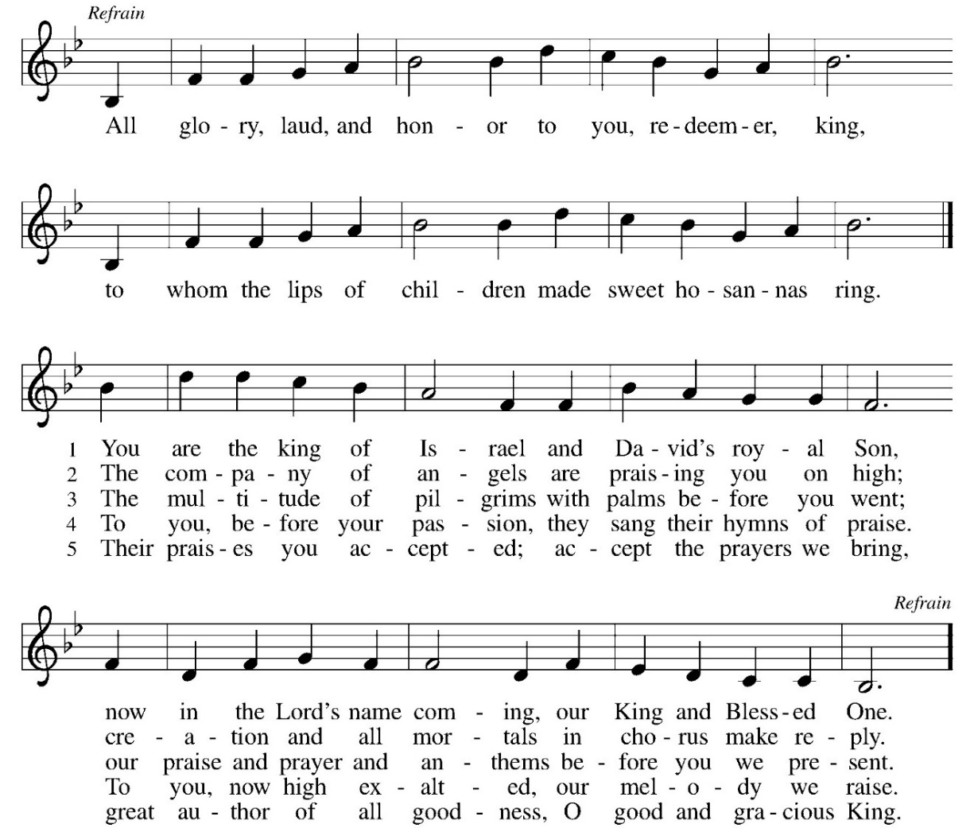
Offering Prayer
P: Let us pray together: Extravagant God, C: you have blessed us with the fullness of creation. Now we gather at your feast where you offer us the food that satisfies. Take and use what we offer here, come among us, and feed us with the body and blood of Christ, in whose name we pray. Amen.
Great thanksgiving and Word’s of Institution
P: The Lord be with you. C: And also with you.
P: Lift up your hearts. C: We lift them to the Lord.
P: Let us give thanks to the Lord our God.
C: It is right to give our thanks and praise.
In the night in which he was betrayed, our Lord Jesus took bread, and gave thanks; broke it, and gave it to his disciples, saying: Take and eat; this is my body, given for you. Do this for the remembrance of me.
Again, after supper, he took the cup, gave thanks, and gave it for all to drink, saying: This cup is the new covenant in my blood, shed for you and all people for the forgiveness of sin. Do this for the remembrance of me.
Lord's Prayer
C: Our Father, who art in heaven, hallowed be thy name, thy kingdom come, thy will be done, on earth as it is in heaven. Give us this day our daily bread; and forgive us our trespasses, as we forgive those who trespass against us; and lead us not into temptation but deliver us from evil. For thine is the kingdom, and the power, and the glory, forever and ever. Amen.
Invitation To Communion:
P. Come and receive Jesus, our strength in the wilderness. So come to this table, You who have much faith and you who would like to have more. You who have been to this sacrament often, and you who have not been for a long time. You who have tried to follow Jesus, and you who have failed. Come. It is Christ who invites us to meet him here. Communion is served by intinction. Please come down the center aisle, take the bread, then receive a cup (wine is dark, juice is light, return to your seats via side aisle.) Those who prefer to take communion in your pews, we will take all together after all is served.
P: This is the body of Christ given for you. (All take bread).
P: This is the blood of Christ shed for you. (All take the wine or juice).
COMMUNION HYMN “Were You There” ELW 353

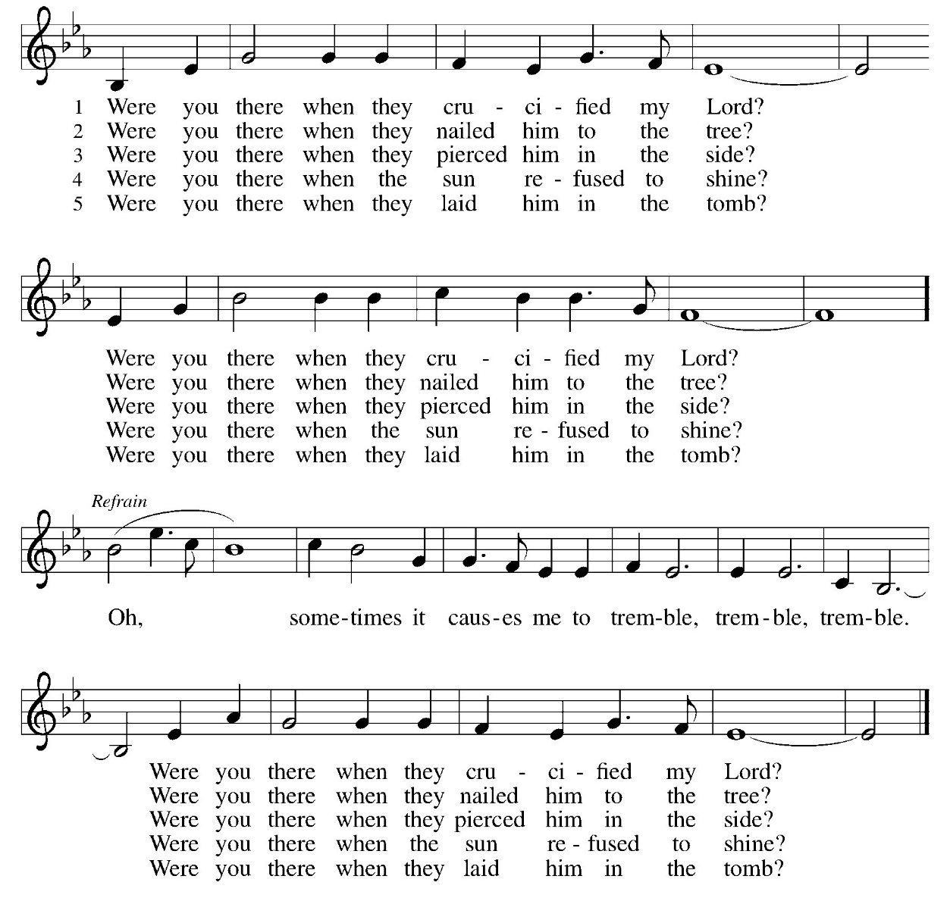

Table blessing
P. May the body and blood of our Lord Jesus Christ strengthen you and keep you in his grace. C. Amen.

Following Jesus’ welcome into Jerusalem – the story moves quickly. Listen as the story continues . . .
The Passion Reading according to Matthew
Narrator: When Jesus had finished saying all these things, he said to his disciples,
Jesus: ‘You know that after two days the Passover is coming, and the Son of Man will be handed over to be crucified.’
Narrator: Then the chief priests and the elders of the people gathered in the palace of the high priest, who was called Caiaphas, and they conspired to arrest Jesus by stealth and kill him. But they said,
Priests: ‘Not during the festival, or there may be a riot among the people.’
Narrator: Now while Jesus was at Bethany in the house of Simon the leper, a woman came to him with an alabaster jar of very costly ointment, and she poured it on his head as he sat at the table. But when the disciples saw it, they were angry and said,
Disciples: ‘Why this waste? For this ointment could have been sold for a large sum, and the money given to the poor.’
Narrator: But Jesus, aware of this, said to them,
Jesus: ‘Why do you trouble the woman? She has performed a good service for me. For you always have the poor with you, but you will not always have me. By pouring this ointment on my body she has prepared me for burial. Truly I tell you, wherever this good news is proclaimed in the whole world, what she has done will be told in remembrance of her.’
Narrator: Then one of the twelve, who was called Judas Iscariot, went to the chief priests and said,
Judas: ‘What will you give me if I betray him to you?’
Narrator: They paid him thirty pieces of silver. And from that moment he began to look for an opportunity to betray him. On the first day of Unleavened Bread the disciples came to Jesus, saying,
Disciples: ‘Where do you want us to make the preparations for you to eat the Passover?’
Narrator: He said,
Jesus: ‘Go into the city to a certain man, and say to him, ‘The Teacher says, ‘My time is near; I will keep the Passover at your house with my disciples.’’
Narrator: So the disciples did as Jesus had directed them, and they prepared the Passover meal. When it was evening, he took his place with the twelve; and while they were eating, he said,
Jesus: ‘Truly I tell you, one of you will betray me.’
Narrator: And they became greatly distressed and began to say to him one after another,
Disciples: ‘Surely not I, Lord?’
Narrator: He answered,
Jesus: ‘The one who has dipped his hand into the bowl with me will betray me. The Son of Man goes as it is written of him, but woe to that one by whom the Son of Man is betrayed! It would have been better for that one not to have been born.’
Narrator: Judas, who betrayed him, said,
Judas: ‘Surely not I, Rabbi?’
Narrator: He replied,
Jesus: ‘You have said so.’
Narrator: While they were eating, Jesus took a loaf of bread, and after blessing it he broke it, gave it to the disciples, and said,
Jesus: ‘Take, eat; this is my body.’
Narrator: Then he took a cup, and after giving thanks he gave it to them, saying,
Jesus: ‘Drink from it, all of you; for this is my blood of the covenant, which is poured out for many for the forgiveness of sins. I tell you, I will never again drink of this fruit of the vine until that day when I drink it new with you in my Father’s kingdom.’
Narrator: When they had sung the hymn, they went out to the Mount of Olives. Then Jesus said to them,
Jesus: ‘You will all become deserters because of me this night; for it is written, “I will strike the shepherd, and the sheep of the flock will be scattered.” But after I am raised up, I will go ahead of you to Galilee.’
Narrator: Peter said to him,
Peter: ‘Though all become deserters because of you, I will never desert you.’
Narrator: Jesus said to him,
Jesus: ‘Truly I tell you, this very night, before the cock crows, you will deny me three times.’
Narrator: Peter said to him,
Peter: ‘Even though I must die with you, I will not deny you.’
Narrator: And so said all the disciples. Then Jesus went with them to a place called Gethsemane; and he said to his disciples,
Jesus: ‘Sit here while I go over there and pray.’
Narrator: He took with him Peter and the two sons of Zebedee, and began to be grieved and agitated. Then he said to them,
Jesus: ‘I am deeply grieved, even to death; remain here, and stay awake with me.’
Narrator: And going a little farther, he threw himself on the ground and prayed,
Jesus: ‘My Father, if it is possible, let this cup pass from me; yet not what I want but what you want.’

Hymn Stay with Me ELW #348 (Sing 3 times)
Stay with me, remain here with me,
watch and pray.
Watch and pray.

Narrator: Then he came to the disciples and found them sleeping; and he said to Peter,
Jesus: ‘So, could you not stay awake with me one hour? Stay awake and pray that you may not come into the time of trial; the spirit indeed is willing, but the flesh is weak.’
Narrator: Again he went away for the second time and prayed,
Jesus: ‘My Father, if this cannot pass unless I drink it, your will be done.’
Narrator: Again he came and found them sleeping, for their eyes were heavy. So leaving them again, he went away and prayed for the third time, saying the same words. Then he came to the disciples and said to them,
Jesus: ‘Are you still sleeping and taking your rest? See, the hour is at hand, and the Son of Man is betrayed into the hands of sinners. Get up, let us be going. See, my betrayer is at hand.’
Narrator: While he was still speaking, Judas, one of the twelve, arrived; with him was a large crowd with swords and clubs, from the chief priests and the elders of the people. Now the betrayer had given them a sign, saying,
Judas: ‘The one I will kiss is the man; arrest him.’
Narrator: At once he came up to Jesus and said,
Judas: ‘Greetings, Rabbi!’
Narrator: and kissed him. Jesus said to him,
Jesus: ‘Friend, do what you are here to do.’
Narrator: Then they came and laid hands on Jesus and arrested him. Suddenly, one of those with Jesus put his hand on his sword, drew it, and struck the slave of the high priest, cutting off his ear. Then Jesus said to him,
Jesus: ‘Put your sword back into its place; for all who take the sword will perish by the sword. Do you think that I cannot appeal to my Father, and he will at once send me more than twelve legions of angels? But how then would the scriptures be fulfilled, which say it must happen in this way?’
Narrator: At that hour Jesus said to the crowds,
Jesus: ‘Have you come out with swords and clubs to arrest me as though I were a bandit? Day after day I sat in the temple teaching, and you did not arrest me. But all this has taken place, so that the scriptures of the prophets may be fulfilled.’
Narrator: Then all the disciples deserted him and fled. Those who had arrested Jesus took him to Caiaphas the high priest, in whose house the scribes and the elders had gathered.
But Peter was following him at a distance, as far as the courtyard of the high priest; and going inside, he sat with the guards in order to see how this would end. Now the chief priests and the whole council were looking for false testimony against Jesus so that they might put him to death, but they found none, though many false witnesses came forward. At last two came forward and said,
Witnesses: ‘This fellow said, “I am able to destroy the temple of God and to build it in three days.”
Narrator: ’The high priest stood up and said,
Priest: ‘Have you no answer? What is it that they testify against you?’
Narrator: But Jesus was silent. Then the high priest said to him,
Priest: ‘I put you under oath before the living God, tell us if you are the Messiah, the Son of God.’
Narrator: Jesus said to him,
Jesus: ‘You have said so. But I tell you, From now on you will see the Son of Man seated at the right hand of Power and coming on the clouds of heaven.’
Narrator: Then the high priest tore his clothes and said,
Priest: ‘He has blasphemed! Why do we still need witnesses? You have now heard his blasphemy. What is your verdict?’
Narrator: They answered,
CROWD: ‘He deserves death.’
Narrator: Then they spat in his face and struck him; and some slapped him, saying,
CROWD: ‘Prophesy to us, you Messiah! Who is it that struck you?’
Narrator: Now Peter was sitting outside in the courtyard. A servant-girl came to him and said,
Servant Girl: ‘You also were with Jesus the Galilean.’
Narrator: But he denied it before all of them, saying,
Peter: ‘I do not know what you are talking about.’
Narrator: When he went out to the porch, another servant-girl saw him, and she said to the bystanders,
Servant Girl: ‘This man was with Jesus of Nazareth.’
Narrator: Again he denied it with an oath,
Peter: ‘I do not know the man.’
Narrator: After a little while the bystanders came up and said to Peter,
Bystanders: ‘Certainly you are also one of them, for your accent betrays you.’
Narrator: Then he began to curse, and he swore an oath,
Peter: ‘I do not know the man!’
Narrator: At that moment the cock crowed. Then Peter remembered what Jesus had said: ‘Before the cock crows, you will deny me three times.’ And he went out and wept bitterly.
When morning came, all the chief priests and the elders of the people conferred together against Jesus in order to bring about his death. They bound him, led him away, and handed him over to Pilate the governor.
When Judas, his betrayer, saw that Jesus was condemned, he repented and brought back the thirty pieces of silver to the chief priests and the elders. He said,
Judas: ‘I have sinned by betraying innocent blood.’
Narrator: But they said,
Priests: ‘What is that to us? See to it yourself.’
Narrator: Throwing down the pieces of silver in the temple, he departed; and he went and hanged himself. But the chief priests, taking the pieces of silver, said,
Priests: ‘It is not lawful to put them into the treasury, since they are blood money.’
Narrator: After conferring together, they used them to buy the potter’s field as a place to bury foreigners. For this reason that field has been called the Field of Blood to this day.
Then was fulfilled what had been spoken through the prophet Jeremiah, ‘And they took the thirty pieces of silver, the price of the one on whom a price had been set, on whom some of the people of Israel had set a price, and they gave them for the potter’s field, as the Lord commanded me.’ Now Jesus stood before the governor; and the governor asked him,
Pilate: ‘Are you the King of the Jews?’
Narrator: Jesus said,
Jesus: ‘You say so.’
Narrator: But when he was accused by the chief priests and elders, he did not answer. Then Pilate said to him,
Pilate: ‘Do you not hear how many accusations they make against you?’
Narrator: But he gave him no answer, not even to a single charge, so that the governor was greatly amazed.
Now at the festival the governor was accustomed to release a prisoner for the crowd, anyone whom they wanted. At that time they had a notorious prisoner, called Jesus Barabbas. So after they had gathered, Pilate said to them,
Pilate: ‘Whom do you want me to release for you, Jesus Barabbas or Jesus who is called the Messiah?
Narrator: For he realized that it was out of jealousy that they had handed him over. While he was sitting on the judgment seat, his wife sent word to him, ‘Have nothing to do with that innocent man, for today I have suffered a great deal because of a dream about him.’ Now the chief priests and the elders persuaded the crowds to ask for Barabbas and to have Jesus killed. The governor again said to them,
Pilate: ‘Which of the two do you want me to release for you?’
Narrator: And they said,
CROWD: ‘Barabbas.’
Narrator: Pilate said to them,
Pilate: ‘Then what should I do with Jesus who is called the Messiah?’
Narrator: All of them said,
CROWD: ‘Let him be crucified!’
Narrator: Then he asked,
Pilate: ‘Why, what evil has he done?’
Narrator: But they shouted all the more,
CROWD: ‘Let him be crucified!’
Narrator: So when Pilate saw that he could do nothing, but rather that a riot was beginning, he took some water and washed his hands before the crowd, saying,
Pilate: ‘I am innocent of this man’s blood; see to it yourselves.’
Narrator: Then the people as a whole answered,
CROWD: ‘His blood be on us and on our children!’
Narrator: So he released Barabbas for them; and after flogging Jesus, he handed him over to be crucified. Then the soldiers of the governor took Jesus into the governor’s headquarters, and they gathered the whole cohort around him. They stripped him and put a scarlet robe on him, and after twisting some thorns into a crown, they put it on his head. They put a reed in his right hand and knelt before him and mocked him, saying,
Soldiers: ‘Hail, King of the Jews!’
Narrator: They spat on him, and took the reed and struck him on the head. After mocking him, they stripped him of the robe and put his own clothes on him. Then they led him away to crucify him.
As they went out, they came upon a man from Cyrene named Simon; they compelled this man to carry his cross. And when they came to a place called Golgotha (which means Place of a Skull), they offered him wine to drink, mixed with gall; but when he tasted it, he would not drink it. And when they had crucified him, they divided his clothes among themselves by casting lots; then they sat down there and kept watch over him. Over his head they put the charge against him, which read, ‘This is Jesus, the King of the Jews.’
Then two bandits were crucified with him, one on his right and one on his left. Those who passed by derided him, shaking their heads and saying,
Passersby: ‘You who would destroy the temple and build it in three days, save yourself! If you are the Son of God, come down from the cross.’
Narrator: In the same way the chief priests also, along with the scribes and elders, were mocking him, saying,
Priests: ‘He saved others; he cannot save himself. He is the King of Israel; let him come down from the cross now, and we will believe in him. He trusts in God; let God deliver him now, if he wants to; for he said, ‘I am God’s Son.’’
Narrator: The bandits who were crucified with him also taunted him in the same way. From noon on, darkness came over the whole land until three in the afternoon. And about three o’clock Jesus cried with a loud voice,
Jesus: ‘Eli, Eli, lema sabachthani?’
Hymn Go to Dark Gethsemane vs. 1 & 2 ELW #347
Go to dark Gethsemane, all who feel the tempter's pow'r;
your Redeemer's conflict see. Watch with him one bitter hour;
turn not from his griefs away; learn from Jesus Christ to pray.

Follow to the judgment hall, view the Lord of life arraigned;
oh, the wormwood and the gall! Oh, the pangs his soul sustained!
Shun not suff'ring, shame, or loss; learn from him to bear the cross.

Prayers
P: As we prepare for one of the holiest of weeks, journeying through praise, traveling through betrayal, we gather at the foot of your cross and lift our prayers to you…
P: God of Steadfast Love: you hand us the palm branches, so we can wave them in hope; you steady us in the days when pain is stuck to the bottom of our lives, when fear is our constant companion. We empty ourselves so you might fill us with joy. Lord, in your mercy, C: receive our prayer.
P: God our Humble Healer: When our mouths turn numb and we cannot speak our dreams, you tenderly caress our cheeks, leaning over to hear our faltering words. When our arms have grown weak from the burdens we carry, you take them from us, and strengthen us with your mercy. We empty ourselves so you might fill us with grace. Lord, in your mercy, C: receive our prayer.
P: God our Voice of Wisdom: when death hovers so close we can feel it’s cold breath, you come to us, the warm breath of resurrection pushing aside our fears. When we hesitate to walk into the unknown stretching before us, you tightly clasp our hands and teach us the first step. We empty ourselves so you might fill us with peace. Lord, in your mercy, C: receive our prayer.
P: God in Community, Holy in One, we open our hearts to you, offering all of our needs and concerns, both those we know and those we only feel in the depth of our guts. Bring us together, in this place to be your people- and then send us out, to be your people in your world. Lord, in your mercy, C: receive our prayer.
P: As we wave palm branches in anticipation, we lay our love and our prayers before you. As our voices join those that cry ‘crucify’ we lay our hurts and betrayals before you. As we join the women who weep, we lay all that we have before you. Into your hands, gracious Lord, we commend all for whom we pray, trusting in your mercy, through Jesus Christ, our Savior and Lord. Amen.
Continuing with the Passion from Matthew
Jesus: ‘Eli, Eli, lema sabachthani?’
Narrator: that is, ‘My God, my God, why have you forsaken me?’ When some of the bystanders heard it, they said,
Bystanders: ‘This man is calling for Elijah.’
Narrator: At once one of them ran and got a sponge, filled it with sour wine, put it on a stick, and gave it to him to drink. But the others said,
Bystanders: ‘Wait, let us see whether Elijah will come to save him.
Narrator: ’Then Jesus cried again with a loud voice and breathed his last. At that moment the curtain of the temple was torn in two, from top to bottom. The earth shook, and the rocks were split. The tombs also were opened, and many bodies of the saints who had fallen asleep were raised. After his resurrection they came out of the tombs and entered the holy city and appeared to many. Now when the centurion and those with him, who were keeping watch over Jesus, saw the earthquake and what took place, they were terrified and said,
Centurion: ‘Truly this man was God’s Son!’
Narrator: Many women were also there, looking on from a distance; they had followed Jesus from Galilee and had provided for him. Among them were Mary Magdalene, and Mary the mother of James and Joseph, and the mother of the sons of Zebedee.
When it was evening, there came a rich man from Arimathea, named Joseph, who was also a disciple of Jesus. He went to Pilate and asked for the body of Jesus; then Pilate ordered it to be given to him. So Joseph took the body and wrapped it in a clean linen cloth and laid it in his own new tomb, which he had hewn in the rock. He then rolled a great stone to the door of the tomb and went away. Mary Magdalene and the other Mary were there, sitting opposite the tomb.
The next day, that is, after the day of Preparation, the chief priests and the Pharisees gathered before Pilate and said,
Priests: ‘Sir, we remember what that impostor said while he was still alive, “After three days I will rise again.” Therefore command that the tomb be made secure until the third day; otherwise his disciples may go and steal him away, and tell the people, “He has been raised from the dead”, and the last deception would be worse than the first.’
Narrator: Pilate said to them,
Pilate: ‘You have a guard of soldiers; go, make it as secure as you can.’
Narrator: So they went with the guard and made the tomb secure by sealing the stone.
This is the Passion of our Lord and Savior, Jesus Christ.
ALL - Praise to you, O Christ.
Hymn Go to Dark Gethsemane vs. 3 ELW #347
Calv'ry's mournful mountain climb; there, adoring at his feet,
mark that miracle of time, God's own sacrifice complete.
"It is finished!" hear him cry; learn from Jesus Christ to die.
Benediction
P: Before this week ends, the palm branches will be drying on the roadside. The joyful crowd will become an angry mob, and Jesus will replace robes of victory with a crown of thorns. So then, go in the knowledge that whatever comes to you in this week, you are held in the hand of God, hugged tight, held close, and may God, Father, Son, and Holy Spirit, bless you, uphold you, and give you strength for the journey ahead.

It was three dark, long days and while we know that Easter comes, we must journey through the darkness of Good Friday first. This morning’s service was much like flying cross country, you covered a lot of ground at a distance.
IN OUR PRAYERS TODAY: Teresa Hesselbacher, Elaine Schlicting, Darlene and Walt Steffes, Bob Schreck, Delores Wampfler, Marge and Gerald Arnold, Don & Judy Brudi, Pat Lawfer, Nancy Dittmar, Karen Dick, Angie Broshous, Grayson Raab, Lisa Law , James Dieter, Christine Happ, Kay Hesselbacher, Mary Lou Bunker, Lillian Sefford, Cindy Kerchner, Russ Synder, Don Kunz, Johnny Blair, Jim Sullivan, John Becker, Cheri Broge, Nancy Bailey, Terry Calhoun, Pastor Lee Leubke (Allure, Mt Carroll) To add someone to the prayer list please contact Pastor Chrissy
CELEBRATING BIRTHDAYS/ANNIVERSARIES THIS WEEK: Janet Haas, Debra Noller, Oaklanyn Wilson, Pam Dascher, Lydia Schuldt, Jerry and Pam Dascher

Thanks be to God for your gifts for the ministry of  Christ Lutheran Church |  |  |  | Offering/ Attendance  Report
Current Expense | $1,494.00 | Lent | $2,111.00 | March 21  March 22 | 15  53
Sunday School | $20.00 | Comm.  Dinner | $100.00 | Sunday School | 10
Benevolence | $10.00 |  |  | March 18 | 19
 |  | Total | $ 3,745.00

February 2026
 | February | Year to Date
Offerings | $10,021 | $16,451
Expenses | $9,330 | $21,997
Overall Gain/ Losses | $691.00 | ($5,546.00)
February Totals: As a way to improve communication around finances, we are sharing the information above:

ANNOUNCEMENTS
SYNOD YOUTH WORSHIP: Join Bishop Stacie Fidlar at LOMC on April 19th from 2:00 pm to 5:00 pm for the 2026 Synod Youth Worship. An afternoon of fun, games, worship, and, of course, snacks. 6th - 12th graders are welcome. $5 per youth, scholarships are available. For more information see Leisa Hubb or Pastor Chrissy for transportation
WELCA SPRING EVENT: Proclamation isn’t shouting louder than hate…it’s speaking, living, and standing in love, truth, and justice as people claimed by Christ. Join the Northern Illinois Synod Women of the ELCA for the 2026 Spring Retreat on Saturday, April 25, 2026, from 9:00 am to 3:00 pm at Lutheran Outdoor Ministries Center in Oregon, IL. Cost $30 per person, scholarships are available. Forms are in the back of the church.

NORTHWEST CONFERENCE ASSEMBLY: join others from our conference for a time of worship, learning about holden village and fellowship, Sunday, April 19th, 2 pm at St. John's Lutheran Church, 8315 South Massbach Road, Elizabeth.
AMAZON WISH LIST: did you know that everyday items used at the church are items you could contribute? Find our list here or on our Facebook page. Thank you!
Anderson House Birthdays: Betsy’s birthday is April 8 Please mail cards or drop off at Anderson House 200 E King Ave. Stockton, IL 61085 or drop off in basket in the back of the church.
COWORKERS IN THE GOSPEL: Consider being a part of one our leadership teams. As of this month, three teams will be helping connect council and congregation as we work together to do ministry together. If you are interested in being a part of one of the teams, please see Pr Chrissy or someone on the team.
- Worship team leader is Patsy Holland -anyone who is interested in serving in any area of worship, especially baking communion bread, communion set up, serving or clean up.
- The building team will access, and address issues related to the building. Please see Cory Haas, team leader, if you would like to help with the building.
- The Education Team over sees Confirmation, Sunday School and Vacation Bible School. Vacation Bible School is going to happen June 1-5 from 9-11:30If you would like to be a part of the education team please see Leisa Hubb (team leader)
Upcoming Events
- March 28 5:30 pm Palm/ Passion Worship
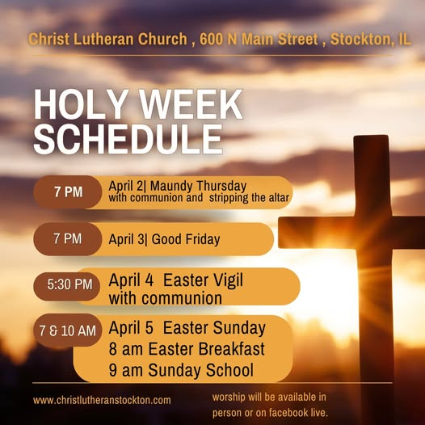
- March 29 9 am Sunday School
- March 29 10 am Palm/ Passion Worship
- March 30- 10 am Clean up outside the church – lunch at noon
- March 31- WELCA Board Meeting
- April 2- 7pm Maundy Thursday Worship
- April 3- 7 pm Good Friday Worship
- April 4- 5:30 pm Easter Vigil
- April 5- 7/ 10 am Easter Worship with Communion and new members
- April 5- 8 am Easter Breakfast
- April 5- 9 am Sunday School
- April 7- 11:30 am Community Table
- April 8- 1:00 pm Naomi Circle
- April 9- 9 am Rebecca Circle at Anne Harmston’s house
- April 12- 9 am confirmation Class
- April 14- Northwest Conference pastors gathering at Christ
- April 15- 9 am Bible Study
- April 15- 7 pm Church Council
- April 16- 5 pm Birthday Dinner at Anderson house
- April 25 9-3 WELCA Spring Retreat at LOMC

