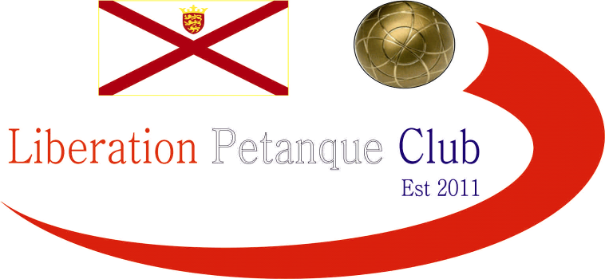

WINTER 2025/26 SEASON
WEEK 13 – 24th January 2026
FREE WEEK

The

NEXT WEEK - DOUBLES LEAGUE

Club email address - liberationpc@gmail.com

Club Website - www.liberationpetanque.co.uk

Kind Regards

Toby Northern

Chairman

Liberation Petanque Club

