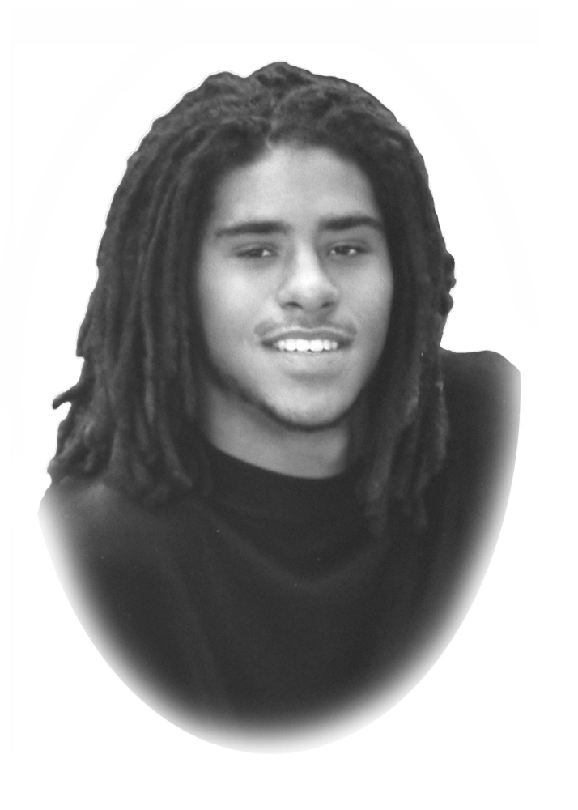
Ian James (Wally) Wallace Scholarship Fund

Our Mission

The Ian James Wallace Scholarship Fund was established to perpetuate Ian’s message and the example he set for all of us.

Eligibility Guidelines:

- Recipients of the Scholarship will demonstrate and be committed to furthering their education in the field of Arts and Science.

- Is a Colorado high school graduate entering college as a freshman;

- Provides a copy of the most current transcript showing an accumulative grade point average of 3.0 or better (unweighted) through the first semester of the student’s senior year;

- Scholarship funds will be earmarked only for the student’s first year of college;

- Scholarship checks will be sent to the institution in which the award recipient is enrolled full-time for their freshman academic school year.

How to Apply:

Applications can be obtained on the Ian James Wallace website. www.ianjameswallace.org

Applications can be downloaded or obtained from Smoky Hill High School or your high school post-graduate center.

Application Deadline is February 15, 2017

The Ian James Wallace Scholarship fund will award a minimum of two scholarships ($1,500 each) for post-secondary education in recognition of one Smoky Hill High School senior and one graduating senior from the state of Colorado who intend to pursue a major in the field of Arts and Science. The senior must exhibit advancement in personal growth and development in one or more of the following areas: community contributions, academic success and personal accomplishments. Community contributions include community service, extracurricular activities, athletics and sportsmanship. Academic success includes improvement in GPA between freshman and senior years, raising and achieving academic goals. Personal accomplishments (in or out of school) include the arts, music, theatre, technology, consumer/family studies, science, athletics, volunteer work, etc. Please contact your counselor if you are uncertain whether or not your submission qualifies for scholarship consideration.

Student’s Name: _______________________________________________________________________________________________
(Print) Last First Middle
Address: ________________________________________________ City: _____________________________ Zip: _______________

Home Phone: _______________________ Cell Phone: ______________________ Email Address: ___________________________

Name of High School _____________________________ Student ID: _____________________ Date of Birth: _______________

How did you hear about this Scholarship Fund? ____________________________________________________________________

Print Parent(s) Name(s): ________________________________________________________________________________________

Parent Signature: _____________________________________________________________Date: ____________________________

Place the following in an envelope and clearly label all documents with your name:

- Write a short essay describing your contribution to help build a more humane and just world. (See page 3)

- Provide documentation of your achievement(s). You are welcome to submit a video, photographs, audiotape or other types of creative documentation. Please do not submit originals.

- Include two letters of recommendation from adults other than immediate family who have personal knowledge of your achievements.

- Include a copy of your official transcript including ACT and or SAT scores and class ranking.

- Include a copy of a letter documenting acceptance to a post-high school education program for your upcoming college freshman year. If this document is not available by the deadline date, a copy must be eventually provided in order to receive scholarship money.

** DEADLINE: Postmark by February 15, 2017 **
Applications accepted ON or BEFORE deadline
Mail to:
Ian James Wallace Scholarship Fund
16748-9C E. Smoky Hill Road #106
Centennial, CO 80015

Student’s Name: _______________________________________Date of Birth: __________________

The IAN JAMES WALLACE SCHOLARSHIP FUND Does Not Discriminate on the Basis of Race, Color, Religion, National Origin, Gender, Sexual Orientation, Marital Status, Medical Condition, Physical or Mental Disability, Economic Status or Type of Higher Education to be Pursued.

ACADEMIC HONORS: Briefly list or describe any scholastic distinctions or honors you have won beginning with ninth grade. (Attach separate sheets as needed)
__________________________________________________________________________________________
__________________________________________________________________________________________

EXTRACURRICULAR, PERSONAL, and VOLUNTEER ACTIVITIES: (Including Summer)

Please list your principal extracurricular, community, and family activities and hobbies in the order of their interest to you. Include specific events and/or major accomplishments such as musical instrument played, varsity letters earned, etc. (Attach separate sheets as needed)

 | Grade Level or Post-Secondary (PS) |  |  |  | Approximate Time Spent |  |  |  | Positions Held, Honors Won  Or Letters Earned
 |  |  |  |  |  |  | Hours/week | Weeks/year
Activity | 9 | 10 | 11 | 12 |  | PS

WORK EXPERIENCE: List any job (including summer employment) you have held during the past three years. (Attach separate sheets as needed)

Specific Nature of Work | Employer | Approximate Dates of Employment | Approximate # of Hours Spent Per Week

MOST MEANINGFUL EXPERIENCE: Briefly describe which of your activities (extracurricular, personal activities or work experience) has been most meaningful to you and why. (Attach separate sheets as needed)
__________________________________________________________________________________________
__________________________________________________________________________________________
__________________________________________________________________________________________

ESSAY:
Write a short essay, (500-750 words) describing how you plan to apply your knowledge, skills and values in order to contribute to building a more humane and just world.

SIGNATURE: I certify that I have carefully considered each question, and that my statements are true and complete to the best of my knowledge. I understand that misrepresentation in any statement may be considered sufficient reason for disqualification.

Student Signature: ___________________________________________________________ Date: _____________________________

TEACHER/COUNSELOR RECOMMENDATION

Student's Name: ___________________________________________________High School_____________
(Last) (First) (Middle)

To be completed by a counselor, teacher, or other school official. The review committee uses this letter of recommendation only in the evaluation process. This letter does not become part of the student’s permanent record.

BACKGROUND INFORMATION

How long have you known this student? _______ In what context? ___________________________________

ACADEMIC CHARACTERISTICS

Scholastic Readiness: Intellectual curiosity, capacity for original thought.

○ Exceptional | ○ Superior | ○ Above Average | ○ Average | ○ Below Average

Motivation: Committed to learning, attentive to goals, inclined to complete tasks.

○ Exceptional | ○ Superior | ○ Above Average | ○ Average | ○ Below Average

Emotional balance and maturity: Even disposition, tolerant of minor disappointments.

○ Exceptional | ○ Superior | ○ Above Average | ○ Average | ○ Below Average

PERSONALITY CHARACTERISTICS

Personal Relationships: Works well with others, liked by others, included in group activities.

○ Exceptional | ○ Superior | ○ Above Average | ○ Average | ○ Below Average

Social Responsibility: Demonstrates concern with the welfare and rights of others, is a good citizen.

○ Exceptional | ○ Superior | ○ Above Average | ○ Average | ○ Below Average

Leadership: Directs activities, serves on committees, and inspires confidence.

○ Exceptional | ○ Superior | ○ Above Average | ○ Average | ○ Below Average

Comments (Attach additional sheets with further comments, if desired)
__________________________________________________________________________________________ __________________________________________________________________________________________

Teacher/Counselor Name and Title: ______________________________________ Telephone: (_____) ____________

Teacher/Counselor Signature: _______________________________________________ Date: ____________________

