Name of Committee: Substance Use Prevention Subcommittee
Chair: Laura Mitchell Phone: (410) 422 – 2694 Committee Email:
Vice Chair: Phone:
Communication (e-list, etc): N/A

SUBCOMMITTEES / WORK GROUPS (if applicable): None/TBD

GOALS & OBJECTIVES: Educate families, students, and the community at large about substance use prevalence, risks and ways to prevent substance use among students. Advocate for services for students who have substance use issues and help ensure the continuation of recovery academic programs.

Substance Use Prevention Subcommittee Activities

The Substance Use Prevention Subcommittee continues to partner with several outside groups and agencies toward prevention efforts and to address current substance use by MCPS students.

Committee work:
- Update: Submitted a proposal to present at the National PTA Legislative Conference on the topics in the “Protect Your Family” initiative. Decisions will be announced in mid-January for the March conference.
- Background: Continuing to assemble resources to supplement the “Protect Your Family” initiative on the MCCPTA website. The objective is to educate parents and guardians about the unseen dangerous substances in their homes and provide tips for creating and maintaining a safe space and healthy habits for their teens and tweens to help reduce the temptation and opportunity to use substances. Eliminating, or at least reducing, the availability of these substances during periods of stress reduces the risk of turning to substances on an impulse or out of boredom and curiosity. The supplemental resources will provide more in-depth information on each topic covered and resources to find help when needed.
- The presentation is in the folder and you are encouraged to share it widely. Most every parent that has seen it has said they had not thought to do one or more of the actions shown.

Montgomery County Alcohol and Other Drug Abuse Advisory Council (AODAAC):
Attended monthly Council meeting as the MCCPTA representative. We continue to see increases in fatal and non-fatal overdoses during COVID-19. Stressors, lack of access to care as many treatment centers refuse new patients, and support meetings switched from in person to virtual.
- The Prevention subcommittee recommended, and the Council approved, a partnership with Parents Against Vaping E-Cigarettes (PAVe).
- Worked with Linda Willard from the Maryland pod of PAVe on ways to collaborate to provide education on the dangers of vaping to students and parents and provide information on how we can advocate for laws that ban flavored vapes at the local, state and federal levels of government. We have scheduled a date for an MCCPTA/PAVe webinar for Montgomery County on December 16, 2020 at 7:00pm.
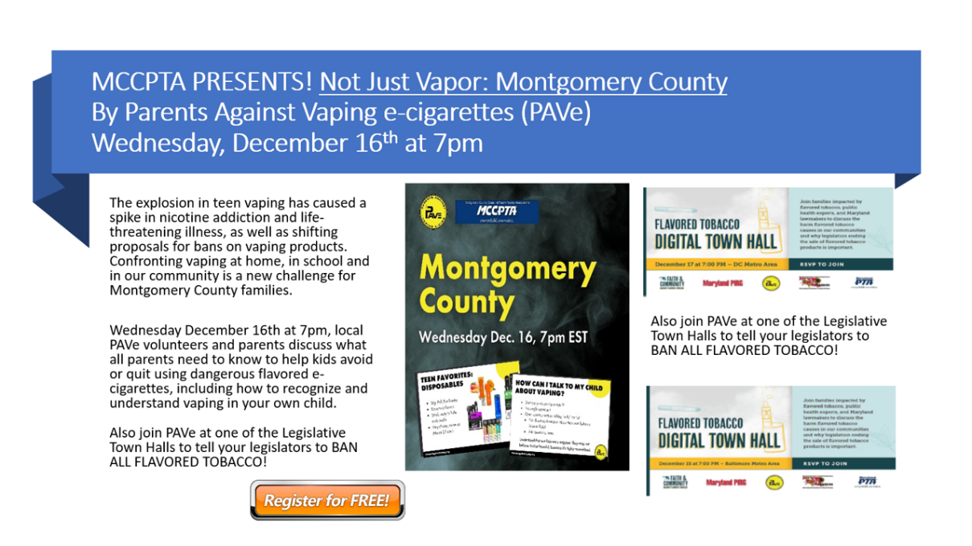
Please share this information with your schools.

- The Montgomery County webinar is bookended by statewide Legislative Town Halls to discuss bills to be introduced in the 2021 MD Legislative session. The draft bills and bill numbers will be released in the next week or so. I plan to provide testimony in support of banning all flavored tobacco products in MD. This initiative aligns with MCCPTA’s Health and Wellness Advocacy Priorities.
  - Register for 12/16 Montgomery County Event: https://pave.salsalabs.org/mccpta/index.html
  - Register for Legislative Town Hall(s) – each Town Hall has different guests:
    - REGISTER FOR 12/15 BALTIMORE AREA LEGISLATIVE TOWN HALL HERE
Panelists:
    - Donna Bartlett , Maryland native and mother, member of Parents Against Vaping e-Cigs (PAVe), member of the Faith and Community against Flavored Tobacco Coalition for the state of Maryland, years of experience working with locally organized addiction programs in her community.
    - State Senator Clarence Lam, MD, MPH , Health and Environmental Affairs Committee, board-certified physician in preventive medicine at the Johns Hopkins Bloomberg School of Public Health, Program Director of the Preventive Medicine Residency program.
    - Special appearances by: Maryland Attorney General Brian Frosh, State Senator Mary Washington, Delegate Jazz Lewis, Dr. Letitia Dzirasa (Baltimore City Commissioner of Health).
    - REGISTER FOR 12/17 DC METRO LEGISLATIVE TOWN HALL HERE
Panelists:
    - Donna Bartlett , Maryland native and mother, member of Parents Against Vaping e-Cigs (PAVe), member of the Faith and Community against Flavored Tobacco Coalition for the state of Maryland, years of experience working with locally organized addiction programs in her community.
    - State Senator Clarence Lam, MD, MPH , Health and Environmental Affairs Committee, board-certified physician in preventive medicine at the Johns Hopkins Bloomberg School of Public Health, Program Director of the Preventive Medicine Residency program.
    - Special appearances by: Maryland Attorney General Brian Frosh, State Senator Mary Washington, Delegate Jazz Lewis, Dr. Letitia Dzirasa (Baltimore City Commissioner of Health).

Opioid Intervention Task Force (OIT):
- The group did not meet this month.

Parity and Equity Coalition, Legal Action Center:
- The most pressing issue for this group is fair and equitable coverage of mental health and substance use treatment via telemedicine by insurance companies and Medicaid. This is proving particularly challenging for audio only, or telephone only, appointments. It is a safety concern and an equity issue for patients who do not have access to internet services and devices needed for an online visit but cannot get in person visits at this time.
- The group determined the legislative priorities for the 2021 Maryland General Assembly session which includes the continuation of coverage for telemed services post-COVID-19 and balance billing issues (when a provider tries to bill the patient for the balance after insurance payments, often in violation of their provider agreements).
- We had the first in a series of meetings with the Maryland Insurance Commission. The new chair, Kathleen A. Birrane, is very empathetic to the consumers plight in dealing with insurance companies and we are encouraged by her comments and hopeful that the MIA will set adequate reporting requirements, and require that insurance providers to meet those requirements, so that parity and equity violations can be easily determined and addressed. Currently, there is no way for the public to obtain the metrics required to see blatant violations. Only the MIA can obtain the information by request, it is not required in ongoing reporting.
- We will continue our work to eliminate the barriers to SUD and mental health treatment that insurance companies continue to erect, in violation of the Mental Health Parity and Substance Use Equity Act. The SUP Chair has joined the legislative committee to advocate for bills that will provide adequate care and insurance coverage for mental health and substance use treatments in Maryland.

MCPS:
- I continue to work with OSFSE on the implementation of Handle With Care, a program that has first responders notify school officials when a school aged child is present at a scene to which they responded. The school is then able to meet with the child with a trauma informed approach to assess the level of trauma (if any) experienced and to provide or refer the family for trauma informed care. Addressing childhood Adverse Childhood Events (ACEs) in a timely and effective manner is a very important step toward reducing the risk of future. Studies have shown that more than 80% of individuals treated for substance use experienced at least one ACE and most went unaddressed.

Local police departments are starting to put this initiative into practice, informally. We are working to ensure that privacy and other critical components of the HWC program are happening with fidelity, even in the informal practice. A pilot of Handle With Care was slated to begin in September, however, that was delayed due to COVID-19 and distance learning. I feel strongly that this the very time we need this program the most. We know that reports of child abuse and neglect are down substantially because students are not in school being seen or able to reach out for help. If MCPS were made aware of calls for service to the home, for whatever reason, their follow up outreach might reveal the students’ need for help.
- Reviewing and providing input on the new MCPS substance use plan/policy.
- We have been asked, and have agreed, to participate in the planning of Anti-Vaping Symposium with MCPS & MCCPTA.
  - We are working to include information or a virtual tour of the C.O.P.E. trailer (mock teen bedroom/bathroom) at this event.

