RSAI Position Paper: Summer School/Reading for 2017
Background: The 2013 Iowa Legislature required that non-proficient third-grade readers attend an intensive summer reading program or be retained in third grade. The 2016 Legislature delayed the mandate until the summer of 2018. The 2017 Legislature and Governor are tasked with funding the requirements of the program, further delaying the mandate, or eliminating it. Iowa Code Section 279.68 requires the summer program or retention conditions, including a list of good cause exemptions for some students to move forward to 4th grade without the summer school program. The Iowa Reading Research Center’s Report on the 2016 Intensive Summer Reading Program (ISRP) Study of several summer 2016 pilot projects provides additional evidence and context for the challenges school districts will face in implementing this mandate. Rural districts which typically experience excess transportation costs and lower class sizes may have additional challenges to offering an Intensive Summer Reading Program within the $9.25-$13.82 million estimated cost range of the report. Find the full report here: http://www.iowareadingresearch.org/documents/2016_ISRP_Study_Report-FINAL.pdf
Current Reality:
- The IRRC report states, “Iowa joins 19 other states and Washington, D.C. in this move, prompted in part by the serious long-term consequences (e.g., dropping out of school, criminal behavior) associated with students’ early reading difficulties. It has been estimated that approximately 25% of Iowa’s third graders (about 9,000 students) are at risk for reading failure and, thus, might benefit from participating in summer reading programs.” The report stated, “Study results show all three conditions used were equally effective at preventing a decline in reading skills that can typically occur during the summer months when away from the classroom. On average, however, the ISRPs did not lead to statistically significant growth on tests of students’ reading abilities.” The study further explained that the professional development required to provide teachers with the instructional skills to improve results was below that which research shows is necessary to prepare teachers to change their practice during the regular school year, but was not specific to summer school professional development.
- The report estimates per pupil summer school expenditures would range from $1,193 to $1,813. Because not all students will be required or choose to attend ISRPs, these figures might be considered the maximum expense. Of course, the cost of retaining the student is an additional year of the school at an average total cost of $11,427, estimated by the report. But if more students choose not to attend Summer School and the retention consequence kicks in, the costs could well exceed the $9.25-$13.82 million median cost in the report.
- For those students who initially attend, but do not successfully complete the summer program, summer school and retention costs incurred range of $12,619 to $13,240 total per student served by both.
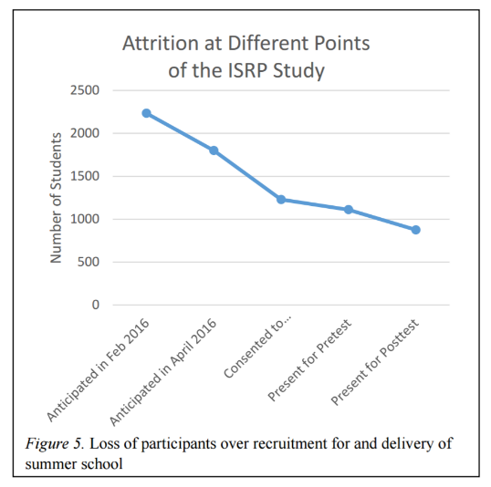
- The IRRC report gives an indication of student attrition: “Of the 149 classes to serve 2,235 students anticipated to be in the study, after adjusting for lack of personnel, internal issues in districts, inability to coordinate transportation across districts forming a consortium, and indicators of low parent interest in summer school, in fact, only 1,229 parents consented for their children to participate and even fewer students (1,111) ultimately showed up for summer school. . . .only 876 student were present for the posttest.” The study reports that total attrition was 51%, and attrition from pretest to post test was 21%. They also suggest that there was no consequence for low attendance in the pilot, so absences and attrition might be different if attending summer school was mandatory.
- Class size challenges were evident in the study. “Any district that had 16 – 18 students who were eligible was required either to accept only the first 15 students whose parents consented to participate or offer two classes of 8 to 9 student in order to maintain compliance with Criterion 4. Given the poor attendance experienced, the latter option might have had classes that dwindled down to two or three students, with the district still responsible for hiring two teachers and maintaining two classrooms.” The study also reported challenges with cooperation between districts.
Reading Interventions/Summer Schools: RSAI supports local district authority to determine if supplemental interventions during the school year, in addition to the regular program, would be more beneficial to non-proficient third-grade readers, if the district determines barriers will prevent offering a quality summer school program.

