These updates are posted on the RSAI legislative web page at http://www.rsaia.org/legislative.html.
The following provides analysis of this week’s statehouse action, primarily status of school funding, appropriations bill status, and what remains on the table. Thanks for all you do to advocate for Iowa’s children! margaret.buckton@isfis.net

Three RSAI priority issues for conversations, in addition to adequate funding which ought to be in every conversation:
- PPEL flexibility for bus repair: Thanks to all House and Senate members who unanimously supported this bill, and thanks to the Governor for signing it! PPEL Flexibility was a priority issue for RSAI’s legislative platform in the 2015 Session. Thanks to all who came to Capitol and advocated from home to get this done!
- Dropout prevention flexibility: RSAI supports the DE proposal to blend uses of at-risk and dropout prevention funding, so we can locally determine how best to serve at-risk students. Flexibility language is included in both the House and Senate versions of the Education Appropriations bill, indicating smooth sailing to the Governor’s desk on this issue.
- Extend the state penny sunset: SF 477 was approved by the full Senate, 37:13. RSAI supports full repeal of the sunset but clearly supports the extension to Dec. 31, 2049 proposed in this bi-partisan bill, still assigned to the House Ways and Means Committee.
- Transportation equity: the education appropriations bill includes language requesting an interim committee to study student equity, including but not limited to transportation. Keep talking to legislators about the need to address this disparity of expenditures per pupil in the coming year.

Governor’s Signature
HF 646 PPEL Flexibility: this bill allows transportation repair costs in excess of $2,500 to be paid from PPEL. Defines “repair” as restoring to its original conditions, as near as may be, after gradual obsolescence or physical and functional depreciation due to wear and tear, corrosion and decay or partial destruction, and includes maintenance of an item of equipment. Although DE will likely provide guidance, looks like the $2,500 limit applies to one bus. RSAI supported this bill as one of the association’s legislative priorities. Signed by the Governor May 16, 2015.
School Funding: Still working on consensus
SF 171 & SF 172 State Cost Per Pupil: The conference committee has not reconvened, but there are reports of continued leadership conversations. Several reports of a deal continue to discuss various levels of agreement for the 1.25%, or $80 per pupil in the formula, plus an additional one-time payment of an estimated $55 million to reach an equivalent amount of funds at the Senate’s 2.625% level. Many unknown assumptions may impact what this funding level looks like for each district. Stay tuned for more information as we find out. The Governor is still pushing for two-years of school aid. Additionally, from the Thursday, May 21, IALNS newsletter,
“The decision by House Republicans to reduce education spending in the 2016-2017 school year, down from 2.45% to 2% (HF 664 EDUCATION FUNDING 16 and HF 665 CATEGORICAL GROWTH 16) is unlikely to help the chambers reach a resolution. The Senate has rejected the proposal. Senator Jochum said that 2% is “inadequate” and that Senate Democrats will wait for the next session to set education funding, rather than agree to the new House number. By law, legislators should have set the education funding rate at the start of the session.”
RSAI testified at the Subcommittee meeting, May 20, that 2% increase for FY 2017 was inadequate, that the economy looks to be in good condition, that student need, both in terms of poverty and growth in non-English speaking students, is increasing, and that low allowable growth contributes to increased property taxes for both budget guarantee and increasing special education deficits. Margaret also shared a scatterplot of school districts in Green Hills AEA (SW Iowa) which compared district enrollment to the percent of unspent authorized budget (spending authority) at the end of FY 2011 and FY 2014, showing the impact of low per pupil increases on all schools, but especially rural schools. RSAI is registered opposed to both HF 664 and HF 665. See coverage of the subcommittee conversation reported in the Quad City Times here.
SF 510 Standing Appropriations was amended and approved by the House, Wednesday, May 20. The House amendment makes the following changes impacting public education:
- Strikes the Senate’s per pupil increase of 2.625% for FY 2016 and 4.0% for FY 2017
- Cuts the AEAs by $15 million (maintains the current level of deappropriation to the AEAs.)
- Includes new language regarding school district exercise of powers, akin to Home Rule, that states that a school board shall operate, control and supervise all public schools located within its district boundaries and may exercise any broad and implied power, not inconsistent with the laws of the general assembly, related to the operation, control and supervision of those public schools. The bill states that this flexibility does not apply to the power to levy any tax except those expressly authorized by the general assembly.
- Extends the repeal of the online learning academies (CAM-Anita and Clayton Ridge to which students may open enroll for an online learning curriculum, but does not alter the enrollment limitations in current law, other than allowing additional open enrollment if the resident district agrees the program is best for the student or there are siblings.)
- Requires written parental consent kept in the Principal’s file for students to attend a conference dealing with human growth and development if the district encourages attendance (during debate, the conversation lead to the Governor’s annual LGTB conference.) Also requires parental consent for students to participate in human growth and development curriculum at school, rather than the current opt out process. Also requires the principal to inform parents how to review the materials for any courses or from such a conference pertaining to human growth and development.
- Changes the timing of enacting school aid at the legislature, requiring that in Sessions occurring in the odd-numbered year, the upcoming July 1 cost per pupil be established within 30 days of the submission of the Governor’s budget and that the cost per pupil for the following year be established before adjournment of the Session.
- Limits the per-pupil supplements for teacher leadership and compensation for districts in their second and subsequent years of TLC implementation to $308.82 per pupil for years beginning July 1, 2015 and July 1, 2016.
- Requires elected officials to post contact information on a government web site.
Additionally, amendments to provide spending authority for the difference between a district’s cost per pupil and the maximum district cost per pupil in the state, one for three years without cash reserve levy limitations, by Rep. Winckler, and another for a one-year time period with the requirement that the FY 2015 cash reserve levy not be increased in order to fund the authority, by Rep. Paustian, were ruled not-germane and withdrawn respectively.
HF 658 Education Appropriations: No official action this week. The bill has been sent to conference committee to work out agreement on both policy and levels of funding. In short, this bill primarily funds regents institutions and community colleges, but includes many line-item appropriations impacting PK-12: TLC grants $50 million for districts participating in their first year, mentoring and induction funding, early literacy, High Needs Schools grants, LEP for PK students, extends LEP service to 7 years of state funding for all students, At-risk and DoP flexibility, PK flexibility, Interim Committee on student equity including but not limited to Transportation, are among the issues we are watching. See the May 1 weekly update for specific details about the differences between the House and Senate versions. The NOBA detail provided to the conference committee members with the House and Senate comparison is found here.
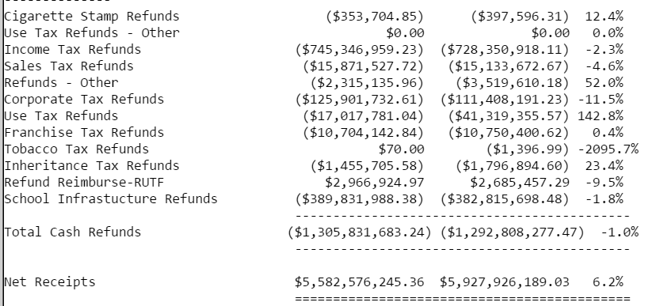
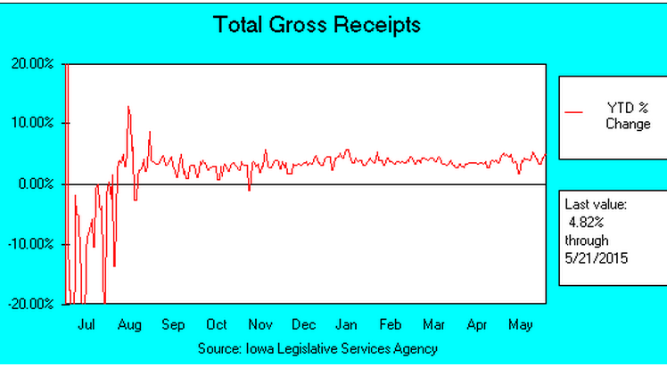
State Revenue Report: Gross receipts are 4.82% above this time last year. Due to both revenue growth and lower cash refunds, net receipts are growing at 6.2%, or $345 million year-to-date through May 21, 2015. Status is found on the Legislature’s Daily Receipts page. Have a great weekend! We will report further action when it happens. In the meantime, keep advocating for the students in your schools! RSAI Professional Advocate, Margaret.buckton@isfis.net 515.201.3755
RSAI Leadership Group
Brad Breon, Moravia/Seymour, Superintendent, brad.breon@rsaia.org
Gregg Cruickshank, Sidney/South Page, Superintendent, gregg.cruickshank@rsaia.org
Joel Davis, Coon-Rapids-Bayard, Board Member, joel.davis@rsaia.org
Kevin Fiene, I-35, Superintendent, kevin.fiene@rsaia.org
Lee Ann Grimley, Springville, Board President, leeann.grimley@rsaia.org
Robert Olson, Clarion-Goldfield/Dows, Superintendent, robert.olson@rsaia.org
Brian Rodenberg, Midland, Superintendent, brian.rodenberg@rsaia.org

