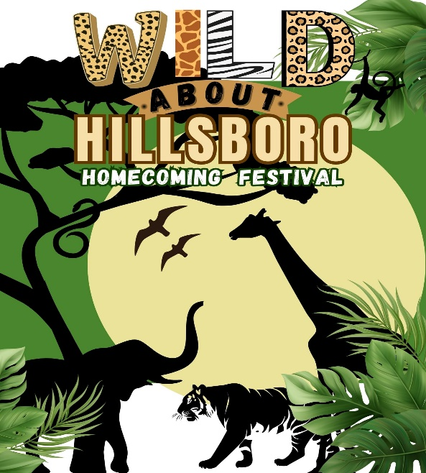
The Greater Hillsboro
Chamber of Commerce
Hillsboro Homecoming & Festival
“Wild About Hillsboro”
May 16th & 17th Hillsboro Homecoming & Festival
May 15th Hillsboro Chamber Golf Tournament

Dear Chamber Member & Supporter:
The Hillsboro Homecoming and Festival Committee is excited to announce we are hosting the Annual Hillsboro Homecoming and Festival on May 16th & 17th. We will kick off the weekend on Thursday, May 15th with the Annual Golf Tournament which will be held at Raintree Country Club. This year our theme will be “Wild About Hillsboro”. We will be turning downtown Hillsboro into a Wild Safari Party! This will be the perfect them for our annual parade! A partial list of the tried-and-true activities are listed below which will take place on Main Street and the surrounding area.

- Dear Darla band on Friday evening
- Main stage bands on Saturday including Modern Yesterday Duo & The Johnathan Braddy Band!.
- Carnival (Friday evening and all-day Saturday)
- Car Show, Parade, Armed Forces Ceremony, Cornhole and much more (Saturday)
- Numerous vendors, including food, crafts and businesses.
- Beer sales provided by the Hillsboro Community Civic Club

Since there is no admission charge, the Chamber is again asking for your help in underwriting the involved expenses. We will have Sponsor Sheets (listing the names of the Festival Benefactors) and event programs posted on attractive A-frame signs at several prominent locations on the grounds. We will offer great advertising opportunities for our members and to help promote the festival. This year we will again focus on Online Social Media Advertising through paid ads on Facebook and using our community following on our Chamber Facebook page. We will also utilize our website www.hillsborochamberofcommerce.com for advertising of the festival and highlight our sponsors for the event!

It truly takes the community to put on a great festival. Please consider volunteering time to help with the festival. Volunteers are needed to help with clean up and running of events on the main stage and other areas and just overall supervision and presence of chamber members. The more volunteers we have the less work for all chamber members. Contributing four hours of time during the festival will be greatly appreciated. If you are interested in volunteering, please complete the attached form.

We hope we can count on you to be as generous this year as you have been in the past. Now more than ever we need your support! This is the largest fundraiser of the year for the chamber and helps ensure that we can continue our efforts to support the community and promote businesses in the greater Hillsboro area. If you can lend a hand with a monetary donation and/or physical labor during setup and cleanup, everyone on the Chamber's Executive Board, the Festival Committee, and all of the attendees will appreciate it. We look forward to seeing you during the festival!

Sincerely,

Mandy Alley, Marketing Coordinator & Festival Co-Chair
Jan Buttner, Chamber Vice President & Festival Co-Chair

SPONSORSHIPS

Help support the Hillsboro Homecoming & Festival by joining us as an event sponsor!

Gold Level - $550
- Company Name and Larger Color logo and recognized as a GOLD sponsor in all featured festival Advertising.
- Recognized as a Gold Level Sponsor on the back of all festival t-shirts and on festival supporter banner listed on the main stage. Larger Print
- Banner (Provided by Sponsor) displayed on main stage during the festival weekend events.**
- Listed on website as a Gold Level Sponsor for the Festival.
- Online Social Media advertising as GOLD sponsor

Silver Level - $350
- Company Name and Smaller size logo and recognized as a SILVER sponsor in all featured festival advertising.
- Recognized as a Silver Level Festival Sponsor on the back of all festival t-shirts and on festival supporter signs at the event. Medium Print.
- Banner (Provided by Sponsor) displayed on festival grounds during the festival weekend events**
- Listed on website as a Silver Level Sponsor for the Festival
- Online Social Media advertising

Bronze Level - $100
- Company name listed as a sponsor in all featured festival advertising.
- Listed under Bronze Level Sponsorship on the back of all festival t-shirts and on festival supporter signs. Smaller Print
- Listed on website as a Bronze Sponsor for the Festival
- Online Social Media advertising

Friends of the Festival- $50
- Listed as a Friend of the Festival in all featured festival advertising.
- Listed as Friends of the Festival on the back of all festival t-shirts and on festival supporter signs listed on the main stage.
- Listed on website as a Friend of the Festival Sponsor for the Festival
- Online Social Media advertising

I would like to contribute__________________ in kind donation or $________________
- Listed as a festival donor on the back of all festival t-shirts and on festival supporter signs listed on festival grounds.

NOTE: **Banners are to be supplied by the advertiser and should be in the Festival Committee’s possession at least one week before the event. Banners should not be larger than 5ft x 3ft. in order to fit all sponsors banners on the main stage. We ask that your banner have grommets to properly hang from the backdrop of the stage.

I would like to help the chamber as a: Sponsor Volunteer Both

Organization/Business Name:
Contact Name: Contact Phone Number: ( ) ______
Name of donor (as you would like it to appear in advertising):
Address:
City: State: Zip:
Email:_______________________________________________________________________________

Authorized Signature:

Amount enclosed: $

If you choose to volunteer a committee member will be in touch to give you more details before the festival.

Friday Set up; 6am-10am

Friday Events; 8pm-Midnight- clean-up.

Saturday Parade; 9:30am-12pm

Saturday Events; 12pm-4pm

Saturday Events; 4pm-8pm

Saturday Events; 8pm-Midnight – clean up

Sunday morning clean up; 8am on Main Street

- Please send your logo to hillsborochamberoffice@gmail.com no later than April 18th.
- Payment is due with this form
Questions? Contact Mandy Alley, Festival Co-Chair- Greater Hillsboro Chamber of Commerce 636-481-6718

The Chamber now offers additional convenient forms of payment with PayPal and Venmo in addition to check or cash
Chamber Venmo link ￼ https://www.venmo.com/u/HillsboroMoChamber
Chamber PayPal link https://www.paypal.com/donate/?hosted_button_id=7PYHKW3VUJD98

Please return the completed form (front & back) by April 18, 2025
All Forms received after April 18, 2025 will not be guaranteed advertising on the
T-shirts or placement in print advertising. Thank you for your support!
Attn: Hillsboro Festival
Greater Hillsboro Chamber of Commerce
PO Box 225
Hillsboro, MO 63050

