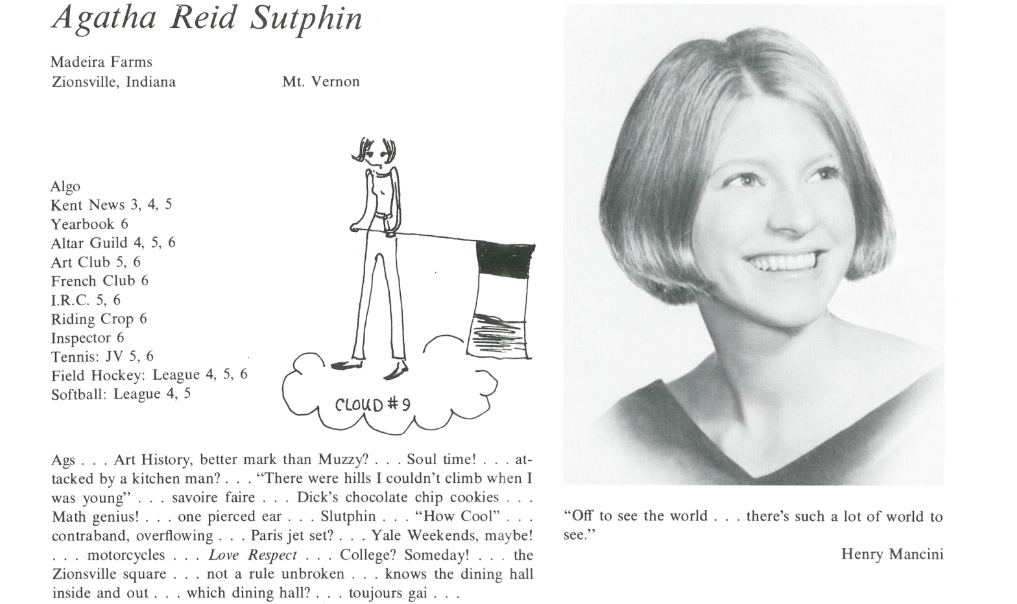

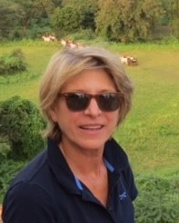Agatha R. Sutphin Barclay

Whoever chose the lines from Moon River, the best movie song in 1962 from Breakfast at Tiffany's, as my yearbook quote, must have known how ready I was to leave Kent and get "off to see the world". Three months after graduation, I was living in Paris.

My passion to see the exotic and remote was fueled by my parents and perhaps James H. Breasted Jr, Kent's distinguished art history teacher. Who can forget his vivid lecture, capturing the moment in 1923 when he witnessed the opening of Tutankhamun's tomb with his father? I vowed to see it for myself, and I have. Unfortunately, Mr. Breasted's requirement that we take notes in italics ruined my already poor penmanship forever.

Since Kent, I have lived in Paris, Boulder and Kenya before settling outside Washington, DC. With my husband, an international consultant, I have circled the globe on motorcycles, camels, horses, bicycles, canoes, boats and calloused feet. His interesting work and our shared curiosity have taken us to more than 50 countries. For the last 25 years my passion for fly-fishing has guided me to rivers and lakes in the American wilderness and to unspoiled beautiful places at home and abroad.

Equally important is my attachment to family and home. After studying landscape design I've developed the gardens around our Potomac farmhouse and have been proud to share them though garden tours, HGTV, newspapers, magazines and in 5 books on American gardens.

Tony, my divine husband of 41 years and I are proud of our two children. Eliza, the science and health editor at [Vox.com](http://Vox.com), lives near us in Washington and Hampton, a real estate developer, and his wife live in Denver. They keep our minds open, and are always ready to hit the road.



______________________________________________________________

______________________________________________________________ ______________________________________________________________ ______________________________________________________________ ______________________________________________________________ ______________________________________________________________ ______________________________________________________________ ______________________________________________________________ ______________________________________________________________

Attach Picture in .jpg Format

______________________________________________________________

______________________________________________________________

___________________________________________________________________________________ _________________________________________________________________________________________________________________________________________________________________________________________________________________________________________________________________________________________________________________________________________________________________________________________________________________________________________________________________________________________________________________________________________________________________________________________________________________________________________________________________________________________________________________________________________________________________________________________________________________________________________________________________________________________________________________________________________________________________________________________________________________________________________________________________________________________________________________________________________________________________________________________________________________________________________________________________________________________________________________________________________________________________________________________________________________________________________________________________________________________________________________________________________________________________________________________________________________________________________

___________________________________________________________________________________