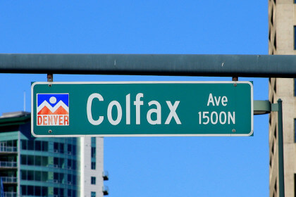

WHAT: Member Meeting and Program

WHEN:
6:00pm – Networking
6:30pm – Short Meeting
6:45pm – Program:

WHERE:

Join Zoom Meeting on Line:
https://us06web.zoom.us/j/82493300693

Meeting ID: 824 9330 0693

Join Zoom Meeting on mobile
+17207072699,,82493300693# US (Denver)

Meeting ID: 824 9330 0693

Find your local number: https://us06web.zoom.us/u/kdZ3ijaZZO

PROGRAM: Catching up with Colfax

Join Mark Blaising on Monday as we explore Colorado's most famous street. The 27 mile concrete river that cuts across the metro area has a rich history and is constantly evolving. Mark Blaising will host an interactive program covering the grand Avenue's past, present and future in a fun and informative format that may alter your perspective of the Fax.

REFRESHMENT: On Your Own

DIRECTIONS: To Join the Meeting click on this link or copy it to your browser: . You may start to join the meeting at 5:50 pm. click on “Join” in the invitation, enter the necessary codes, and wait to be admitted.

PARKING: Your garage, driveway, or curbside.

GUESTS: Members are encouraged to invite potential members as a guest to the meeting.

CONTACT: J. Mark Blaising, Program Chair 303-830-8440 (voice) 303-263-8647 (text)

