Dear Friends,

For the first time in the history of the United States, former U.S. President Barack Obama has taken up residency in Washington, D.C. and has expressed his intent to take down the current President and members of his administration. This is one of the subjects mentioned in this week's World News on the JoyBySurprise.com website.

As many of you know, we expect the United States (Babylon the Great) and the Roman Catholic Church (Mystery Babylon) to be destroyed in one day and one hour by fire at the end of the age.

The "Handwriting on the Wall" that told of the demise of ancient Babylon appeared on the wall on the evening of 10/11/539 BC. Later that same night the army of King Darius the Mede entered Babylon and took the city. Also, that same night King Belshazzar was killed by his own servants. The Handwriting on the Wall event and the demise of ancient Babylon would have been after sunset 10/11/539 BC, which in Hebrew reckoning would have been 10/12/539 BC.

At about 2:00 AM on 10/12/1492 AD, land was sighted by the crew of Christopher Columbus. It would come to be known as America. The New World of America would include 13 original Colonies known as "Columbia". Columbia would later be identified as the Babylon the Great of the Book of Revelation, the world's economic superpower at the end of the age.

Below is a graphic that shows a relationship between the Handwriting on the Wall of ancient Babylon and the discovery of America by Christopher Columbus. Remember that the enigmatic "Handwriting on the Wall" had the number 2520 encoded into it. It is significant that the 2520th year from the fall of ancient Babylon should coincide to the very night with the 490th year from the discovery of America which would become modern Babylon the Great.

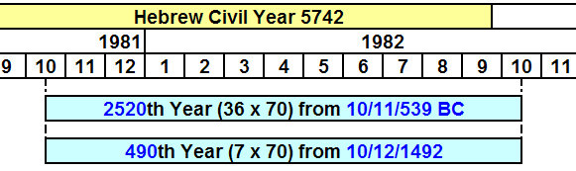
Many consider the completion of the 490 years (70 weeks, or 70 sevens) of the book of Daniel 9:24 to be a signal of the end of the age.

Now let's consider some events of 1981 and 1982.

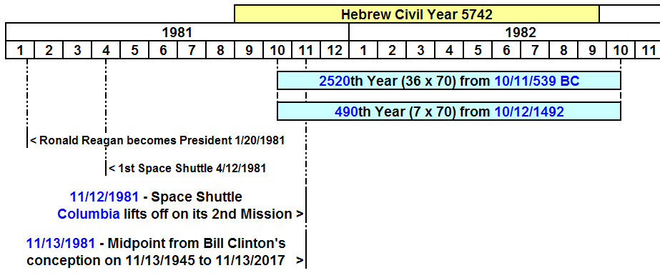

Ronald Reagan was sworn into office as President of the United States on 1/20/1981. It's significant that immediately thereafter 52 American hostages were released by the Iranian government on the 444th day of their captivity. Modern Iran is the land of the ancient Medes and Persians, the very same people, who conquered ancient Babylon on the night of 10/11/539 BC.

Note that the Space Shuttle Columbia, significant of the United States of America and Babylon the Great, was the very first Space Shuttle manufactured.

The very first Space Shuttle launch of Columbia was on 4/12/1981. The 2nd Columbia launch is mentioned because it occurs in the 2520th year from 539 BC and is closely associated timewise with the 11/13/1981 36 year midpoint between Bill Clinton's conception and the coming special date of 11/13/2017. The date 11/12/2017 will be exactly 50 days after the birth of the man child of Revelation chapter 12. These dates have been mentioned in previous articles.

Space Shuttle Columbia is the shuttle that would disintegrate over Palestine, Texas, with Israeli astronaut Ilian Ramon aboard. There is spiritual significance, and warning, in the names involved in the disaster such as Columbia (the USA), Palestine (the Palestinians), Israel (Ilian Ramon), and Texas (President Bush's home state).

The Conception and Birth Dates of Modern Presidents and Vice Presidents

Here is the color key for the following information:

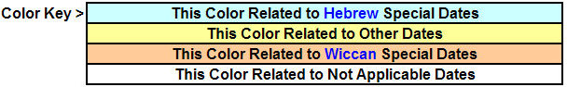

Below is a list of the birth and conception dates of some Presidents. Note that some conceptions were on Hebrew holidays and some on Wiccan holidays.

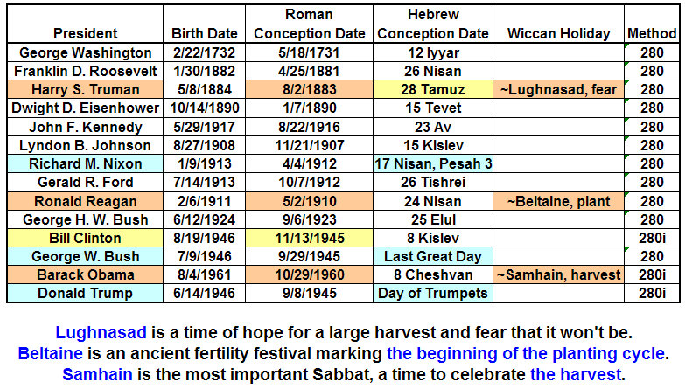
Harry Truman was the President who gave the go ahead for atomic devices to be dropped on Hiroshima and Nagasaki.

Below is a graphic of Vice President's births and conception dates.

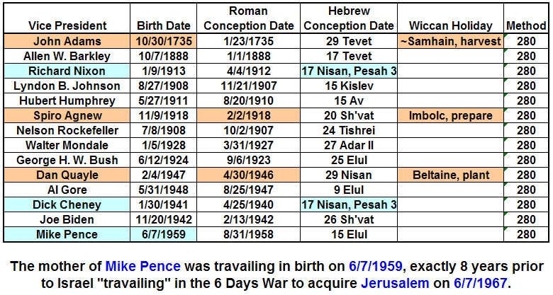

Below is a graphic showing just the last 4 Presidents and Vice Presidents.

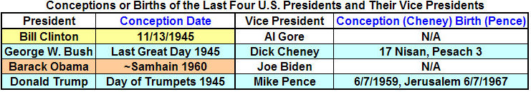

Note that the Presidents and Vice Presidents highlighted in blue in the graphic above have conception date relationships with special days set apart to YaHuWaH Elohim for His purposes. In 30 AD, Nisan 17, Pesach 3, (Conception of Dick Cheney) would have been the Day of the Firstfruits barley wave sheaf offering in Jerusalem and the resurrection day (birth from the tomb) of YAHUSHUA our Messiah.

Be aware that on 2/24/2017 at midnight, Witches gathered outside of Trump Tower in New York City to cast a spell upon Donald Trump. Also be aware that former President Obama's grandparents attended a Wiccan congregation near Seattle, Washington. Obama's stated goal is to destroy Donald Trump's administration, which is the government of the United States.

Only YaHuWaH Elohim can ordain the conceptions and births at the times noted on the graphics above. These are signs given to us at this time in history by our heavenly Father to alert us that this is a special time in our history. These signs are indicative of YaHuWaH 's care for us, and His mighty powers and abilities that are beyond human comprehension. The signs embedded in the conceptions and births of our current elected officials also indicate a battle now occurring between YaHuWaH Elohim and His enemies (signified by the conception date of Barack Obama) and relating to Jerusalem (Mike Pence).

Again, in any event, we expect the United States (Babylon the Great) and the Roman Catholic Church (Mystery Babylon) to be destroyed in one day and in one hour by fire at the end of the age. Babylon will be swept with the besom of destruction Isaiah 14:23. Prepare.

Please visit the JoyBySurprise.com website for instruction regarding repenting of sin, keeping the commandments of YaHuWaH Elohim, and having the faith of YAHUSHUA Messiah.

