January 10 & 11, 2026
Christmas Lessons and Carols
Reflections from Martin Luther
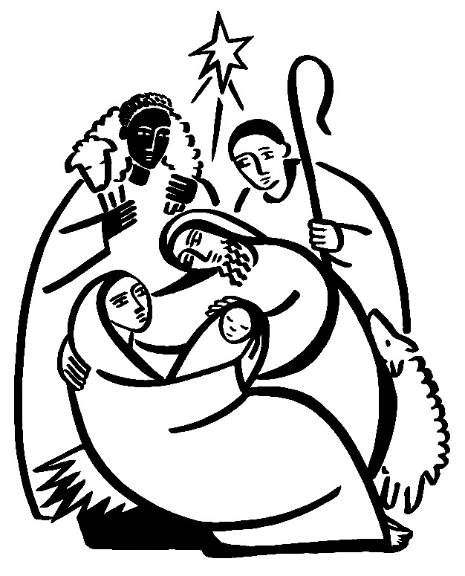
Christ Lutheran Church
“A Place Where You are Always Welcome”
Services: Saturday 5:30 pm and Sunday 10:00 am Sunday School: 9:00 am
600 North Main Street, Stockton, IL 61085 Office: 815-947-2033
Email: christlutheranchurch70@gmail.com http://www.christlutheranstockton.com
Ministers: ALL members of the congregation
Pastor: Rev. Chrissy Salser chrissytherev@att.net 815-988-9450
From Sundays and Seasons.com. Copyright 2017 Augsburg Fortress. All rights reserved. Reprinted by permission under Augsburg Fortress Liturgies Annual License #40643.New Revised Standard Version Bible, copyright 1989, Division of Christian Education of the National Council of the Churches of Christ in the United States of America. Used by permission. All rights reserved. Luther’s reflections are drawn from Martin Luther’s Christmas Book as translated and edited by Roland H. Bainton, Minneapolis: Fortress Press, 2017. Original edition copyright 1948 W. L. Jenkins. Used by permission of Westminster John Knox Press.
WELCOME: Thank you for joining us for worship today. We are glad you are with us. Communion will be served in the aisle or in your pew. All are welcome to share this meal. Jesus is our host and invites everyone. Those who would like to come forward, bread and wine will also be available in the front. When directed by the usher, come forward down the center aisle, Pr Chrissy will give you bread (she will be masked and wearing cloves) and then you will take a cup of wine (grape juice) from the tray. After taking communion, you will return to your seat by the side aisle. For those who are unable to come forward, communion elements can be found as you entered worship. At that part of the service, you are invited to take the bread and wine (or grape juice) when Pr. Chrissy leads. On Saturday’s offering is collected as you enter or leave worship. On Sunday we will pass the plate as a response to God’s grace. Online giving is available. Please see QR code on back of bulletin or visit our website.

Gathering: The Holy Spirit calls us together as the people of God.
PRELUDE
WELCOME AND ANNOUNCEMENTS
DIALOGUE
L: Come! Look upon the baby Jesus, cradled in the arms of his mother.
C: Seeing this wondrous sight, may our hearts be comforted and our spirits filled with peace.
L: Come! Listen to choirs of angels announcing good news to all people.
C: Hearing this marvelous song, may we too sing: Glory to God in the highest!
L: Come! Receive this ancient story in your heart, not as history but as a gift.
C: Opening our hearts to this great mystery, may Christ be born in us today.

GATHERING HYMN: Jesus the Light of the World ACS 914
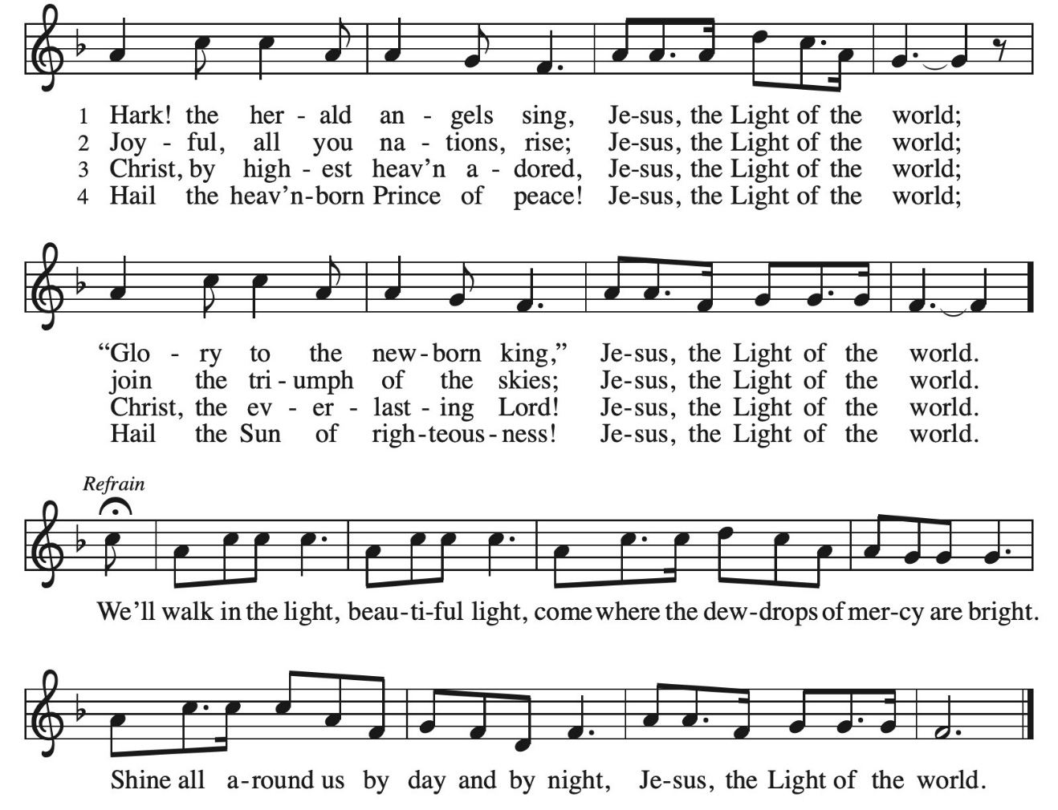
GREETING
L: The grace of our Lord Jesus Christ, the love of God, and the communion of the Holy Spirit be with you all.
C: And also with you.
OPENING PRAYER:
L: The Lord be with you. C. And also with you.
L: Let us pray. O Lord God, C: you know that we cannot place our trust in our own powers. As you protected the infant Jesus, so defend us and all the needy from harm and adversity, through Jesus Christ, our Savior and Lord, who lives and reigns with you and the Holy Spirit, one God, now and forever. Amen.
WORD: God speaks to us in scripture reading, preaching, and song.

CHILDREN SERMON (SUNDAY ONLY) Leisa Hubb

FIRST READING: Luke 2:1-7

A reading from Luke : ¹ In those days a decree went out from Caesar Augustus that all the world should be registered. ² This was the first registration and was taken while Quirinius was governor of Syria. ³ All went to their own towns to be registered. ⁴ Joseph also went from the town of Nazareth in Galilee to Judea, to the city of David called Bethlehem, because he was descended from the house and family of David. ⁵ He went to be registered with Mary, to whom he was engaged and who was expecting a child. ⁶ While they were there, the time came for her to deliver her child. ⁷ And she gave birth to her firstborn son and wrapped him in bands of cloth and laid him in a manger, because there was no place in the guest room.
Word of the Lord. C. Thanks be to God.
Reflection Luther’s reflections on the birth of Jesus
Behold Christ lying in the lap of his young mother. . . . What can be sweeter than the Babe, what more lovely than the mother! . . . Look at the Child, knowing nothing. Yet all that is belongs to him, that your conscience should not fear but take comfort in him. Doubt nothing. Watch him springing in the lap of the maiden. Laugh with him. Look upon this Lord of Peace and your spirit will be at peace. . . . You will see how great is the divine goodness, which seeks above all else that you should not despair. Trust him! Trust him! Here is the Child in whom is salvation. To me there is no greater consolation given to mankind than this, that Christ became man, a child, a babe, playing in the lap and at the breasts of his most gracious mother. Who is there whom this sight would not comfort? Now is overcome the power of sin, death, hell, conscience, and guilt, if you come to judge this gurgling Babe and believe that he is come, not to judge you, but to save. (Martin Luther’s Christmas Book, p. 33)
Infant Holy, Infant Lowly ELW 276
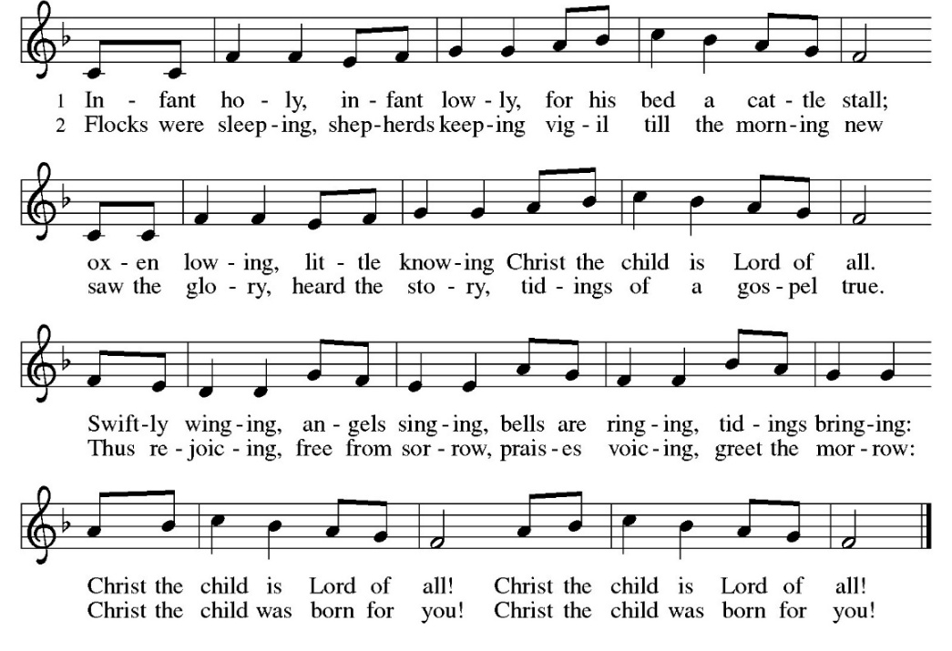
SECOND READING: Luke 2:8-16
⁸ Now in that same region there were shepherds living in the fields, keeping watch over their flock by night. ⁹ Then an angel of the Lord stood before them, and the glory of the Lord shone around them, and they were terrified. ¹⁰ But the angel said to them, “Do not be afraid, for see, I am bringing you good news of great joy for all the people: ¹¹ to you is born this day in the city of David a Savior, who is the Messiah, the Lord. ¹² This will be a sign for you: you will find a child wrapped in bands of cloth and lying in a manger.” ¹³ And suddenly there was with the angel a multitude of the heavenly host, praising God and saying, ¹⁴ “Glory to God in the highest heaven, and on earth peace among those whom he favors!”
¹⁵ When the angels had left them and gone into heaven, the shepherds said to one another, “Let us go now to Bethlehem and see this thing that has taken place, which the Lord has made known to us.” ¹⁶ So they went with haste and found Mary and Joseph and the child lying in the manger.
The word of the Lord C. Thanks be to God.
Reflection Luther’s reflections on the shepherds and angels
Look at the shepherds. They were watching their flocks by night, and an angel came and made them apostles, prophets, and children of God. . . . This is a great miracle that the shepherds should have believed this message. They might easily have thought to themselves, “Are we two shepherds worthy that the whole host of heaven should be marshaled for us and all the kings on the earth and the dwellers in Jerusalem be passed by?” I know I would have appealed to common sense and I would have said: “Who am I compared to God and angels and kings? It is an apparition.” But the Holy Spirit, who preached through the angels, caused the shepherds to believe. They were so strong in the faith that they were worthy to be spoken to by angels and to hear every angel in heaven singing a cantata just for them. This is a pure wonder that enters not into the heart of man. Our God begins with angels and ends with shepherds. Why does he do such preposterous things? He puts a Babe in a crib. Our common sense revolts and says, “Could not God have saved the world some other way?” (Martin Luther’s Christmas Book, pp. 36, 40)
Go Tell it on a Mountain ELW #290
Refrain: Go! {clap} tell it on the mountain, over the hills and ev’rywhere;
Go! {clap} tell it on the mountain that Jesus Christ is born!
While shepherds kept their watching o’er silent flocks by night,
behold, throughout the heavens there shone a holy light. Refrain
The shepherds feared and trembled when, lo, above the earth
rang out the angel chorus that hailed our Savior’s birth. Refrain
Down in a lonely manger the humble Christ was born;
and God sent us salvation that blessed Christmas morn. Refrain

THIRD READING: Matthew 2:1-12
A Reading from Matthew: ¹ In the time of King Herod, after Jesus was born in Bethlehem of Judea, magi from the east came to Jerusalem, ² asking, “Where is the child who has been born king of the Jews? For we observed his star in the east and have come to pay him homage.” ³ When King Herod heard this, he was frightened, and all Jerusalem with him, ⁴ and calling together all the chief priests and scribes of the people, he inquired of them where the Messiah was to be born. ⁵ They told him, “In Bethlehem of Judea, for so it has been written by the prophet: ⁶ ‘And you, Bethlehem, in the land of Judah, are by no means least among the rulers of Judah, for from you shall come a ruler who is to shepherd my people Israel.’ ”
⁷ Then Herod secretly called for the magi and learned from them the exact time when the star had appeared. ⁸ Then he sent them to Bethlehem, saying, “Go and search diligently for the child, and when you have found him, bring me word so that I may also go and pay him homage.” ⁹ When they had heard the king, they set out, and there, ahead of them, went the star that they had seen in the east, until it stopped over the place where the child was. ¹⁰ When they saw that the star had stopped, they were overwhelmed with joy. ¹¹ On entering the house, they saw the child with Mary his mother, and they knelt down and paid him homage. Then, opening their treasure chests, they offered him gifts of gold, frankincense, and myrrh. ¹² And having been warned in a dream not to return to Herod, they left for their own country by another road.
Word of the Lord. C. Thanks be to God.
Reflection Luther’s reflections on Herod and the wise men
When the Wise Men received the divine revelation that the king of the Jews was born, they made straight for Jerusalem, for, of course, they expected to find him at the capital in a lordly castle and a golden chamber. Where else would common sense expect to find a king? But because they were so sure of themselves, the star left them.
Then they were sorely tried, and had they relied solely on human wisdom, would surely have said: “Confound it! We have come all this way for nothing. The star has deceived us. The devil has led us by an apparition. If a king had been born, would he not be in the capital and in a palace? But when we come, the star disappears and we find no one who knows anything about him. Can it be that we foreigners should be the first to have news of him in the royal city? Everyone is so cold and unfriendly that no one offers to go with us and show us the child. They do not believe themselves that to them a king is born, and shall we come and find him? How desolate for the birth of a king! If a puppy were born there would be some little stir, and here a king is supposed to be born and everything is so still. . . . Should not the people be singing, capering, lighting lamps and torches, bedecking the streets with roses and mayflowers? What a miserable king we are seeking! What fools we have been to let ourselves start on this quest!” Nature wants to feel and be certain before believing, but grace will believe before she feels. Faith steps gaily into the darkness, trusting simply in the Word.
But having come, they decided to inquire of the king before returning. At their report, Herod the king “was troubled, and all Jerusalem with him.” Why was Herod terrified and all Jerusalem with him? He had good reason to be afraid because he had tyrannized over the Jews for thirty years. . . . Now Herod had a crafty plan. “The Jews,” thought he, “will hide the truth from me, but I will find out the town where this king is to be born and also the time, and then if they hide him, I will catch him anyway. I will kill so many babies that he cannot escape.” So he called the scribes to him and said, “Where is Christ to be born?” Then perhaps through fear, the scribes answered him that in the Prophet Micah it is written that He should be born in Bethlehem. (Martin Luther’s Christmas Book, pp. 50-52)

The First Noel ELW #300 Verse 1 & 2
1 The first Noel the angel did say was to certain poor shepherds in fields as they lay; in fields where they lay, keeping their sheep, on a cold winter's night that was so deep.
Refrain Noel, Noel, Noel, Noel! Born is the King of Israel.
2 They looked up and saw a star shining in the east beyond them far; and to the earth it gave great light,
and so it continued both day and night. Refrain

FOURTH READING: John 1:1-5, 14-18
A Reading according to the gospel of John:
¹ In the beginning was the Word, and the Word was with God, and the Word was God. ² He was in the beginning with God. ³ All things came into being through him, and without him not one thing came into being. What has come into being ⁴ in him was life, and the life was the light of all people. ⁵ The light shines in the darkness, and the darkness did not overtake it.
¹⁴ And the Word became flesh and lived among us, and we have seen his glory, the glory as of a father’s only son, full of grace and truth. ¹⁵ (John testified to him and cried out, “This was he of whom I said, ‘He who comes after me ranks ahead of me because he was before me.’ ”) ¹⁶ From his fullness we have all received, grace upon grace. ¹⁷ The law indeed was given through Moses; grace and truth came through Jesus Christ. ¹⁸ No one has ever seen God. It is the only Son, himself God, who is close to the Father’s heart, who has made him known.
Word of the Lord. C. Thanks be to God.
Reflection Luther’s reflections on the Word made flesh
Let us, then, meditate upon the Nativity just as we see it happening in our own babies. I would not have you contemplate the deity of Christ, the majesty of Christ, but rather his flesh. Look upon the baby Jesus. Divinity may terrify man. Inexpressible majesty will crush him.
That is why Christ took on our humanity, save for sin, that he should not terrify us but rather that with love and favor he should console and confirm.
This is the word of the prophet: “Unto us a child is born, unto us a son is given” (Isaiah 9:6). This is for us the hardest point, not so much to believe that He is the son of the Virgin and God himself, as to believe that this Son of God is ours. That is where we wilt. . . . Truly it is marvelous in our eyes that God should place a little child in the lap of a virgin and that all our blessedness should lie in him. And this Child belongs to all mankind. God feeds the whole world through a Babe nursing at Mary’s breast. This must be our daily exercise: to be transformed into Christ, being nourished by this food. Then will the heart be suffused with all joy and will be strong and confident against every assault. (Martin Luther’s Christmas Book, pp. 33, 16)
What Child is this ? ELW #296
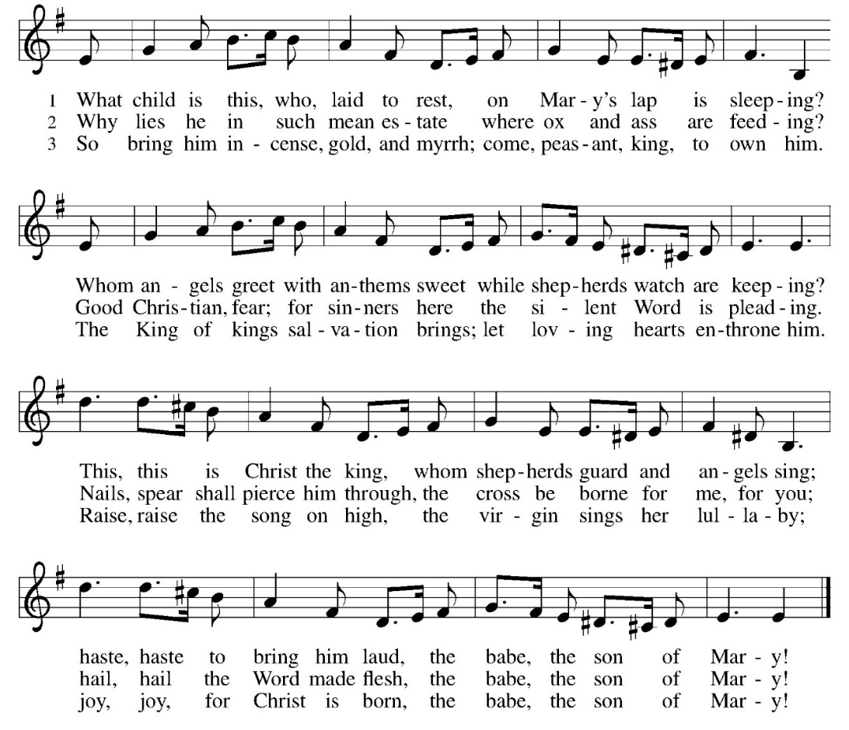

APOSTLES’ CREED:
I believe in God, the Father almighty, creator of heaven and earth.
I believe in Jesus Christ, God’s only Son, our Lord, who was conceived by the Holy Spirit, born of the virgin Mary, suffered under Pontius Pilate, was crucified, died, and was buried; he descended to the dead. On the third day he rose again; he ascended into heaven, he is seated at the right hand of the Father, and he will come to judge the living and the dead.
I believe in the Holy Spirit, the holy catholic church, the communion of saints, the forgiveness of sins, the resurrection of the body, and the life everlasting. Amen.
PRAYERS OF INTERCESSION
P: Merciful God, C: Receive our prayer
PEACE
P: The peace of Christ be with you always. C. And also with you.
OFFERING: Our offering is a significant act of worship; we worship God through our giving. The ministry of this congregation is completely dependent upon your partnership and generosity. Offering is collected as you enter worship on Saturday. We will pass the offering plate on Sundays. Online giving is available.
Offering SONG Love Has Come ELW #292 (next page)
OFFERING PRAYER:
P. Let us pray together: God of abundance,
C. receive and bless these gifts we have offered. Join our hearts with the song of the angels, and gather us at your table of celebration. Strengthen us to share with all the world the abundance of your grace upon grace, poured out in Jesus Christ, the Word made flesh. Amen.

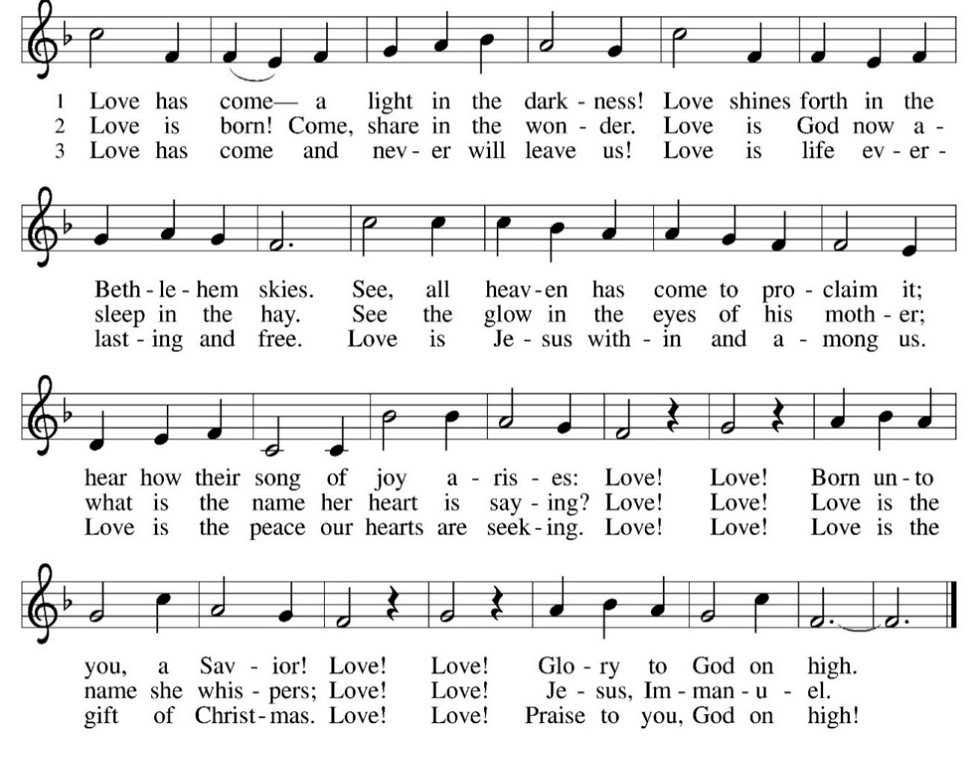
THE LORD’S PRAYER:
Our Father, who art in heaven, hallowed be thy name,
thy kingdom come, thy will be done on earth as it is in heaven.
Give us this day our daily bread; and forgive us our trespasses,
as we forgive those who trespass against us; and lead us not into temptation,
but deliver us from evil. For thine is the kingdom, and the power,
and the glory, forever and ever. Amen
BLESSING:
L: May the Word that Mary brought to birth carry you into new and abundant life.
C: May the Word that Joseph cradled in his arms enfold you with love and strength. May the Word that angels proclaimed in song bring harmony to our world.
L: And the blessing of almighty God, the Father, the ☩ Son, and the Holy Spirit, be upon you and remain with you always.
Amen.
SENDING SONG Good Christian Friends Rejoice ELW #288
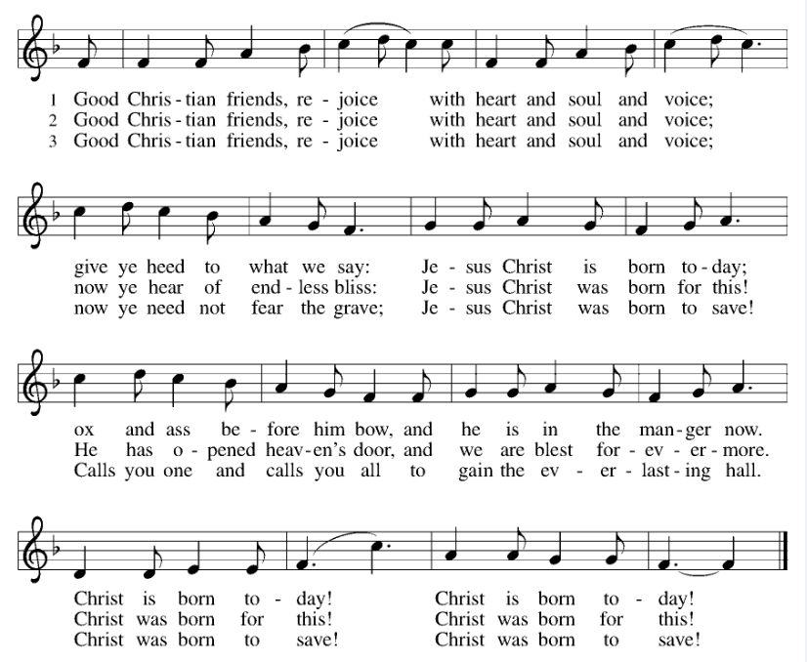DISMISSAL
L: Glory to God in the highest!
C: And peace to God’s people on earth!
L: Go in peace. Share the gift of Jesus. C: Thanks be to God.
POSTLUDE

IN OUR PRAYERS TODAY: Teresa Hesselbacher, Elaine Schlicting, Darlene and Walt Steffes, Bob Schreck, Delores Wampfler, Marge and Gerald Arnold, Don & Judy Brudi, Grayson Raab, Dan Bonnet, James Dieter, Christine Happ, Kay Hesselbacher, Mary Lou Bunker, Lillian Sefford, Judy Wilson, Russ Synder, Don Kunz, Johnny Blair, Jim Sullivan, Sally Duran Salser, Chris Marek, Joe Karr, John Becker and the family and friends of Darrell Lindstrom To add someone to the prayer list please contact Pastor Chrissy
Celebrating birthdays/anniversaries this week: Mary Ellen Gibbs, Lori Ertmer, Tom Jordan, Mark Rice, Wendy Elders
Thanks be to God for your gifts for the ministry of  Christ Lutheran Church *these numbers do not reflect online giving- only offering in worship |  |  |  | Offering/ Attendance  January 3/4
Current Expense | $1232.00 | Building Fund | $10.00 | Jan 3 | 16
Benevolence | $15.00 | Sunday School | $20.00 | Jan 4  Community Table | 34  28
 |  | Missions | $5.00 | SUNDAY SCHOOL | 4

ONLINE GIVING: Your gift has a big impact on our ministries and those we serve. Scan this code or visit our website to give online today.
December Totals: As a way to improve communication around finances, we are sharing the following information:
*these numbers reflect online giving contribution
2025
 | December | Year to date
Offerings: | $13,503 | $120,115
Expenses: | $10,797 | $122,527
Overall Gain / Loss | $2,706 | ($2,412)
ANNOUNCEMENTS
WELCA BIBLE STUDY- This year we will be studying the book “Women of the New Testament” Each month we will encounter and learn about different women of the New Testament. No prep required. Come as you are to explore scripture together. Groups will meet on the second Wednesday at 1 pm, at the church (or Betsy’s house) or the second Thursday at 9 am, at a member’s house or church. All women are welcome to join us for bible study and time of fellowship.
THE COMMUNITY TABLE: The Community Table is an opportunity for outreach to the local community. This is a twice a month meal on the first and third Tuesday of the month at 11:30, here at Christ to gather for food, fellowship and fun, if you are interested in volunteering please talk with Janet Haas or Debbie Goebel. Join us on Tuesday January 20th. All are welcome.
HOW WILL YOU SERVE IN WORSHIP: We need you!!!! to light the candles, read scripture, usher, prepare communion, set up coffee, run Facebook live, help make the space inviting. Sign up in the back of the church on the clip board. Sign up for one service or many. Questions ask Pastor Chrissy or someone on the worship team.

AMAZON WISH LIST: did you know that everyday items used at the church are items you could contribute? Find our list here or on our Facebook page.
BREAKING BREAD TOGETHER: On Saturday, January 17 at 8 am join us as we come together and share a meal together. We will meet at Copper Leaf Cafe. We gather on the Thursday Saturday of the month for a chance of fellowship with others from Christ. We are hoping to bring everyone from both Saturday night and Sunday morning to share in a meal and fellowship together. All are welcome.

CHRISTMAS DAY DINNER: thank you to all who helped make the Christmas day dinner happen. The area churches, businesses and you helped make the day possible. Thank you. Meals served- 74 deliveries and 82 (including volunteers). Thank you for the many hands who set up tables and cleaned them up as well!
Readings for next week: Isaiah 60:1-6; Psalm 72:1-7, 10-14; Ephesians 3:1-12; Matthew 2:1-12
Upcoming Events
- January 10- 5:30 pm Lessons and Carols with no communion
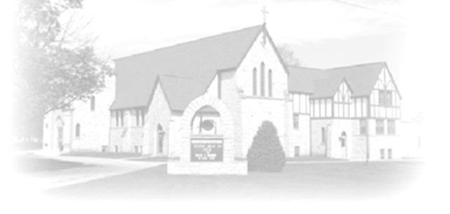
- January 11- 8:30 am Confirmation Class
- January 11- 9 am Sunday School
- January 11- 10 am Lessons and Carols with no communion
- January 11- 2-4 pm June Dittmar’s visitation
- January 12- 9:30 am Dittmar Funeral
- January 14- 9 am Bible study (chapter 14)
- January 14- 1pm Naomi Circle
- January 17- 8 am Breaking Bread
- January 17- 5:30 Epiphany Worship
- January 18- 9 Sunday School
- January 18- 10 am Epiphany Worship
- January 18 - 11 am Annual Congregational Meeting / lunch
- January 18- council meeting to elect officers
- January 20- 11:30 Community table
- January 20- 2 pm Pastor’s text study group
- January 21- 9 am Bible Study
- January 24/25- worship with installation of officers
- January 25- 8:30 Confirmation Class

Thank you Debbie Goebel for preaching and leading worship on this weekend while Pastor Chrissy is off.

