Pleasant Township Board of Trustees Meeting Highlights
Date _November 25, 2025______________ Next Resolution No._ 59—11-25-2025_ _

- Call to Order -Meeting tonight will also be on WebEx. Please stand-Pledge of Allegiance & Roll Call
- Visitors –
- Minutes to approve- No minutes
- Financial Reports – Paula
  - Bills since last meeting totaled $26,076.84
  - Received a donation from Tractor Supply of $250.00
  - Have one firefighter in the process of buying back military time. Found out that the township is not liable for the pension during that period of time.
  - Lowes bill was not received in the bills so there is a late fee.
  - This is from last meeting. Has it been resolved? NO Why does the invoice for Stryker say it starts 8/20/25 thru 8/19/26 we approved with resolution 48 on 10/14/25. That should be corrected before we pay and it was for $10,401.00 did not have the $4,538.36 we were double charged for.
  - MOTION to pay expenditures.
- Department Reports
- Franklin County Sheriff’s Dept-Community Liaison, Deputy Adkins, 1120- Cell: 614-809-5843
- Road Department- Greg Geiger
- Arm mowing finished
- Headstone footers poured
- Graessle Road bermed – Franklin County Engineers office will help get the road back in shape when the bridge is done.
- Young Road edge repair
- P.M. on truck 21
- Equipment repair
- Fire Dept. – Chief Whiting
- Apparatus
  - Boat 231 (reported 10-14-25)
- Personnel
  - Recommend an executive session
- Equipment
  - Received Rit Craft for water and Ice Rescue
- Training
  - EMS Training
- Station
  - Concrete front ramp (ongoing)
  - Waiting on Quote for back door.
  - Bathroom update- $23,000 to turn the men’s restroom into a females with a shower and use the current female restroom for a men’s or unisex. Resolution__59__ hire Magpie Homes to remodel the bathroom at no more than $23,000. Chief also talked to him about a partition in the sleeping quarters for approximately $5,000.
  - Block Repair (In the spring, the building will need to be painted once repaired)
- CRR
  - Smoke Alarms
  - Adoption of the New Fire Code (Board motion) Resolution_60_ to adopt the new State Fire Code.
- Presentation on Buildings-Tom Hale the Director of Building in West Jefferson gave a presentation about inspections, occupancy permits and building codes and violations.
- WebEx has expired and our IT, Grove City IT did not notify us. Chief is working on this.
Has Paula received a copy of Carroll's letter of resignation? no
We need to make room in the meeting room for more file cabinets for Paula
What was the problem with a 5/3 credit card?
- Old Business-
- New Business –
NOW THEREFORE, be it resolved by the Board of Trustees of Pleasant Township, Franklin County, Ohio that the following Resolution_61_ be, and it hereby, is adopted:
1. Township official Ronald McClure of Jackson Township is hereby approved by this Board of Trustees to serve as a member of the Solid Waste Authority of Central Ohio Board of Trustees and represent Franklin County townships for a two-year term.
2. This Resolution shall take effect and be in force from and after the date of enactment.

- Announcements -.
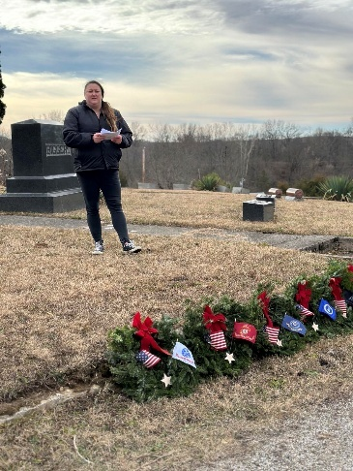
  - Please plan to join us Saturday, December 13, 2025 at noon, Oak Grove Cemetery.
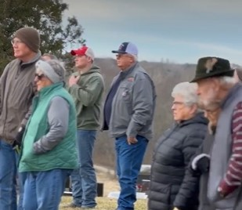

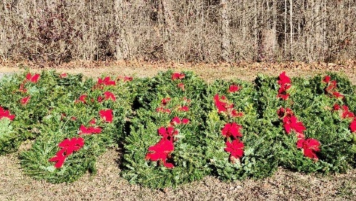

- Clerk Updates- Paula
- Miscellaneous correspondence
- Speaker Sheets- (come to the podium to be heard on WebEx)
- Executive Session- requested by Chief Whiting
“I move to go into Executive Session according to Ohio Revised Code Section 121.22 (G)(_1_) for the purpose of discussing personnel. Do I have a second?” ROLL CALL VOTE
Reconvene
Under the Ohio Revised Code Section 121.22(G), I move to come out of Executive Session, do I have a second? ROLL CALL VOTE
- Adjourn

