2/18/2017 Deep State and the Coming Flood

The news of the last several days has been a bit disturbing. There has been Top Secret information "leaked" to the public media from inside our government. The problem with this is that President Trump and his staff are being manipulated by a member, or members, of a secret United States intelligence agency or agencies. All of the people in these agencies should be subservient to the President and the American people.

The ability of certain hostile people deep within secret departments of our government to control public opinion concerning our President and his advisers speaks of a secret government within our government. If those unknown people can effectively inhibit and affect the actions of our President and his advisory staff, then we have lost at least partial control of our country to who knows who.

General Michael Flynn, who was President Trump's first pick to be his National Security Adviser, had been previously fired by President Obama because Flynn refused to go along with a plan by President Obama to help the Islamic State in Syria. Secret information concerning Flynn was then criminally leaked to the public media while Obama was still President.

This week's World News by Monte Judah looks at the above information. The most important information begins at about 17:25 into the video, but it is helpful to view the previous parts for a more complete understanding. http://www.joybysurprise.com/world-news.html

The above video also mentions the possibility of a coming flood of anarchy, both in the United States and world wide. This is confirmed by signs in the heavens and in the earth which indicate 11/13/2017 to be the beginning of the end. That date has been mentioned in a previous article as being 969 days from the total solar eclipse of 3/20/2015, the 969 days being identified with the 969 years of the life of Methuselah. When Methuselah died the flood of Noah came upon the earth.

Presidential Conception Dates and Chiastic Structure

The date 11/13/2017 had been previously revealed as being significant by YaHuWaH Elohim to at least two researchers that I know of.

This is not an attempt at date setting. This information is just what it is, information. It is what it is.

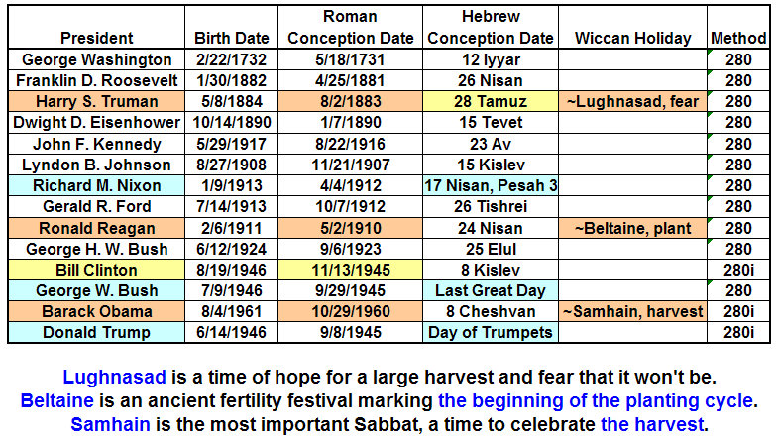
Graphic Above: The Birth and Conception Dates of Recent Presidents

A chiastic structure is a sequence of sentences in a document that are symmetrical and point to a central event or theme. Chiastic structure is used frequently by YaHuWaH Elohim in the bible.

Chiastic structure explained: https://www.youtube.com/watch?v=6YNcueVysHg&t=7s

Because the date 11/13/1945 begins the inverted coherent sequence of conceptions (inverted because the Last Great Day comes before the Day of Trumpets in the graphic above) in 1945 (except for Obama's in 1960, which we will presently ignore), we can look for a Chiasm with a central theme to be revealed as follows:

11/13/1945 - Bill Clinton
Last Great Day 1945 - George W. Bush
Day of Trumpets 1945 - Donald Trump

Emphasized Date -> 11/13/1981 - Hebrew Civil 2nd Month 16th Day, Noah's Flood at Sunset

Day of Trumpets 2017
Last Great Day 2017
11/13/2017

In the chiastic structure above, 11/13/1945 + 36 Years = 11/13/1981 + 36 Years = 11/13/2017

The 36 year periods above relate to the ancient Babylonian Magic Square, modern Mystery Babylon the Great, and the number 666 mentioned in the book of Revelation concerning the end times.

The central emphasized date of 11/13/1981 would have been the 2nd month 16th day in Noah's day. According to the Masoretic Text, the waters of Noah's flood came upon the earth on the 17th day of the 2nd month. 11/13/1981 at sunset was the beginning of the 17th day of the 2nd Hebrew month, and the beginning of the flood in Noah's day.

The conception dates of these recent Presidents form an ordered chiastic sequence that points to the beginning of Noah's flood (11/13/1981), and also to 11/13/2017. According to the bible, only YaHuWaH Elohim determines the conception dates of individuals, not Satan.

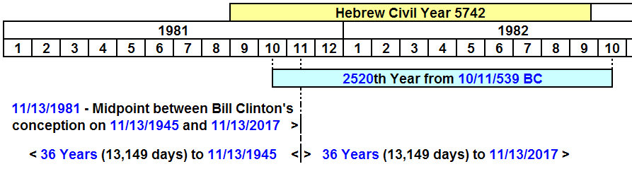

The number 2520 was encoded into the "Handwriting on the Wall" on 10/11/539 BC. The above graphic shows the 2520th year from 10/11/539 BC, and the chiastic structure emphasizing the beginning of Noah's flood. The "Handwriting on the Wall" signaled the fall of ancient Babylon. Noah's flood signaled the end of the ancient world. Both of these combine with other signs to point to 11/13/2017 and a coming end.

As mentioned by Monte Judah in the World News at the video link above, the rising tide of violent mob protests in 2017 may develop into a flood. It's time to think about the safety of our loved ones and be prepared to leave the cities quickly and go into the "Wilderness of the Peoples", the countryside. We need to have a place already prepared ahead of time to go to away from the city. Most important is our spiritual safety, Salvation through YAHUSHUA our Messiah and repentance from sin.

