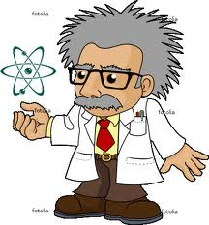
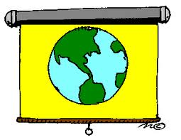
Nonfiction
INFORMATIONAL
www.kbumreading.com


MAIN TOPIC
What is this text
mostly informing
the reader about?

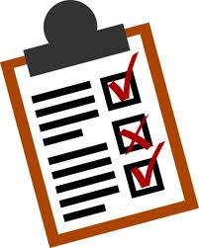
SEQUENCE
Of Information
What is the overall structure of this text? How is information organized?

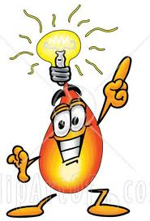
BIG IDEA(S)
Key Details
What is the Central Message?
What are the relevant supporting details?
What are MOST important points made?


KEY ACADEMIC
VOCABULARY
What are the Domain Vocabulary
Words that define the TOPIC?
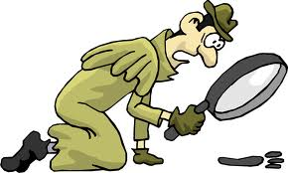
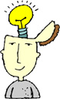
CONCLUSIONS
Lesson taught? /Inferences
What did I infer / conclude?
What are the MOST important points? Reasons? THEMES? Evidence?

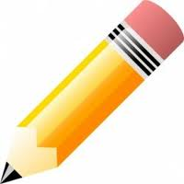
AUTHOR’S
PURPOSE
What is the author’s MAIN purpose(s)?
What does author want to explain/describe?
How are these used: Text features / Word Choice / Pt of View / Tone ?
CONNECTIONS / Prior Knowledge
What connections can you make?
(Text/text; text/self; text/world-big ideas)


COMPARE and CONTRAST
Deeper Understanding…
How do connections help increase overall understanding of this text?
Read and Reread to Check Understanding!

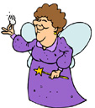

Fiction
LITERATURE
www.kbumreading.com

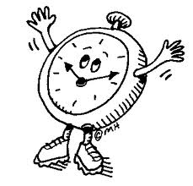
SETTING
Where? What time?
Did the setting change during the STORY? Was the setting important? What was the effect of this setting on the plot?


CHARACTER(s)
Who are the main characters?
What trait describes them?
Their thoughts? Words? Motivations?
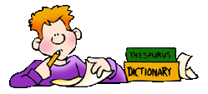
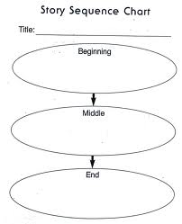
SEQUENCE OF
Major EVENTS
What happened in this story?
KEY DETAILS: First, Then, Next, Conclusion-
What is the overall structure of this story?
How does this affect the overall plot?
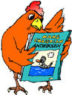
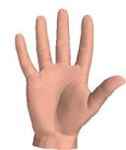
PLOT-Summary
Someone, Wanted,
But, Then, So …
Problem/Action/Solution/Points of view
CONCLUSIONS
Central Message/Predictions
Lesson? Ideas? Moral?
What is the THEME? Give TEXT EVIDENCE.
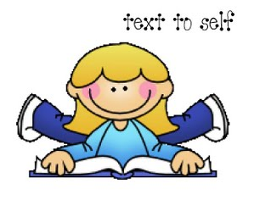
AUTHOR’S
PURPOSE
What is the author’s purpose(s)?
How words/phrases used? Mood? What are the Text features the author used? WORD CHOICE? Point of view?
Give text evidence and explain.
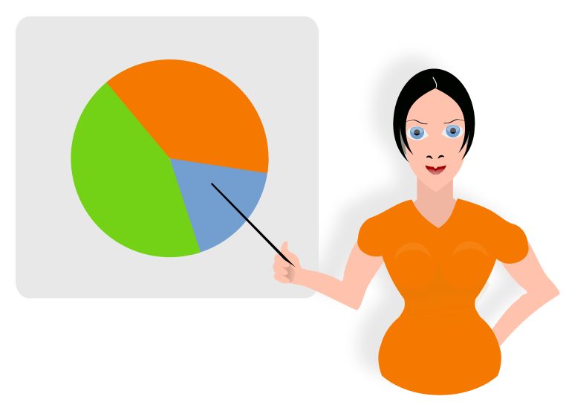
CONNECTIONS / Prior Knowledge
What connections can you make?
(Text/text; text/self; text/world-big ideas)
COMPARE and CONTRAST
Deeper Understanding…
How do connections help increase overall understanding of this literature?
Read and Reread to Check Understanding!

