**HOA Yard-of-the-Month Winner for September**

The September winner was 2110 Mallard Place, on the corner of Mallard Place and Mallard Circle, belonging to Theresa and Richard Pickner. The Pickner’s yard won for having great curb appeal, with incredible flower beds behind a low sandstone wall on left and right sides of the sidewalk to the porch, and healthy, edged grass. The Pickner’s designed the beds to display continuous color from spring to fall and to attract pollinators. In the spring, there were blooming daffodils, tulips, hyacinths, irises, Easter lilies, and lilac bushes. Summer flowers still apparent include yellow black-eyed susans, pink and red roses, a butterfly bush, phlox, plumbago, chrysanthemums, and snapdragons. There are also hostas, two globe spruce, a burning bush, and hops growing by the house. The porch has dual giant hanging flower baskets from the Flower Bin and planters with annuals. Trees in the yard include two blue spruce that started out as “living Christmas trees”, a Douglas fir, and an autumn maple; an ailing English oak was removed last year. On the corner surrounding a pine tree is a smaller bed with rose bushes, peonies, hens and chicks, and tall sunflowers.

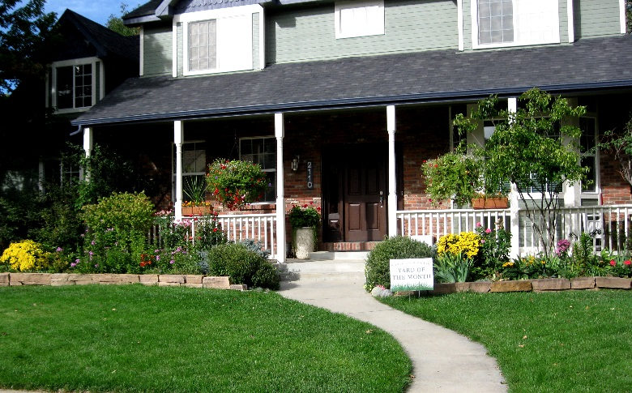

As a reminder, we will recognize the best Halloween-decorated yard in October, and the best holiday-decorated yard in December.

**Neighborhood Oktoberfest Will Begin 4 p.m. September 30 at the Eagleview Circle Island**

This party is family friendly, with snacks and beverages for kids. Clothing (men’s jeans, socks, underwear) will be collected for HOPE, a charity that provides support to those experiencing homelessness in Longmont and promotes self-sufficiency (www.hopeforlongmont.org). Wanted: chili contest and homebrew contest entrants. If you plan to enter or can serve as a beer judge, email the Social Committee ([soc@fachoa.org](mailto:soc@fachoa.org)). We could use a few EZ-Ups, too (and help that day to put them up).