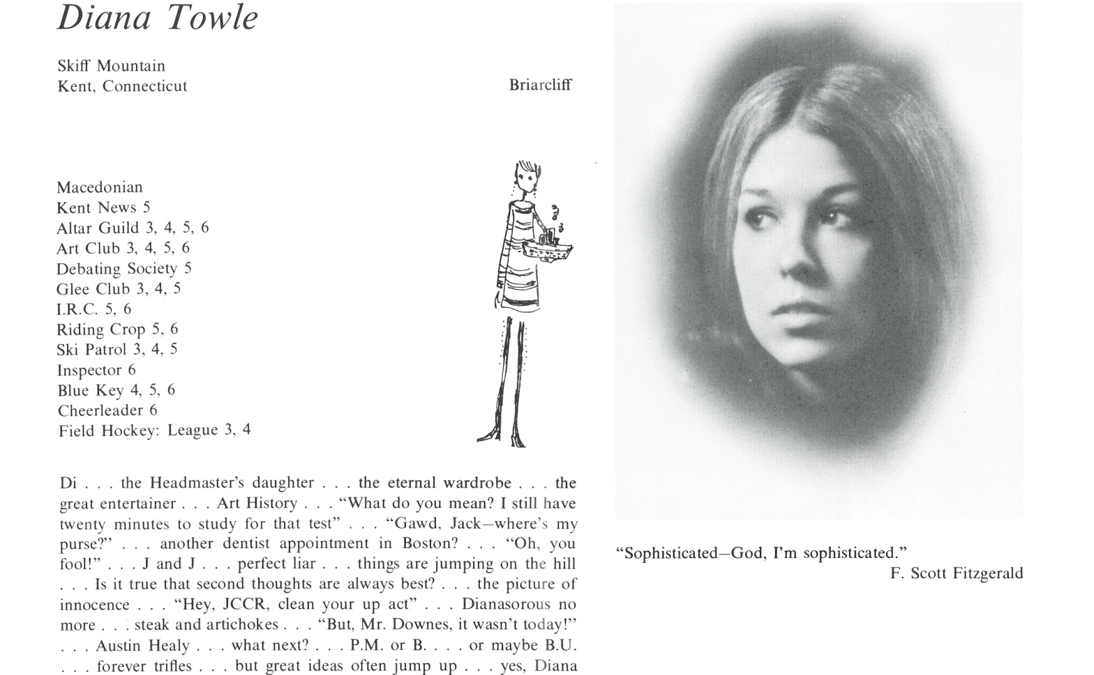

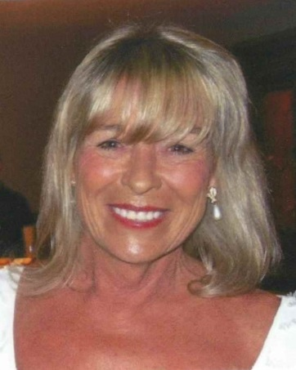Diana Towle Burwell

Although I will not be at the reunion this year, I am pleased to say that my ties with Kent are stronger than ever as I have visited quite often in the past. My son, Max, also graduated from Kent in ’09.

I still have a residence in Aspen … 46 years later! However, my husband and I find ourselves spending more and more time in the desert where we have a home at PGA West and play a lot of golf!

I have had a blessed life and thank Kent for instilling so many solid values for me to follow.

Enjoy yourselves and a couple of you … I will catch up with in the near future.



______________________________________________________________

______________________________________________________________ ______________________________________________________________ ______________________________________________________________ ______________________________________________________________ ______________________________________________________________ ______________________________________________________________ ______________________________________________________________ ______________________________________________________________

Attach Picture in .jpg Format

______________________________________________________________

______________________________________________________________

___________________________________________________________________________________ _________________________________________________________________________________________________________________________________________________________________________________________________________________________________________________________________________________________________________________________________________________________________________________________________________________________________________________________________________________________________________________________________________________________________________________________________________________________________________________________________________________________________________________________________________________________________________________________________________________________________________________________________________________________________________________________________________________________________________________________________________________________________________________________________________________________________________________________________________________________________________________________________________________________________________________________________________________________________________________________________________________________________________________________________________________________________________________________________________________________________________________________________________________________________________________________________________________________________________