REGULAR MEETING

SEPTEMBER 19, 2024

The Regular Meeting of the Town Board of the Town of Hampton, County of Washington and the State of New York was held at the Town Hall, 2629 State Route 22A, Hampton, New York, on the 19th day of September, 2024.

PRESENT: David K. O’Brien------------Supervisor

Donald Sady----------------- Councilman

Tamme Taran----------------Councilwoman

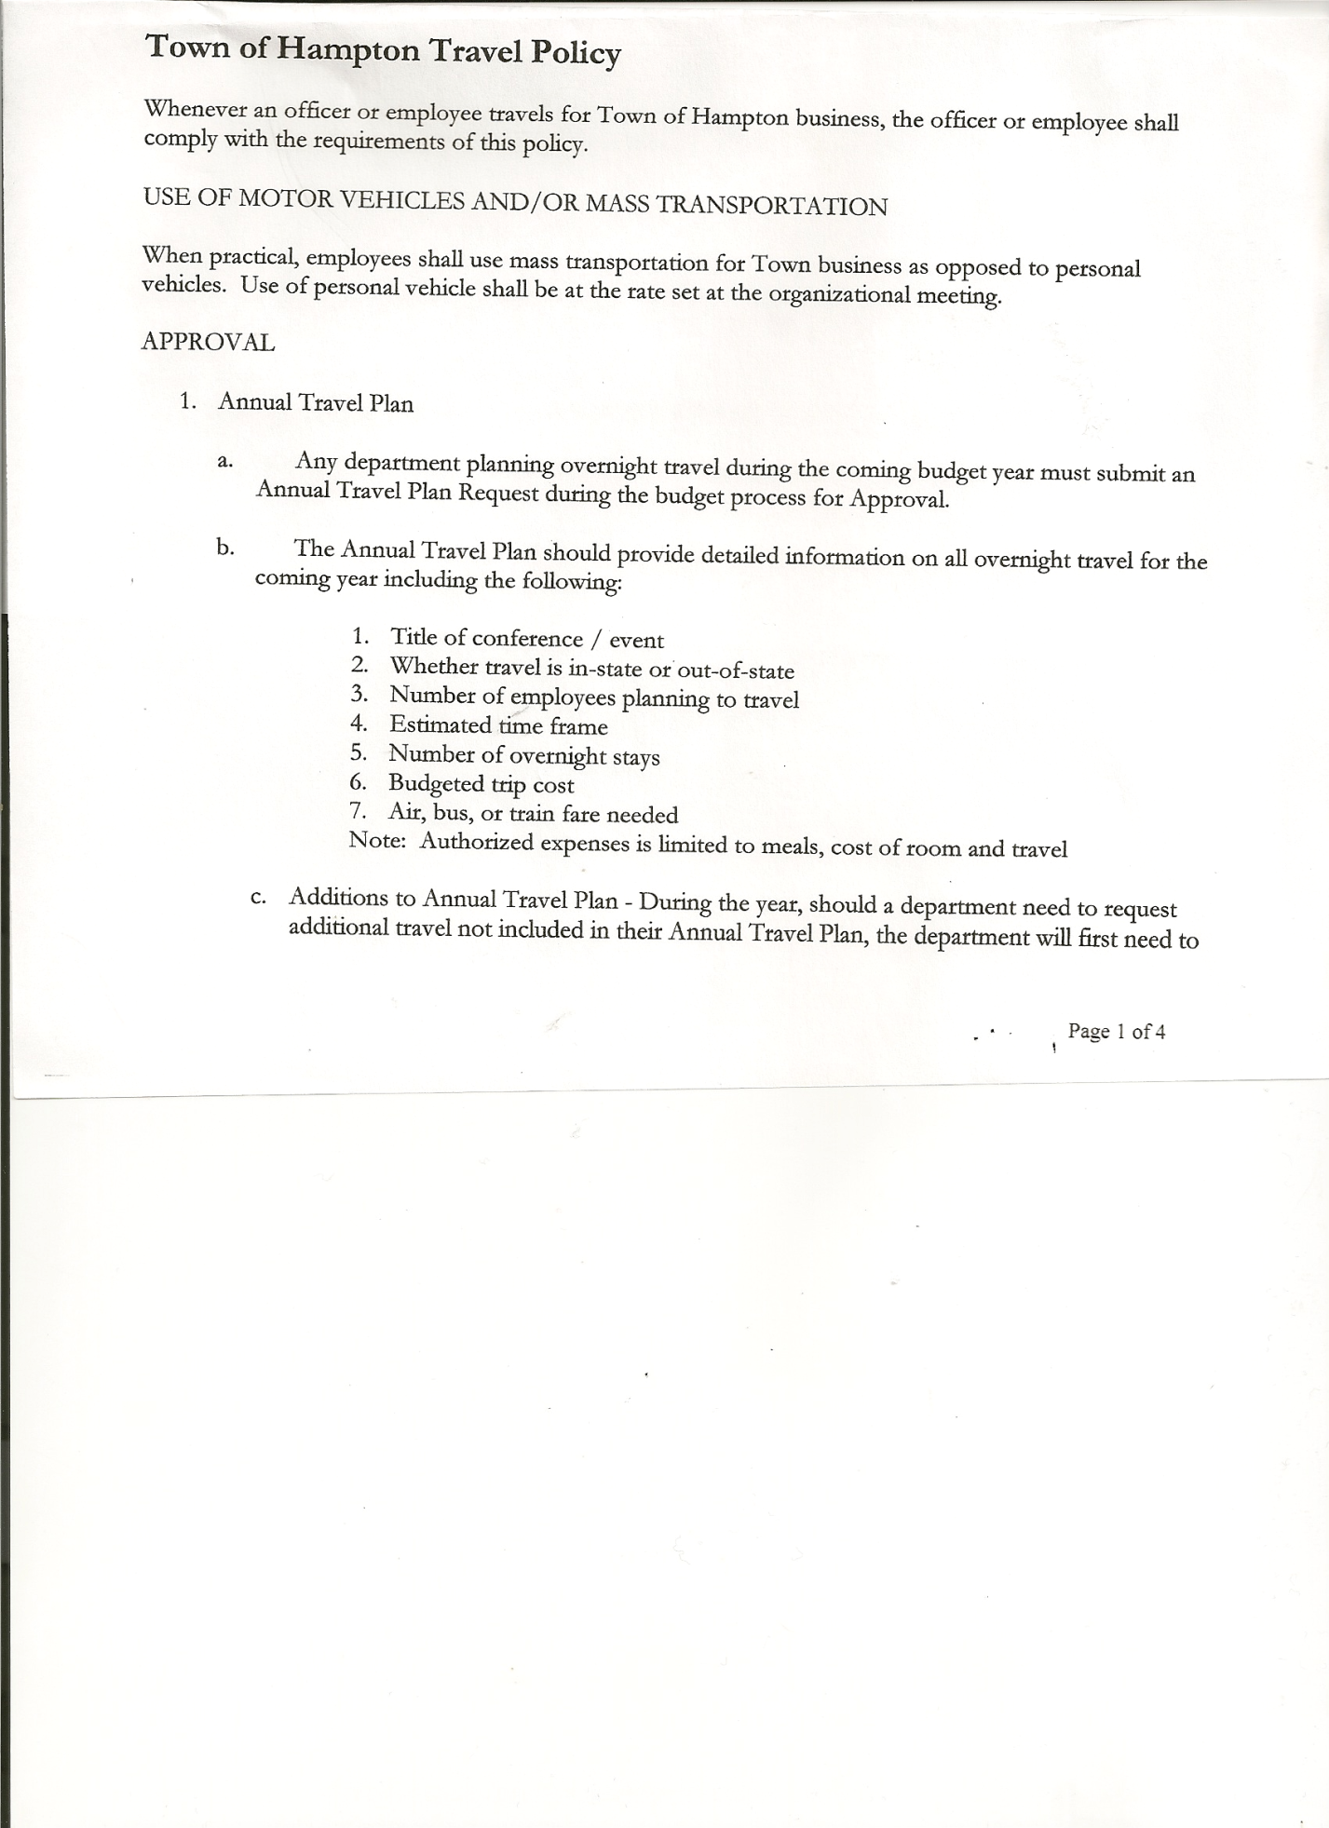 Michael Pietryka------------Councilman

Andrea Kugler---------------Councilwoman - absent

Rebecca Jones---------------Town Clerk

Camilla Shaw----------------Deputy Town Clerk

Tyler McClure---------------Highway Superintendent

Planning Board Member (s):… Bonnie Hawley, Chair; and Matthew Pratt

Others present at the Town Hall: see attached sheet

The Regular Meeting was called to order by Supervisor O’Brien at 7:30pm, followed by the Pledge of Allegiance. Location of Fire Exits were given. Quorum of board members present.

Supervisor O’Brien asked for a moment of silence in memory of Penny Bailey, Gary Parrot and Brian Crossman

**RESOLUTION NO. 80-2024**

**APPROVAL OF THE MINUTES**

On a motion of Councilman Pietryka, seconded by Councilman Sady, the following resolution was ADOPTED: AYES 4 O’Brien, Sady, Pietryka, Taran

NAYS 0

ABSENT 1 Kugler

RESOLVED, that the Regular Town Board Meeting Minutes for August 15h, 2024 are approved.

Dog Control Officer Report….currently working on an issue on County Route 18

Tax Collector Report….Zero balance. The Town Clerk/Collector had Board Members review and sign bank reconciliation statements for the Tax Collector Account dated August 31, 2024.

Bonnie Hawley, Chair Planning Board….Planning Board Meeting was held September 11th, 2024, copy of minutes is attached. Next meeting will be October 9th, 2024 @7:00 at the Town Hall.

Tyler McClure, Highway Superintendent…submitted his report, copy of which is attached.

TOWN BOARD MEETING

SEPTEMBER 19, 2024 PAGE 2

**SUPERVISOR’S REPORT/COUNTY UPDATES/COMMUNICATIONS**

**RESOLUTION NO. 81-2024**

**APPROVAL OF SUPERVISOR’S MONTHLY REPORT**

On a motion of Councilman Sady, seconded by Councilwoman Taran, the following resolution was ADOPTED: AYES 4 O’Brien, Sady, Pietryka, Taran

NAYS 0

ABSENT 1 Kugler

RESOLVED that, the Supervisor’s Monthlyreport be accepted as submitted for **AUGUST**

ACCOUNT 8/01/24 Receipts Disbursed 8/31/24

Citizens Cemetery $ 3,027.80 $ 255.13 $ 0.00 $ 3,282.93

Citizens Total $ 3,027.80 $ 255.13 $ 0.00 $ 3,282.93

GFNB Fire, Trust & Agency $ 1,418.04 $ $ 0.00 $ 1,418.04

GFNB Fire, Trust & Agency ICS $ 33,805.00 $ $ $ 33,805.00

GFNB Health Insurance $ 2,591.23 $ $ $ 2,591.23

GFNB Trust & Agency $ 8,197.35 $ 0.00 $ 4,413.13 $ 3,784.22

GFNB General Fund $ 3,137.31 $ 5,704.64 $ 5,321.77 $ 3,520.18

GFNB General Fund ICS $ 64,675.84 $ 293.59 $ 4,000.00 $ 60,969.43

GFNB Total $113,824.77 $ 5,998.23 $ 13,734.90 $106,088.10

GFNB Highway Fund $ 108,321.22 $ 35,500.00 $ 131,182.84 $ 12,638.38

GFNB Highway Fund ICS $ 105,133.61 $ 363.25 $ 24,000.00 $ 81,496.86

GFNB Capital Reserve $ 1,005.02 $ $ $ 1,005.02

GFNB Capital Reserve ICS $ 151,213.55 $ 677.01 $ $151,890.56

GFNB Total $ 365,673.40 $ 36,540.26 $ 155,182.84 $247,030.82

TOTALS $482,525.97 $ 42,793.62 $ 168,917.74 $356,401.85

All Board Members present signed Supervisor’s Report.

**OLD BUSINESS**

Signs for the cemeteries, stating they are closed from dusk to dawn. Following a discussion, the following resolution was introduced:

**RESOLUTION NO. 82-2024**

**TOWN CEMETERIES-SIGNAGE CLOSED FROM DUSK TO DAWN**

On a motion of Councilwoman Taran, seconded by Councilman Pietryka, the following resolution was ADOPTED: AYES 4 O’Brien, Sady, Pietryka, Taran

NAYS 0

ABSENT 1 Kugler

RESOLVED, to have signs ordered and put up stating that the Town cemeteries are closed from dusk to dawn.

**NEW BUSINESS**

Supervisor O’Brien received notice from Washington County Real Property Tax Services that Alfred Washburn needs to be reappointed to the Board of Assessment Review.

**RESOLUTION NO. 83-2024**

**BOARD OF ASSESSMENT REVIEW MEMBER - REAPPOINTMENT**

On a motion of Councilman Pietryka, seconded by Councilwoman Taran, the following resolution was ADOPTED: AYES 4 O’Brien, Sady, Pietryka, Taran

NAYS 0

ABSENT 1 Kugler

RESOLVED, to reappoint Alfred Washburn to the Board of Assessment Review for the term 10/1/24 to 9/30/29.

TOWN BOARD MEETING

SEPTEMBER 19, 2024 PAGE 3

The Town Board received information from the New York Citizens Audit Group, regarding Elections and Election Laws. The Town Board, after reviewing said information, took no action.

Supervisor O’Brien handed out “Financial Stress Level” sheets that covered years 2021, 2022 and 2023 which were received from the Comptroller’s Office. These sheets are for informational purposes only.

The **TENTATIVE BUDGET FOR 2025** was presented to the Town Board.

**PUBLIC/COUNCIL COMMENTS**

Discussion on a new truck…gave Tyler the go ahead to start looking for one.

Received a bid for 2025 Cemetery Mowing, which included: mowing 5 times @ 675.00, Fall cleanup $100.00 and Spring cleanup $100.00 for the four town cemeteries. Board will discuss at a future meeting.

**RESOLUTION NO. 84-2024**

**AUDIT OF CLAIMS**

On a motion of Councilwoman Taran, seconded by Councilman Pietryka, the following resolution was ADOPTED: AYES 4 O’Brien, Sady, Pietryka, Taran

NAYS 0

ABSENT 1 Kugler

RESOLVED that the bills have been reviewed by the Town Board and are authorized for payment in the following amounts.

General Fund No. 99 through No 107 $ 4,584.92

Highway Fund No.124 through No.140 $ 11,029.01

Total both funds $ 15,613.93

The Town Clerk’s report for August 2024 was submitted to the Board. The Town Clerk had Board Members review and sign bank reconciliation statements for the Town Clerk Account and Special Town Clerk Account dated August 31, 2024.

**RESOLUTION NO. 85-2024**

**MEETING ADJOURNED**

On a motion of Councilwoman Taran, seconded by Councilman Sady the following resolution was ADOPTED: AYES 4 O’Brien, Sady, Pietryka, Taran

NAYS 0

ABSENT 1 Kugler

RESOLVED that the meeting adjourned at 8:44pm.

Respectfully submitted,

Rebecca S. Jones, RMC

Town Clerk