1/30/2018 Implications of the 1/31/2018 Total Lunar Eclipse

A total lunar eclipse will occur overnight tonight in the early morning hours of 1/31/2018 that is related to the lunar tetrad of 2014-2015, the four consecutive total lunar eclipses that fell on the biblical Feast days of Passover - Sukkot (Tabernacles) - Passover - Sukkot.

The lunar eclipse of 1/31/2018 is thrice rare and is a:
1. Super Moon
2. Blue Moon
3. Blood Moon

It will be visible from about 5 AM to 6 AM PST for those on the west coast of the United States. The sun will be rising for those people in the eastern United States when the moon enters the earth's shadow.

The final lunar eclipse of the 2014-2015 lunar tetrad occurred on 9/28/2015. That lunar eclipse was also known as a "Supermoon" because the moon was close to the earth in its orbit, causing it to appear larger in size when the eclipse occurred.

The lunar eclipse of 1/31/2018 will also be a Supermoon, closer to the earth than normal. It will also be known as a "blue moon", the 2nd full moon this month.

Because the lunar eclipse of 1/31/2018 will be the 1st total lunar eclipse since the lunar tetrad of 2014-2015, we can investigate it's relationship with the tetrad.
It happens that the midpoint between the final eclipse of the tetrad on 9/28/2015 and the total lunar eclipse of 1/31/2018 is 11/29/2016.

11/29/2016 was the 69th anniversary of the dividing of the Promised Land by the United Nations on 11/29/1947. Actually, 69 inclusive complete years of days were filled on 11/28/2016, with 11/29/2016 being the very first day of the 70th year from 11/29/1947.

The number 70 is found recurring in the bible and has a symbolic completeness attached to it, 7 x 10, with 7 signifying completeness and 10 signifying perfect completeness.

The 70th year from 11/29/2016 ended on 11/29/2017, during Israel's 70th year as a modern sovereign nation.

The Witness of the Moon

Below is a graphic showing the information presented above.

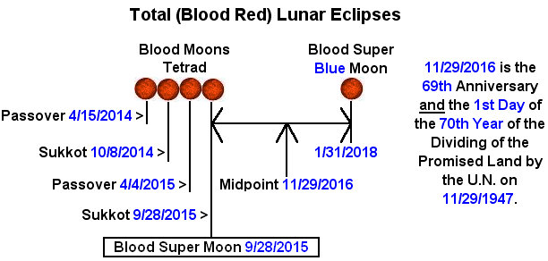

The heavens declare to us the abilities of our Creator Elohim to arrange the workings of the universe to synchronize with the history of the nation of Israel and biblical prophecy.

Psalm 19:1 The heavens declare the glory of Elohim; and the firmament sheweth His handywork.
2 Day unto day uttereth speech, and night unto night sheweth knowledge.
3 There is no speech nor language, where their voice is not heard.

Genesis 1:14 And Elohim said, Let there be lights in the firmament of the heaven to divide the day from the night; and let them be for signs (distinguishing mark, warning), and for seasons, and for days, and years:

For some reason the 1st day of the 70th year from 11/29/1947 was important enough to our Creator Elohim for them to structure the universe to point to that particular day in history.

The Witness of the Sun

But that's not all, YaHuWaH Elohim has given us a second witness as to the importance of the date 11/29/2016 as indicated in the graphic below.

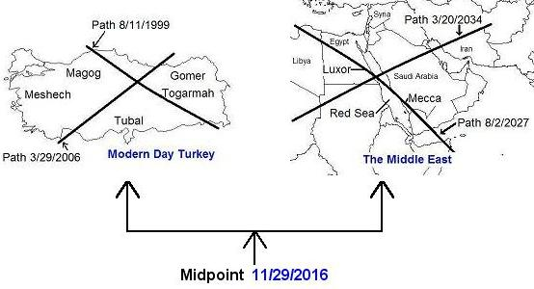

The midpoint date of the solar eclipse sequences shown above is also 11/29/2016, the 69th anniversary, and also the 1st day of the 70th year, of the dividing of the Promised Land by the United Nations.

From the solar eclipse sequences above:

1. 8/11/1999 to 3/20/2034 is 12640 days. 8/11/1999 + 6320 days = 11/29/2016
2. 3/29/2006 to 8 /2/2027 is 7796 days. 3/29/2006 + 3898 days = 11/29/2016

The four solar eclipses noted above place ancient Paleo Hebrew Tavs (end marks) over portions of the earth governed by Islamic authorities.

The path of the total solar eclipse of 8/2/2027 passes directly over the Kaaba, the global hub of Islam in Mecca, Saudi Arabia, revealing the constellation Leo, signifying Israel's Messiah, to those in the path of the total solar eclipse.

Further information on these Tav "X" eclipses can be found here: http://www.joybysurprise.com/the-four-tavs.html

Summary

Our Creator Elohim have given us multiple witnesses from the heavens, two lunar and four solar eclipses, pointing directly to 11/29/2016, the 1st day of the 70th year from the dividing of His Land by the United Nations on 11/29/1947.

This information, and much more, has been placed in the heavens by YaHuWaH Elohim where man can't get to it in order to change it.

The information above testifies to the very existence of our Almighty Creator Elohim and His ability to structure heavenly events in advance (at the time of Creation) in order to coincide with the future actions of earthly governments.

