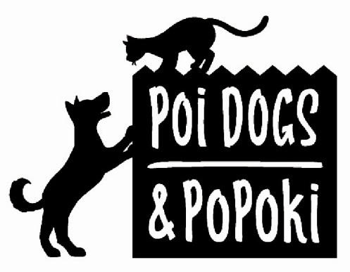

Dog’s Name _____________________________
Description of dog ______________________________
Microchip ID#__________________________
Sex:_______Age:_______
Date:_______________

DOG ADOPTION APPLICATION

Please print clearly and answer all questions.

Applicant's name______________________________________________________________________________________
Local Address_________________________________________________________________________________________
City____________________________________State__________________Zip______________________
Home Phone ____________________Work Phone ________________________ Cell Phone _________________________
Email ________________________________________________________________________________
Occupation (s) of Owner (s) -----__________________________________________________________________________

DESCRIPTION OF RESIDENCE:

Do you Rent?______Own?______ Do you own/rent: House ________ Town Home _________ Condo __________

Property owner's name if renting:_________________________________Phone_______________________
How long have you lived at this addres?________________________ How many years in Hawaii? _________________
#Adults in house_________ Adult’s Ages __________________
#Children_________Children's Ages__________

What pets do you currently have in your household? What are their ages? Are they sterilized?

What pets have you had previously and where are they now? (not including pets of parents)

Where will the dog live? Inside?______outside?______ both? _________
If outside, describe the area(s)?

What happens if you must leave suddenly or if you travel? Who will care for the dog?

What are some situations in which you feel you might surrender this dog?

What will you do if your dog shows destructive behavior? (Digging, chewing, jumping, tearing up plants/furniture or running off)

Dogs often live longer than 10 years. Are you committed to providing a forever home for this dog?______________________

By signing this adoption application,
- I agree that I will NOT surrender or rehome this dog. I will return the dog to PDP.
- I agree that I will NOT crop the ears or dock the tail and if I do, then PDP will pursue civil damages for breach of contract.

_________________________________________ ________________________
Printed Name Date

_________________________________________
Signature

