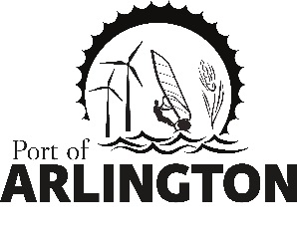
Port of Arlington
Budget Hearing

Port of Arlington
AGENDA
5:00 pm
Tuesday, January 14, 2020
Meeting Location:
Gilliam County Courthouse
Condon, Oregon 97823

THIS MEETING HAS BEEN POSTPONED DUE TO WEATHER. NEW DATE TO BE
DETERMINED.

- Call meeting to order

- Public Comment on non-agenda items

- Consent Agenda:
- Approval of December 10, 2019 Commission meeting minutes
- Approval of December 2019 payables

- Presidents Report

- Commissioner’s Reports

- Small Business Assistance Quarterly Grant Update
6.1 The Drive In / Vicki Ackerman
6.2 Bighorn Press / Steve Allen

- Approve or Deny Resolution 2019-144 - Port of Arlington Establishing A No Harassment Policy and Statement Of Employee Rights That Seeks To Prevent Workplace Harassment

7. EDO Report

Upcoming Meetings:
Regular Commission Meeting on Tuesday, February 4, 2020 at 5pm – Port of Arlington, Arlington, Or.

This meeting location is accessible to persons with disabilities. A request for an interpreter for the hearing impaired or for other accommodations for persons with disabilities should be made at least 48 hours before the meeting by contacting Kelly.margheim@portofarlington.com / 541-454-2868
Posted: Tuesday, January 7, 2020: Bank of Eastern Oregon - Condon & Arlington; U.S. Post Office - Condon & Arlington; Condon Times-Journal; Arlington City Hall; Port Office and Website.
PO Box 279, Arlington, Oregon 97812

