WELCOME TO
HOLY SPIRIT LUTHERAN CHURCH
A Member of the Evangelical Lutheran Church in America, New Jersey Synod
1220 Bayshore Rd., Villas, NJ 08251, 609-886-2414,
holyspiritlutheran@comcast.net, holyspiritvillas.com, facebook.com/holyspiritvillas
Vicar Vince Piekarski can be contacted at any time for conversation or prayer through call or text at 412-225-0287, or through email at vpie8282@gmail.com.
SUNDAY, MARCH 22ND, 2026
FIFTH SUNDAY IN LENT
10:30AM WORSHIP SERVICE WITH HOLY COMMUNION


We, the Evangelical Lutheran Church of the Holy Spirit, are People of God, who
are called by the Holy Spirit to pray, worship, joyfully proclaim Jesus Christ,
and compassionately witness and serve others in Christian Love.


We are glad that you joined us for Worship today! Thank you for enriching our time together! We would like to get to know you better, and for you to get to know us better too. Brochures, welcome gifts, prayer shawls, Bibles, and other items are available throughout the church. We would be happy to show you around and share about our ministries. Please do not hesitate to speak up and ask questions.
Also, please make sure you sign-in on our clipboard on the podium in the lobby.


Our Worship Services are conducted in coordination with our Conference Call.
Join us at 657-390-7423 or 701-802-5170, with access code 8221190#.
You may need to dial 1 first depending on your phone plan. After logging in please announce your name and feel free to talk with others until we get started.


SANCTUARY CANDLE FOR MARCH
Given to the Glory of God & In Memory of DOROFFEY KIROW
by Rose Lang, Vicar Vince & Heather Piekarski.
ALTAR CANDLES FOR MARCH
Given to the Glory of God & In Memory of DONNA GAIN
by Jean, Phil, & Bob Zimmerman.
CONFERENCE CALL CHECK-IN, WELCOME, & ANNOUNCEMENTS
(Vicar (V), Assistant (A), Reader (R), and Congregation (C).)

INTRODUCTION
A. In today’s gospel Jesus reveals his power over death by raising Lazarus from the
dead. The prophet Ezekiel prophesies God breathing new life into dry bones. To
those in exile or living in the shadows of death, these stories proclaim God’s
promise of resurrection. In baptism we die with Christ that we might also be
raised with him to new life. At the Easter Vigil we will welcome the newly baptized
as we remember God’s unfailing promise in our baptism.

PRELUDE
(Music offered by our Organist at the start of our Worship Service.)
Spirit of God

CHIMES
(Music offered by our Organist at the start of our Worship Service.)
There is a Fountain

(We invite you to stand as you are able.)

CONFESSION & FORGIVENESS
(All may make the sign of the cross, the sign that is marked at baptism.)
V. Blessed be the holy Trinity, ☩ one God,
who forgives all our sin,
whose mercy endures forever.
C. Amen.

V. Let us confess our sin before God, who removes our guilt
and blots out all offenses.

(Silence is kept for reflection.)

V. Gracious God,
C. have mercy on us according to your steadfast love.
V. For seeking worldly delights that deceive us and dishonor you:
Gracious God,
C. have mercy on us according to your steadfast love.

V. For desiring self-reliance instead of hungering for your word:
Gracious God,
C. have mercy on us according to your steadfast love.
V. For failing to recognize your coming reign,
and for hindering the work of the Spirit:
Gracious God,
C. have mercy on us according to your steadfast love.
V. For drawing from the well of self-serving ambition,
and for disdaining the living water Christ offers:
Gracious God,
C. have mercy on us according to your steadfast love.
V. For disregarding voices from the margin,
and for distrusting signs of your healing and hope in the world:
Gracious God,
C. have mercy on us according to your steadfast love.
V. For dwelling in tombs of self-pity and discontent,
and for disregarding Christ’s call to come forth to life:
Gracious God,
C. have mercy on us according to your steadfast love.

V. God’s steadfast love, grace, and forgiveness abound.
Through faith, the free gift of God,
you have been clothed in the righteousness of Christ.
In the name of ☩ Jesus Christ, your sins are forgiven.
The Spirit of the One who raised Christ from the dead dwells in you,
pours God’s love into your hearts,
and gives you life and peace.
C. Amen.

GATHERING HYMN
(We invite you to sing along.)
Lutheran Book of Worship—Green Book
559—Oh, For a Thousand Tongues to Sing

APOSTOLIC GREETING
V. May the grace of our Lord Jesus Christ, the love of God,
and the communion of the Holy Spirit be with you all.
C. And also with you.

KYRIE
V. In peace, let us pray to the Lord.
C. Lord, have mercy.

V. For the peace from above, and for our salvation, let us pray to the Lord.
C. Lord, have mercy.

V. For the peace of the whole world, for the well-being of the church of God,
and for the unity of all, let us pray to the Lord.
C. Lord, have mercy.

V. For this holy house, and for all who offer here their worship and praise,
let us pray to the Lord.
C. Lord, have mercy.

V. Help, save, comfort, and defend us, gracious Lord.
C. Amen.

PRAYER OF THE DAY
V. The Lord be with you.
C. And also with you.

V. Let us pray,
Almighty God, your Son came into the world to free us all from sin and death.
Breathe upon us the power of your Spirit, that we may be raised to new life in
Christ and serve you in righteousness all our days, through Jesus Christ, our
Savior and Lord, who lives and reigns with you and the Holy Spirit, one God, now
and forever.
C. Amen.

(We invite you to be seated for our Readings and Psalm.)

FIRST READING
Ezekiel’s vision of the valley of dry bones is a promise that Israel as a nation,
though dead in exile, will live again in their land through God’s life-giving spirit.
Three times Israel is assured that through this vision they will know that “I am the
Lord.”

R. Our First Reading is from Ezekiel (Chapter 37, Verses 1-14).

R. 1 The hand of the Lord came upon me, and he brought me out by the spirit of the
Lord and set me down in the middle of a valley; it was full of bones. 2 He led me
all around them; there were very many lying in the valley, and they were very dry.
3 He said to me, “Mortal, can these bones live?” I answered, “O Lord God, you
know.” 4 Then he said to me, “Prophesy to these bones and say to them: O dry
bones, hear the word of the Lord. 5 Thus says the Lord God to these bones: I will
cause breath to enter you, and you shall live. 6 I will lay sinews on you and will
cause flesh to come upon you and cover you with skin and put breath in you, and
you shall live, and you shall know that I am the Lord.”

7 So I prophesied as I had been commanded, and as I prophesied, suddenly
there was a noise, a rattling, and the bones came together, bone to its bone. 8 I
looked, and there were sinews on them, and flesh had come upon them, and skin
had covered them, but there was no breath in them. 9 Then he said to me,
“Prophesy to the breath, prophesy, mortal, and say to the breath: Thus says the
Lord God: Come from the four winds, O breath, and breathe upon these slain,
that they may live.” 10 I prophesied as he commanded me, and the breath came
into them, and they lived and stood on their feet, a vast multitude.

11 Then he said to me, “Mortal, these bones are the whole house of Israel. They
say, ‘Our bones are dried up, and our hope is lost; we are cut off completely.’
12 Therefore prophesy and say to them: Thus says the Lord God: I am going to
open your graves and bring you up from your graves, O my people, and I will
bring you back to the land of Israel. 13 And you shall know that I am the Lord
when I open your graves and bring you up from your graves, O my people. 14 I
will put my spirit within you, and you shall live, and I will place you on your own
soil; then you shall know that I, the Lord, have spoken and will act, says the
Lord.”

R. This is the Word of the Lord.
C. Thanks be to God.

PSALM
R. Our Responsorial Psalm is from the 130th Psalm.
C. I wait for you, O Lord; in your word is my hope. (Ps. 130:5)

R. 1 Out of the depths
I cry to you, O Lord;
2 O Lord, hear my voice!
Let your ears be attentive to the voice of my supplication.
3 If you were to keep watch over sins,
O Lord, who could stand?
4 Yet with you is forgiveness,
in order that you may be feared.
C. I wait for you, O Lord; in your word is my hope. (Ps. 130:5)

R. 5 I wait for you, O Lord; my soul waits;
in your word is my hope.
6 My soul waits for the Lord more than those who keep watch for the morning,
more than those who keep watch for the morning.
7 O Israel, wait for the Lord, for with the Lord there is steadfast love;
with the Lord there is plenteous redemption.
8 For the Lord shall redeem Israel
from all their sins.
C. I wait for you, O Lord; in your word is my hope. (Ps. 130:5)

SECOND READING
For Paul, Christian spirituality entails living in the reality of the Holy Spirit. The
driving force behind our actions and values is not our sinful desire for self-
satisfaction but the very Spirit by which God raised Jesus from the dead and will
also raise us from the dead.

R. Our Second Reading is from Romans (Chapter 8, Verses 6-11).

R. 6 To set the mind on the flesh is death, but to set the mind on the Spirit is life and
peace. 7 For this reason the mind that is set on the flesh is hostile to God; it does
not submit to God’s law—indeed, it cannot, 8 and those who are in the flesh
cannot please God.

9 But you are not in the flesh; you are in the Spirit, since the Spirit of God dwells
in you. Anyone who does not have the Spirit of Christ does not belong to him.
10 But if Christ is in you, then the body is dead because of sin, but the Spirit is life
because of righteousness. 11 If the Spirit of him who raised Jesus from the dead
dwells in you, he who raised Christ Jesus from the dead will give life to your
mortal bodies also through his Spirit that dwells in you.

R. This is the Word of the Lord.
C. Thanks be to God.

V. I invite you to stand as you are able, and I invite you to announce the Gospel
Acclamation with me.

GOSPEL ACCLAMATION
C. I am the resurrection and the life; whoever believes in me will never die.
(John 11:25, 26)

GOSPEL READING
Jesus is moved to sorrow when his friend Lazarus falls ill and dies. Then, in a
dramatic scene, he calls his friend out of the tomb and restores him to life.

V. The Holy Gospel According to John (Chapter 11, Verses 1-45).
C. Glory to you, O Lord.

V. 1 Now a certain man was ill, Lazarus of Bethany, the village of Mary and her sister
Martha. 2 Mary was the one who anointed the Lord with perfume and wiped his
feet with her hair; her brother Lazarus was ill. 3 So the sisters sent a message to
Jesus, “Lord, he whom you love is ill.” 4 But when Jesus heard it, he said, “This
illness does not lead to death; rather, it is for God’s glory, so that the Son of God
may be glorified through it.” 5 Accordingly, though Jesus loved Martha and her
sister and Lazarus, 6 after having heard that Lazarus was ill, he stayed two days
longer in the place where he was.

7 Then after this he said to the disciples, “Let us go to Judea again.” 8 The
disciples said to him, “Rabbi, the Jews were just now trying to stone you, and are
you going there again?” 9 Jesus answered, “Are there not twelve hours of
daylight? Those who walk during the day do not stumble because they see the
light of this world. 10 But those who walk at night stumble because the light is not
in them.” 11 After saying this, he told them, “Our friend Lazarus has fallen asleep,
but I am going there to awaken him.” 12 The disciples said to him, “Lord, if he has
fallen asleep, he will be all right.” 13 Jesus, however, had been speaking about
his death, but they thought that he was referring merely to sleep. 14 Then Jesus
told them plainly, “Lazarus is dead. 15 For your sake I am glad I was not there, so
that you may believe. But let us go to him.” 16 Thomas, who was called the Twin,
said to his fellow disciples, “Let us also go, that we may die with him.”

17 When Jesus arrived, he found that Lazarus had already been in the tomb four
days. 18 Now Bethany was near Jerusalem, some two miles away, 19 and many
of the Jews had come to Martha and Mary to console them about their brother.
20 When Martha heard that Jesus was coming, she went and met him, while
Mary stayed at home. 21 Martha said to Jesus, “Lord, if you had been here, my
brother would not have died. 22 But even now I know that God will give you
whatever you ask of him.” 23 Jesus said to her, “Your brother will rise again.”
24 Martha said to him, “I know that he will rise again in the resurrection on the last
day.” 25 Jesus said to her, “I am the resurrection and the life. Those who believe
in me, even though they die, will live, 26 and everyone who lives and believes in
me will never die. Do you believe this?” 27 She said to him, “Yes, Lord, I believe
that you are the Messiah, the Son of God, the one coming into the world.”

28 When she had said this, she went back and called her sister Mary and told her
privately, “The Teacher is here and is calling for you.” 29 And when she heard it,
she got up quickly and went to him. 30 Now Jesus had not yet come to the village
but was still at the place where Martha had met him. 31 The Jews who were with
her in the house consoling her saw Mary get up quickly and go out. They followed
her because they thought that she was going to the tomb to weep there. 32 When
Mary came where Jesus was and saw him, she knelt at his feet and said to him,
“Lord, if you had been here, my brother would not have died.” 33 When Jesus
saw her weeping and the Jews who came with her also weeping, he was greatly
disturbed in spirit and deeply moved. 34 He said, “Where have you laid him?”
They said to him, “Lord, come and see.” 35 Jesus began to weep. 36 So the Jews
said, “See how he loved him!” 37 But some of them said, “Could not he who
opened the eyes of the blind man have kept this man from dying?”

38 Then Jesus, again greatly disturbed, came to the tomb. It was a cave, and a
stone was lying against it. 39 Jesus said, “Take away the stone.” Martha, the
sister of the dead man, said to him, “Lord, already there is a stench because he
has been dead four days.” 40 Jesus said to her, “Did I not tell you that if you
believed you would see the glory of God?” 41 So they took away the stone. And
Jesus looked upward and said, “Father, I thank you for having heard me. 42 I
knew that you always hear me, but I have said this for the sake of the crowd
standing here, so that they may believe that you sent me.” 43 When he had said
this, he cried with a loud voice, “Lazarus, come out!” 44 The dead man came out,
his hands and feet bound with strips of cloth and his face wrapped in a cloth.
Jesus said to them, “Unbind him, and let him go.”

45 Many of the Jews, therefore, who had come with Mary and had seen what
Jesus did believed in him.

V. This is the Gospel of the Lord,
C. Praise to you, O Christ.

(We invite you to be seated.)

SERMON
(Delivered by Vicar Vince Piekarski.)

(Following the Sermon, we invite you to stand as you are able.)

HYMN OF THE DAY
(We invite you to sing along.)
Lutheran Book of Worship—Green Book
385—What Wondrous Love is This

APOSTLES’ CREED
V. God has made us his people through our Baptism into Christ. Living together in
trust and hope let us confess our faith together using the Apostles’ Creed.
C. I believe in God, the Father almighty,
creator of heaven and earth.

I believe in Jesus Christ, God’s only Son, our Lord,
who was conceived by the Holy Spirit,
born of the Virgin Mary,
suffered under Pontius Pilate,
was crucified, died, and was buried;
he descended to the dead.
On the third day he rose again;
he ascended into heaven,
he is seated at the right hand of the Father,
and he will come to judge the living and the dead.

I believe in the Holy Spirit,
the holy catholic church,
the communion of saints,
the forgiveness of sins,
the resurrection of the body
and the life everlasting.
Amen.

PRAYERS OF INTERCESSION
V. Reconciled by God’s mercy and sustained by God’s presence, let us pray for the
world and its needs.

(A brief silence.)
A. We pray for the church. Grant life and peace to all who gather in your name.
Breathe into us so that we may share your message of forgiveness, hope, and
love. Hear us, O God.
C. Your mercy is great.

A. We pray for creation. Renew landscapes that have dried up, prosper the work of
those who restore homes and habitats after natural disasters, and sustain places
where biodiversity thrives. Hear us, O God.
C. Your mercy is great.

A. We pray for the nations. Unbind leaders trapped by fear to act boldly for justice,
free all who live in places of war and violence, and guide refugees and asylum
seekers to safety. Hear us, O God.
C. Your mercy is great.

A. We pray for all people in need. Take away the stone of poverty that weighs down
so many. Console any who weep and heal all who are sick; especially:
BettyAnn Rich-White (Church Member)
Chip & Marie Hand (Church Members)
Lynn Bargstadt (Church Member)
Frank Ford (Church Member)
Carol Amundsen (Church Member)
Kim McGinley (Church Member)
Anthony DeLuca (Church Member)
Frank Brunner (Church Member)
Joan Sommerman (Church Family)
Arleen Kinka (Church Family)
Rick Lang (Church Family)
Suzie Clark (Rose Lang's Friend)
Francis Clock (Dianna DeNote’s Family)
Andrew Hudak (Rose Lang’s Friend)
Viena Murtha (Bob Fritsch’s Friend)
Sharon Waicus (Skip & Bonnie Millard's Friend)
Karen O'Brien (Paul Bowker's Friend)
Dustin Irizzary (Mary Melnicoff's Family)
The Bryan Family (Wanda Bryan's Family)
Craig Brearey (Judy Brannan & Mary Melnicoff's Friend)
Sarah Dutton (Frank Ford's Family)
Christina McNasby (Fran Green’s Family)
Mark Stephen Dennis (Diana DeNote's Family)
Bill Lodge (Skip & Bonnie Millard's Friend)
Ron Anderson (Bill Kelly's Friend)
Bud Brearey (Judy Brannan & Mary Melnicoff's Friend)
Mary Skain (Kathy Poehler's Friend)
Robert Chaplin (Mary Melnicoff's Friend)
Jack Wieckouski (Theresa & Kim McGinley's Family)
Carolyn Santarpio (Bob Fritsch's Friend)
Harry (Judy Brannan's Friend)
Janet K (Philomena Noak's Friend)
Michael Hart (Diana DeNote's Friend)
Rocco Leonard DeNote (Diana DeNote's Family)
Sherri Lynn (Bob Fritsch's Friend)
John Bannco (Bob Fritsch's Friend)
Nancy Pazarinie (Bob Fritsch's Family)
Jane & Paul Eiben (Rose Lang's Friend)
Joe DiMassimo (Judy Brannan & Mary Melnicoff's Friend)
Denny Papst (Rose Lang’s Friend)
Mike & Alice Rhoades (Rose Lang’s Friends)
Chris (Judy Brannan's Friend)
Helen Ehlers (Judy Brannan's Friend)
Leanne Bueth (Joan Kilcoyne's Family)
Janett MacFarlane (Carol Amundsen's Friend)
Thish Kelly (Theresa & Kim McGinley's Family)
Edward Chapleski (Allison Call's Family)
Scott Levin (Rose Lang's Friend)
Alice Ann Dennis (Diana DeNote's Family)
Nancy Taylor (Ted & Diane Bell's Family)
Santa Isabel Lutheran Church (Elizabeth, NJ)
Messiah Lutheran Church (Oakland, NJ)
Joyce Thompson (TDPWC Member)
Barbara Paynter (Leon Stitt’s Family)
Ruth (Anthony & Vincent Bruno's Family)
William T Hodgetts (Pastor William Hodgetts’ Family)
Paul Bowker (Church Member)
Bob Poole (Kathy Poehler's Family)
David Smith (Heather & Vicar Vince Piekarski’s Family)
Barbara Hoitink (Lucas & Sabrina Munson's Family)
Kathy Raynor (Philomena Noak & Mary Melnicoff’s Friend)
Jordan (Carol Amundsen's Friend)
Jeremy Pochatko (Vicar Vince Piekarski's Friend)
Ann Wieckouski (Theresa & Kim McGinley's Family)
Rich (Kim McGinley's Friend)
Amy Johnson (Ted Bell's Sister)
Jerry & Marlana (Carol Amundsen's Friends)
Theresa Dolan (Joan Kilcoyne's Family)
Sandy Bloomberg (Judy Brannan's Family)
Simon (Carol Amundsen's Family)
Bill Ransing & Family (Frank Ford’s Friends)
Barbara Brosius (Philomena Noak's Friend)
Barbara Schmiedel (Bob Fritsch's Family)
Cathy Bell (Ted & Diane Bell's Family)
Linda Stonelake (Kathy & Butch Poehler's Friend)
Anne Pfaff (Bonnie Millard & Vicki Rinier's Friend)
Celeste (Community Member)
Robin (Community Member)
Anna Perez (Bob Fritsch's Family)
Denise Graham (Mary Melnicoff's Friend)
Ann Duhadway (Community Member)
Louise Helmes (Wayne & Eleanor Rand's Family)
Barry & Kathy (Kathy & Butch Poehler's Friends)
Marion & Ernie Rink (Fran Green's Friends)
Paul Rand (Wayne & Eleanor Rand's Family)
Dr. Ed. Tinney (Bonnie & Skip Millard's Friend)
Gracie (Vicar Vince Piekarski's Friend)
Dorothy (Carol Amundsen's Friend)
(Additional Names Added Prior to the Worship Service.)
A. Hear us, O God.
C. Your mercy is great.

A. We pray for this assembly. Ready the hearts and spirits of all. Deepen our wonder
at the mystery of your resurrection and life. Hear us, O God.
C. Your mercy is great.

A. We offer our thanksgiving for all people who have died in faith. Give us faith to
trust in your power to redeem and save, and bring us up from our graves to life in
you. Hear us, O God.
C. Your mercy is great.

(Here other intercessions may be offered.)

V. Watch over all of us who are worried and suffering, and especially those whose
names we now say aloud or hold within our hearts (pause). Hear us, O God.
C. Your mercy is great.
V. Receive our prayers, O God, through Jesus Christ, our strength and salvation.
C. Amen.

SHARING OF THE PEACE
V. May the peace of the Lord be with you always.
C. And also with you.
V. Now, let us share God’s Peace with one another.



(Please respect your neighbor if they desire to still only offer a peace sign or wave.)

(Following the Sharing of the Peace, we invite you to be seated.)

OFFERING
V. We now worship God with our tithes and offerings, wine and bread for use in holy
communion, and monetary gifts to support our ministry for service in God’s name.
Our Ushers will be around to your pews to pass the Offering Plates.

(Ushers come forward to get the Offering Plates from the Assistant.)

(Vicar and Assistant prepare the Altar for Communion.)

OFFERING SONG
(We invite you to sing along.)
Worship & Praise
156—What Have We to Offer?
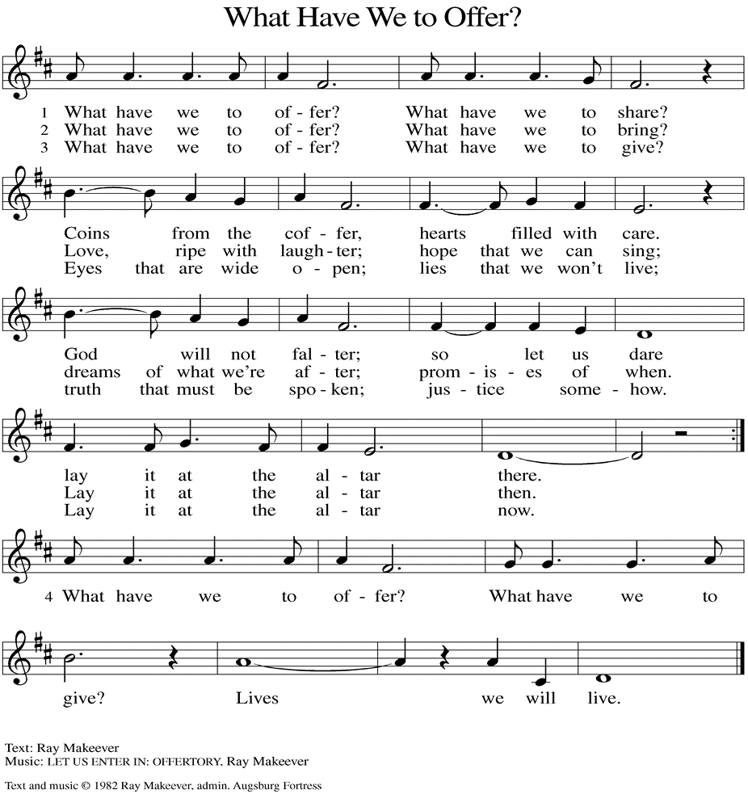
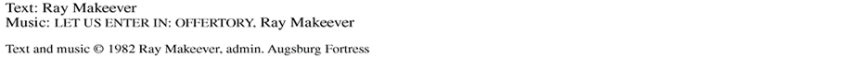

(Usher(s) brings the Tithes and Offerings up front to the Assistant.)
V. We invite you to stand as you are able.

OFFERING PRAYER
V. Let us pray,
O God, maker of heaven and earth,
your steadfast love embraces all creation.
You send rain and sunshine to nourish the earth
and bring forth its bounty.
Through these gifts of bread and wine,
draw us into the death and life of your Son,
who calls us to bear witness to his saving work.
We ask this in Jesus’ name.
C. Amen.

GREAT THANKSGIVING
V. The Lord be with you.
C. And also with you.

V. Lift up your hearts.
C. We lift them to the Lord.

V. Let us give thanks to the Lord our God.
C. It is right to give him thanks and praise.

V. It is indeed right and salutary that we should at all times and in all places offer
thanks and praise to you, O Lord, holy Father, through Christ our Lord; who rose
beyond the bounds of death and, as he promised, poured out your Spirit of life
and power upon the chosen disciples. At this the whole earth exults in boundless
joy. And so, with the Church on earth and the hosts of heaven, we praise your
name and join their unending hymn:

SANCTUS
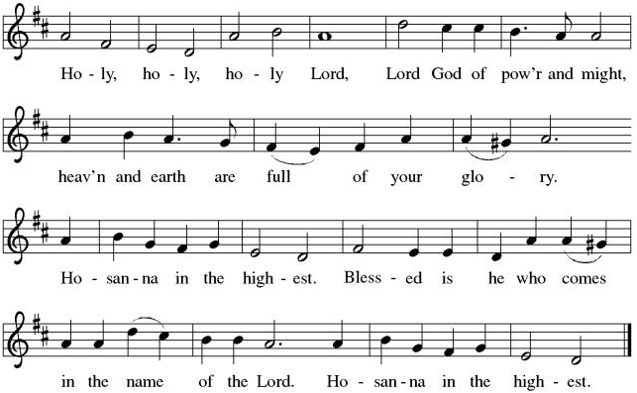

THE EUCHARISTIC PRAYER
V. Blessed are you, Lord of heaven and earth, in mercy for our fallen world you gave
your only Son, that all those who believe in Him should not perish, but have
eternal life. We give thanks to you for the salvation you have prepared for us
through Jesus Christ. Send now your Holy Spirit into our hearts that we may
receive our Lord with a living faith as He comes to us in His holy supper.
C. Amen. Come, Lord Jesus.

V. In the night in which he was betrayed our Lord Jesus took bread,
he gave thanks; broke it, and gave it to his disciples, saying:
Take and eat; this is my body, given for you.
Do this for the remembrance of me.

V. Again, after supper, He took the cup, he gave thanks,
and gave it for all to drink, saying:
This cup is the new covenant in my blood,
shed for you and for all people for the forgiveness of sin.
Do this for the remembrance of me.

THE LORD’S PRAYER
(We ring the bell throughout the Lord’s Prayer at all services to
invite those in the community to join in praying the Lord’s Prayer.)
V. May we now join with one another and pray together as Jesus has taught us.
C. Our Father, who art in heaven, hallowed be thy name, thy kingdom come,
thy will be done, on earth as it is in heaven. Give us this day our daily
bread; and forgive us our trespasses, as we forgive those who trespass
against us; and lead us not into temptation, but deliver us from evil. For
thine is the kingdom, and the power, and the glory, forever and ever.
Amen.

LAMB OF GOD

(We invite you to be seated.)

HOLY COMMUNION
V. We extend the invitation to Communion to all who are baptized and believe in
Jesus Christ.

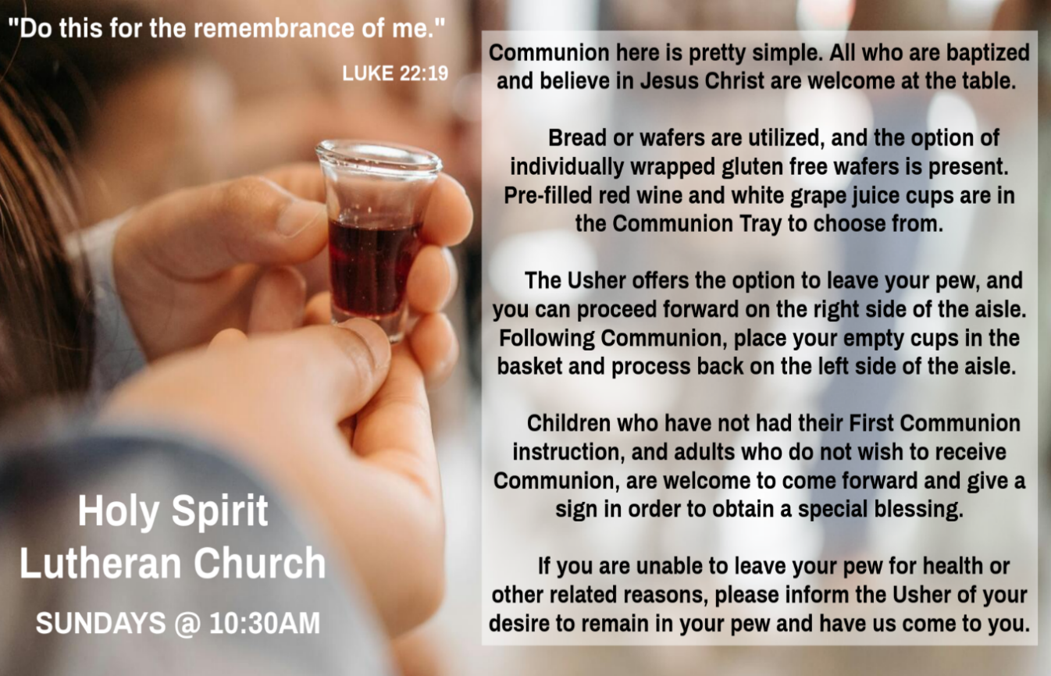

INVITATION TO COMMUNION
V. Come to the table.
Feast on God’s goodness and mercy.
C. Amen.

(Distribution of Holy Communion)

COMMUNION HYMN
(Please enjoy various music offered by our Organist during your
quiet time, prayer, and reflection following Holy Communion.)

(Vicar and Assistant remove Communion Vessels from the Altar.)

V. We invite you to stand as you are able.

POST COMMUNION BLESSING
V. May the body and blood of our Lord Jesus Christ strengthen us and keep us
always in His grace.
C. Amen.
POST COMMUNION CANTICLE
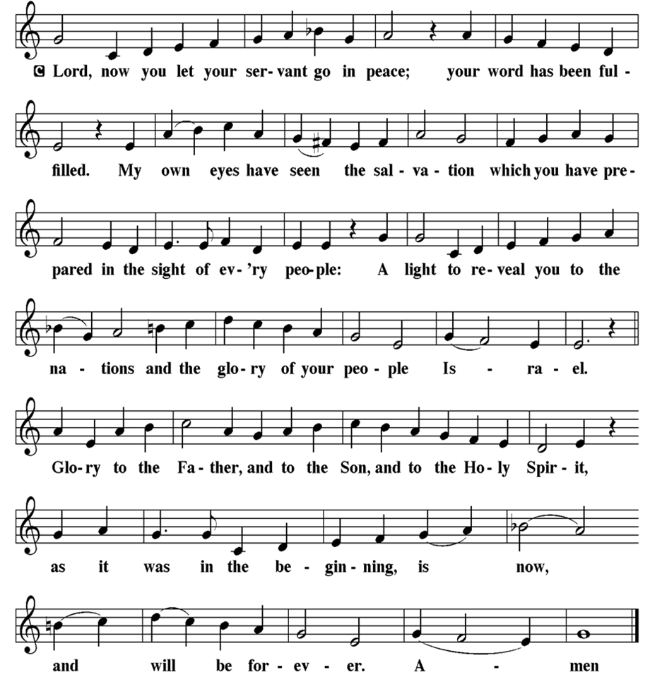

PRAYER AFTER COMMUNION
A. Let us pray,
God of our salvation,
we give you thanks for this meal that restores our souls,
reconciles us to you, and strengthens us for the journey.
Through the body and blood of your Son,
may we become Christ’s body in the world,
bearing witness to your love for all creation,
through Jesus Christ, our Savior and Lord.
C. Amen.

BLESSING
V. Receive the blessing of the holy Trinity:
God, who calls all things into existence,
Jesus Christ, who redeems us,
and the Holy Spirit, whose breath sustains creation,
☩ bless you now and always.
C. Amen.

SENDING HYMN
(We invite you to sing along.)
With One Voice—Blue Book
731—Precious Lord, Take My Hand

(Assistant extinguishes the Altar Candles half way through the Sending Hymn.)

(Vicar processes out once the Altar Candles have been extinguished.)

(We invite you to be seated.)

BIRTHDAYS, ANNIVERSARIES, & ANNOUNCEMENTS
(Offered by Assistant and Congregation.)

BIRTHDAYS
25th Bob Rinier
28th Sharon Yarwasky

DISMISSAL
A. Go in peace. Believe the good news.
C. Thanks be to God.
POSTLUDE
(Music offered by our Organist as we depart following our Worship Service.)
Moment Musicale

LICENSES & EXPIRATION DATES
Worship Service Content is used via permission through Augsburg Fortress Liturgies Annual License #SB144368. The next Subscription Renewal Date is 2/28/2027.
Our Hymns and Worship Music are used via permission through CCLI One
License #11327166. The next Subscription Renewal Date is 1/31/2027.

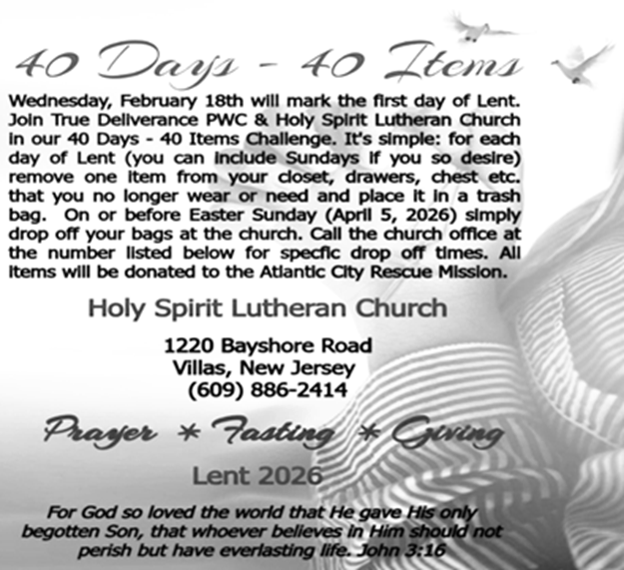

2026 FINANCIAL STANDING
FEBRUARY INCOME | $8,570.00
FEBRUARY SPENDING | $6,702.26
FEBRUARY GAIN OR (LOSS) | $1,867.74
2026 INCOME | $11,480.00
2026 SPENDING | $12,124.07
2026 GAIN OR (LOSS) | ($644.07)
ED GREEN CAPITAL IMPROVEMENT FUND | $2,958.55
FOOD PANTRY FUND (SOCIAL MINISTRY) | $13,515.13
CD | $26,414.45

CONFIRMATION & SUNDAY SCHOOL
“Here We Stand” allows our young folks to go through a 2-year process focusing on the Bible and Luther’s Small Catechism. Classes are on Sundays from 9-10AM.

WORSHIP MINISTRY
The most important thing we do each week is gather together as God's people to Worship. God is the center and focus of everything we do. Participating in Worship is active, as Liturgy means the work and actions of the people gathered. Everything we do during the week to prepare for Worship, and everything we do as we Assist in leading Worship is important. We are thankful for all the wonderful work being done. If you have questions, or are interested in any position, reach out to Vicar Vince.
Sign-up sheets are located on the bulletin board between the church offices.

NEWSLETTER
Collect information, stories, pictures, and reports for our next publication. Everything needs submitted to Vicar Vince in-person or via email at vpie8282@gmail.com.
Your Spring Publication will be out to you soon!

BIBLE STUDY & FAITH DISCUSSIONS
Bible Study & Faith Discussions focuses on various readings, books, Bible verses, people of faith, and other general topics. Group Members offer various points of view while being respectful and supportive of one another. Join us on Tuesdays at 6PM.
FOOD PANTRY
Open every Thursday, and the last Saturday of every month, from 10AM to 1PM. 106 people were served in February and 240 people have been served in 2026. Donations can be dropped in the outdoor drop-box, in the money jug in the back of the Church, mailed into the Church Office, or placed in the Offering Plate. Volunteers are needed. Sign-up sheets are located on the bulletin board between the church offices. If you have questions or need training see Heather, Vicar Vince, or Bonnie.
A special thank you goes out to all who donate, pray, and help in any way!

Thursday, 3/26 | Saturday, 3/28 | Thursday, 4/2
Kim, Theresa, & Bob | Vicki & Bonnie | Garnet & Joe

COMMUNITY FOOD DONATIONS, DELIVERIES, & MORE
North Cape May Acme provides us with Expiring, Recently Expired, and Slightly Damaged Food and Items. Kathy delivers on Saturdays in the community, brings items to church and the food pantry, and to the Branches Outreach in Rio Grande.

BULLETIN ENTRY DEADLINE
The Bulletin is printed on Thursdays during Church Office Hours. Changes need to be submitted to Vicar Vince no later than Thursday by 4PM. Thank you!

CHURCH OFFICE HOURS
Open Thursdays from 6PM to 8PM. It is open to serve the Congregation, the Community, and to handle the business of the Church. Feel free to stop in to talk, pick-up or drop off something, pray in the Sanctuary, or for whatever reason.

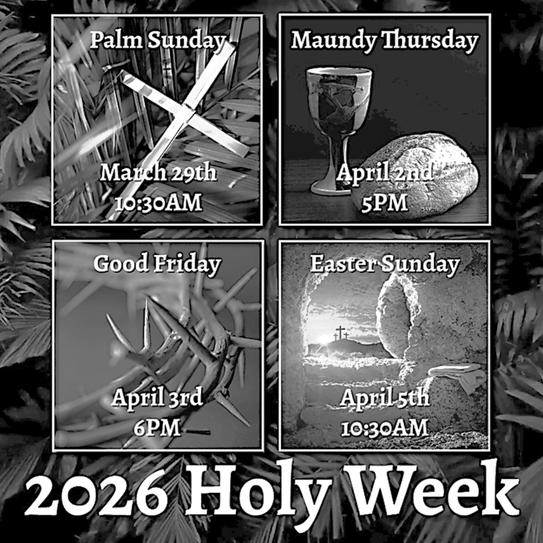
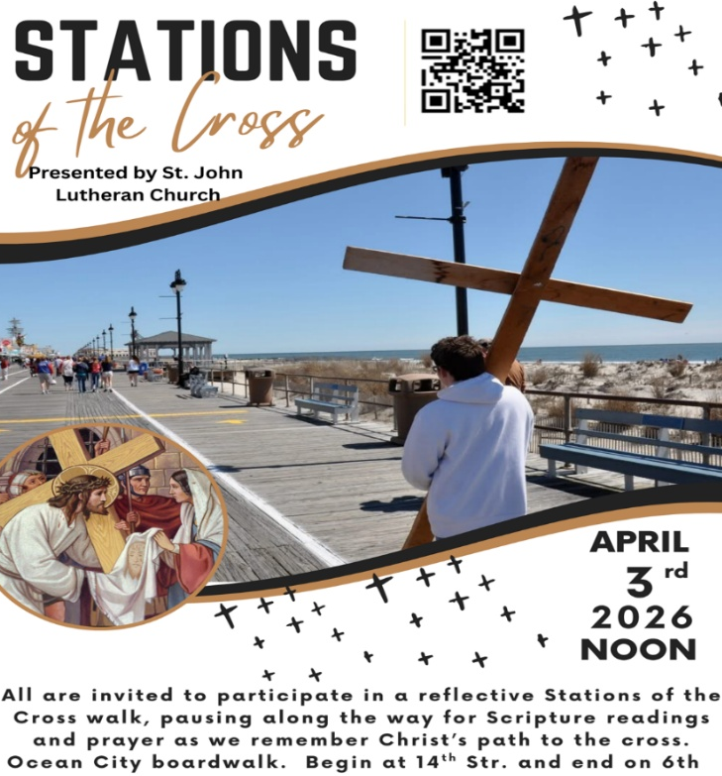

EASTER VIGIL INVITATION
Father Marcel has extended an invitation again this year to celebrate the Easter Vigil together. Please consider joining us at St. Simeon’s By The Sea in North Wildwood, on Saturday, April 4th, at 5PM. Vicar Vince will assist with various points of the service. Vicar Ken from Holy Trinity in Wildwood will be delivering the Sermon. Please see Vicar Vince with any questions, or to confirm your interest in attending.

DONATION STATION
Get on the train and place all purchased items in the specified project donation bins located on the counter by the front doors. See Heather for more information.


WOMEN OF THE CHURCH
Their next meeting is on Monday, April 6th, at 6PM. New members are always invited and welcome to attend! Contact Judy for more information.



CHURCH COUNCIL
Share your comments, concerns, questions, or joys with one of our Church Council Members who can bring them back to our meetings. Visitors are always welcome to attend and listen to what is going on in and around the church. Join us In- Person or on our Conference Call at our next Meeting on Tuesday, April 21st, at 6PM.

SPECIAL PREACHER
Chip Hand is looking forward to Preaching on Sunday, April 26th, as Vicar Vince will be back in Pittsburgh for a few days for the NFL Draft and some vacation time. Please be aware that there will not be Holy Communion this Sunday as a result.


Our NJ Synod Assembly will be on Saturday, May 30th, 2026. Wayne & Judy are attending with Vicar Vince. Registration will need completed and paid for soon.


Confirmation is a journey of faith filled with new questions and answers, new discoveries, new relationships, new responsibilities, and new possibilities. Clearly confirmation is intended to be a milestone, not a destination; it is not graduation! Rather, Confirmation is a tool that equips for the life-long process of living out Christian identity. Traditionally we would be celebrating Confirmation on Pentecost Sunday. However, due to it falling on Memorial Day Weekend, and the schedules of our young folks, we will be moving it to Sunday, June 14th, during our 10:30AM Worship Service. Please come out and join Caylee Thomas and Robert Thomas on this special day and celebrate with them at the Coffee Hour afterwards.

CHURCH DIRECTORY
2026 Church Directories are by the Church Office on the bookshelves. We continue keeping it updated, but we undoubtedly miss a few changes or have made a few errors. Please inform the Church Office of updates or changes to keep us up to date.

FAVORITE HYMNS
Carol is willing to play some of your favorite hymns for the Prelude & Postlude each Sunday during our Worship Service. Feel free to let her know of your suggestions.

TITHES, OFFERINGS, & ENVELOPES
We worship God with our tithes and offerings. We hear in scripture, “Each of you must give as you have made up your mind, not reluctantly or under compulsion, for God loves a cheerful giver.” (2 Corinthians 9:7) Envelopes can be dropped in the offering plate, mailed to the church, or dropped in the locked mailbox. Thanks for your support in the mission of our church, its ministries, the NJ Synod, etc!

SPACE AVAILABLE
​​​​​Interested in utilizing our Fellowship Hall for a Party or Event? There is a suggested $50 refundable security deposit, and it is $250 for facility use. No alcohol or games of chance permitted due to ELCA policy. Please contact Vicar Vince for more info.

ED GREEN CAPITAL IMPROVEMENT FUND
We are seeking out a new fundraiser at this time. We also have the donation bin in the back of the church and we have our Annual Church Rummage Sale to raise funds. Thanks for your continued donations, prayers, and support!
HOME COMMUNION MINISTRY
A Minister is available if you have a loved one, or if you desire services. We look forward in sharing the Word and Holy Communion! Please inform Vicar Vince, Kathy, or the Church Office so plans can be made for visits.

PRAYER SHAWL MINISTRY
Prayer Shawls, Lap Quilts, Scarves, and other items have been made with love. Blessed items are located in the Narthex, and are free for anyone. Members of the group continue working at home on new stitches and patterns. We are blessed to be able to continue collecting new items. We have a donation station of yarn and other items located in the Narthex. You can find some new supplies for your next creation!

PRAYER LIST
Our Prayer List continues to lengthen and we realize the important need for prayers and healing. Sometimes the unfortunate result is that someone has passed away, and the words “The Family & Friends of” appear before someone’s name. However, sometimes we forget names are still on the list and their health has improved and they can be removed. Please share various stories as we continue to pray for strength and healing. Names can be added or removed from the list on the clipboard in the Narthex prior to the Worship Service, by calling the church office, or addressing it on the Conference Call. Please let us know the relation to the person(s) you listed so we can be more mindful with our prayers.

LIBRARY
New books are added to our library from time to time. Several are borrowed and read and exchanged. Who knows, you might find one particularly interesting and share that with someone as well. Reading is a great way to pass spare time, learn, and explore. You may find some fresh ideas for prayer, ways to grow more spiritually, ways to grow closer to God, or some opportunities to understand our faith more. We also have an extended library located in Vicar Vince’s office. There are Bibles of various translations, books from his personal collection, books inherited from Pastor Leah, movies, past Bible Study Curriculums, and more. Visit the library between the church offices or just ask to be able to check things out.

INTERESTED IN BECOMING A NEW MEMBER
Have you been attending our church for a while? Have you just recently returned to church after being away for a bit? Maybe you transitioned from another church,
or just started to recently attend our church. We are glad to have you, and would love to have you as a member of our Congregation. See Vicar Vince for more info.

BAPTISM
We are a church whose unity is in Jesus Christ, who gathers us around word and water, wine and bread. Baptism is a significant part of our faith journey as we come from the baptismal waters to live a new life as children of God. Our baptism sets us out on a lifelong journey that is characterized by our relationship to God, our relationship to our faith community, our relationships in our community and the wider world. Living our baptismal covenant means living a life of growth in the faith practices of discipleship. Please see Vicar Vince for more information.

FIRST COMMUNION
Although no particular age for first communion is prescribed by The Use of the Means of Grace, one guideline is offered. Because admission to the Sacrament is by invitation of the Lord to the baptized, "baptized children begin to commune on a regular basis at a time determined through mutual conversation that includes the pastor/vicar, the child, and the parents or sponsors involved, within the accepted practices of the congregation.” Each congregation is encouraged to ask the question of readiness for first communion, establish their own policies regarding age and practice, and accompany that practice with catechesis appropriate to the age of the communicant. If anyone has questions, please see Vicar Vince.

VICAR VINCE’S DAY OF REST
A day of rest can have physical, mental, and spiritual benefits. “Mittwoch,” German for mid-week, or Wednesday, is the day that Vicar Vince will use to recharge and do some other things. Please do not hesitate to reach out if there is an emergency!

VICAR APPOINTMENT ON MARCH 19TH, 2023
A Memorandum of Understanding on the Matter of Pastoral Appointment
In Theological Education for Emerging Ministries (TEEM) Candidacy
TO: Congregation Council, Holy Spirit Lutheran Church, Villas
FROM: The Rev. Tracie L. Bartholomew, Bishop, New Jersey Synod

Dear Brother and Sisters in Christ,
This memorandum is in support of your discussions with Vincent Piekarski as pastor of Holy Spirit, Villas. Because this is not the usual pattern for completing the educational and candidacy requirements for ordination, it is my hope that this memorandum will both provide guidelines and engage in conversation with those who are invested in this process.

I would say at the outset that because Vincent is an outstanding candidate for the Ministry of Word and Sacrament, we will all want to do whatever is necessary to assure that his placement serves the mission of the church in the best possible fashion.

The following notes reflect my own understanding of this matter:
(1) The appointment for Vincent will begin on April 1, 2023. At this time, Vincent
will assume all responsibilities of a regularly called pastor, including presiding at
the Sacrament of Holy Communion and Baptism at Holy Spirit, Villas.
(2) A pastoral appointment in the TEEM process is an option for completing
seminary educational requirements and the steps of the candidacy process.
Upon completion of the candidacy process and seminary education, the
candidate may receive and accept a call to ordained ministry from the
congregation where the appointment is being served.
(3) This appointment is jointly supervised by the Office of the Bishop and the TEEM
pastor’s seminary. A mentoring relationship with a local pastor is required for the
length of this appointment.
(4) The synod of candidacy origin will be responsible for the approval process.
(5) Upon approval for ordination, the congregation would be expected to extend a
call to the pastoral appointee.
(6) Compensation for the TEEM pastor will be according to the guidelines of the New
Jersey Synod. All normal forms of compensation should be in place for the term
of the appointment, including stipulation that base salary and housing shall be in
accord with synod guidelines for first call at time of ordination.
(7) The ELCA Portico benefit plan for lay persons in full-time church service should
be used for the pastoral appointee up to the time of ordination, whereupon the
benefit package is to be converted to the plan for ELCA clergy.
(8) A decision for Pastoral Appointment is made with the agreement of a synod and
its candidacy committee, and the ELCA, normally represented by the regional
staff person of each in consultation with the seminary and its Director for
Contextual Education.
(9) Pastoral Appointment in a TEEM Candidacy is an option that is to serve the
mission of the Church in a particular and vital way and is not to be viewed or
used as a means to circumvent the normal candidacy process and/or first call
placement process.

In the specific case of Vincent, the New Jersey Synod remains responsible for the candidacy and approval process, and has agreed to this proposal for Appointment at Holy Spirit, Villas.

Continued blessings to both Holy Spirit and Vincent Piekarski as you embark on this journey of mutual ministry. As partners in ministry, we walk with you and rejoice in this new relationship.
VICE PASTOR UPDATE
Pastor William Hodgetts continues to attend our Church Council Meetings
and provides Supervision and Support to Vicar Vince.

WHAT IS THE EVANGELICAL LUTHERAN CHURCH IN AMERICA?
The ELCA was formed in 1987 by the merger of three Lutheran Church bodies –
the ALC (American Lutheran Church), the LCA (Lutheran Church in America), and the AELC (Association of Evangelical Lutheran Churches). Learn more at elca.org.

NEW JERSEY SYNOD
The New Jersey Synod is a geographical grouping of Evangelical Lutheran Church in America (ELCA) congregations that share the mission and ministry of the Church on the New Jersey territory. It is one of 65 synods in the ELCA. The NJ Synod is comprised of 143 congregations, which include over 45,000 baptized members.

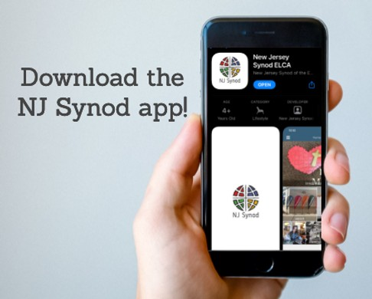
There is a weekly e-newsletter connecting our synod together with weekly prayer, upcoming events, synod and churchwide activities, mission stories, congregational activities, & more. Sign up at www.njsynod.org/stay-connected or download the app.

TRUE DELIVERANCE PRAISE & WORSHIP CENTER
TDPWC utilizes our facilities from 1-4PM on Sundays. TDPWC hosts or assists with other events. TDPWC hosts a Prayer Line on Mondays, Wednesdays, & Fridays at 5PM on the Conference Call 1-657-390-7957; & Bible Study on Thursdays at 6:30PM on Zoom. See Rev. Brooks for more information.

JUST FRIENDS
The group promotes a spirit of fellowship among adults 50 years and older. Bring your own lunch, beverages and deserts are provided. Everyone is welcome. The group meets in Our Lady Star of The Sea Parish Hall on the last Wednesday of the month from 12Noon to 2PM from September through May. For information, please call Martine Simonis 609-884-5312 x 110.

ADDITIONAL OFFERINGS FROM OUR FRIENDS & NEIGHBORS
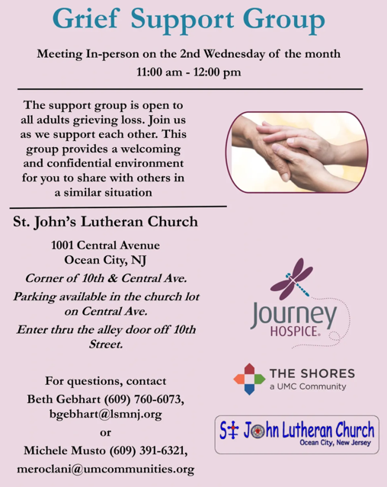

CHURCH STAFF & VOLUNTEERS
VICAR
Vicar Vince Piekarski
VICE PASTOR
Pastor William Hodgetts
ORGANIST & PIANIST
Carol Amundsen
CHURCH OFFICE, SUNDAY SCHOOL, & FOOD PANTRY
Heather Piekarski
CHURCH COUNCIL PRESIDENT & CHURCH PROPERTY
Wayne Rand
CHURCH COUNCIL VICE PRESIDENT & WOMEN OF THE CHURCH
Judy Brannan
CHURCH COUNCIL TREASURER
Bonnie Millard
CHURCH COUNCIL SECRETARY
Vicki Rinier

