PHOENIX BAPTIST HOSPITAL
TEMPE ST. LUKE’S HOSPITAL
Endoscopy (EGD) Report
Date: XXxXXxxXX

Patient Name: JohnOrJaneDoe

Physician: Dr. Rick Shacket Office Seen: Comprehensive Health Services

Anesthesia: Staff | Dr. Noon

Preoperative Diagnosis: Heartburn or gastro esophageal reflux disease (GERD) despite an appropriate drug Trial; Heartburn or gastro esophageal reflux disease (GERD) with anorexia or weight Loss; Gastrointestinal bleeding (occult or obscure); Persistent vomiting; Upper abdominal or periumbilic pain; Persistent nausea; History of long-term anti-coagulation, or non-steroidal anti-inflammatory drug (NSAID) therapy; Anemia - iron deficiency or pernicious (when colonoscopy is negative); Surveillance of adenomatous gastric polyps (1-4 year follow up in patients with prior adenomatous gastric polyps;); Dysphagia; Odynophagia; Surveillance of Barrett's esophagus (1-2 year follow-up of Barrett’s esophagus without dysplasia; or 2-3 month follow-up of Barrett’s esophagus with dysplasia); Gastric ulcers (2-4 month follow up of selected esophageal or gastric ulcers until healed); Familial adenomatous polyposis syndrome or 2-4 year follow-up of in patients wit\h familial adenomatous polyposis.

Specimen: None. Biopsies for H Pylori test. Biopsies of the esophagus and stomach antrum, and corpus, and fundus; and duodenum.

Procedure: Esophagogastroduodenoscopy with biopsy(s).

Description:
The patient was prepped and lying in a left lateral position. A bite block was placed between the upper and lower incisors. The endoscope was then inserted through the bite block into the oropharynx to a point where the vocal cords could be visualized. Under direct visualization the patient was asked to swallow, and the tip of the instrument was placed through the cricopharyngeus muscle into the esophagus. The endoscope was advanced down the esophagus to a point where the ora serrata or “Z” line could be identified. The endoscope was then passed through the lower esophageal sphincter into the gastric lumen. The scope was then aimed where a distal view of the gastric antrum could be seen. The endoscope was passed further into the antrum up to the pylorus. The endoscope was then passed through the pylorus into the first part of the duodenum. The mucosa of the duodenal bulb was free of folds, but the second and third parts of the duodenum demonstrated characteristic folds of Kerckring. The papilla of Vater located on the medical wall of the descending duodenum was visualized. The endoscope was then withdrawn slowly, with careful attention given to the surrounding mucosa. The endoscope tip was retroflexed, bent back upon itself and drawn upwards, to see the gastric tissue of the fundus and the cardia as it surrounds the endoscope. The endoscope was lightly jiggled back and forth in order to evaluate the cardia for snugness. The endoscope was then straightened and withdrawn slowly. Careful attention was given to re-examining the esophageal lumen. The endoscope was withdrawn through the oropharynx. The bite block was removed when the procedure was terminated.

Impressions:
- NORMAL: Normal Appearing Esophagus, Stomach, and Duodenum

- GLYCOGENIC ACANTHOSIS: Small nodules on the mucosal surface of the esophagus were consistent with findings of glycogenic acanthosis. They were round to oval, sharply demarcated, and distinctly whiter than the surrounding mucosa. Glycogenic acanthosis is the most common tumor like condition of the esophagus. In older individuals one may commonly see glycogen granules in the esophageal mucosa. The presence of these granules is of uncertain significance.

- H. PYLORI TESTING: The endoscope was pulled into the gastric antrum and retroflexed upon the angularis and lesser curvature; where multiple biopsies were taken for an H Pylori test. Helicobacter pylorus (H. pylori) is the bacteria responsible for most ulcers and many cases of stomach inflammation (chronic gastritis). The bacteria can weaken the protective coating of the stomach, allowing digestive juices to irritate the sensitive stomach lining.

- CELIAC DISEASE BIOPSY: People who test positive for celiac disease antibodies should have a small intestinal biopsy to confirm the diagnosis. A small intestinal biopsy is performed of the intestinal lining of the duodenum. A pathologist evaluates the tissue samples for loss of villi and other characteristics of celiac disease, such as an increased number of lymphocytes.
FYI
  - Who should undergo antibody blood tests for celiac disease?
    - Chronic diarrhea (diarrhea that does not resolve in three weeks), increased amount of fat in the stool (steatorrhea), and weight loss
    - Excess gas, bloating, and abdominal distension
    - Parents or siblings with celiac disease
    - Growth retardation
    - Unexplained iron deficiency anemia, or deficiency of folate and vitamin B12
    - Skin blisters that are itchy (dermatitis herpetiformis)
    - Recurrent, painful mouth sores (aphthous stomatitis)
    - Diseases associated with celiac disease, such as type I (insulin-dependent) diabetes, autoimmune thyroid disease, rheumatoid arthritis, systemic lupus, ulcerative colitis, etc.

- GASTRIC POLYPS: Gastric polyps are typically found incidentally when upper gastrointestinal endoscopy is performed for an unrelated indication; only rarely do they cause symptoms or other clinical signs. Nevertheless, their discovery can be important since some types of polyps have malignant potential. Gastric polyps are found in approximately 6 percent of upper gastrointestinal endoscopic procedures in the United States.
  - Gastric mucosa histology — Because hyperplastic polyps and adenomatous polyps are often associated with atrophic gastritis, the normal appearing antral and corpus mucosa should be sampled to assess the stage and type of gastritis and, thus, cancer risk.

- 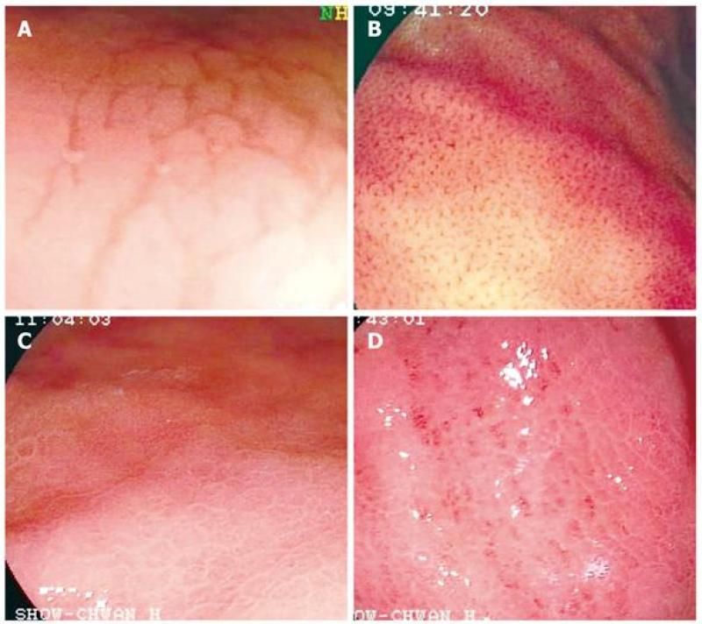AREAE GASTRICAE: With careful inspection of the gastric and antral mucosa, the observation of areae gastricae, types 1 & 2 & 3 & 4 were | was visualized. Mucosal patterns: Type 1 mucosal pattern showing benign cleft-like appearance; Type 2 mucosal pattern showing regular arrangement of red dots; Type 3 mucosal pattern showing mosaic (tile-like) appearance; Type 4 mucosal pattern showing mosaic appearance with focal area of hyperemia. These were visible macroscopic patterns of gastric glandular structures. This pattern is absent in patients with atrophic gastritis, and accentuated in patients with hypersecretion and duodenal ulcers. Therefore, a hypersecretion state may presume to exist.
  - Prominent areae gastricae (types 3 & 4) can be similar to the mosaic mucosal pattern in patients with portal hypertension; and in patients without cirrhosis, have been shown to be a characteristic finding in gastritis caused by H. pylori infection.
FYI:
  - The gastric mucosa viewed en face looks like an irregularly ploughed field and the areas between the furrows contain a multitude of holes. In section therefore, the mucosa is 'perforated' by the gastric pits into which the gastric glands empty; the pits are lined principally by mucus secreting cells. The mucosa undulates in a fairly regular manner giving a cobblestone effect-the bottom of each groove commonly being bounded by a relatively large gastric pit. This undulation of the gastric mucosa is a fundamental intrinsic feature of the anatomy and is not dependent on the state of contraction of the muscularis mucosa and by definition is unaltered by the degree of stretching or contraction of the stomach wall.

- NONSPECIFIC GASTRITIS: nonspecific gastritis was evident by irregular areas of erythema and areas of papular discoloration in the antrum and body of the stomach. This condition was not considered extensive. The mucosal reddening or erythema probably reflects superficial mucosal hyperemia, which is often undetectable histologically. As this condition is not severe, a definitive pathologic confirmation can not always be ascertained.

- ACUTE GASTRITIS: Found, was mucosal erythema and edema, which is consistent with acute gastritis.
  - Superficial small erosions, that appeared as tiny areas of dried blood that could not be rinsed away.
  - No correlation exists between microscopic inflammation (histologic gastritis) and the presence of gastric symptoms (eg, abdominal pain, nausea, vomiting). In fact, most patients with histologic evidence of acute gastritis (inflammation) are asymptomatic. The diagnosis is usually obtained during endoscopy performed for other reasons. Acute gastritis may present with an array of symptoms, the most common being nondescript epigastric discomfort.
  - Acute gastritis has a number of causes, including certain drugs; alcohol; bile; ischemia; bacterial, viral, and fungal infections; acute stress (shock); radiation; allergy and food poisoning; and direct trauma. The common mechanism of injury is an imbalance between the aggressive and the defensive factors that maintain the integrity of the gastric lining (mucosa).
FYI
  - Acute gastritis is a term covering a broad spectrum of entities that induce inflammatory changes in the gastric mucosa. The different etiologies share the same general clinical presentation. However, they differ in their unique histologic characteristics. The inflammation may involve the entire stomach (eg, pangastritis) or a region of the stomach (eg, antral gastritis). Acute gastritis can be broken down into 2 categories: erosive (eg, superficial erosions, deep erosions, hemorrhagic erosions) and nonerosive (generally caused by Helicobacter pylori).
  - Acute erosive gastritis can result from the exposure to a variety of agents or factors. This is referred to as reactive gastritis. These agents/factors include nonsteroidal anti-inflammatory medications (NSAIDs), alcohol, cocaine, stress, radiation, bile reflux, and ischemia. The gastric mucosa exhibits hemorrhages, erosions, and ulcers. NSAIDs, such as aspirin, ibuprofen, and naproxen, are the most common agents associated with acute erosive gastritis. This results from oral or systemic administration of these agents either in therapeutic doses or in supratherapeutic doses.
  - Reactive gastropathy is the second most common diagnosis made on gastric biopsy specimens after H pylori gastritis.
  - Because of gravity, the inciting agents lie on the greater curvature of the stomach. This partly explains the development of acute gastritis distally on or near the greater curvature of the stomach in the case of orally administered NSAIDs. However, the major mechanism of injury is the reduction in prostaglandin synthesis. Prostaglandins are chemicals responsible for maintaining mechanisms that result in the protection of the mucosa from the injurious effects of the gastric acid. Long-term effects of such ingestions can include fibrosis and stricture.

- ATROPHIC GASTRITIS: The endoscopic criteria for atrophic gastritis are. 1. Pale mucosa; 2. Shiny surface and 3. Prominent submucosal vessels. Mucosal and submucosal capillaries and vessels were visible without distention by air because of marked atrophy and thinning of mucosa. In addition a decrease in rugal fold prominence and tiny mucosal excrescences contrast with slightly depressed areas of atrophy.
  - Not uncommon with atrophic gastritis, xanthelasma, small yellow appearing defect(s) were also seen.
  - Atrophic gastritis and achlorhydria are often found in association with pernicious anemia. Usually presents with vague dyspeptic or ulcer like symptoms; or symptoms may be absent. Patients with this disease are often at a higher risk for intestinal metaplasia.
FYI
  - Atrophic gastritis is a histopathological entity characterized by chronic inflammation of the gastric mucosa with loss of gastric glandular cells and replacement by intestinal-type epithelium, pyloric-type glands, and fibrous tissue. Atrophy of the gastric mucosa is the endpoint of chronic processes, such as chronic gastritis associated with Helicobacter pylori infection, other unidentified environmental factors, and autoimmunity directed against gastric glandular cells.
  - Atrophic gastritis represents the end stage of chronic gastritis, both infectious and autoimmune. In both cases, the clinical manifestations of atrophic gastritis are those of chronic gastritis, but pernicious anemia is observed specifically in patients with autoimmune gastritis and not in those with H pylori– associated atrophic gastritis.

- EROSIVE GASTRITIS: Evidence of erosive gastritis was found. Erosions were found in the area of the antrum or/and fundus. A distinction is made noting that these lesions were mostly “incomplete, or superficial in type” / “complete, or varioliform in type.”
  - These flat superficial erosions are typical of erosive gastritis. Typically these lesions have a white-yellow base or exudate surrounded by a delicate red halo. They often occur on the crest of gastric folds
  - These raised varioliform erosions are typical of erosive gastritis. Typically these erosions have an elevated, inflamed border surrounding a small-depressed central hemorrhagic or necrotic patch. They appear mostly as a series of nodules or bulges on the crests of the folds, characteristically in the antrum.
  - Erosive gastritis, based largely on endoscopic findings. Usually presents with vague dyspeptic or ulcer like symptoms; or symptoms may be absent (e.g., in many chronic aspirin users). The etiology may be known or expected (e.g., Crohn’s disease, viral infection), or idiopathic. Interestingly, although these lesions usually heal in a few days, they may persist for months or years.
  - Erosive gastritis is most always a reaction to mucosal injury by a noxious chemical agent (e.g., drugs [especially NSAIDs] or alcohol).
FYI
  - An erosion never penetrates the muscularis mucosa, for if it does, then the lesion is an ulcer. Lymphomatous or metastatic lesions in the stomach occasionally mimic the appearance of complete erosions, and is reason for taking multiple biopsy specimens.
  - Erosive gastritis is a severe form of gastritis (inflammation of the stomach) where the stomach lining is eroded. This can lead to bleeding and perforation of the wall of the stomach. Long-term (chronic) gastritis is associated with smoking and alcoholism. Symptoms include pain, nausea and vomiting. Treatment uses ulcer-healing drugs and antacids.

- 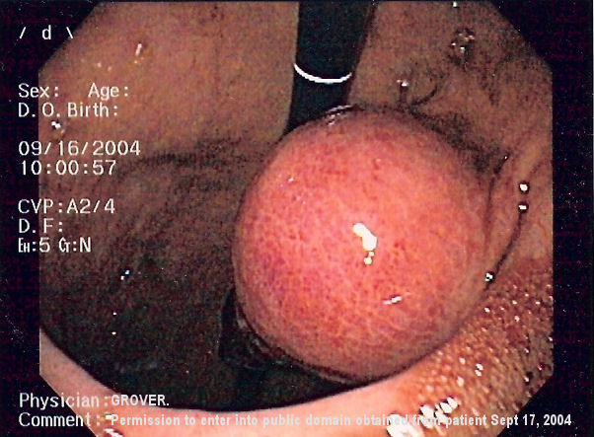 SUBMUCOSAL INTESTINAL LESION(S): Biopsies of a (i.e., pyloric sphincter lesion, and in the duodenum, biopsied were made of probable hypertrophied Brunner's glands) in order to rule out gastrointestinal stromal tumors.
  - Gastrointestinal stromal tumors (GISTs) are the most common mesenchymal neoplasms of the gastrointestinal tract. GISTs can also originate in the mesentery and omentum. Overall, GISTs are rare and rank a distant third in prevalence behind adenocarcinomas and lymphomas (among the histologic types of gastrointestinal tract tumors). Not all GISTs are cancerous. Some are benign– they don't grow into other areas or spread to other parts of the body. However, it is important to note that all GISTs can become cancerous, which is why a biopsy is made – to rule out a GIST or any other type of tumor.
FYI
  - Patients present with trouble swallowing, gastrointestinal hemorrhage or metastases (mainly in the liver). Intestinal obstruction is rare, due to the tumor's outward pattern of growth. Often, there is a history of vague abdominal pain or discomfort, and the tumor has become rather large by time the diagnosis is made. Generally, the definitive diagnosis is made with a biopsy.
  - GISTs are thought to arise from interstitial cells of Cajal (ICC), that are normally part of the autonomic nervous system of the intestine. They serve a pacemaker function in controlling motility.
  - GISTs belong to a group of cancers called soft tissue sarcoma. Soft tissue sarcomas are a group of cancers that develop in the tissues that support and connect the body. They are nonepithelial. About 70% occur in the stomach, 20% in the small intestine and less than 10% in the esophagus. Small tumors are generally benign.

- PYLORIC STENOSIS: Pyloric stenosis is defined as an obstruction to gastric emptying due to any cause situated above the biliary ampulla. In almost all cases of pyloric stenosis distortion by inflammatory edema is the precipitating cause of obstruction.
  - It is exceptional to find a healed ulcer in a patient with unrelieved pyloric stenosis. Vomiting is the cardinal symptom and is rarely absent. Usually it is preceded by a long history of recurrent dyspepsia and is sometimes episodic. The episodes coinciding with active phases of the ulcer. In half the patients the vomit is copious, usually free from bile and may contain undigested (and recognizable) food taken many hours before. Typically the vomiting occurs in the late hours of the evening or in the early hours of the morning. Anorexia and weight loss are the rule.

- BULBODUODENITIS: Bulboduodenitis is of specific concern Patchy erythematous areas were discernible. Small red patches with intervening pale areas, gave a slight salt and pepper appearance to the duodenal bulb, consistent with bulboduodenitis.. Nonspecific bulboduodenitis may be a manifestation of duodenal ulcer disease. Whether duodenitis is the precursor or the healing state of the bulboduodenal ulcer, is unclear. Based on the available evidence, bulboduodenitis seems to be a stage for the formation of an ulcer. Although a definite ulcer is not seen, anti ulcer therapy with an H2 blocker will be indicated.

- DUODENAL ULCER: A peptic ulcer in the duodenum is called a duodenal ulcer. Peptic ulcers occur most commonly in the duodenal bulb. Duodenal ulcers are most always benign. However the possibility of an occult malignancy is good reason for taking multiple biopsy specimens. The ulcer was round or oval. The surrounding mucosa was hyperemic and edematous. A thin layer of gray or white exudate covered the crater base.
  - Non-cancerous peptic ulcers are caused by an imbalance between stomach acid, an enzyme called pepsin, and the natural defenses of the stomach’s lining. Many influences can disturb the stomachs acid balance and it’s protective mucosal lining, including anti-inflammatory drugs, stress, alcohol, coffee, and smoking. An ulcer penetrates the muscularis mucosa, if it does not the lesion is an erosion.

- GASTRIC ULCER: A peptic ulcer in the stomach is called a gastric ulcer. Duodenal ulcers are most always benign, but a gastric ulcer may be malignant. The possibility of an occult gastric malignancy is good reason for taking multiple biopsy specimens. A round or oval ulcer was found in the NameLocation area. The surrounding mucosa was hyperemic and edematous. A thin layer of gray or white exudate covered the crater base.
  - Non-cancerous peptic ulcers are caused by an imbalance between stomach acid, an enzyme called pepsin, and the natural defenses of the stomach’s lining. Many influences can disturb the stomachs acid balance and it’s protective mucosal lining, including anti-inflammatory drugs, stress, alcohol, coffee, and smoking. An ulcer penetrates the muscularis mucosa, if it does not the lesion is erosion.

- HIATAL HERNIA: An axial (sliding) hiatal hernia was found.
  - During quiet respiration and without excessive air insufflation, the squamocolumnar junction was located approximately 2-3 cm. above the diaphragmatic impression.
  - The cardia was observed to be incompetent in the retroflexed view. A space was evident around the instrument as it passed through the cardia. The squamocolumnar junction was patulous allowing a look into the hiatal hernia pouch.
  - Small ulcers were seen in the hernia. These are referred to as riding ulcers if they occur on the gastric tissue separating the hiatal hernia from the remainder of the stomach.
  - The symptoms of gastroesophageal reflux have little to do with the diagnosis of hiatal hernia. Reflux can occur without a hernia, and patients with a hernia may be free of reflux. These two diagnoses should not be linked automatically.
  - The endoscope was advanced down the esophagus to a point where the squamocolumnar junction, ora serrata or “Z” line could be identified. It was at this point where changes associated with gastroesophagitis were noted. A small island of mucosa at the E-G junction extending onto the esophageal wall was biopsied.

- REFLUX ESOPHAGITIS: The endoscope was advanced down the esophagus to a point where the squamocolumnar junction, ora serrata or “Z” line could be identified. It was at this point where changes associated with reflux esophagitis were noted.
  - There were several linear red streaks extending upward from the ora serrata or “Z” line.
  - The streaks extended up approximately “(2-5)“cm. and were visible in approximately “(1-5)“ area(s), or stage I reflux esophagitis. Nonconfluent red patches or streaks were noted just proximal to this squamocolumnar junction. As damage has not been seen to progress among this point, the possibility of complication associated with Barrett’s metaplasia may be prevented with proper treatment to decrease gastric acid production.
  - Finger like lesions with a white exudate in the center of the lesion marks mucosal damage, or stage II reflux esophagitis. In stage two of reflux esophagitis disease, finger like lesions with a white exudate in the center of the lesion marks mucosal damage. As damage has not been seen to progress among this point, the possibility of complication associated with Barrett’s metaplasia may be prevented with proper treatment to decrease gastric acid production.
  - The inflammatory lesion extends to the entire circumference of the lower esophagus and is accompanied by edema, hyperemia, and friability; evidence of stage III reflux esophagitis. In stage three of reflux esophagitis disease, the inflammatory lesion extends to the entire circumference of the esophagus and is accompanied by edema, hyperemia, and friability. As damage has not been seen to progress among this point, the possibility of complication associated with stricturing or Barrett’s metaplasia may be prevented with proper treatment to decrease gastric acid production.
  - Approximately one (or several) ulcers appeared to be associated with circumferential stricturing, esophageal shortening, or Barrett’s metaplasia; evidence of stage IV reflux esophagitis. In stage four of reflux esophagitis disease, approximately one (or several) ulcers appeared to be associated with circumferential stricturing, esophageal shortening, or Barrett’s metaplasia.
  - Reflux esophagitis may occur in association with an active duodenal ulcer since both are manifestations of excess and secretion.

- BARRETT'S ESOPHAGUS is a condition in which the tissue lining the esophagus—the muscular tube that connects the mouth to the stomach—is replaced by tissue that is similar to the lining of the intestine. This process is called intestinal metaplasia. Noted is pink esophageal mucosa proximally, an ora serrata in the upper or middle third of the esophagus, and a salmon pink segment of Barrett’s metaplasia extending below the ora serrata, joining the similar appearing mucosa of the stomach below.
- A Schatzki ring or Schatzki-Gary ring is a narrowing of the lower part of the esophagus that can cause difficulty swallowing. The narrowing is caused by a ring of mucosal tissue (which lines the esophagus) or muscular tissue.[1] Patients with Schatzki rings can develop intermittent dysphagia (difficulty swallowing), or, more seriously, a completely blocked esophagus. The ring is named after the German-American physician Richard Schatzki.

- SCHATZKI RING: A Schatzki ring is a specific type of "esophageal ring", and Schatzki rings are further subdivided into A rings and B rings. An A ring refers to a ring above the esophagus/stomach junction. A B ring is found in the lower esophagus at the squamocolumnar junction. The ring is usually located a few centimeters above the gastro-esophageal junction, where the esophagus joins the stomach.
  - Esophageal Rings cause intermittent mechanical dysphagia, meaning patients will usually present with transient discomfort and regurgitation while swallowing solids and then liquids, depending on the constriction of the ring.
  - Schatzki rings are usually mucosal rings rather than muscular rings, and are located near the gastroesophageal junction at the squamocolumnar junction. Presence of multiple rings may suggest eosinophilic esophagitis.
FYI
  - Not all patients with Schatzki rings have symptoms. When Schatzki rings cause symptoms, they usually result in episodic dysphagia with solid foods, or a sensation that the food "sticks" while swallowing, especially if the food is not chewed thoroughly. Patients usually are able to regurgitate or force through the food material and resume eating. However, complete obstruction of the esophagus by a bolus of food (often called steakhouse syndrome) can occur. This can cause crushing chest pain and may need immediate treatment with endoscopy. After the obstruction is located, snares or forceps are inserted to pull the food out of the esophagus or to push it into the stomach. The latter is done with caution, usually when the anatomy of the structures around the obstruction is already known.
  - Treatment is with esophageal dilatation, using bougie or balloon dilators. Dilatation can produce some temporary irritation. A short course of proton pump inhibitor therapy may decrease aggravation postoperatively. The duration of the benefit of dilation varies, and may be repeated in months to years if narrowing recurs.

- ESOPHAGEAL WEBS: Webs are usually squamous mucosal protrusion into the esophageal lumen, especially anterior cervical esophagus behind the cricoid area. Patients are usually asymptomatic or have intermittent dysphagia.

- ACHALASIA: Achalasia is an idiopathic motility disorder characterized by failure of lower esophageal sphincter (LES) relaxation as well as loss of peristalsis in the distal esophagus, which is mostly smooth muscle. Both of these features impair the ability of the esophagus to empty contents into the stomach. Patients usually complain of dysphagia to both solids and liquids. Dysphagia to liquids, in particular, is a characteristic of achalasia. Other symptoms of achalasia include regurgitation, night coughing, chest pain, weight loss, and heartburn.
  - The internal tissue of the esophagus generally appears normal in endoscopy, although a "pop" may be observed as the scope is passed through the non-relaxing lower esophageal sphincter with some difficulty, and food debris may be found above the LES.
  - Sublingual nifedipine significantly improves outcomes in 75% of people with mild or moderate disease. Esophageal dilation or surgical myotomy provides greater benefit in those who fail medical management.

- 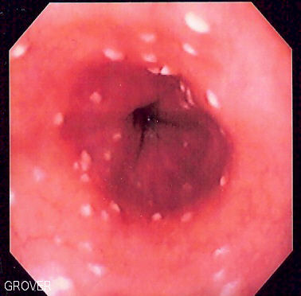 WHITISH ESOPHAGEAL LESIONS: Suggestive of esophageal candidiasis. A brush biopsy of the esophagus was performed. Esophageal candidiasis is an opportunistic infection of the esophagus by Candida albicans. The disease occurs in patients in immunocompromised states, including post-chemotherapy and in AIDS. It is also known as candidal esophagitis or monilial esophagitis. Patients where esophageal candidiasis is suspected should undergo esophagogastroduodenoscopy if it is safe to do so. Endoscopy often reveals classic diffuse raised plaques that characteristically can be removed from the mucosa by the endsocope. Brushing or biopsy of the plaques shows yeast and pseudohyphae by histology that are characteristic of Candida species.

- ESOPHAGEAL VARICES are enlarged veins in the lower part of the esophagus. Esophageal varices occur when blood flow to your liver, via the portal vein, is slowed, and venous blood backs up into the esophageal veins casing an abnormal distention or swelling. They occur most often in people with cirrhosis of the liver. Although many people with advanced liver disease develop esophageal varices, most won't experience bleeding.
  - Sometimes, esophageal varices can rupture and cause a life-threatening bleeding.When viewed through the endoscope some varices show long, wale marks (defined as longitudinal dilated venules resembling whip marks on the variceal surface) or cherry red spots, which may indicate a danger of hemorrhage. Treatments to lower blood pressure in the portal vein may reduce the risk of bleeding esophageal varices.
FYI:
  - A drug called octreotide (Sandostatin) is often used in combination with endoscopic therapy to treat bleeding from esophageal varices. The drug is usually continued for five days after a bleeding episode.
  - Three Grade Classification
esophageal varices are graded according to their size, as follows:

Small (Grade 1): small straight varices
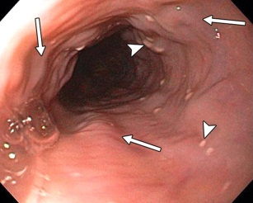

Medium (Grade 2): enlarged tortuous varices occupying less than one third of the lumen
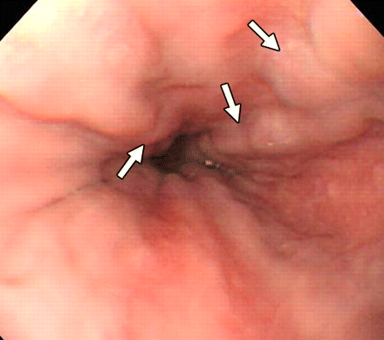

Large (Grade 3): large coil-shaped varices occupying more than one third of the lumen.
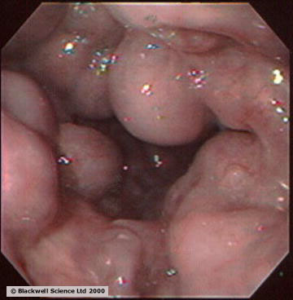 There are no predictions of increased risk for bleeding (e.g. "cherry red spots"). Since the patient had a previous history of esophageal variceal bleeding, serial band ligation was recommended.

Plan:
  - H. Pylori bacteria test: Make an appointment with my office to see me in 14 day to go over today’s test results. If indicated, initial therapy for the treatment of H. pylori would be triple therapy with: a proton pump inhibitor (PPI), amoxicillin (1 g twice daily) or metronidazole 400 to 500 mg twice daily, and clarithromycin (500 mg twice daily) for 10 days to two weeks.

  - Antacids may be prescribed. Gaviscon® is preferred because the combination of the alginic acid and bicarbonate creates a foam barrier or "raft" that floats on the stomach acid. This raft foam barrier helps reduce the number of reflux episodes and provides longer lasting action against "heartburn" than ordinary antacid products.

  - H2 blocker therapy may be prescribed.

  - A proton pump inhibitor may be prescribed.

  - Stress reduction may be prescribed.

  - Lifestyle changes: Some patients may receive benefit by eating slowly, chewing their food well, drinking plenty of water with meals, and by avoidance of eating near bedtime.

  - Elevating the head of the bed 3 inches may be prescribed. Raising the head of the bed or sleeping with a wedge pillow promotes emptying of the esophagus by gravity.

  - Gastric Polyps Surveillance — Patients in whom polyps are not removed require follow-up endoscopy in one year to document regression. Large (>2 cm) hyperplastic polyps are at increased risk for malignant transformation and should be resected completely. Follow up in patients with adenomatous gastric polyps should be every one to four years. Fundic gland polyps have virtually no malignant potential when associated with Proton Pump Inhibitors (PPI) use or when occurring sporadically. Thus, the presence of fundic gland polyps in patients taking chronic PPIs who do not have a family history of polyps is not an indication for colonoscopy.

  - Because of the increased risk of cancer in patients with atrophic gastritis or achlorhydria, some authorities recommend regular gastroscopic screening.

  - Whitish esophageal lesions suggestive of esophageal candidiasis. If positive, an HIV blood test may be indicated to rule out immunosuppressive disease state.

  - The current first-line treatment for Esophageal Candidiasis is fluconazole, 200 mg. on the first day, followed by daily dosing of 100 mg. for at least 21 days total. Treatment should continue for 14 days after relief of symptoms.

  - Patient diagnosed with esophageal varices should consult with a liver specialist in order to obtain a Child-Pugh score (sometimes called the Child-Turcotte-Pugh score). This score employs five clinical measures of liver disease, Total bilirubin, Serum albumin, PT INR, Ascites, and Hepatic encephalopathy, which the specialist then uses to determine the appropriate treatment and recommendations.

  - This was a screening EGD. Refer patient to Phoenix Gastroenterology Specialists for specialized management and follow-up for the uncommon condition(s) described above.

Rushda Mumtaz MD
Phoenix Gastroenterology Specialists
525 North 18th Street Suite 501
Phoenix, AZ 85006
Phone: (602) 254-1234

Akshay V. Shah, MD
Krishdeep Chadha, MD
Daljit S. Bal, MD
2040 W Bethany Home Rd
Phoenix, AZ 85015
(623)773-1161

Dr. Sanjay Verma
2040 W Bethany Home Rd
Phoenix, AZ 85306
(602) 343-6300

  - Discussion with the patient of this report and of any significant pathology. The patient is asked to please call my office for a follow-up appointment.

__________________________
Rick A. Shacket, DO, MD (H)
Diplomate American Osteopathic Board Of Proctology
3543 N. 7th Street, Phoenix Arizona 85014 (602) 492-9919

