7/2/2016 A Short Note Concerning July 4, 2016

Just a short note to make you aware of an important prophetic timeline that will be filled shortly.

Field Marshal Edmund Henry Hynman Viscount Allenby, 1st Viscount Allenby, walked through the Jaffa Gate into Jerusalem on 12/11/1917, taking control of Jerusalem from the Muslims who had controlled it for 400 years, from the year 1517. Here's a link to the information concerning 1st Viscount Allenby: https://en.wikipedia.org/wiki/Edmund_Allenby,_1st_Viscount_Allenby

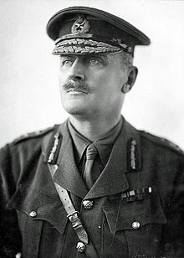
Field Marshall Edmund Allenby

Rabbi Judah ben Samuel (born 1140 - died 1217) prophesied that Muslims would control Jerusalem for 400 years, which they did from 1517 to 1917. He also prophesied that there would be two Jubilee periods afterward concerning Jerusalem (about 100 years total), then the times of Messiah would begin. Here is a link to his prophecy: http://destination-yisrael.biblesearchers.com/destination-yisrael/2012/12/rabbi-judah-ben-samuels-jubilee-prophecy-gives-the-year-of-the-messiah.html

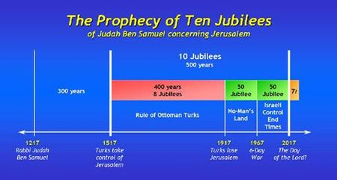

1st Viscount Allenby was a Christian man who recognized Jerusalem as a City of Peace. He determined to enter Jerusalem on foot as a man of peace, not on a horse or vehicle, in respect of the Word of YaHuWaH Elohim.

Because he entered the Jaffa Gate on foot, taking control of Jerusalem after many years, 1st Viscount Allenby was a symbol of Messiah YAHUSHUA who will also enter Jerusalem on foot at some time in our future. Messiah YAHUSHUA will take control of Jerusalem, delivering it from it's enemies. Field Marshall Allenby entered Jerusalem through the western Jaffa Gate, but Messiah YAHUSHUA is prophesied to enter on foot through the Eastern Gate. He will arrive from the sky and set foot first on the Mount of Olives directly across the valley from the Eastern Gate.

Here's the immediate prophetic timeline fulfillment mentioned in the opening sentence above:

12/11/1917 (1st Viscount Allenby enters Jerusalem on foot, signifying the Messiah) + 100 prophetic years (10 x 10 prophetic years, or 36,000 days) = July 4, 2016

