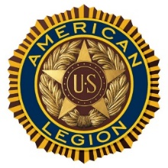
Hole Sponsorships
are available for the Annual Commander Stephen J. Robillard
Golf Tournament
on
Saturday – September 19, 2026– 9:00 a.m.
at
Hilton Head Lakes Golf Course

$ 100 donation

Includes:
Your sign on one of 18 Hole’s
Sponsor listing on our website for 1 Year
(www.alpost205.org)
Submission deadline is Wednesday, September 12, 2026
Sponsor’s name:
Address:
Email address:
Website:
Phone Number:
Contact Name:

Post 205 is a 501(c)3 non-profit organization. Your $100 donation is tax-deductible.

Please Make Check out to American Legion Post 205 and mail to
American Legion Post 205,
P.O. Box 2376, Bluffton , S.C. 29910
For information: please contact
Mike Miranda – 854-683-5577 – Web Site - Alpost205.org

