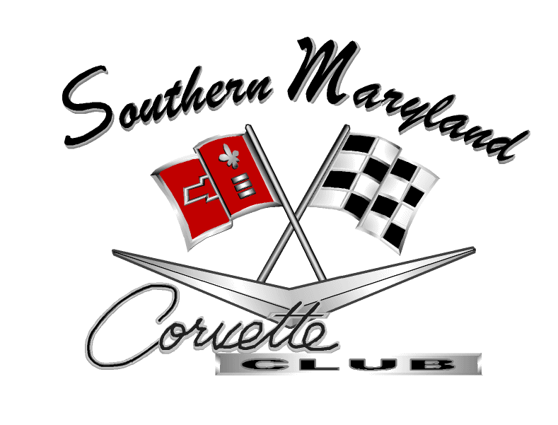

Meeting Minutes

Southern Maryland Corvette Club

August 13, 2012 Meeting Minutes

- Attendees: Fourteen (16): Rick Davis, Dennis Lyons, Jim and Jane Quigley, Ray and Linda Smith, Tom Santangelo, Sam Lupi, Don Byrne.
Guests: Doug Smith

- Where/When: Meeting held at the Leonardtown Commissioners' Office on Monday May 14, 2012 and called to order at 7:00 PM by our Club Vice-President Rick Davis.

- The Pledge of Allegiance was lead by Dennis Lyons.

- Welcome membership: Vice President, Rick Davis, welcomed members and guests. The members introduced themselves and their cars.

- Meeting Minutes: The April meeting minutes was reviewed during the meeting with a few typing errors mentioned.

- Treasurer’s (Charles Wheeler) Report as of May 14, 2012:
Our treasurer is on vacation from May 22 to June 22, so did not provide us with us a

- Balance as of Previous Report dated April 9, 2012: $ 8,233.73
- Available balance for use as of April 9,2012: $ 6,933.73

- Committee Chair Reports (Note: Minutes reflect only those Committee Chairs that needed to report)

- Membership Chair (Vince Merz): Mr. Merz did not attend the meeting.

- Activities Chair (Mike Donovich): Mr. Donovich was on travel and did not attend the meeting. However, a list of activities was sent out electronically to our members. The events list was read during the meeting. A copy of the SMCC activities list is attached for your convience.

- Web Site ( Dave Grimsley) – Mr.Grimsley did not attend the meeting, however he has taken over our website with the in site of our club members. He is taking the original website and incorporating numerous changes upon getting the password from Scott Bear.

- Merchandise - President Ben Mendoza acknowledged that we still do not have a merchandise chair.

- Scholarship - Mr.Wheeler was elected as our new Treasurer during the April 9, 2012 meeting. Therefore, we do need a scholarship chair to replace him. It was reported that the $1000 scholarship was awarded to Benjimin Morgan, who is planning to continue his education in engineering.

- Old Business:

- Our By-Laws dated 12 November 2001 and Revision (H). Per By-Law protocol timeline, April 9, the draft was to be reviewed during this business meeting. Revision (H) was reviewed and was ready for the final vote as all necessary changes were made to date. However, it was realized that the final version was not sent out electronically. This version will be sent out to everyone by May 15, 2012.

- Seven (7) members attended the Spring Fling XXVII Car Show on the Leonardtown Square, Sunday April 29, 2012. Thanks Ben Mendoza, Mike Donovich, Dennis Lyons Rick Davis, Vince Merz, Sam Lupi and Brian Katafiaz for representing SMCC and showing off your Vettes!

- Ten (10) members celebrated the Mother’s Day breakfast brunch on May 13, 2012 at Shymanski’s restaurant on Cobb Island.

  - Other Business:

- In April, President Ben Mendoza planned a picnic on the Patuxent River Naval Base beach house. The date was later announced as June 9, 2012. He sent out e-mails asking for an RSVP and who had access to the base. He received few responses, but now realized it conflicts with another SMCC activity. Now another date of July 14, 2012 has been proposed. Ben still has to check availability and will e-mail us later.

- The May 19, plans to have a wine tasting party at Leila and Dave Grimsley’s home has been cancelled until September.

- Birthdays: May Birthdays were recognized:

Happy Birthday to Jack Raynor (4), Bill Gilligan (14), and Scott Bear (20)

- Next SMCC Meeting: The next meeting will be on Monday June 11, 2012 at 7:00 PM, in the Leonardtown Commissioners' Office, 41660 Courthouse Drive, Leonardtown, MD 20650.

- Motion to Adjourn: Motion was made by Tom Santangelo, seconded by Dennis Lyons to adjourn, passed by a voice vote. The meeting ended at 7:45 PM.

Minutes Recorded by: Leila Grimsley, Secretary

Southern Maryland Corvette Club, May 14, 2012

